A Major Project Final Report on

**Budget Travel Plan: Plan your trip within Budget**

Submitted in Partial Fulfillment of the Requirements for the **Bachelor of Engineering** in **Software Engineering** under **Pokhara University**

Submitted by:

**Binay Dahal, 14709**

**Saroj Adhikari, 14732**

**Niroj Prasain, 14741**

**Ojaswee Thapa, 14720**

**Under Supervision of**

**Er. Roshan Sah**

Date: December 9, 2018.

**Department of Software Engineering**

**NEPAL COLLEGE OF**

**INFORMATION TECHNOLOGY**

**Balkumari, Lalitpur, Nepal**

# ACKNOWLEDGEMENT

First and foremost, we would like to thank our supervisor Er. Roshan sah for his guidance throughout this project. Without his invaluable advice and assistance, it would have not been possible for us to complete this part of our project on time.

We would like to provide our special thanks to Dr. Roshan Chitrakar, for providing technical support with enormous suggestions which helped us to coordinate our project. We would also like to thank Er. Birendra Bista (Head of Department of Software Engineering), for their valuable guidance throughout the project development period.

Moreover, we would like to owe our special thanks to all subject teachers who provided us with necessary information during the course of studies, which somehow helped us in various ways for the development of project. Similarly, we truly admire the effort of all persons who knowingly or unknowingly provided us with the concept about the project that assisted us for development of the system.

# Abstract

**Budget Travel Plan** is a web based budget managing application that brings the entire major travel destination to life in the palm of the hand and is designed to provide users with a platform to know exciting destination details with affordable budget.It alsohelps the user to estimate the best set of activities that could be done under their budget starting from getting the best rate of money exchange to flight plans, hotels and other set of adventurous activities. People usually doesn’t calculate the possible activities that could be done in given budget, so this led to lack of money to do certain task they wanted to do. Budget Travel Plan overcomes this situation by providing a platform by managing or controlling the travel plan.

With Budget Travel Plan, users will get to be updated with the various destination places across the country.

Keywords: Budget, Travel, Money, Plan, Scrape

**LIST OF FIGURES**

Figure 1: Incremental Model …………………………………………….….………… 8

Figure 2: Use Case Diagram …………………………………………………….……. 14

Figure 3: ER Diagram ………………………………………………………………… 15

Figure 4: Activity Diagram ………………………………………..……………………15

Figure 5: Sequence Diagram ………………………………………..………..…………16

Figure 6: Database for Total Price …………………………………..………..…………18

Figure 7: Database for Total Price …………………………………..………..…………18

Figure 8: Exchange Rate ………..…………………………………..………..…………19

Figure 9: User interface display for live calculation ………………..………..…………19

Figure 10: Gantt Chart …………………………………………………………………. 21

**LIST OF TABLES**

Table 1: Tools used ……………………………………………………..…………….. 10

Table 2: Required System …………………………………………………………….. 11

Table 3: Work Division ……………………………………………………………….. 13

Table of Contents

**ACKNOWLEDGEMENT**I

**ABSTRACT** II

**LIST OF FIGURES** III

**LIST OF TABLES** IV

1. **INTRODUCTION** 1

1.1 PROBLEM STATEMENT 2

1.2 OBJECTIVE 3

1.3 SIGNIFICANCE 4

1.4 SCOPE AND LIMITATION 5

2. **LITERATURE REVIEW** 6

2.1 REVIEW 6

2.2 EXISTING SOLUTION 6

2.3 SOLUTIONS OFFERED TO THE EXISTING DEFICIENCIES 7

3. **METHODOLOGY** 8

3.1 SOFTWARE DEVELOPMENT LIFECYCLE 8

3.1.1 SYSTEM ANALYSIS 8

3.1.2 SYSTEM DESIGN 9

3.1.3 CODING 9

3.1.4 TESTING 9

3.2 TOOLS USED 11

3.3 TECHNOLOGIES USED 11

3.4 **SYSTEM REQUIREMENT** 12

4. **FEASIBILITY STUDY** 13

5. **WORK DIVISION** 14

6. **TECHNICAL DESCRIPTION** 15

7. **FEATURES** 18

8. **RESULT DISCUSSION** 19

9. **WORK SCREENSHOTS** 20

10. **TASK AND TIME SCHEDULE** 22

11. **LIMITATIONS AND FUTURE ENHANCEMENT** 23

12. **CONCLUSION** 24

**REFERENCES** 25

# INTRODUCTION

Nepal is country of natural beauty. Due to its natural beauty many tourist visits Nepal for refreshment tourism is one of the good source of economic. During their stay in Nepal they visit different part of the country. Also they enjoy the place and involve in the different activities available according to the place. The many factors that affect their stay in the Nepal is their budget. In context of Nepal the value of foreign currency is high. During their visit they have to exchange their currency into Nepali currency. The exchange rate is different in different exchanger. In the previous days people has to visit the different currency exchanger one after another to find the best exchange rate.

Our project helps to find the current exchanger to the foreigner in a single screen. With the completion of this project one can find the best exchange rate at his/her screen. We should not visit the exchanger one after other to find the best exchange rate. Also this project helps to plan the overall stay of the tourist. Our system provides/shows the different refreshment activities that can be done in different place of the Nepal. The only thing the user has to choose their destination. Our system helps plan their visits as it show the money they have to spend for the particular refreshment activities. This feature of the system helps involve in the activities according to their budget. The system/ project help the user to manage/ plan their visit according to the budget. Our system helps the user to know the activities that can be done in different part of Nepal. Also this helps the visitor/ user to estimate or arrange the budget before beginning their visit.

1.1 PROBLEM STATEMENT

Money is limited, specially applied to normal middle class people. So there must be proper planning of everything to make the best use of their money. This also applies while travelling.

Firstly the main problem people face, especially tourists, is that how much money they will get in exchange with local currency (i.e. Nepali currency). Tourists don’t know the exact equivalent local rupees for their available money. So they have to visit a country in order to get all the required information or they have to visit all the websites for the latest money exchange rates for their money.

While travelling, unplanned trips normally led to unfulfilled set of the user’s wish due to lack to money. People normally spend money on something of lower priority before on that of higher one. Due to this, a person spend money on those lower priority tasks and lose their money and gets nothing left for the higher one. For example a person going to Pokhara for paragliding and zip flyer activities might spend their money on more expensive hotel and might not get enough money left to do both of his bucket lists. This is due to improper planning; he only managed money for his activities but neglected the other areas where they might lose their resources.

Budget management also depends on seasons. Fine weather and holiday season might be expensive whereas off seasons might be cheaper. So it is difficult to know what the current price of the places is. People might expect same lower price from the off season time to be in expensive high traffic time. User also does not have idea about the daily expenditure on their needs like water, food and more. So they won’t be able to estimate how much money they might require for these items.

# 1.2 OBJECTIVE

The main objective of the system is to provide the present exchange rate and also helps the user to estimate the budget and plan their travelling.

Specific objectives of the system are as follows:

* Providing the current exchange rate.
* Estimate their budget for travelling in local currency.
* User knows about the different available refreshment activities in the particular location.
* Choose the best travel places that are available and famous among tourists.
* Provide real time rate of different activities they wants to do, like paraglide, hotel and more.
* Allow user to choose the best plan for their travel on budget.
* Minor description of the hotel and other recreational activities they wanted to do.
* To estimate the daily expenditure of the user, and calculate the overall daily need price that includes water, food and more.

# 1.3 SIGNIFICANCE

Budget travel plan is hugely benefited to those who want to travel in limited budget. With provided exchange rate of different agencies of everyday rates, users are able to know the real time exchange rate they will get in return so that they can get the local currency.

This money is then used to make the travel plan for them. This includes different hotels, flight plans, recreational activities and more from the place they wants to visit. This makes effective budget travel since they can know how many activities they can get involved within their money so that they won’t face much financial problems later which is major plus point since they can get full benefit of their money in right order. User can also book their travel plan which will be linked to their respective sites so that they can immediately fix their plan.

# 1.4 SCOPE AND LIMITATIONS

Budget travel plan will be built to make the best travel plan the user can get within their budget. So it has very high scope in the tourism industry as they can know about the estimated budget in real time from their smart device and PCs in home without having to visit the place. Also they can get information about where to get money exchanged and how much they will get in return. User will be able to get destination plan and recreational activities available, all these in same system. This will be very helpful for those people who want to know about Nepal and want to visit here.

Despite these, there are some limitations on this app. Since our system is based on web scraping, only those hotels and recreational areas will be included that has provided their rates online. This can be further extended in future by giving each clients their account from where manually update their details so that they can even provide discounts and other details for the app user only. Also we won’t be able to add details of remote areas for same reason that their information isn’t provided online. At its peak, this app can be extended to worldwide destination so that global tourism can be more explored.

# LITERATURE REVIEW

As a part of literature survey, we investigated some applications of budget travel plan that already exist in market. The aim is to observe how these applications work and to see how they can be improved and how are they different. To date it is identified that the following Apps/Website of budget travel plan are good and are offering relatively similar service.

2.1 REVIEW

Budget travel plan application has been very popular these days because it makes us possible to manage travel plan with limited money. In earlier days, the budgets were planned informally in the papers which were really difficult to handle all those calculations. With the further development in the technology many systems regarding the budget plan were built to handle all the calculations efficiently.

Since budgeting allows you to create a spending plan for your money, it ensures that you will always have enough money for the things you need and the things that are important to you. Many projects have been done for Budget travel plan having different types of problems. Hence our project provides them with the proper tool to help to improve the system.

* 1. EXISTING SOLUTION

1. Trail Wallet: [[1]](http://voyagetravelapps.com/trail-wallet/) Whether you're backpacking through the rainforest or relaxing at a beach resort on the other side of the country, Trail Wallet helps you organize your expenses in just a few screen taps. The daily budget feature gives you details about how much you're spending along the way. Just log your receipts and bills on the app's "Quick Add" screen to keep a running tally of your daily spend. Check the detailed summary screen for a snapshot of what you've spent so far and switch between the amounts you spent versus how much you budgeted to keep yourself on track with your goals.

2. Spent: [[2]](https://play.google.com/store/apps/details?id=com.spentapp.android&hl=en) This app can help you get paid for your budgeting efforts as you travel. Spent includes the familiar expense-tracking and budgeting tools – scanning of receipts, customizable budget folders, automatic downloading of transactions from linked credit and banking accounts – along with some quick and easy interface tricks to help you organize your expenses. The app's main draw is a cash back rewards program on purchases. There's an online store affiliated with Spent that offers additional cash back rewards for purchases. Spent is free and available for iOS and android.

3. Tripcoin: [[3]](https://tripcoinapp.com) **Tripcoin** works with or without an internet connection, so you can rely on it in even the most remote areas. Use it to get a snapshot of all your expenses for the day, see how your actual spending compares with your budget and spot which spending categories are eating up your budget the fastest. You can also set up custom categories and custom payment methods to smooth out transactions while you're on the road.

4. Trivago: [[4]](https://en.wikipedia.org/wiki/Trivago) **Trivago** is a German multinational technology company specializing in internet-related services and products in the hotel, lodging and meta search fields. The American travel company Expedia Group owns a majority of the company's stock.

Trivago's hotel search engine was the first of its kind in Germany and has websites in 50+ countries. Trivago claims to be the world's largest online hotel search site, comparing rates from over 1 million hotels and more than 250 booking sites worldwide. The site includes over 190 million hotel ratings and 14 million photos, and reports over 120 million visitors per month.

Trivago's search tool scans hotel booking sites for prices, availability, images and reviews within seconds. When users choose a hotel, they are redirected to a partner website to complete the booking.

2.3 SOLUTIONS OFFERED TO THE EXISTING DEFICIENCIES

The prime objective of “Budget Travel Plan” is to

1. Manage efficiently your plan under affordable budget.
2. Show possible visiting places on the end destination.
3. Show available major destinations and the list of activities that can be done in that page
4. Real time price of recreational activities and of exchange rates so that user can see actual data, not based on e-commerce.

# METHODOLOGY

We have planned to work following these methodologies for the application of knowledge, skills, tools and techniques to a broad range of activities in order to meet the requirements of our project, Budget Travel Plan. This section presents detailed information about the software development process, project approach and the tool that we used for our project.

3.1 SOFTWARE DEVELOPMENT LIFECYCLE

The framework that we planned to incorporate for developing this project is **Incremental** model. This model combines linear sequential model with the iterative prototype model. New functionalities will be added as each increment is developed. The phases of the linear sequential model are: Analysis, Design, Coding and Testing. The software repeatedly passes through these phase in iteration and an increment is delivered with progressive changes.

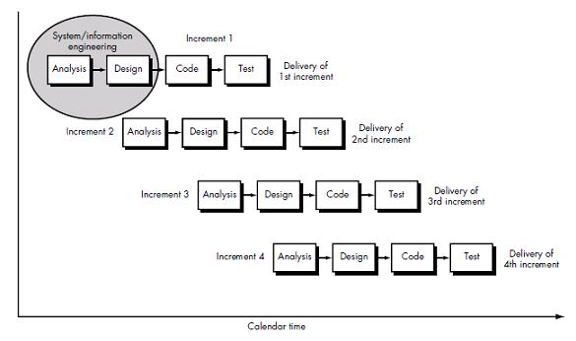

Figure 1: Incremental Model [[5]](https://tripcoinapp.com)

3.1.1 System Analysis

The goal of system analysis is to determine where the problems are an attempt to fix the system. This step involves breaking down the system in different pieces and drawing to analyze the situation, analyzing project goal, breaking need to be created and attempting to engage users so that definite requirements can be defined. This project was developed by doing some analysis of existing systems. We saw how other existing system was providing their service and where they lacked to satisfied user. We found out that people had to visit different sites for information of different elements. There doesn’t exist a system where someone can get their complete travel plan under their budget, most of the sites are based on commercial perspective. So, we did some research on what can be done to make user’s task much easier. So we included everything including exchange rate along with hotels and other recreational activities in same system. We also decided to allow user to allocate certain amount of money that they want to spend on their personal expenses.

3.1.2 System Design

In systems design functions and operations are described in detail, including screen layouts, process diagrams, and pseudo code and a complete entity relationship diagram with a full data dictionary. The output of this stage will describe the system as a collection of modules or subsystems.

3.1.3 Coding

Modular and subsystem programming code will be accomplished during this stage. This phase involves implementing the system by using front end with html/css, back end as php and python programming for web scrape using its tools such as scrappy, beautiful soup and anaconda. Other technical used for developing this application are java script, bootstrap, python and more.

3.1.4 Testing

The designed system will be tested to ensure that it works correctly and efficiently. In this phase, with each testing, if change is evitable, then the process is analyzed from the very beginning and carried out until all the requirements are fulfilled.

Unit testing and module testing are done in this stage by the developers before the integration of main project. Unit, system and user acceptance testing are often performed. This is a grey area as many different opinions exist as to what the stages of testing are and how much if any iteration occurs.

So, using this incremental model which is iterative linear sequential model, in the first increment we just created a design for our project and secondly during the next increment we developed a module for our safety map. Similarly, after the third increment we developed another module and we continued this approach until all modules are developed.

Unit testing was done on each module, such as database, scrape, frontend, JavaScript, CSS and more.

Integration testing was done while combining them. For example when CSS was imported into HTML section to see if we get required result. Similarly, when we imported scrape data into our system.

System testing was done when all modules were bought together as a fully functioning system. This included showing user interface, using user’s data for calculation, importing external data from scrape, storing the calculation data in database for further calculation and future analysis process.

Different phases of iteration that went through this incremental model are as follows:

Iteration I:

* Analysis of Problem statement
* Analysis of existing solution

Iteration II:

* Analysis of possible solutions
* Research on new system
* System design

Iteration III:

* Basic user interface template design
* Front end development
* Research on scrape data
* Front end UI testing

Iteration IV:

* Scraping of Web data
* Backend analysis and methodology
* Discussion of possibility of database
* Testing of completed task

Iteration V:

* Backend development
* Work with database
* Integration and System testing

3.2 TOOLS USED

The tools used for documentation, designing and developing UI/UX, testing are listed below in table:

|  |  |
| --- | --- |
| TOOLS | PURPOSE |
| Adobe Photoshop CC | Designing UI/UX and Graphics Design |
| Github | Manage Source Code and Version Control |
| Anaconda | Data Science tool for developing, testing and training on a single machine |
| Sublime Text | Script Editor |
| Beautiful Soup | HTML Parse |
| Scrapy | Open source framework for collecting data form website |

Table 1: Tools used

3.3 TECHNOLOGIES USED

1. HTML and CSS to develop interactive user interfaces.
2. JavaScript, for event handlers and behaviours to add user interaction.
3. Bootstrap, a CSS framework for further styling the application.
4. PHP for backend.
5. Python for scraping.
6. SQL Server for database.
7. Excel and JSON for storing scrape data.
   1. SYSTEM REQUIREMENT

|  |  |
| --- | --- |
| Operating system | Windows XP or more, Linux |
| RAM | 256 MB or higher |
| Database | MySqli |
|  |  |

Table 2: System Requirement

# 

# FEASIBILITY STUDY

The feasibility study is performed to determine whether the proposed system is viable considering the Technical, Operational and Economical factors. After going through feasibility study we can have a clear-cut view of the system’s benefits and drawbacks.

**Technical Feasibility**

The proposed system is developed using HTML, CSS and JavaScript as front-end tool and PHP as the back end. For Data scraping Python is used. As application is very user friendly and GUI OS it is very easy to use. Hence the system is technically feasible.

**Operational Feasibility**

The proposed system is operationally feasible because of the following reasons.

* The users are benefited more as this website aims and serves for the various functionalities and features required to them.
* The cost of the proposed system is almost negligible when compared to the benefits gained.

**Economical Feasibility**

* As the necessary software is available in the market at a low cost or free, the initial investment is the only cost incurred and does not need any further enhancements. Hence it is economically feasible.
* The system is feasible in all respects and hence it encourages taking up the system design.

# Work Division

|  |  |  |  |
| --- | --- | --- | --- |
| S.N | Name | Role | Activities |
| 1 | Binay Dahal | Developer | * Back End Developer * Research * Validation * Project Planning * Documentation |
| 2 | Saroj Adhikari | Developer | * Back End Developer * Resource Allocation * Documentation |
| 3 | Niroj Prasain | Quality Manager | * Front End Developer * Research * User Experience Test |
| 4 | Ojaswee Thapa | Tester | * Front End Developer * Testing Application * User Experience Test * Validation Of Application |

Table 3: Work Division

# TECHNICAL DESCRIPTION

Budget travel plan is a based on web scrape technology. So this system is run in every operating system as well as every browser. Few ways of extracting information were either API or manual or scrape. Since API might not be provided by agencies and manual would be time consuming and have to be regularly updated, scraping seems to be best option. This was done by manipulating the front end code of the website of the company and abstracting the requirement code. This helped us to provide the required data that will be used to make the travel plan for user. Scraping was done using python programming, which provide data in CSV and JSON format.

PHP was used to provide the backend of the system, it was the portion that user doesn’t have to deal with. It provides the backbone of the system where actual work happens.

HTML/CSS provide the front end design for system where user will be interacting and will display the result and processing on the screen.

Other softwares that were used during the development of Budget travel plan are:

* Adobe Photoshop to design the visuals and element for front ends.
* Microsoft Visio to design the charts and statistics.
* ATOM and sublime text was used as script editor where entire coding was done.

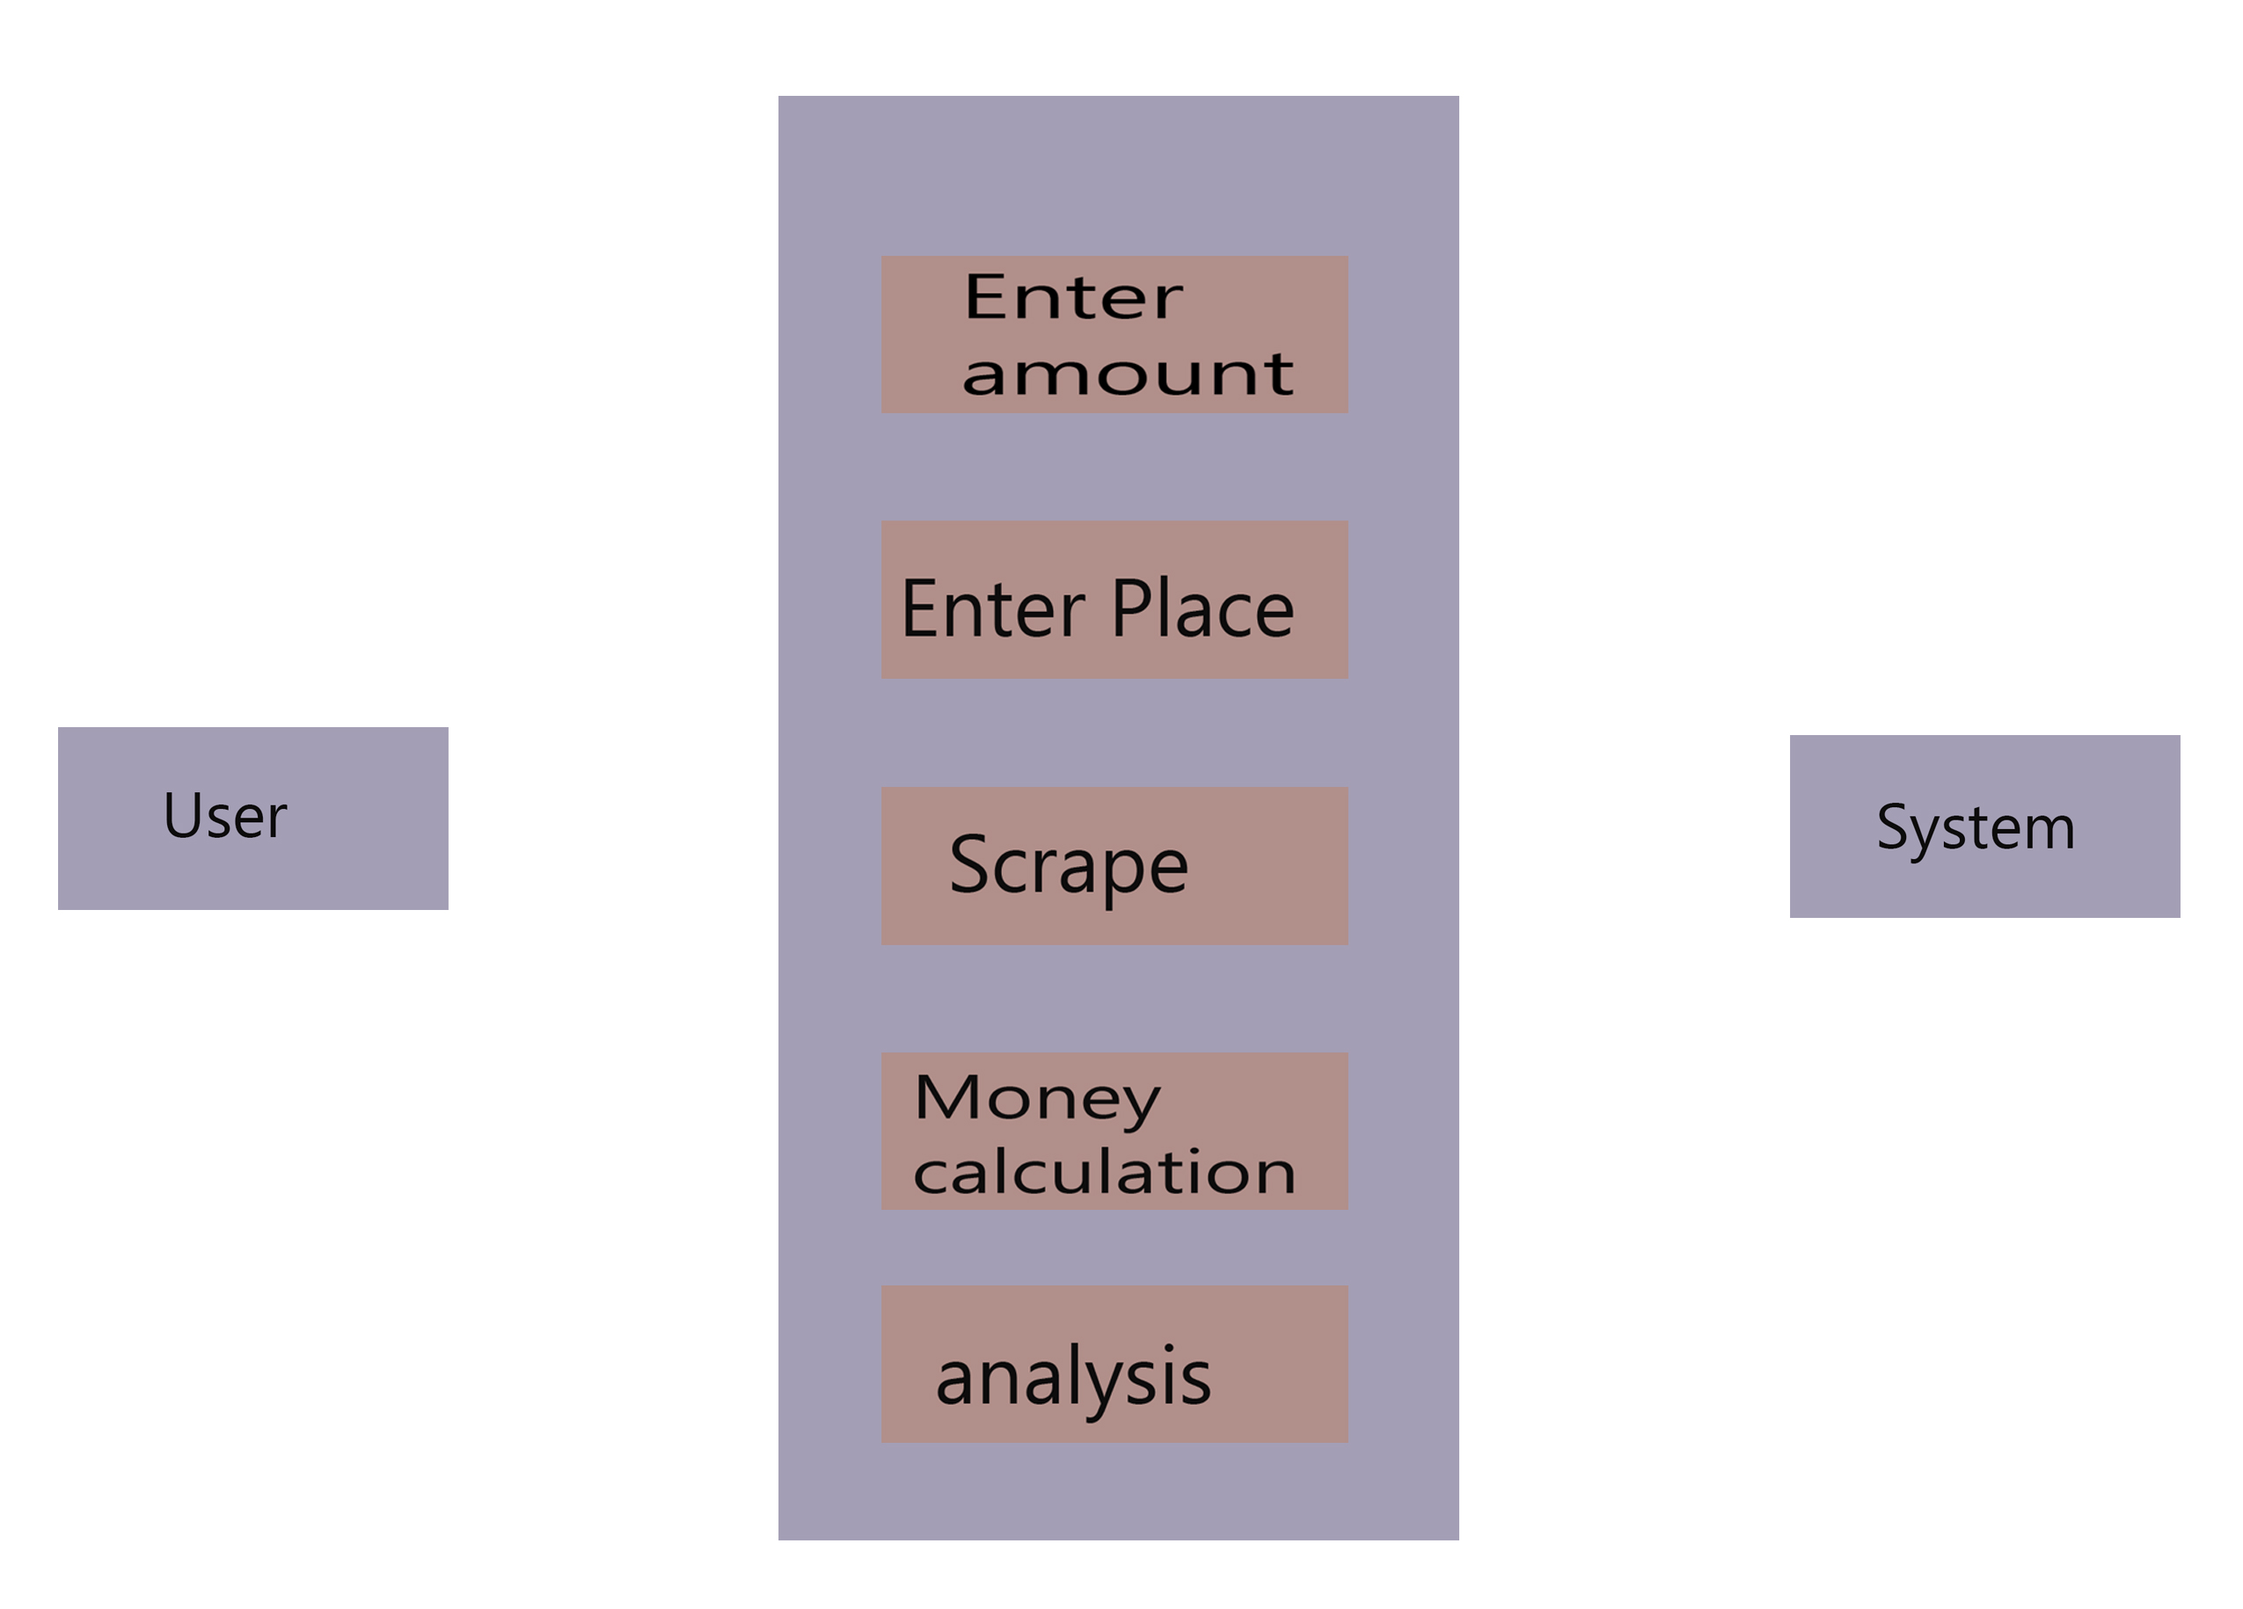

Figure 2: Use Case Diagram

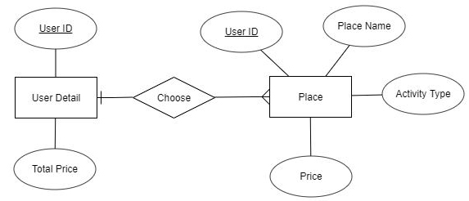

Figure 3: ER diagram

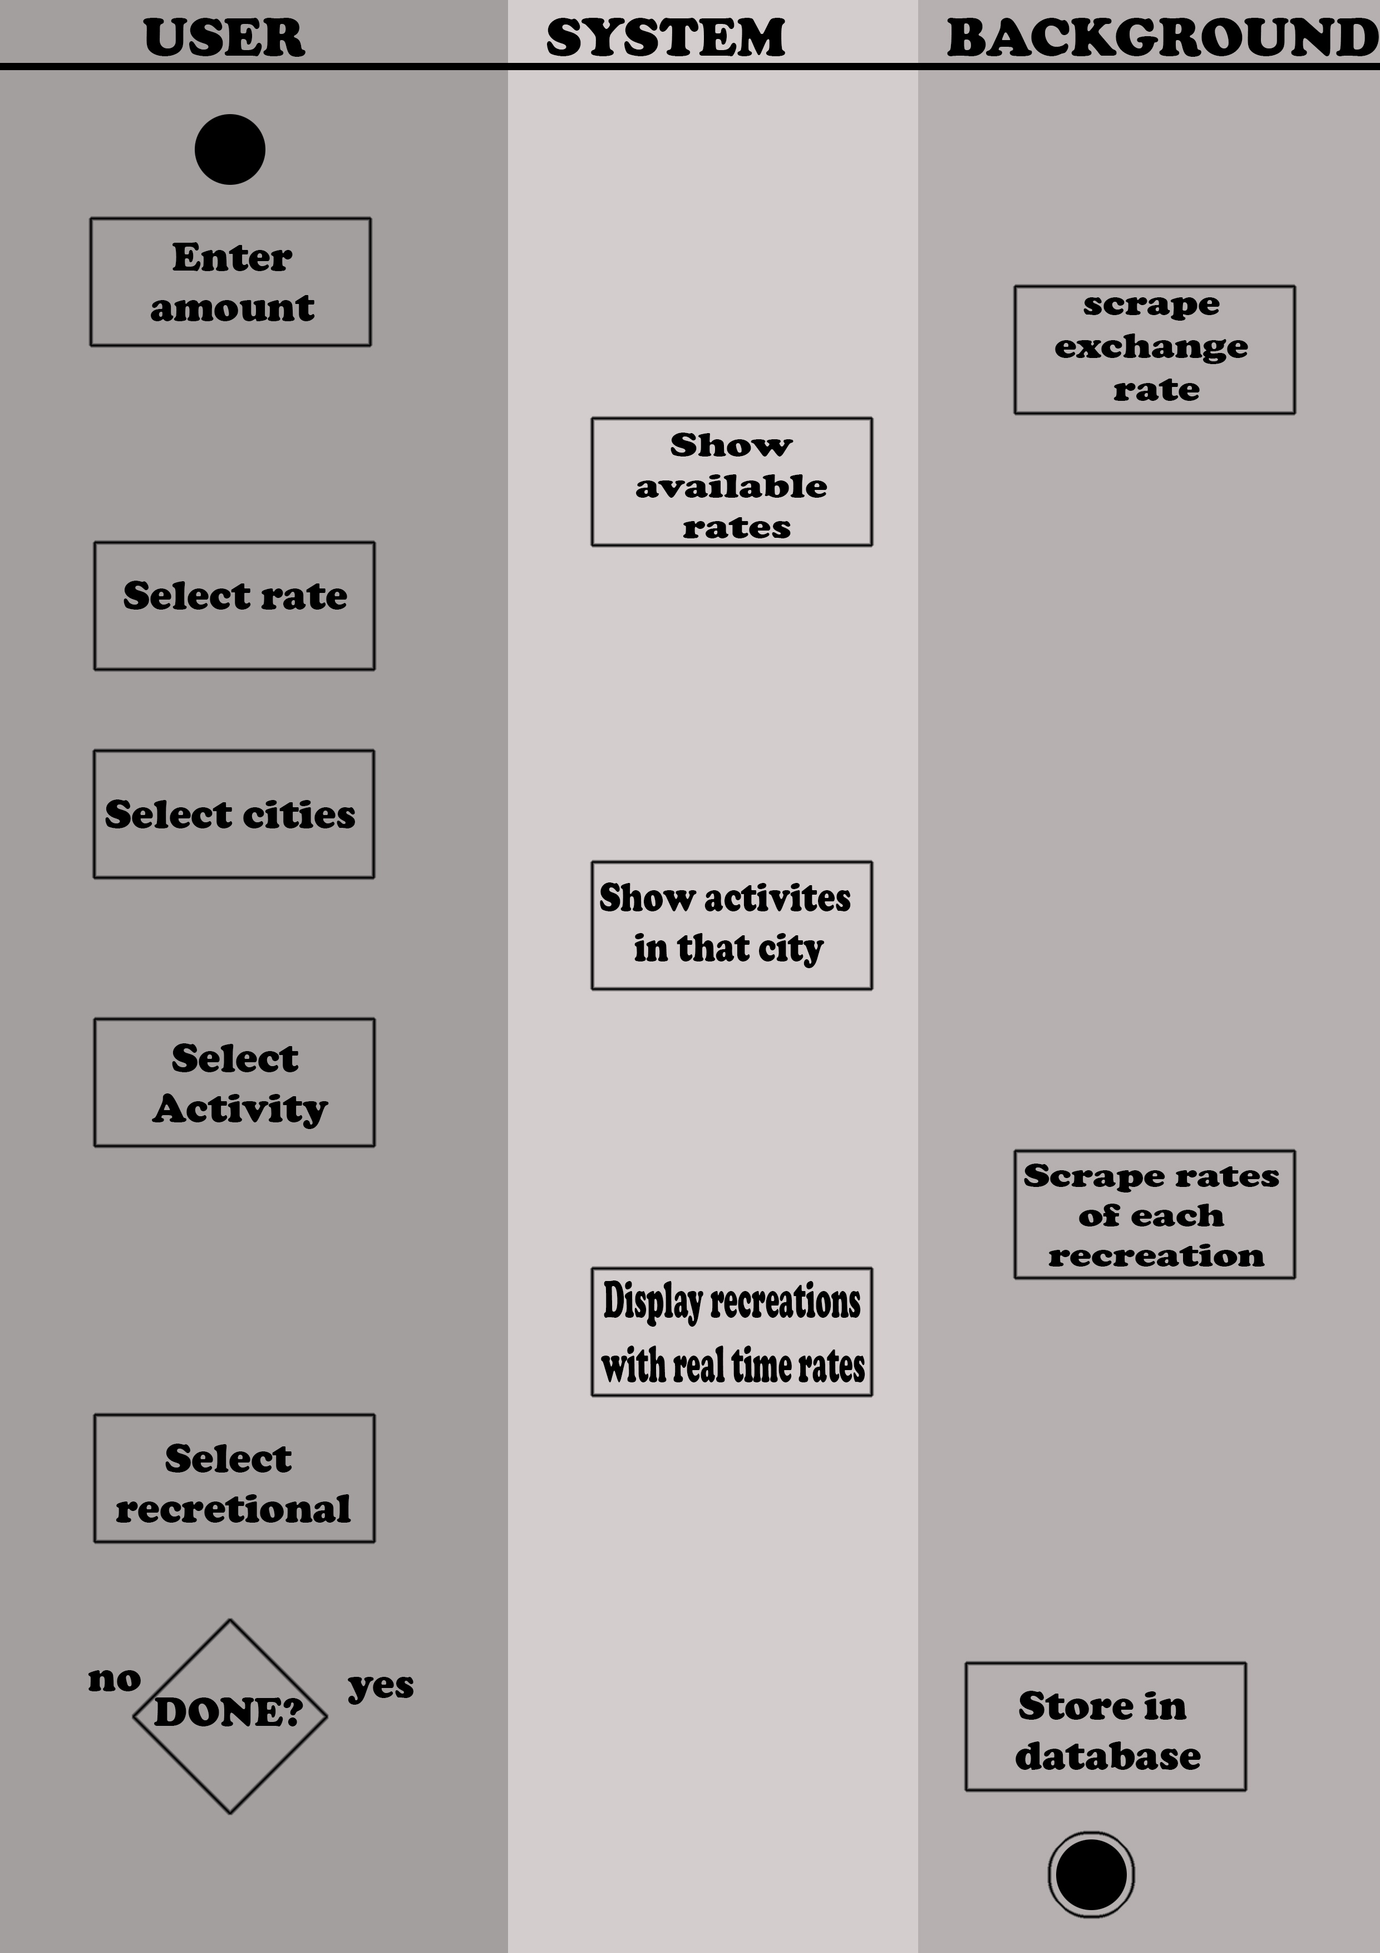

Figure 4: Activity diagram

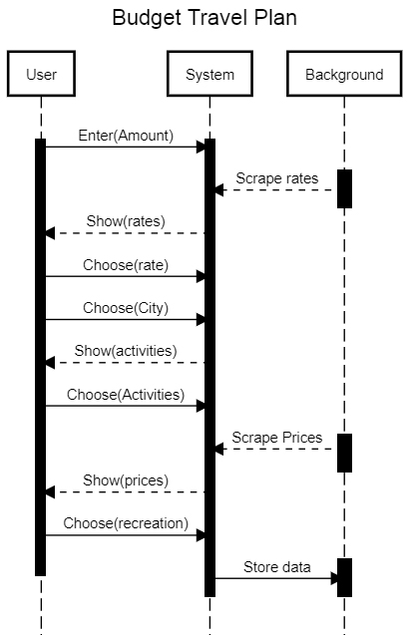

Figure 5: Sequence diagram

# FEATURES

* Estimate the current exchange rate for the user.
* Allow user to choose the destination they wants to visit.
* Show the possible adventure and activities of the selected destination.
* Make the proper plan for the travel by showing live calculation of how money will be used in user’s trip.
* Show the estimated cost for the travel.
* Make booking easier for user so that they can immediately book their vacation.
* Show the short description of the activity and destination that user wants to do so that they can get some knowledge about it before going there.
* Give user option to select different items according to price so that they can choose their travel plan according to their budget.
* Users are given option to see plan of past users if they enter same amount as past so that new user can get idea of how past users managed their same amount of money.
* Email is send to company whenever any user choose to book from our side. This will inform the company that new customer has been redirected from our system.

# RESULT DISCUSSION

* Front end section of site has been completed starting from home screen to currency selection and more.
* City selection has been made more users interactive where they can get demo preview of the city named thumbnail instead of searching, as people who has no idea about the cities can get some idea about existing best tourist destination.
* Best entertainment activities from different cities has been researched and kept in thumbnail hyperlink so that visitor can get little idea about the activity from thumbnail itself.
* Scraping section of the website has been completed using python as major language and tools such as beautiful soup to parse html of existing sites and anaconda for data science to help us better for the project.
* Scrape data has been stored in its best format so that it can be retrieved in easier way. For example scraping of national currency exchange rate information is stored in excel .csv file so that it can be stored in matrix form and we can abstract them using its coordinate.
* Details of every recreational place such as hotels, paragliding, etc have been added so that user can get idea about the place from our site itself and doesn’t have to visit each and every section’s real website. Pictures also have been added to get better perspective.
* Special button of “Book” is added to every recreational place so that visitors can not only get detail of the place but can do online booking immediately. We do not book by our self since we do not promote e-commerce, so we will redirect them to original booking area.
* Backend section has been completed where user’s money is being used for calculation purpose to make them a proper plan
* Database is done in both the total price and full detail section.

# Work Screenshots

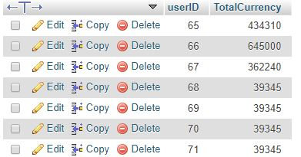

Figure 6: Database for Total Price

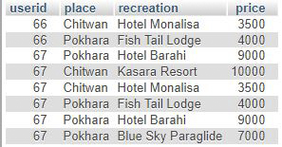

Figure 7: Database for detailed price

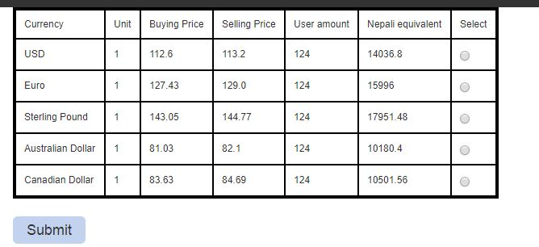

Figure 8: Exchange rate

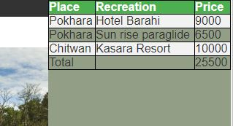

Figure 9: User interface display for live calculation

# Task and Time schedule

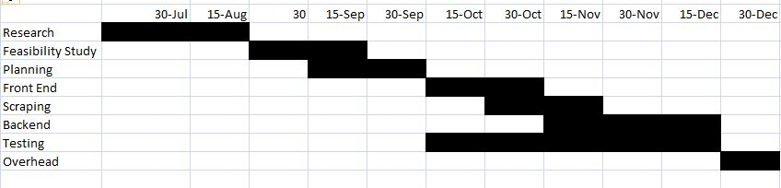

Figure 10: Gantt chart

# LIMITATIONS AND FUTURE ENHANCEMENT

# Limitations

There are many kinds of advantages of our project but some amounts of limitation are present. These certain limitations are the following:

* Our system is based on web scraping, only those hotels and recreational areas was included that has provided their rates online.
* Also we won’t be able to add details of remote areas for same reason that their information isn’t provided online.

**Future Enhancement**

* This can be further extended in future by giving each clients their account from where manually update their details so that they can even provide discounts and other details for the app user only.
* With much more research and improvement, we can be added other more famous destination places across the country.
* We can add internal booking system so that company’s special offers can be displayed through this system

# CONCLUSION

After the development of our project we have come to the following conclusion:

* Allowed user to manage their trip under affordable budget.
* Gave the details of user’s searched destination places.
* Users can manually calculate their trip budget with all the additional expenses.

We believe that any project no matter how or where is done we must fulfill the condition or reach the goal of the system. Also the project must solve the real world problem and also help to upgrade the existing system. Also, our team has learned about the importance of teamwork, work division and time management skill while doing our project.

# REFERENCES

[1] Trail Wallet official website: <http://voyagetravelapps.com/trail-wallet> [Accessed: 2018 Oct 20]

[2] Google play store app for spent app: <https://play.google.com/store/apps/details?id=com.spentapp.android&hl=en> [Accessed: 2018 Oct 22]

[3] Trip coin official website: <https://tripcoinapp.com> [Accessed: 2018 Oct 20]

[4] Wikipedia page for Trivago company: <https://en.wikipedia.org/wiki/Trivago> [Accessed: 2018 Oct 25]

[5] Incremental model of software development: Roger S. Pressman, PhD., Seventh Edition Software Engineering: A Practitioner’s Approach, McGraw Hill, 2010 [Accessed: 2018 Nov 5]