s

A Major Project Final Report on

**Online Passport System**

Submitted in Partial Fulfillment of the Requirements for

the Degree of **Bachelors of Engineering in Computer Engineering**

under Pokhara University

Submitted by:

**Denisha Thapa, 14312**

**Sulav Guragain, 14344**

Under the supervision of

**Ramu Pandey**

Date**:**

**08/12/2018**



**Department of Computer Engineering**

**NEPAL COLLEGE OF**

**INFORMATION TECHNOLOGY**

Balkumari,Lalitpur,Nepal

**Acknowledgement**

It gives us immense pleasure to express our deepest sense of gratitude and sincere thanks to our highly respected and esteemed supervisor Er Ramu Pandey for his valuable guidance, enthusiastic encouragement and help for completing this work. His useful suggestions for this whole work and co-operative behavior are sincerely acknowledge. His willingness to give his time so generously has been very much appreciated.

We would like to express our sincere thanks to Dr RoshanChitrakar for giving us this opportunity to undertake this project. We are also grateful to our teachers for their constant support and guidance. At the end, we would like to express our sincere thanks to all our friends and others who helped us directly or indirectly during this project.

**Abstract**

Today, the changing world has dragged us towards the age of science and technology which has made a heavy contribution for the modernization of the world and the people living. Implementation of new and advanced technologies has simplified the life style of people. The core purpose of the project “Online Passport System” is to provide online passport form (with details such as name, address etc.). The development of this system tries to automate the entire process keeping in view of database integration approach. The project we’ve proposed has three level of users i.e. Applicants, Editors and Super Admin. Firstly, an online form is provided to the applicants where they fill in their details which is then checked and verified by the editors. The editors are controlled and monitored by Super Admin.

***Keywords:*** *Automate, passport form, users, verified.*

**Contents**

1. Introduction 1

2. Literature Study/Review 2

2.1 Review 2

2.2 Existing System 2

2.3 Proposed System 3

3. Problem Statement 4

4. Project Objectives 5

5. Scope and Limitations 6

5.1 Scope 6

5.2 Limitations 6

6. Proposed Methodology 7

7. Results and Discussion 11

8. Requirements 12

8.1 Hardware Requirements 12

8.2 Software Requirements 12

9. Project Task 14

10. Conclusion 15

11. Further works / recommendations 16

12. Project Schedules 17

13. Bibliography 18

**List of Figures**

*Figure 1: Incremental model* 7

*Figure 2: DFD Level 0* 8

*Figure 3: DFD Level 1* 8

*Figure 4: DFD level 2 of user* 9

*Figure 5: DFD level 2 of editor* 9

*Figure 6: DFD level 2 of super admin* 10

*Figure 7: MVC Architecture* 12

**List of Tables**

*Table 1: Project Task* 12

*Table 2: Project Schedules* 15

# Introduction

A passport is an essential travel document, usually issued by a country’s government for those

who are travelling abroad for education, tourism, pilgrimage, medical attendance, business purposes and family visits that certifies the identity and nationality of its holder. From last few years, the growing economy and spreading globalization have led to an increased demand for passport. The passport demand is estimated to be growing by around 20% annually. To meet the increasing demand of passport, easy way or process can be applied. Online application for the registration of passport could be one step. The project we have proposed is online passport system which will surely minimize the problems for passport registration. Researching on a present context of Nepal, process of making passports seems to be very tedious. People need to wait in long queue to fill up the form which is very time consuming.

Our project aims to adapt a comprehensive approach to minimize the manual work and schedule time in an effective manner. The core of the system is to get the online passport registration form.

# Literature Study/Review

## Review

In Nepal, mobile app called “Nepal Passport” was released on 23 November, 2016. The Department of Passport had released mobile application with the aim of easing the process of applying for passport. At that time, when “Nepal Passport” had released, the service for online registration was available only at the Department of Passport (DoP) office in Narayanhiti, Kathmandu as well as 10 Nepali embassies and diplomatic missions based in New York and Washington of USA, Doha of Qatar, Riyadh and Jeddah of Saudi, Kaula Lumpur of Malaysia, Dhabi of UAE, London of UK, Kuwait and Hongkong. The[3] new Online Passport Application Service (OPAS) was launched in Dublin by Minister of foreign Affairs and Trade, Charlie Flanagon. Initially, it was only provided to existing passport holders over the age of 18. In Philippines an Online Passport System was started on 29 march, 2018. In India, to meet an increasing demand of passport, Ministry of External Affairs (MEA) had launched “Passport Seva Project” (PSP) on May 2010 which is an online passport application. This application was launched for faster and efficient services. Indian citizens must use the online application as the old paper forms will not be accepted. This “Passport Seva” enables simple, efficient and transparent processes for delivery of passport and related services.

## Existing System

Manual System which still does exist in our country does not provide secure registration and management of all users properly. In the previous management system all the requirement details for passport like name, date of birth, citizenship number, district, etc were taken manually in the form of paper or documents. In that system every applicants or users had to stand in a queue. Maintaining of documents submitted for passport registration was a tedious work. Every applicants has to go to the passport office for registering of passport through a government agent who acts as a mediator who demands a huge amount of money. But in the recent years, the Government of Nepal has taken many initiatives to user to improve the delivery of public services like Online License Application. Creating a need for wider reach and availability, the demand for passport comes from both larger cities and smaller town. Hence to augment and improve the services for passport to Nepalese citizens, the Department of Passport (DoP) had launched an android application called “Nepal Passport” which provides an online form service. In that application, firstly the form should be downloaded which is then filled and printed and is submitted to central passport office.

## Proposed System

In previously developed system, many of their features were non-functional. Also applicants have to visit the central passport office frequently in case of some errors as that system only provided an online form but has no feature of evaluating the submitted form. The system we’ve proposed tries to minimize the problems which were encountered in previously developed system. This system “Online Passport System” also provides an online form service which is filled by the applicants and a pdf of that form can only be printed out when the editor i.e. government officers evaluates and validates all the details filled in the form which reduces frequent visit to the passport office. Also, this system can only be accessed by authenticate user which provides security.

**Feature of our project are:-**

* Image-to-text including OCR for uploaded identity image.
* And for address, Jquery-chained plugin is implemented.
* Only the Authorized user can access the system.
* Super Admin have control on editors like create, activate and deactivate.
* User can view their log, i.e. by whom, his/her form is corrected.
* In case of error like, mistake in name, address, dob etc. editors can text to user through error message button.

# Problem Statement

Researching on a present context of Nepal, process of making passports seems to be very tedious. People need to wait in long queue to fill up the form which is very time consuming.

Our project aims to adapt a comprehensive approach to minimize the manual work and schedule time in an effective manner. The core of the system is to get the online passport registration form.

# Project Objectives

* To provides online form fill up service to the applicants.
* To provide effective platform to theeditors(government employees) for handling and managing submitted passport forms.
* To notify applicants about their form status i.e. approved or rejected via mail.

# Scope and Limitations

## 

## Scope

* This system provides online interface to the user where they can perform their respective task efficiently.
* The authority concerned with the issue of passport can use this system to reduce their workload and process the application in a speedy and secure manner.
* It provides communication platforms between the applicants and administrator.

## Limitations

* The applicants have to visit central passport office to submit their fingerprint.
* No service of payment for passport.

# Proposed Methodology

The[1] Model we’ve followed in developing this project is incremental model. Incremental model is a method of software development where the product is designed, implemented and tested incrementally (a little more is added each time) until the product is finished.

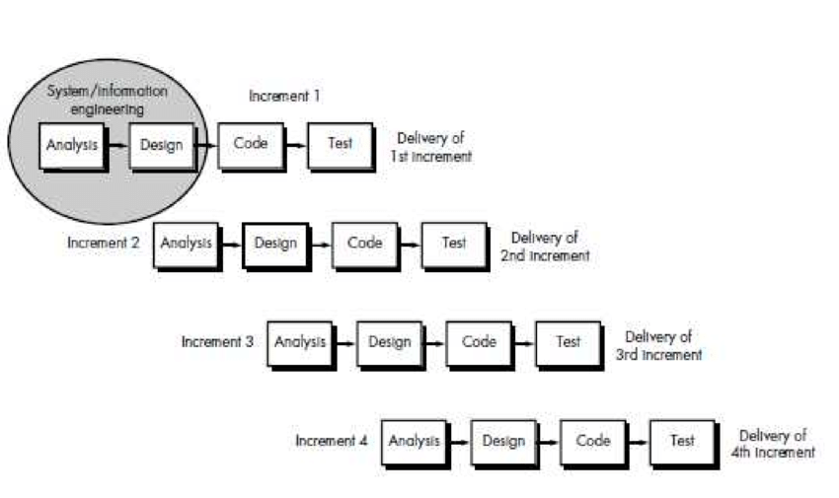

*Figure 1: Incremental model*

Incremental Model includes following phase:

* 1st increment: In this increment we will make a form for passport system in five steps, login form.
* 2nd increment: After deciding about the systems functionalities, we will make the editor user that may be the passport office employee who has authority for checking the applicant’s passport form for validation.
* 3rd increment: In this increment we will make the super admin who will be the boss of the employee, either manager or other senior employee of the office who will provide the task to editors.He/She has authority to activate and deactivate the editors and also can view all the details about the number of applicants who applied for the registration of passport.
* 4th increment: In this increment we will combine all the parts and test the system.

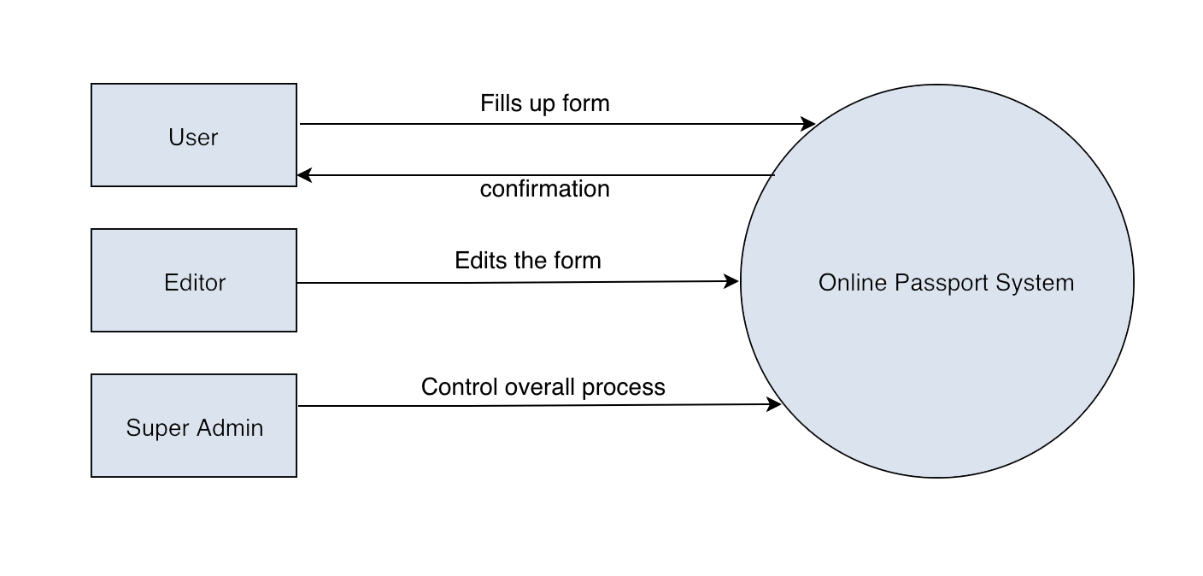

*Figure 2: DFD Level 0*

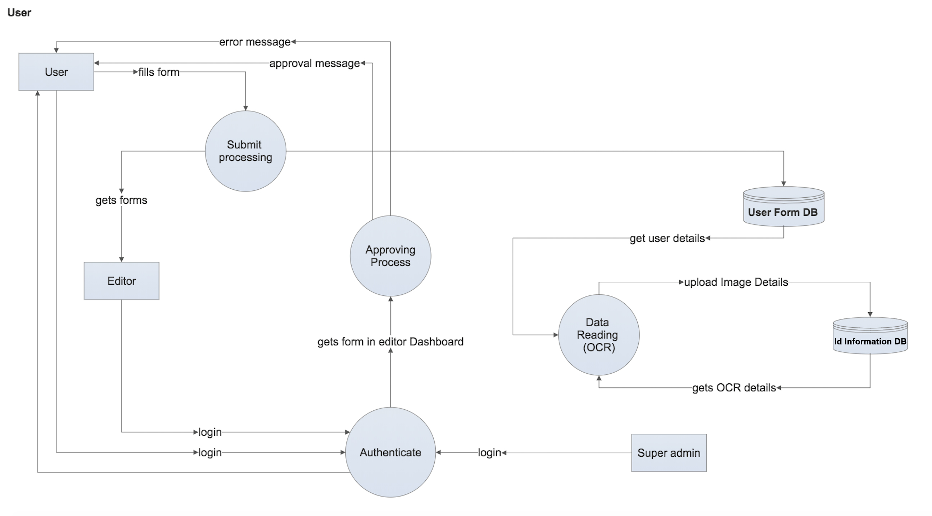

*Figure 3: DFD Level 1*

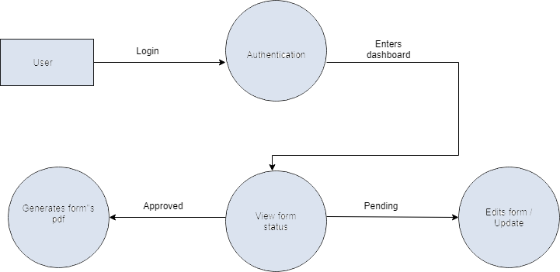

*Figure 4: DFD level 2 of user*

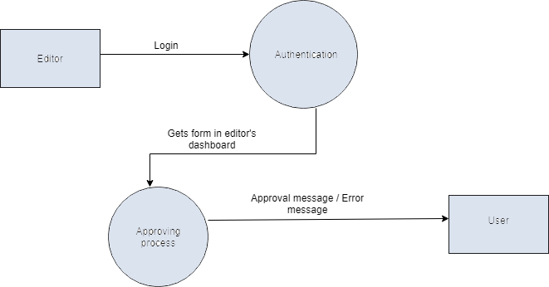

*Figure 5: DFD level 2 of editor*

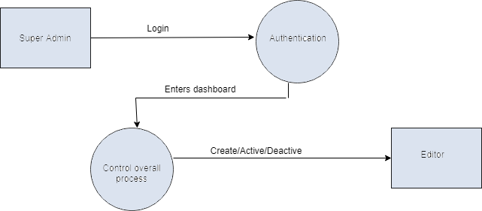

*Figure 6: DFD level 2 of super admin*

# Results and Discussion

There comes a positive result in all section that we have carried out. The form for passport is submitted successfully. Edition and error notifications now can be send to applicants. For the approved form, pdf of that form can be generated and OCR is successfully implemented.

Our team has discussed on how to make the project effective by the scrum meeting on daily routine.

# Requirements

## Hardware Requirements

1. Laptop

## Software Requirements

1. PHP
2. MySQL

PHP is a widely used open source general purpose scripting language that is especially suited for web development and can be embedded in HTML. We have used Laravel framework of PHP in this project.

Laravel is a free, open source PHP web framework, created by Taylor otwell and intended for the development of web applications following the MVC architecture. Main features of laravel is a modular packaging system with a dedicated dependency manager, different ways for accessing relational databases, utilities that aid in application deployment and maintenance. We’ve used middleware concept of laravel in our project to authenticate the users.

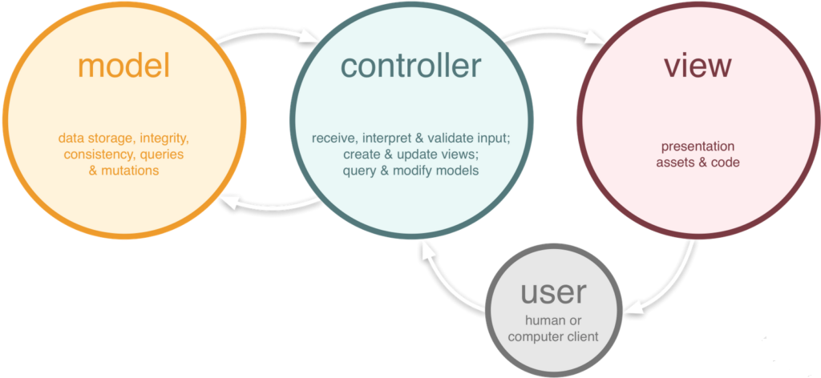

*Figure 7: MVC Architecture*

**Model**

The [2]model defines what data the system should contain. If the state of this data changes then the model will usually notify the view (so the display can change as needed) and sometimes controller (if different logic is needed to control the updated view).

Going back to our Online Passport System, the model would specify what data the list items should contain i.e. name, address etc. and what list items are already present.

**View**

The view defines how the system’s data should be displayed**.**

**Controller**

The controller contains logic that updates the model and /or view in response to input from the user of the system.

# Project Task

|  |  |  |
| --- | --- | --- |
| Name | Roles | Responsibilities |
| DenishaThapa | Programmer | Phpprogramming, Review overall projects |
| SulavGuragain | Documentation | Develop Documentation, Designing |

*Table 1: Project Task*

# Conclusion

The project we have developed is Online Passport System. Prototype system for Online Passport System is successfully implemented. Finally, it generates the pdf of verified passport form of the user.

# Further works / recommendations

Our further works includes the addition of fingerprint device in order to submit the fingerprint through it which make easy for applicants and reduce their works. We can also add the features of online payment on our project to make it more flexible.

# Project Schedules

The time scheduling of our project is shown below:

|  |  |  |  |
| --- | --- | --- | --- |
| Process | Start | End | Duration |
| 1st increment  -Analysis  -Design  -Coding  -Testing | 2075/02/30  2075/03/14  2075/03/25  2075/04/10 | 2075/03/14  2075/03/25  2075/04/10  2075/04/15 | 15 days  6 days  19 days  5 days |
| 2nd increment  -Analysis  -Design  -Coding  -Testing | 2075/04/15  2075/04/20  2075/04/27  2075/05/06 | 2075/04/20  2075/04/27  2075/05/05  2075/05/09 | 5 days  7 days  7 days  3 days |
| 3rd increment  -Analysis  -Design  -Coding  -Testing | 2075/06/02  2075/06/07  2075/06/14  2075/06/21 | 2075/06/06  2075/06/13  2075/06/19  2075/06/25 | 4 days  6 days  5 days  4 days |
| 4th increment  -Analysis  -Design  -Coding  -Testing | 2075/08/01  2075/08/08  2075/08/09  2075/08/18 | 2075/08/07  2075/08/12  2075/08/18  2075/08/22 | 7 days  4 days  10 days  10 days |

*Table 2: Project Schedules*

# Bibliography

1. [*https://www.w3schools.com*](https://www.w3schools.com) *,*
2. Jon Duckett*“HTML & CSS: Design and Build Web Sites”, October 25-2011.*
3. AlanBeaulieu“*LearningSql”, August 22-2005.*
4. [*https://laravel.com/docs/5.6*](https://laravel.com/docs/5.6)
5. [*https://stackoverflow.com/*](https://stackoverflow.com/)
6. <https://www.researchgate.net/figure/Incremental-Model_fig3_311559089>
7. <https://www.tonymarston.net/php-mysql/model-view-controller.html>
8. <https://www.gadgetbytenepal.com/nepal-passport-app-mrp-passport/>