A Minor Project Final Proposal Report on

**Photo Care**

Submitted in Partial Fulfillment of the Requirements for

the Degree of **Bachelor of Engineering in Information Technology**

under Pokhara University

Submitted by:

**Dhan Bdr. Oli (14462)**

**Hari Khadka (14463)**

**Saroj Bhattarai (14477)**

**Sumit Simkhada (1447)**

Under the Supervision of

**Birendra Bista**

Date:18-11-2018

**Department of IT Engineering**

**NEPAL COLLEGE OF**

**INFORMATION TECHNOLOGY**

Balkumari, Lalitpur, Nepal.

# ACKNOWLEDGEMENT

We are thankful to Nepal College of Information and Technology for providing us the chance to build software during the minor project and managing the resources and specialists to assist our project.

We are indebted to Head Project Coordinator Dr. Roshan Chitrakar, who is our actual supporter for this action they have managed everything a student need.

We are grateful to our respected HOD Er. Madan Kadariya and Er. Birendra Bista, who will be the part of our project team with their assistance, advice and suggestions.

# ABSTRACT

The project titled “**PHOTO CARE**” is a photo studio management system. The aim of this project is to develop a web-based application (**Photo Care**) for a photo studio. This system can be used to store the details of the customers and employee. Photo care will facilities admin to insert data, update data, delete data, search data from the computer.

Commonly every detail about photo lab are entered in the form of paper work. Person should be able to enter entire details about everything in the paper work every work but this is a difficult work for any one which takes a lot of time and this is the main disadvantage of the existing system. Recoding of customer details, updating, searching comes under the paper work it takes a lot of time. So, this project eliminates all the paper works and gives output to the customer in short period of time.

This application can facilitate photo studio in business processes and government operations and in many more. It supports photo studio business strategies and helps establish a powerful human resource management project. This has been designed and developed after a thorough study of Photo Finishing Industry’s needs and manual system of operations. So, this product has come out as whole and Smooth solution for today’s needs. In every data entry, before storing the data in computer, the system will confirm with the Admin. Administrator checks about status of the photo lab every day.

This project is completely based on java web-application and codes are in java programming language. The records of customer are recorded on database.

***Keywords:*** *Photo care, Information storage, Database.*

**Table of Contents**

ACKNOWLEDGEMENT i

ABSTRACT ii

LIST OF FIGURES v

LIST OF TABLE vi

1. INTRODUCTION 1

1.1 PROBLEM STATEMENT 1

1.2 OBJECTIVES 1

1.3 SIGNIFICANCE OF THE STUDY 2

2.METHODOLOGY 3

2.1 SOFTWARE DEVELOPMENT LIFECYCLE 4

2.1.1 ANALYSIS PHASE 4

2.1.2 DESIGN PHASE 4

2.1.3 CODING PHASE 4

2.1.4 TESTING PHASE 5

2.2 TOOLS TO BE USED 5

3.LITERATURE REVIEW 6

3.1 WHAT IS PHOTO CARE? 6

3.2 MAKING A DATABASE CONNECTION 6

3.3 STORE PROCEDURE 6

3.4 USE A DATABASE 7

4.RELATITIONSHIP DIAGRAM 8

4.1 USECASE DIAGRAM 8

4.2 ACTIVITY DIAGRAM 10

4.3 SEQUENCE DIAGRAM 11

5.SECTION OF WORK DETAIL 12

5.1 SCHEDULE 12

5.2 WORK BREAKDOWN 13

6.COMPLETED TASK 14

7.1 HOME PAGE 15

7.2 ADMIN/USER LOGIN SYSTEM 16

7.3 CUSTOMER REGISTRATION FORM 16

7.4 USER REGISTRATION 17

7.5 ORDER FORM 17

7.6 PRINTING BILL 18

8. REFERENCES 19

# LIST OF FIGURES

Figure 1: Data flow diagram…………………………………………………...…………………………..3

Figure 2: Incremental Model……………………………………………………………………………….4

Figure 3: Use Case Diagram……………………………………………………………………………….9

Figure 4: Active Diagram…………………………………………………………………………………10

Figure 5: Sequence Diagram………………………………………………………………………………11

## LIST OF TABLE

Table 1: TOOLS TO BE USED 5

Table 2 : PROJECT TASK AND SCHEDULE 12

Table 3 : WORK BREAK DOWN 13

# 1. INTRODUCTION

**Photo Care** is application software focused on organizing, storing the digital images in a computer. It represents one kind of desktop organizer software application.Photo Care is a software that primarily focused on improving the user's workflow by facilitating the handling of large numbers of images in database.

It is also the management system for photos especially implied for photo studio. If we turn history of pages we can find out drastic changes in the field of photography. A negative system had flooded the market of photography in the ancient time. But nowadays this system has almost totally wiped out. A memory or the storage device has made discriminated on this. A world is digitized. All the customer always prefers for digital photos nowadays. So, with regard of this photo care may have a vital role in terms of photo management.

## 1.1 PROBLEM STATEMENT

-Lack of awareness.

-Re-establishment

-Rebranding presenting opportunity to expand to different mediums.

-Reflecting their values.

## 1.2 OBJECTIVES

The objective of this project is to give facilities for both customer and the administrator.

-To eliminate the cost of paper work.

-Efficient and effective flow of record display.

-To record customer’s information for long time.

-To order their previously taken photograph.

-Every customer is given unique number.

-Customers are also serviced even if they do not have their bill.

-To provide Login/Sign up facility for each customer.

-System security and Authorization.

## 1.3 SIGNIFICANCE OF THE STUDY

**Photo Care** has the potential to store customers photo as well as their identities with easier and more accessible for the administrators. This is true for remote places that admin use to store information on register or on a copy that takes lots of time beside this administrator probably lost this record of customers, to overcome this we are building such a software that can be able to record all the information of the customer as well as employers on computer. The administrator can be able to record the information on their own computer and can be able to access anytime and anywhere.

The customers can also visit our web-site and can be able to know them our facilities and the quality of the pictures. The software is built according to customer needs and their satisfaction. Customer even can achieve their photos after-a-long time by providing *Customer ID* to the administrator.

# 2.METHODOLOGY

This project work adopts the following methodology for the application of knowledge, skills tools and technique to a broad range of activities in order to meet the requirements of our project **“Photo Care”**.

**Data Flow Diagram:**

Figure 1: Data flow diagram

Website

Customer

Admin Login

Delete

View

Search

Login

Register

Add

Enter Id

Customer Form

Order Form

Print Bill

Successful

## 2.1 SOFTWARE DEVELOPMENT LIFECYCLE

The framework we will be using for developing this project is Incremental model. This model combines linear sequential model with the iterative prototype model. New functionalities will be added as each increment is developed. The phases of the linear sequential model are: Analysis, Design, Coding and Testing. The software repeatedly passes through these phase in iteration and an increment is delivered with progressive change.

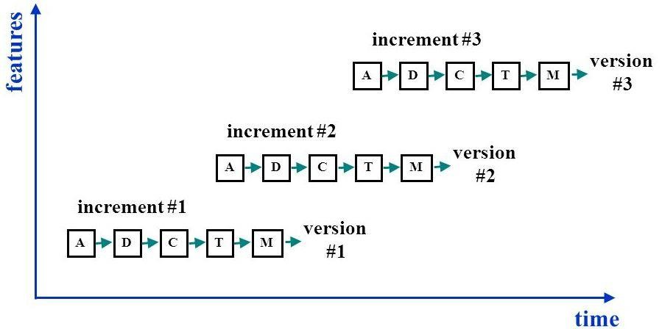

Figure 2: Incremental Model

### 2.1.1 ANALYSIS PHASE

In this phase, analysis will be performed in order to find out the requirements of the system. The outcome of this phase would be a SRS which is an acronym for “System Requirement Specifications”.

### 2.1.2 DESIGN PHASE

In this phase, the SRS would be translated into the system’s design. Context Diagram, DFD, ER – Diagram, Use Case Diagram and Class Diagram will be developed.

### 2.1.3 CODING PHASE

In this phase, coding will be done according to the design and a working system will be developed by the end of this process.

### 2.1.4 TESTING PHASE

In this phase, the system is tested with each testing a list of changes to the system developed is suggested and the changes will be applied to the software and the software would be delivered as a successive increment until a satisfying system is achieved. The tools used for documentation, designing and developing UI/UX, testing are listed below in table:

## 2.2 TOOLS TO BE USED

Table 1: Tools to be used

|  |  |
| --- | --- |
| **TOOLS** | **PURPOSE** |
| Eclipse | Interface for Programming |
| JDK1.7.0_45 | Development kit |
| Java | Programming Language |
| MySQL Workbench or XAMPP | Handling Database |
| Microsoft Windows 8/10 | OS for Development and Testing |
| HTML, CSS and JSP | Designing |
| Tomcat 7.0.75 | Server |

# 3.LITERATURE REVIEW

## 3.1 WHAT IS PHOTO CARE?

Photo Care is a software that primarily focused on improving the user's workflow by facilitating the handling of large numbers of images in database.

Several works have been carried out on the design of a photo management system for various industries and establishments. Although no photo management system has been developed yet. This project has been developed to eliminate the paper work in photo studio. The main aim of our project is to provide efficient and comfortable service for customers at photo studio.

## 3.2 MAKING A DATABASE CONNECTION

When making a connection to a database, the first thing we will need is a connecting string. This contains the initial catalog, data source, or data source name, and optionally the type of security to use. Next, we will need to create a connection to the database. This is done using one of the *Connection Classes* (use SQL Command), passing in the connecting string created in the first step.

## 3.3 STORE PROCEDURE

A stored procedure is a group of SQL statements compiled into an execution plan and stored under a unique name in the database. It is executed as a unit. A stored procedure can have multiple SQL statements to perform such a task as selecting data from one table and updating data in another table.

Stored procedures increase application performance in a couple of way. First, they enable fewer SQL statements to be transmitted across the network, as you need the name of the stored procedure and any parameters it may require.

Second, stored procedures are similar to procedures and functions in other programming languages, as users can contain input and output parameters and can return values. We use logic to control the flow of processing and numerous functions and SQL statements can be used in stored procedures.

We can use stored procedure to execute routine functions, such as selecting, inserting, updating, and deleting data. A single stored procedure can be executed by multiple applications, thus providing code reuse.

## 3.4 USE A DATABASE

Data-Centric application in this project allow user to view, add, update and change data. This data can be textual or binary data. The data used in the system created by this application, entered by the admin or user, and retrieved from archival storage in a database.

This database can store user information as well as information about itself.

# 4.RELATITIONSHIP DIAGRAM

## 4.1 USECASE DIAGRAM

Use case diagrams are considered for high level requirement analysis of a system. So, when the requirements of a system are analyzed the functionalities are captured in use cases. So, we can say that uses cases are nothing but the system functionalities written in an organized manner. Now the second things which are relevant to the use cases are the actors. Actors can be defined as something that interacts with the system. The actors can be human user, some internal applications or may be some external applications. So, in a brief when we are planning to draw an use case diagram we should have the following items identified.

* Admin Login, and store the customer Records details in database.
* Customer Register from the register process.
* Then the database is searched for details and verified.
* Database stores the details and returns acknowledgement.

**For Admin:**

Login

Add customercustomer

Delete

**Database**

**Admin**

Update

Search

Print

**For customer:**

**Customer**

ID

Name

Email

Password

Register

Login

Order

Success

**Figure 3: Use case Diagram**

## 4.2 ACTIVITY DIAGRAM

Activity diagram are graphical representations of workflows of stepwise activities and actions with support for choice, iteration and concurrency. An activity diagram shown as a rounded box containing the name of the operation. This activity diagram flow of stepwise activities performed in recruitment system. The customers details are Add and stored in database.

Website

Fill Form

Logout

Register

Admin

Option

Login

Print

Figure 4: Activity Diagram

## 4.3 SEQUENCE DIAGRAM

Since the administrator have the most priority of over other participators, the main development task focus on them. The rights of administrator include the overall management of project (editing the basic information & project of tutors & customers, approve, add & delete). It also contains creating the form of final approved projects. The mapping between UML model benefit designers speed up to understand the problems. Therefore, the developing complexity of system will be reduced efficiently.

Order Received

SEQUENCE DIAGRAM OF PHOTO CARE STUDIO

Database

Customer Information

Admin

Add or delete user

Login system Notify

Success

Success

Approval Customer Add or delete customer Show

Information Success

Update Customer Show

Manage success

Customer Updates

Search customer Search Customer Show

Success

Figure 5: Sequence Diagram

# 5.SECTION OF WORK DETAIL

The project schedule has been designed as per requirements and constraints involved. This project is scheduled to be completed in about 2 months. Requirement analyses have been given more emphasis. Research and database management is to be done first and well documented. Debugging and Testing is to be done prior to the completion of the project.

## 5.1 SCHEDULE

Table 2 : Project task and Schedule

|  |  |
| --- | --- |
| **TASK** | **APPROX. DURATION (in days)** |
| Requirement Analysis and Specification | 8 |
| Undertake Analysis of the System | 8 |
| Design System | 14 |
| Produce Requirement Specifications | 9 |
| Testing and Debugging | 8 |
| Test System Modules | 4 |
| Overall System Test | 5 |
| Develop Documentation | 60 |

## 5.2 WORK BREAKDOWN

Below is the labor division of the entire workload of this project:

Table 3 : Work break down

|  |  |  |
| --- | --- | --- |
| **S.N.** | **Task** | **Team Members** |
| 1 | Frontend and UI Design | Saroj, Hari, Dhan |
| 2 | Back-end and Core Programming | Dhan, Saroj, Hari |
| 3 | Testing | Saroj, Dhan, Sumit |
| 4 | Documentation | Saroj, Hari, Sumit |

# 6.COMPLETED TASK

The project has almost completed its task but there are some remaining features to add. Some of the completed task are listed below:

1.Designed of Website with CSS.

2.Website has provided contact number, Email, HD pictures.

3.Each customer can join with us by registering their details.

4.Only admin can be able to control the follow of admin panel.

5.Sessions are also used in this project.

6.Customers can order their previously taken photo by providing unique id.

7.Project will provide printed bill to customers after the end of inserting data into the database.

8.Customer can visit its own profile and can check its own activity (Only for registered customer).

9.This .jsp pages has been designed by using CSS, Scripts, Html tags etc.

7.IMPLEMENTATION

The project **“Photo Care”** is aimed to deliver output be like.

## 7.1 HOME PAGE

Photo Care is a online web-based management software which is specially designed and developed for the photo studios. The software provides services for every modules of the studios which makes the work more efficient and consumes less time for retrieving the data. This software contains different modules such as customer & admin Advising. It shows the home pages which have many categories. Admin should change any data for this page, and Admin always update and delete the information.

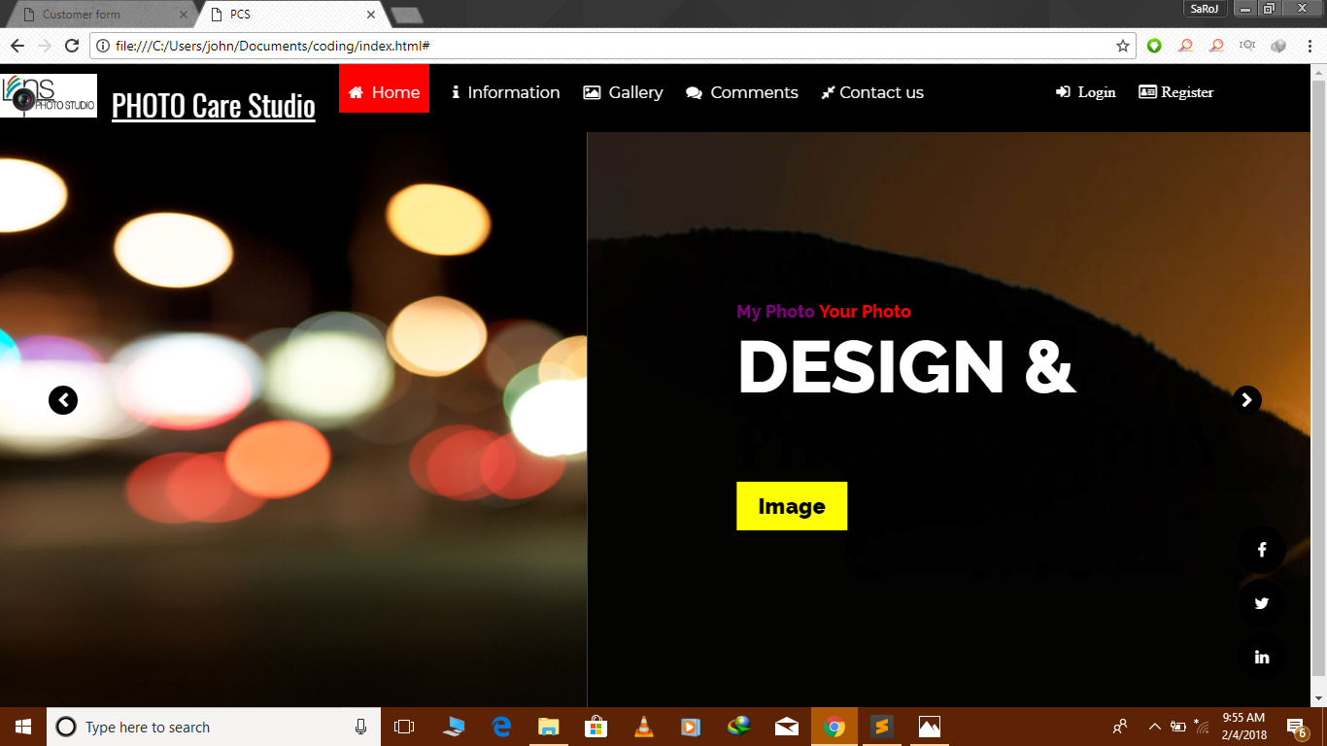

## 7.2 ADMIN/USER LOGIN SYSTEM

Admin has a user Id which gives in the database. Admin should Registration and login the page.

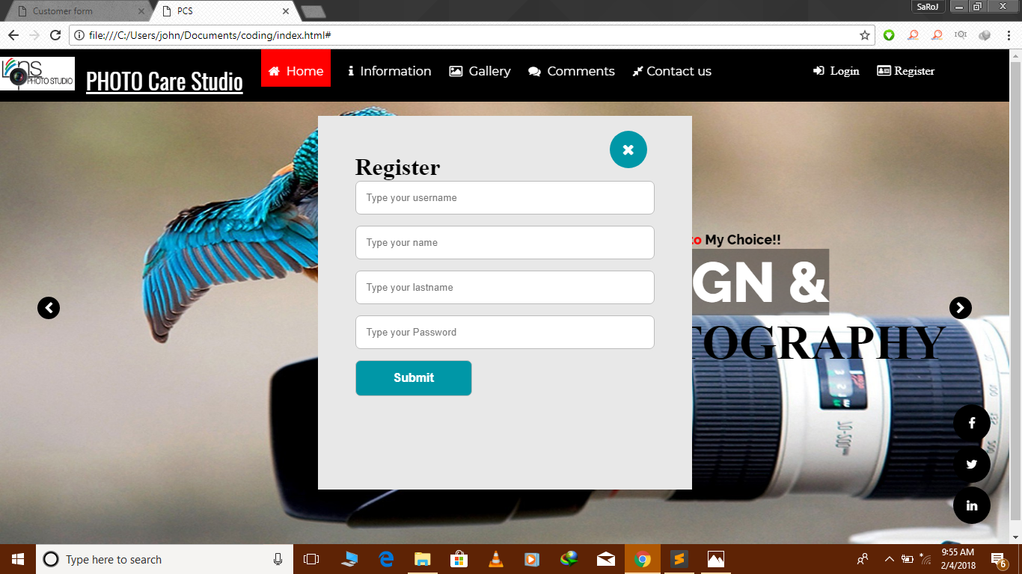

## 7.3 CUSTOMER REGISTRATION FORM

Create a customer biography which contain customers name address, id, email and contact number etc. And the total cost of the photos.

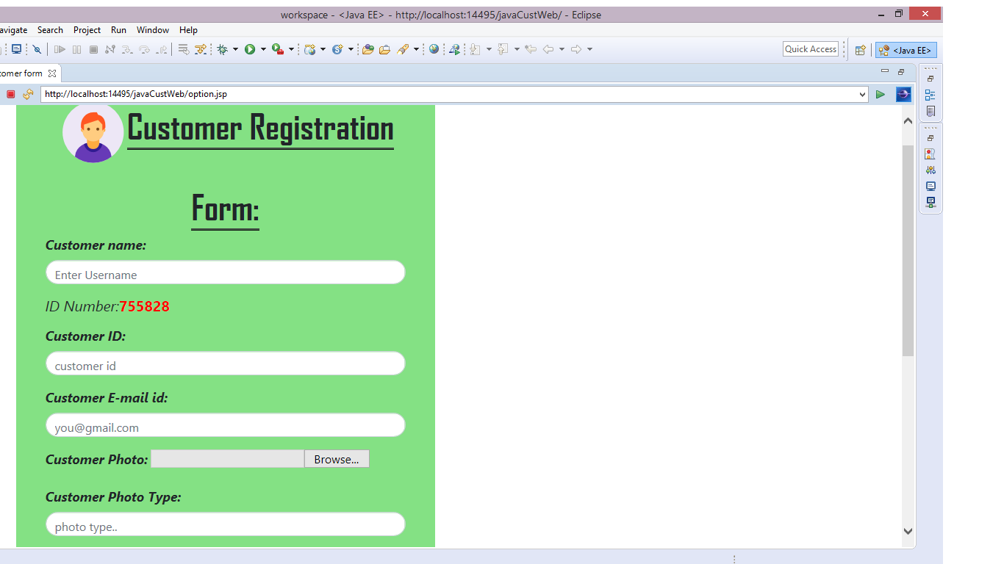

## 7.4 USER REGISTRATION

Customer should create a new account in order to order their previously taken photos with the given customer id.

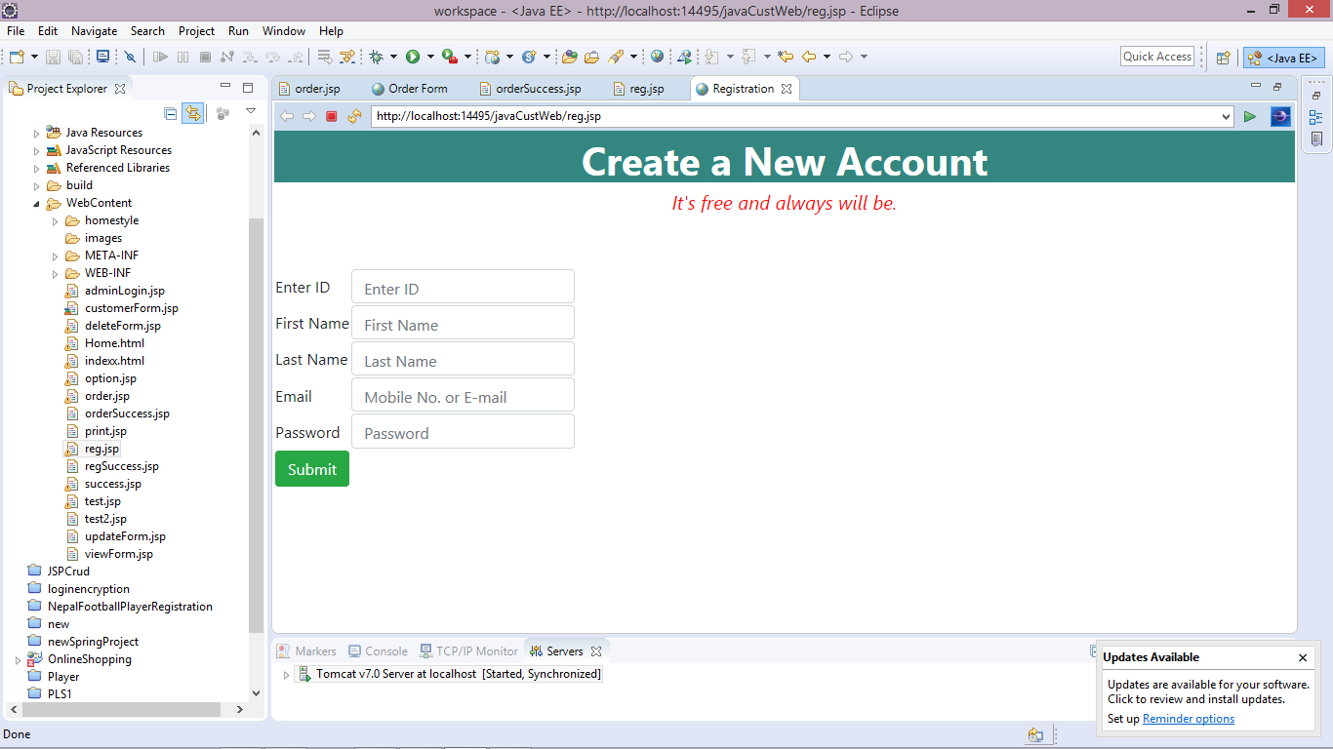

## 7.5 ORDER FORM

Customer must fill this form to order their previously taken photo. Customer must remember their *Unique ID* which has been provided by admin at the time of billing.

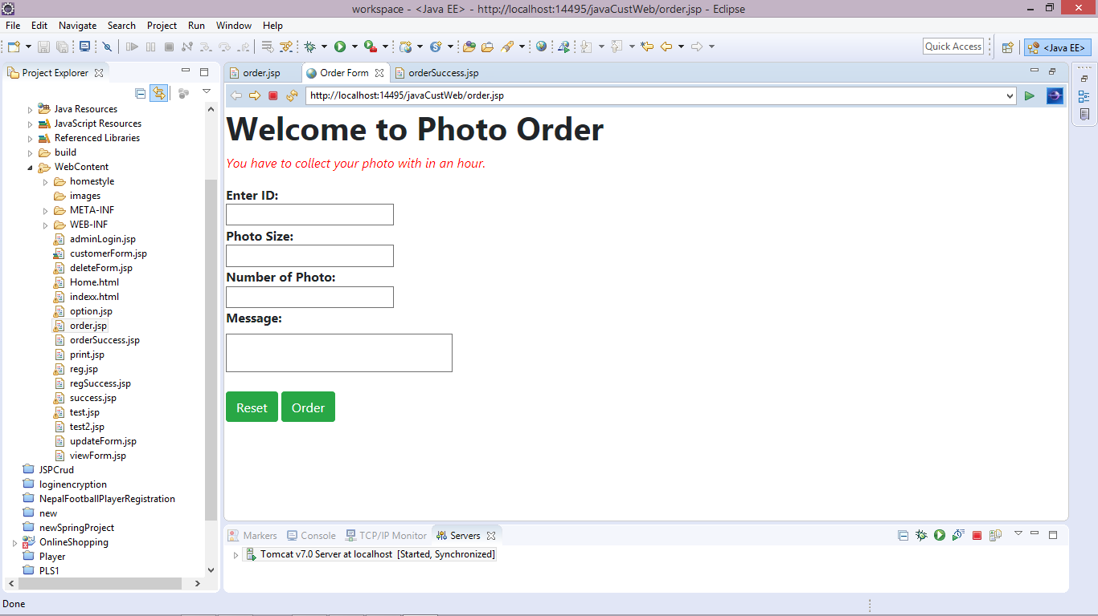

## 7.6 PRINTING BILL

Admin is responsible to print bill digitally by filling all the information of customer.

# 8. REFERENCES

* Benington, H. D. (1983) ‘Production of large computer programs’, *Annals of the History of Computing*, vol. 5, no. 4, pp. 350–61.
* https://link.springer.com/chapter/10.1007/978-3-642-57939-4_2

Cook, S. and Daniels, J. (1994) *Designing Object Systems: Object-Oriented Modeling with Syntropy*, Upper Saddle River, NJ, Prentice-Hall.

* Hall, J. G. and Rapanotti, L. (2003) ‘A reference model for requirements engineering’, in *Proceedings of the 11th International Requirements Engineering Conference, 2003*. Montery Bay, CA, September 8–12 2003. New York, IEEE, pp. 181–7.
* Jackson, M. (1995) ‘The world and the machine’, in *ICSE 1995: 17th International Conference on Software Engineering*. Seattle, WA, April 23–30 1995. New York, IEEE, pp. 283–92.
* Jacobson, I., Booch, G. and Rumbaugh, J. (1999) *The Unified Software Development Process*, Addison-Wesley.
* Pressman, Roger S., Software Engineering: A Practitioner’s Approach. McGraw-Hill, 2001.

**Online**

* <https://www.oracle.com/applications/performance-management/solutions/business-planning.html>/
* <https://www.pdnonline.com/gear/software/best-software-managing-studio-photography-business/>
* <https://en.wikipedia.org/wiki/Photographic_studio>/
* https://www.stackoverflow.com/generate+unique+id/