Major Project Report on

**PRASNOTTAR: E-Learning Class Module**

Submitted in partial fulfillment of the requirements for the degree of

**Bachelors of Engineering in Computer**

under Pokhara University

Submitted by:

**Ashmita Bhatta, 15343**

**Saruna Maharjan, 15331**

**Shrena Bajiko, 15334**

Under the supervision of

**Er. Nipesh Shrestha**

Date:

22nd Nov 2019

**Department of Computer Engineering**

**NEPAL COLLEGE OF**

**INFORMATION TECHNOLOGY**

Balkumari, Lalitpur, Nepal

**ACKNOWLEDGEMENT**

This project would not have been possible without the joint efforts of many individuals. It has been a pleasure for us to acknowledge the assistance and contributions that were very important and supportive throughout the project. We would like to thank them sincerely.

We are indebted to our project supervisor **Er. Nipesh Shrestha** for his guidance and support throughout the project development period which helped our project to grow and foster to a level we didn’t think of reaching in such a short period of time.

Last, but not the least, we would like to thank our teachers and colleagues who have been knowingly or unknowingly the part of this project with their views during the entire development time.

**ABSTRACT**

*Prasnottar: E-learning Class Module is an android-based question answer application that is designed to provide users specially students with a platform to ask questions and get answers. Sometimes students get confused with small things. They can seek help from teachers and friends. But teachers and friends may not be available all the times so Prasnottar will be the one they will seek for. Surfing through the internet is the easiest way nowadays but the same internet might be insecure to share the information so Prasnottar assures security as well. Questions can be asked by any users and multiple users can answer the questions if they know it. Also the users will be able to rate the answers. Feature of chatting will be integrated as well so that anyone can freely interact with tutor regarding their doubts. Students also seek study materials online which generally cannot be obtained free of charge. Prasnottar will have the study materials feature where anyone can share their for the purpose of sharing knowledge.*

*Pranottar is intended to be user friendly android application being developed with the Django RestAPI as backend and Android Studio as frontend. There are other many similar platforms for QA, so combining advantages and improving disadvantages this project have been proposed.*

Keywords: Prasnottar, RestAPI, QA, Study materials, Tutor

TABLE OF CONTENTS

**1.** **INTRODUCTION** 1

1.2. OBJECTIVES 1

1.3. PROJECT SCOPE AND LIMITATIONS 2

1.3.1. SCOPE 2

1.3.2. LIMITATIONS 2

1.4. SIGNIFICANCE OF STUDY 2

2.1. PREVIOUS SIMILAR WORKS 3

**3.** **TEAM MEMBERS AND DIVIDED ROLES** 5

**4.** **METHODOLOGY** 6

4.1. SOFTWARE DEVELOPMENT LIFE CYCLE 6

4.1.1. REQUIREMENT PHASE 7

4.1.2. ANALYSIS AND DESIGN PHASE 7

4.1.3. IMPLEMENTATION 7

4.1.4. TESTING 7

4.1.5. EVALUATION 7

4.2. WHY ITERATIVE MODEL? 9

4.3. TOOLS USED 9

4.4. TECHNOLOGIES 9

**5.** **REQUIREMENT ANALYSIS** 10

5.1. SYSTEM REQUIREMENT SPECIFICATION 10

5.1.1. FUNCTIONAL REQUIREMENTS 10

5.2. NON FUNCTIONAL REQUIREMENTS 10

5.3. INPUT REQUIREMENTS 11

5.4. INPUT LIST AND VALIDATION 12

5.5. OUTPUT REQUIREMENT 12

5.6. SECURITY REQUIREMENTS 12

**6.** **SYSTEM DESIGN AND UML MODELS** 13

6.1. SYSTEM ARCHITECTURE 13

6.2. USE CASE DIAGRAM 13

6.3. ER DIAGRAM 14

6.4. CONTEXT DIAGRAM 15

6.6. DOMAIN MODEL DIAGRAM 16

6.7. ACTIVITY DIAGRAM 17

6.7.1. ACTIVITY DIAGRAM FOR ASKING QUESTION 17

6.7.2. ACTIVITY DIAGRAM FOR UPLOADING 19

6.7.3. ACTIVITY DIAGRAM FOR PROFILE ACTIVITY 20

6.7.4. ACTIVITY DIAGRAM FOR COURSES 21

6.8. SEQUENCE DIAGRAM 22

**7.** **TESTING** 23

7.1. TESTING TABLE 23

7.2. TESTING EVIDENCE THROUGH SNAPSHOTS 24

**8.** **PROJECT TASK AND TIME SCHEDULE** 27

8.1. GANTT CHART 27

**9.** **CONCLUSION AND FUTURE EXTENSIONS** 29

**10.** **REFERENCE** 30

**APPENDIX** 31

**LIST OF TABLES**

Table 1: Divided roles and responsibilities 5

Table 2: Tools used 9

Table 3: Functional Requirements 10

Table 4: Non-functional Requirements 11

Table 5: Input list and validation 12

Table 6: Testing Table 23

Table 7: Project Task and Time Schedule 27

Table 8: ITERATION 1: Develop Full-fledged Android Application 28

Table 9: ITERATION 2: Recommendation 28

Table 10: ITERATION 3:System Deployment 28

**LIST OF FIGURES**

Figure 1: Iterative model of software development life cycle 6

Figure 2: System Architecture 13

Figure 3: Use Case Diagram 14

Figure 4: ER Diagram 15

Figure 5: Context Diagram 15

Figure 6: Dataflow Diagram 16

Figure 7: Domain Model 17

Figure 8: Activity Diagram for ‘Ask’ 18

Figure 9: Activity Diagram for ‘Upload’ 19

Figure 10: Activity diagram for profile activity 20

Figure 11: Activity diagram for adding course 21

Figure 12: Sequence Diagram 22

Figure 13: Question adding API 24

Figure 14: Successfully added question 24

Figure 15: User registration API 25

Figure 16: User added successfully 25

Figure 17: Home Page 26

Figure 18: Login 31

Figure 19: Profile 32

Figure 20: Sign Up 32

Figure 21: Create Question 33

Figure 22: Add As Tutor 33

Figure 23: Add Note 34

**LIST OF ABBREVIATIONS**

**DFD:** Dataflow Diagram

**QA:** Question Answer

**SDLC:** Software Development Life Cycle

**ER:** Entity Relationship Diagram

**UI:** User Interface

**IDE:** Integrated Development Environment

**M:** Many

**UML:** Unified Modeling Language

**API:** Application Program Interface

**REST:** Representational state transfer

# 

# **INTRODUCTION**

Prasnottar: E-learning class module is an android based networking application that provides the user with ease to sharing and gaining the knowledge about different subject matter. This project deals with asking and answering the questions and queries of students of different programs. It also contains various notes uploaded by tutors of different programs and subjects. Here, a student can also become a tutor if they want to, so that knowledge can be shared to others. In this section, problem and motivation, objectives and project scope and limitations will be described in detail.

* 1. **PROBLEM STATEMENT**

With the advancement in the technology, android has been one of the most effective platform for day to day applications . In the existing system, the students need to wait for teachers in order to ask questions. However, if the teacher is not able to provide appropriate time to the students then they are oblige to rely on internet to find the answers. In such cases, the students browse various sites to view the answers and may be involved in involuntarily sharing their personal information to unknown websites. They may not obtain notes according to the syllabus or they may not understand the contents.

Mostly, during the examination time, students may get confused about the information given in websites since they appear to be very complex to understand. Similarly, students may become quite busy in their own study as a result of which they don’t get enough time to response to others queries.

## OBJECTIVES

The drawbacks mentioned in problem statements need to be solved, for which a new and easier method to better link the teachers and students needs to be derived. Prasnottar : e-learning class module is such an app where the students can present their queries and receive answers from the users. Following are the objectives of this project:

1. To develop app for asking and answering the questions related to various faculties of the college and upgrade knowledge.
2. To upload and download necessary notes.
3. Develop an interactive android application with user friendly search interface.
4. To allow people to communicate to increase flow of information among them.

## PROJECT SCOPE AND LIMITATIONS

The scope of this project is to provide user with all the services through an android-based networking service. In this project, an app will be developed where users of the college will be able to ask and answer questions, as well as, upload and download notes.

### SCOPE

1. The targeted people are the teachers and students of the college.
2. This app can be modified and used for various college/school or even universities.

### LIMITATIONS

1. This is only app not a website.
2. This app is mainly focus to students.

## SIGNIFICANCE OF STUDY

This project is proposed with the intention to develop an Android Application of the QA platform where users can ask the questions of their concern and obtain answers from other users. The existing platform provides the QA platform however this project will have some additional features regarding the study materials and chat feature. So this project is meant for providing user friendly Android application in efficient way.

1. **LITERATURE REVIEW**

## PREVIOUS SIMILAR WORKS

**Quora** is a Q&A platform that empowers people to share and grow the world’s knowledge. People come to Quora to ask questions about any subject, read high quality knowledge that's personalized and relevant to them, and share their own knowledge with others. Quora is a place to share knowledge and better understand the world. [5]

**Pros**

* In Quora application you just not become a good reader but also becomes a good writer. [6]
* It always find very effective answer for your questions which is written on the basis of true experience and event. [6]
* An additional feature here is that you can create your own blog, group where you can share articles and lift up your and others’ life. [6]

**Cons**

* There is no service to search inside this answers. [4]
* Sometimes get comment without notification about it. [4]
* There is no option to prevent flow of answer request from people that are not follow. [4]

**Stack overflow** is a network of [question-and-answer websites](https://en.wikipedia.org/wiki/Comparison_of_Q%26A_sites) on topics in diverse fields to enable users to post questions and answer them. Users can vote on both answers and questions, and through this process users earn reputation points. Users can also add comments to the questions and answers, as well as, edit text written by others. [2]

**Pros**

* It helps to ask questions, get answers, no distractions. [2]
* Tags make it easy to find interesting questions. [2]
* You earn reputation when people vote on your posts. [2]

**Cons**

* The web page blocked user if they didn’t have enough reputation as a new user . [7]
* Its biggest weakness is that it is not a very good platform for facilitating discussions. [7]
* Its second biggest weakness is the unbalanced reputation system. [7]

**Yahoo Answers** is one of the most popular Quora alternatives.  It’s free to sign up for, and includes a sort of “game” system where you gain points for answering other people’s questions.  This increases the number of questions that you can ask or answer per day. [3]

**Pros**

* You are able to ask any question. [1]
* You are able to get any answer, whether it’s the best or the worst. [1]

**Cons**

* Yahoo Answers isn’t quite as professional or heavily-moderated . [3]
* Certain questions may be poorly formed or trivial, and answers may not necessarily correct. [3]
* There is often a limited amount of time to answer a question. [3]

# **TEAM MEMBERS AND DIVIDED ROLES**

|  |  |  |
| --- | --- | --- |
| Name | Roles | Responsibilities |
| Ashmita Bhatta | Backend developer  Documentation  Database | * Development of the backend API and testing. * Development of documentation. * Timely review of database data. |
| Saruna Maharjan | UI Designer  Frontend and backend developer  Documentation | * User friendly interface for Android device. * Integration of backend API to frontend Android and testing. * Development of documentation. |
| Shrena Bajiko | Backend developer  Documentation  Database Management | * Development of the backend API and testing. * Development of documentation. * Manage Database data. |

Table : Divided roles and responsibilities

# **METHODOLOGY**

In this section we have described about the method that we will be using to meet the requirement of the project.

## SOFTWARE DEVELOPMENT LIFE CYCLE

The model to be used for developing of this project is Iterative model of SDLC. Iterative model is simple and emphasizes on initial and simple implementation and with progress in the project it gains more feature. It is advantageous since it has unique feature of repetitive nature i.e. during development phase one can go back to check out the previous works without any complications and flaws can be improved if any. Further explanation about the model has been described below.

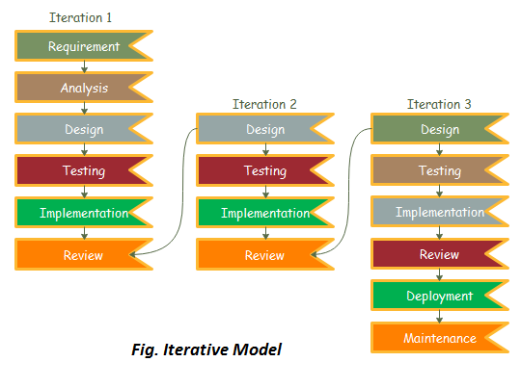

Figure : Iterative model of software development life cycle

### REQUIREMENT PHASE

In this phase, all the necessary requirements are analysed. Till now necessary requirement for further analysis of project is gathered from end-user, Internet and teachers. And as a result, final specification of the project will be gained.

### ANALYSIS AND DESIGN PHASE

In this phase, the specification gathered is designed as per the requirement. Further the database models, technical requirement and the logic will be implemented in the project.

### IMPLEMENTATION

After the analysis and design the coding is done according to the specifications. Coding is in progress and hence a working system will be obtained in this phase.

### TESTING

Once a system is developed series of testing will be performed in order to remove bugs and errors. Till now some of the functionalities have been developed and tested which is described below in the testing section of this project. Also in this phase certain changes, if necessary, will also be applied to obtain complete and successful system.

### EVALUATION

Evaluation is the last step performed after all the prior steps, where the project will be evaluated to check if it meets the specification or not.

Our project which implements iterative model comprises of three iterations which are discussed below:

* **ITERATION 1: Develop Full-fledged Android Application**

In this phase we focused on the analysis and design of our system with the help of the objectives of our project. A full-fledged android application was developed at this phase. We developed an initial project plan to help us in our future iterations. The system which is an essential part was developed in this iteration. The artifacts to be produced in this phase are:

* Actors and use cases
* System Modules
* Risk Assessment
* ER Diagram
* Context Diagram
* Activity Diagram
* Feasibility Study

The modules created during this phase are:

* Login
* Sign up
* Profile
* Ask and answer questions
* Search questions
* **ITERATION 2: Recommendation**

In this phase, we worked on validating the system architecture with our backend. Some conclusions from the previous iteration were helpful in the further development of the system. Here, we seek to develop a platform that seeks to predict the “rating” or “preference” that a user would give an item, especially the question. Recommendation Systems produce a list of recommendations in either of the two ways – Collaborative or Content-based filtering. We seek to build a model from the user’s past behaviour as well as similar decisions made by the other users. However, due to time-constraint and insufficient resources, we couldn’t implement Recommendation Algorithm in this version.

* **ITERATION 3: System Deployment**

In this phase, we worked on finalising our deployment of the Android system for the initial part. We also made few changes to the system architecture as per our need. The artifacts to be produced in this phase are:

* Class diagram
* Integrated System Module

## WHY ITERATIVE MODEL?

* Requirements can be changed if necessary by going back to the previous phases without any effect to the further ongoing process.
* This project is based on API so, iterative testing and implementation is required.

## TOOLS USED

|  |  |
| --- | --- |
| TOOLS | PURPOSE |
| Android Studio | Official IDE for Android App Development |
| Github | To manage Source Code |
| Adobe Photoshop CS6 | Logo Design |
| Pycharm | Text Editor for backend |
| Android device | For Testing |

Table : Tools used

## TECHNOLOGIES

* Rest API used as functioning backend.
* Java for the backend and frontend development in Android studio.
* Django framework for the development of backend API.
* HTML for the form development of API.
* Sqlite3, for database to store all application data.
* JSON, to transmit data objects consisting of key-value pairs.

# **REQUIREMENT ANALYSIS**

Requirement analysis, in software engineering encompasses those tasks that go into determining the need and conditions to meet for a new or altered product, taking account of possibly conflicting requirements of the various stakeholders, such as beneficiaries and users.

## SYSTEM REQUIREMENT SPECIFICATION

### FUNCTIONAL REQUIREMENTS

|  |  |  |
| --- | --- | --- |
| **ID** | **REQUIREMENT** | **PRIORITY** |
| 1 | User is able to view questions | High |
| 2 | User is able to view answers | High |
| 3 | User must be logged in to ask or answer questions | Essential |
| 4 | User can manage profile | Optional |
| 5 | User is able to sign out of the application | Optional |
| 6 | User must be connected to the internet | Essential |
| 7 | Provide an interface for the user to search and view the questions | Essential |
| 8 | User is able to view notes | Low |

Table : Functional Requirements

## NON FUNCTIONAL REQUIREMENTS

The correct specification and adherence of non-functional requirements similarly plays at least an equal, if not a greater role in the success of mobile applications. This is due to the following reasons:

Mobile devices are uniquely constrained in several dimensions such as the processor speed, memory, multi-tasking support, available network bandwidth, screen real estate, etc. These constraints translate into strict bounds being imposed on the operating characteristics of an application running on a mobile device.

|  |  |  |
| --- | --- | --- |
| **ID** | **REQUIREMENT** | **PRIORITY** |
| 1 | The system works on Android Phone | Essential |
| 2 | The application should be user friendly | Essential |
| 3 | Applications need to operate successfully within a wide spectrum of operating conditions, such as a range of supported screen resolutions and form factors, network bandwidth situations and network types, etc. | Desirable |
| 4 | Application should emphasize on High Performance, High Responsiveness, Good Scalability, Good Usability, High Reliability, Good Security, Modifiability and Maintainability. | Desirable |

Table : Non-functional Requirements

## INPUT REQUIREMENTS

Data Required

The data to be input are:-

* User information

This contains user’s full name, username, email and password.

* Questions

This contains the question details input by the user.

Source of data

* The information will be given by user themselves.
* Recommender System.

## INPUT LIST AND VALIDATION

The user inputs, for each, are categorized on the basis of entry by the user. They are tabulated below along with data description, validation and data length which would be helpful in Design Phase.

|  |  |  |  |  |
| --- | --- | --- | --- | --- |
| S.N. | INPUT | DATA TYPE | LENGTH | DESCRIPTION |
| 1. | Username | Character | 30 characters | It is the username that is addressed by the web application |
| 2. | Email | Character | 30 characters | It is the mailing address of the user |
| 3. | Password | Character | 15 characters | It is the password of the user for the system |

Table : Input list and validation

## OUTPUT REQUIREMENT

The user requires following outputs from the system:

1. The questions and answers related to their course of study.
2. The notes of the course.
3. The medium to personally contact the tutors.

## SECURITY REQUIREMENTS

Users are to sign up and then only get access to the information regarding the notes, questions, answers and tutors that are related to their course. Therefore each user has been given their own account with username and password to login. Password informations are kept safe from intruders as well as those who are authorized to manage database only.

# **SYSTEM DESIGN AND UML MODELS**

## SYSTEM ARCHITECTURE

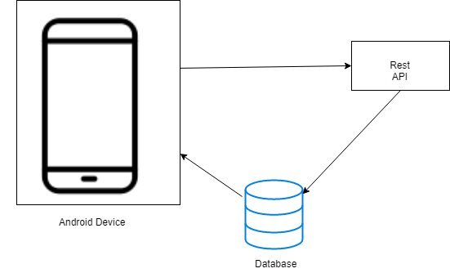

Figure : System Architecture

Above architecture skeleton shows overview of the concept used in this project. Rest API is the backend for the project which will be consumed in Android platform. The Rest API contains the database of the project. Similarly, the database data will be displayed in the device. The device retrieves the Rest API for functioning of various entities.

## USE CASE DIAGRAM

A use case diagram summarizes the relationship and use cases between user and the system. There are altogether three actors: user, system and admin. The below figure depicts the relationship between these actors.

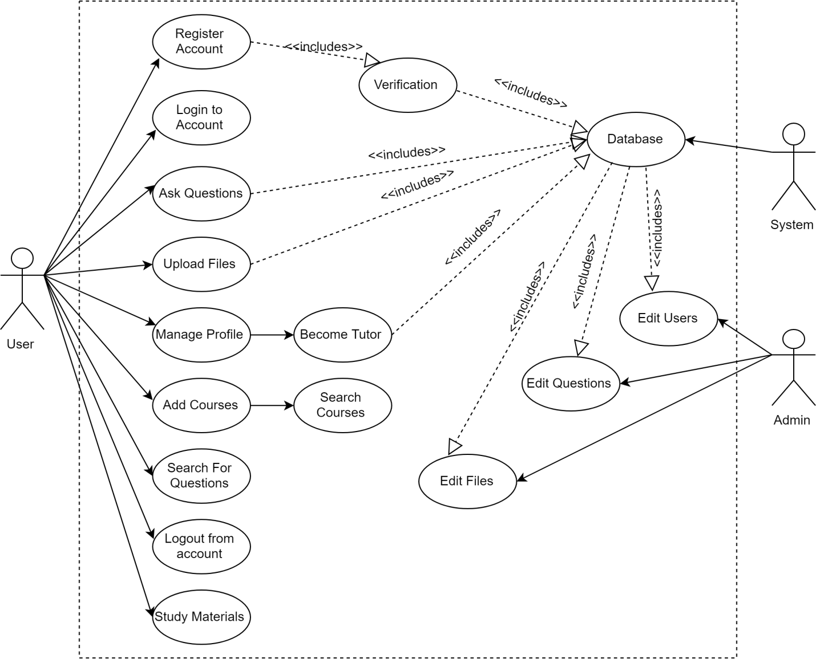

Figure : Use Case Diagram

## ER DIAGRAM

ER diagram pictures detailed relationship existing between various entities of the project. The entities are represented in the rectangle, their attributes are represented in the oval and the attribute that are underlined are the primary keys in the below figure.

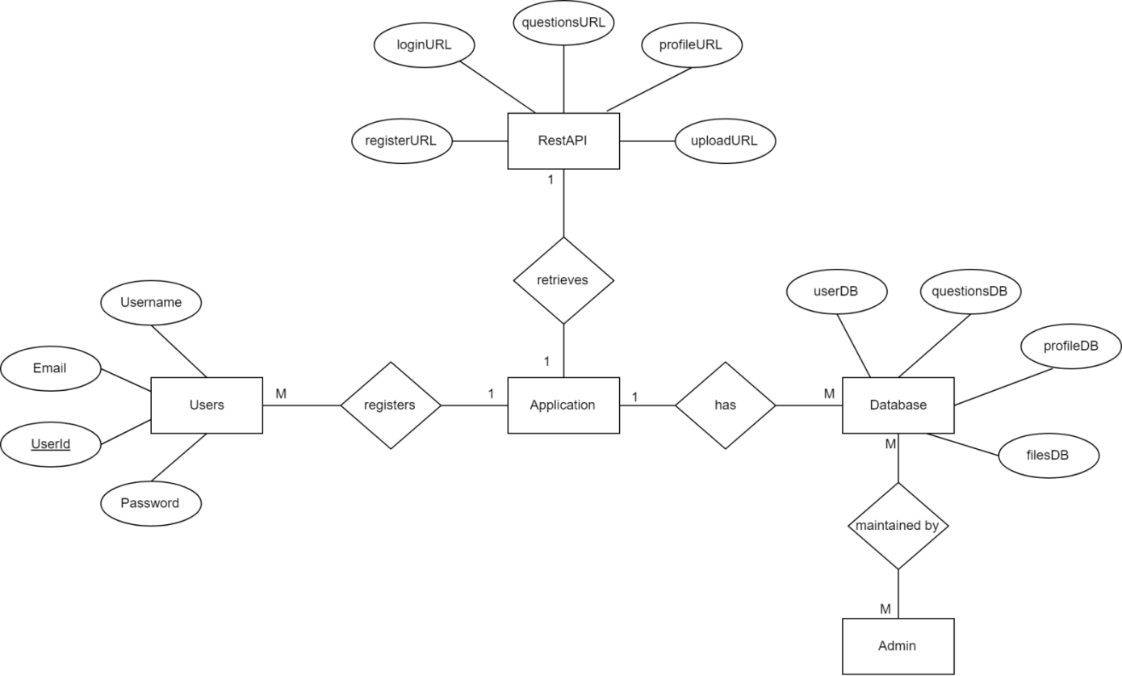

Figure : ER Diagram

## CONTEXT DIAGRAM

The Context diagram shows boundaries of the system and also depicts the flow of information among entities. The diagrammatic representation is as below:

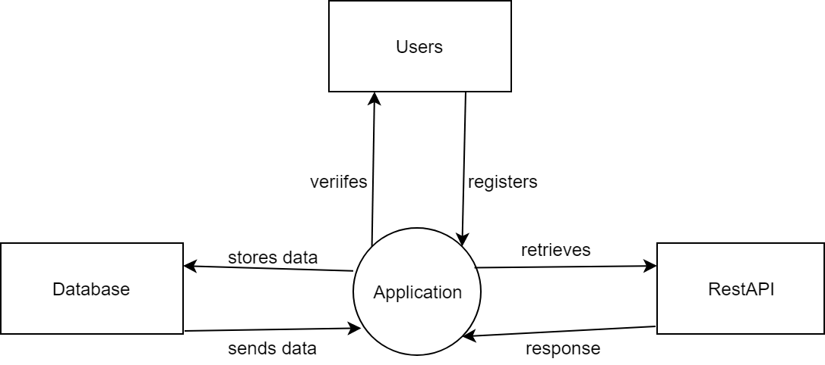

Figure : Context Diagram

* 1. **DATAFLOW DIAGRAM**

Through Dataflow Diagram it is clearer to understand the general overview of the project and the diagrammatic representation of the DFD is given below:

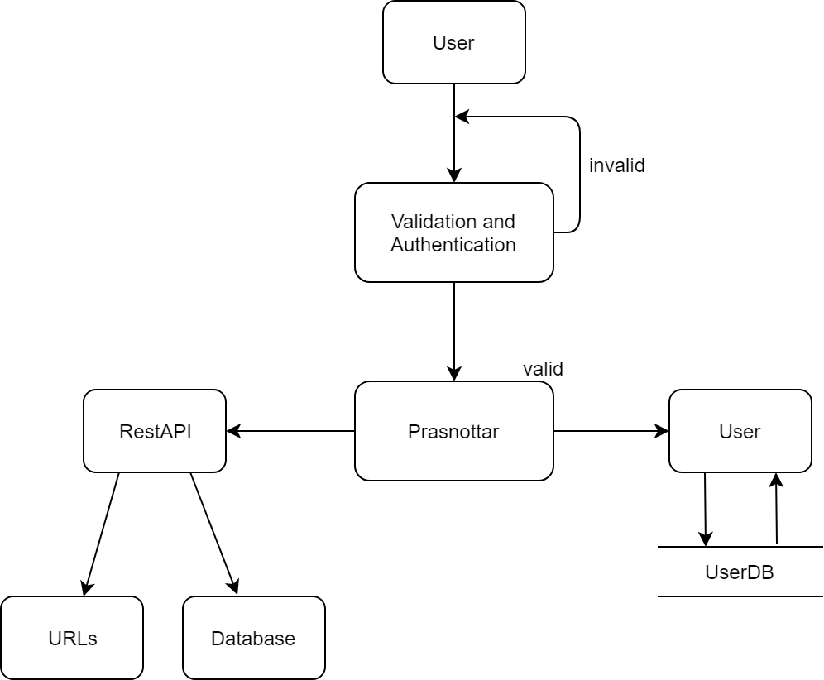

Figure : Dataflow Diagram

## DOMAIN MODEL DIAGRAM

The domain model given below shows both the relation among the systems and the particular tasks performed by the systems. The relation is shown as 1(one) and *(many). Like; application has one-many relationship with the users.

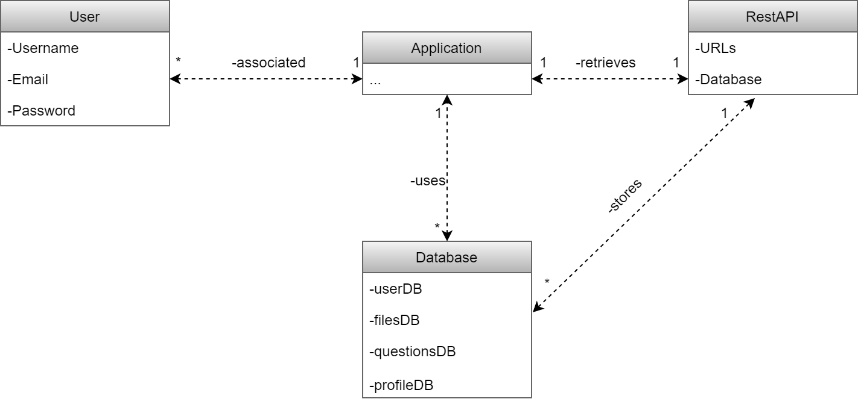

Figure : Domain Model

## ACTIVITY DIAGRAM

### ACTIVITY DIAGRAM FOR ASKING QUESTION

The below figure gives detail about the workflow and sequences of activity. There is user, database and application involved while asking the questions and the detailed activity is shown as:

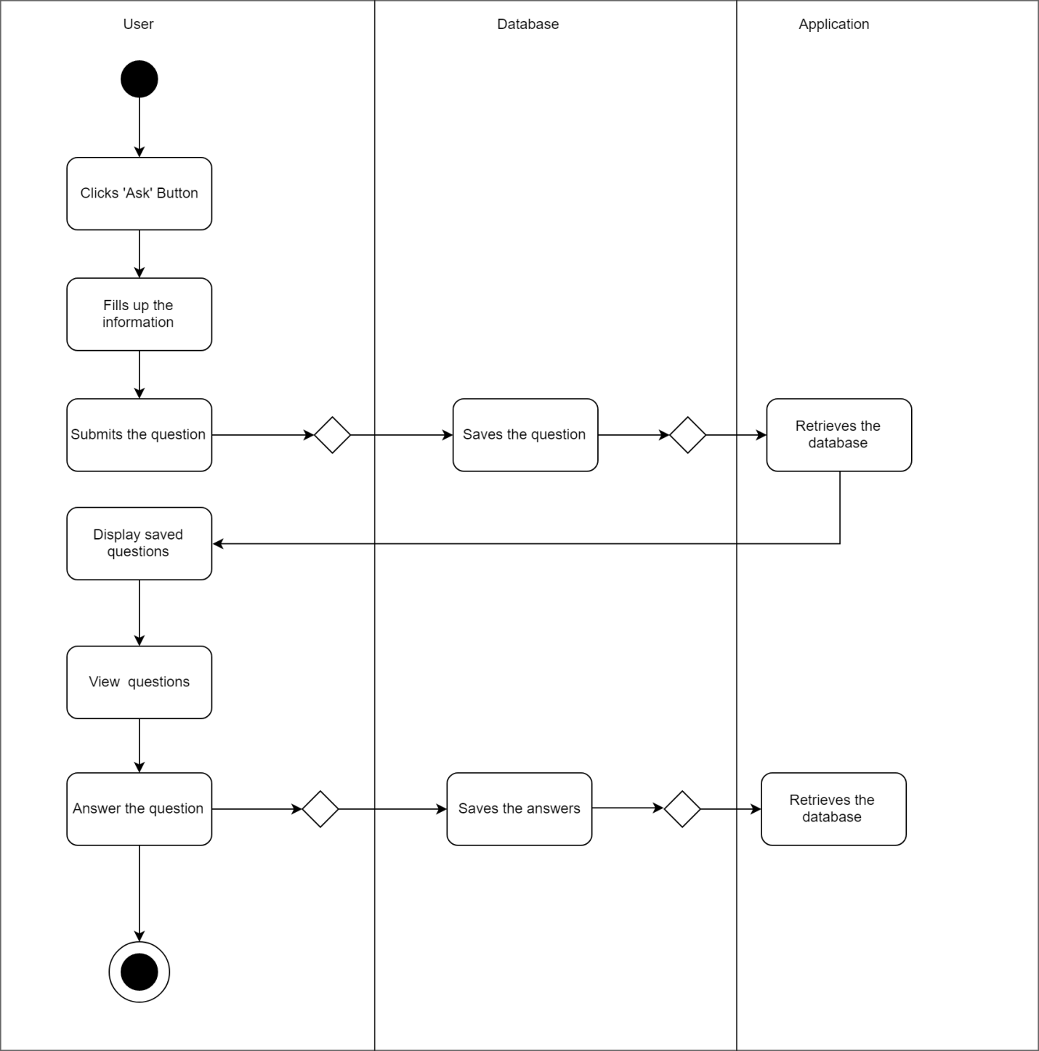

Figure : Activity Diagram for ‘Ask’

### ACTIVITY DIAGRAM FOR UPLOADING

Similarly, the below figure shows how user upload’s task is carried out throughout the system and database.

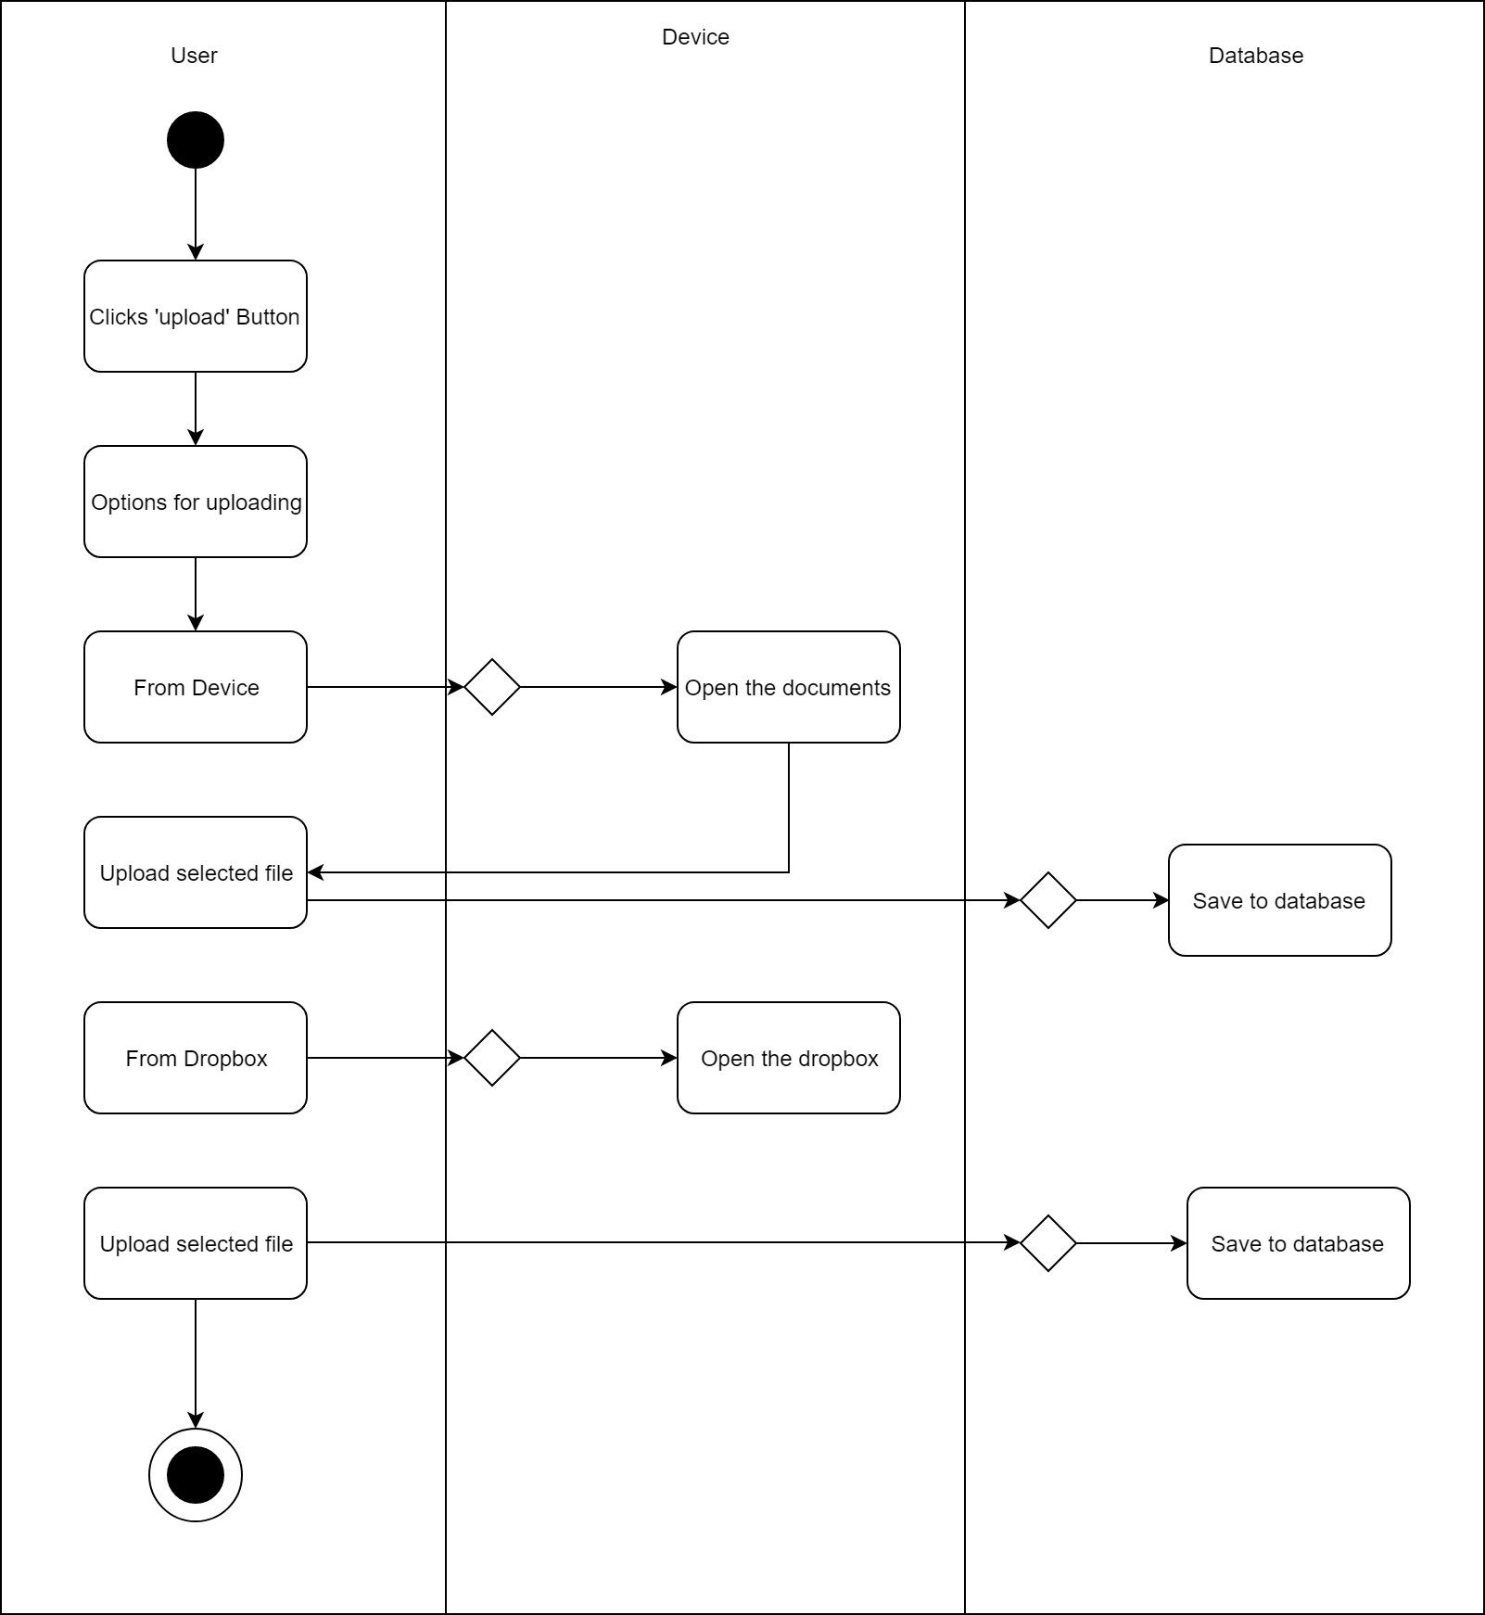

Figure : Activity Diagram for ‘Upload’

### ACTIVITY DIAGRAM FOR PROFILE ACTIVITY

In profile activity, User’s can update their profile and add themselves as a tutor. Detail is depicted in the figure below.

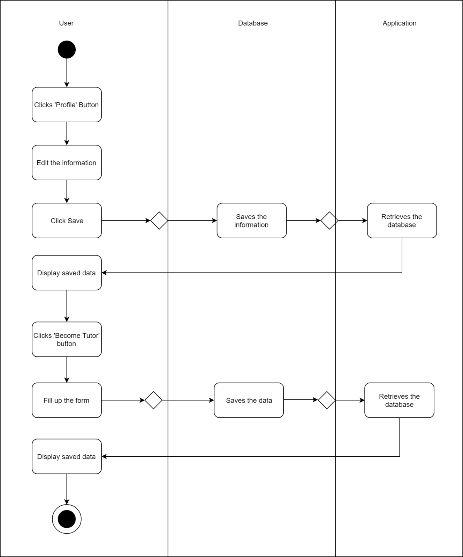

Figure : Activity diagram for profile activity

### ACTIVITY DIAGRAM FOR COURSES

The below figure gives detail about the task carried out when the users will add the course. User and application have close relation regarding the course activity.

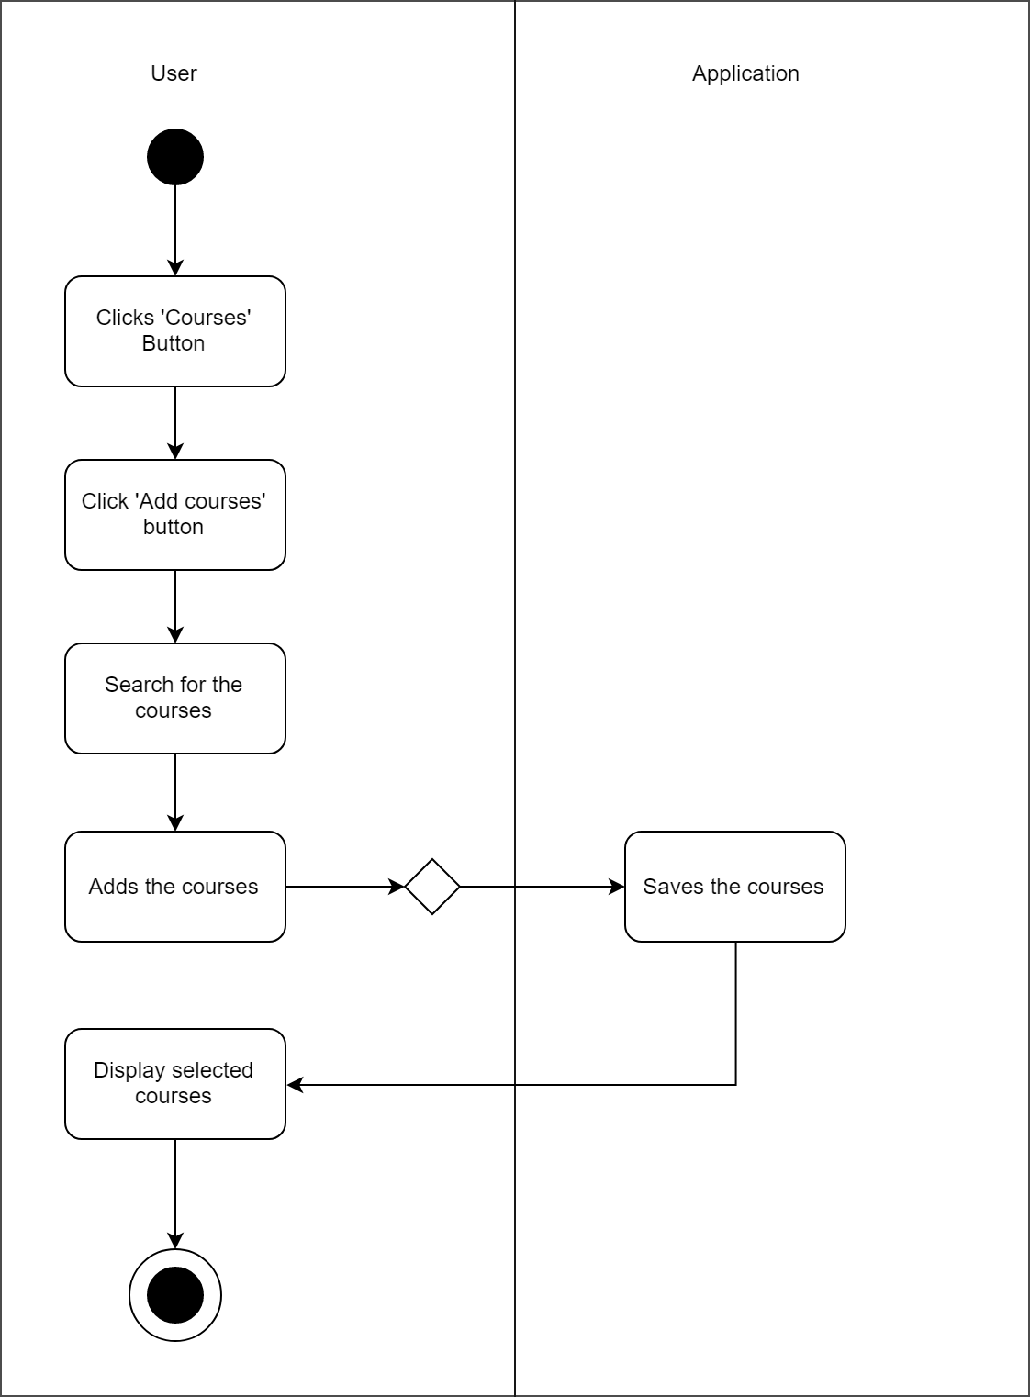

Figure : Activity diagram for adding course

## SEQUENCE DIAGRAM

Sequence Diagram is an interaction diagram. It shows how the user can interface with the device and in turn device with the internal system and database.

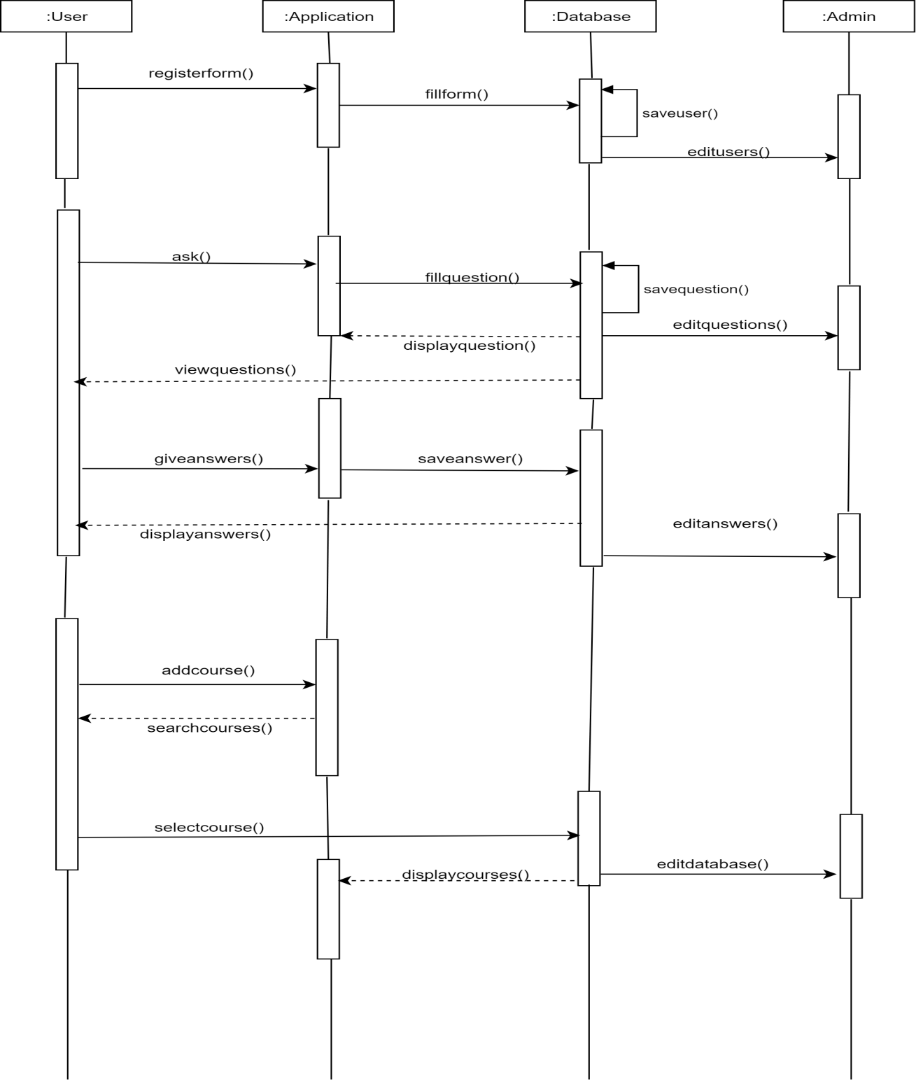

Figure : Sequence Diagram

# **TESTING**

The task done so far has been tested. The below table shows the detailed explanation of the testing carried out.

## TESTING TABLE

|  |  |  |  |  |  |
| --- | --- | --- | --- | --- | --- |
| **Test No.** | **Unit** | **Test** | **Expected Result** | **Test Outcome** | **Evidence** |
| 1 | Register API | Tested signing up the users | User successfully signed up and added in database | Successful | Figure 15 |
| 2 | Register | Register with Android Device | Successfully registered to application | Failed | Figure 16 |
| 3 | Add Question API | Tested whether questions will be added or not | Question successfully added to database | Successful | Figure 13 |
| 4 | Home Page | Consuming data from database | Data display in homepage | Successful | Figure 17 |

Table : Testing Table

## TESTING EVIDENCE THROUGH SNAPSHOTS

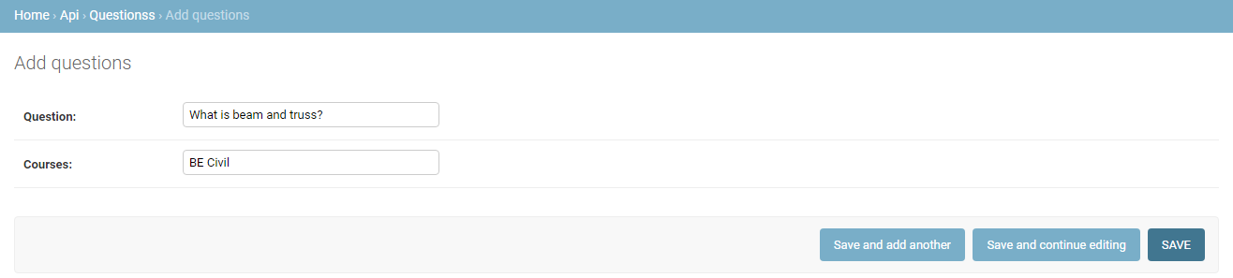

Figure : Question adding API

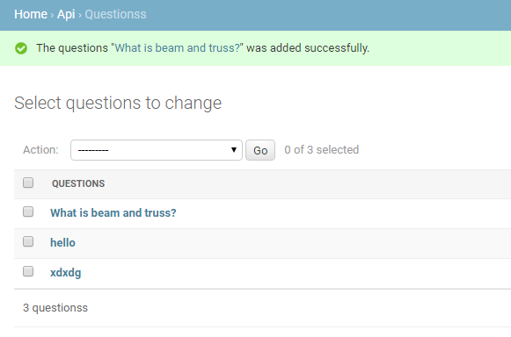

Figure : Successfully added question

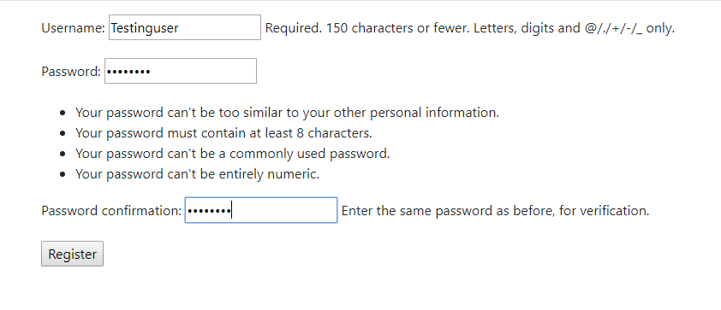

Figure : User registration API

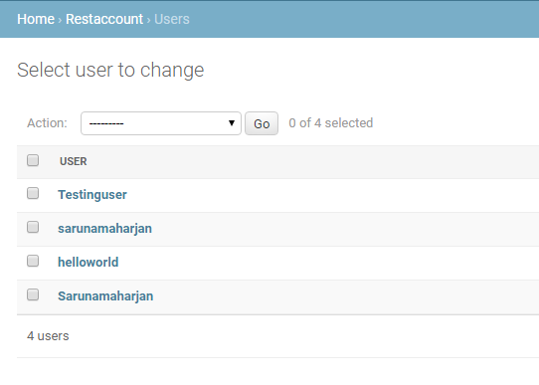

Figure : User added successfully

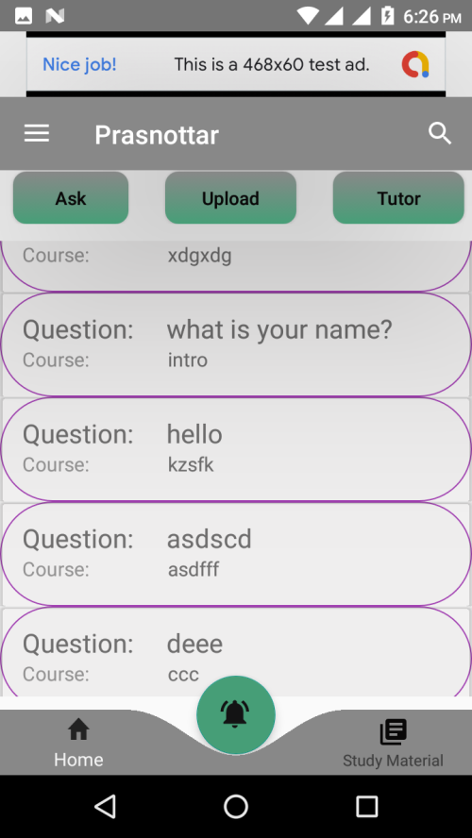

Figure : Home Page

# **PROJECT TASK AND TIME SCHEDULE**

The project schedule has been designed as per requirements of the project. Various tasks have been enlisted in the table as per the requirements. Debugging and testing is to be done prior to the completion of the project. Similarly, approximate duration has been scheduled as per the tasks.

|  |  |  |  |  |
| --- | --- | --- | --- | --- |
| **TASK** | **First Iteration** | **Second Iteration** | **Third Iteration** | **APPROX DURATION in days** |
| Preliminary Investigation | 10 | 5 | 7 | 22 |
| Problem and requirement analysis | 11 | 8 | 10 | 29 |
| Project study | 12 | 9 | 16 | 37 |
| System design | 15 | 7 | 21 | 60 |
| Debugging and Testing | 5 | 5 | 10 | 20 |
| Implementation | 17 | 9 | 20 | 46 |
| Documentation | 40 | 20 | 25 | 85 |

Table : Project Task and Time Schedule

## GANTT CHART

The Gantt chart below has been constructed on the basis of the above project schedule. According to the table the project is estimated to be completed in 3 months. The task is started from preliminary investigations and the other tasks are scheduled in accordance.

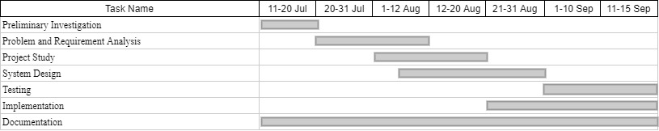

Table : ITERATION 1: Develop Full-fledged Android Application

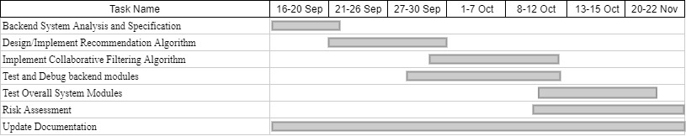

Table : ITERATION 2: Recommendation

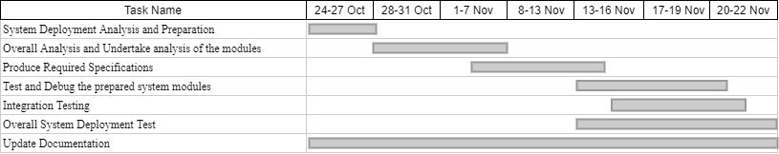

Table : ITERATION 3:System Deployment

# **CONCLUSION AND FUTURE EXTENSIONS**

The Prasnottar app is now at the initial state having most of the basic functionalities discussed before. All the modules have been integrating and are ready for the demo. However it is not complete with the ideas we have put through and may need more improvisation in the coming days as well. So, various extensions can be implemented in this application. Some of the extensions we have planned are:

1. Hybrid Recommender Systems (Content based and collaborative based) for intelligent recommendations of questions.
2. Get notified when questions related to the chosen course are added.

# **REFERENCE**

1. (2017, Nov 27). Retrieved from The Pros & Cons of using Yahoo Answers: https://www.startschoolnow.org/the-pros-cons-of-using-yahoo-answers-for-college-research-papers/
2. Bhujel, U. (2017). *Stack overflow*. Retrieved from Stack Overflow's Features: https://stackshare.io/stack-overflow
3. boomers, t. (2018, jun 20). *Yahoo Answers*. Retrieved from https://techboomers.com/sites-like-quora
4. Zheleznov, A. (2019, Jan 25). *Quora*. Retrieved from What are the disadvantages of Quora?: https://www.quora.com/What-are-the-disadvantages-of-Quora
5. Quora. (2019, Nov 8). *About us*. Retrieved from Quora — Questions, Answers, and More: https://play.google.com/store/apps/details?id=com.quora.android&hl=en
6. Sharma, S. (2018, May 22). *Quora*. Retrieved from What is the Quora app?: https://www.quora.com/What-is-the-Quora-app
7. *Stack overflow*. (2019, jan 14). Retrieved from why i refuse stackoverflow?: https://www.sitepoint.com/community/t/why-i-refuse-to-use-stackoverflow/38483/10
8. Stack Overflow. (2019, Mar). *Stack Overflow's Features*. Retrieved from Stack Overflow: https://stackshare.io/stack-overflow

# **APPENDIX**

SYSTEM SNAPSHOTS

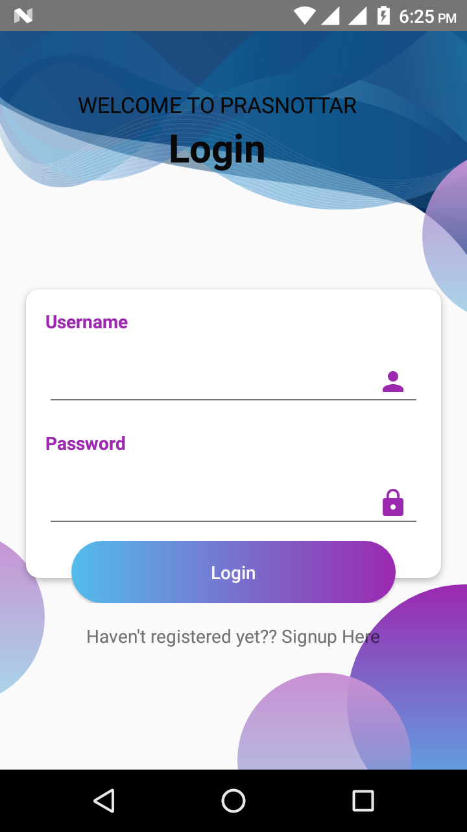

Figure : Login

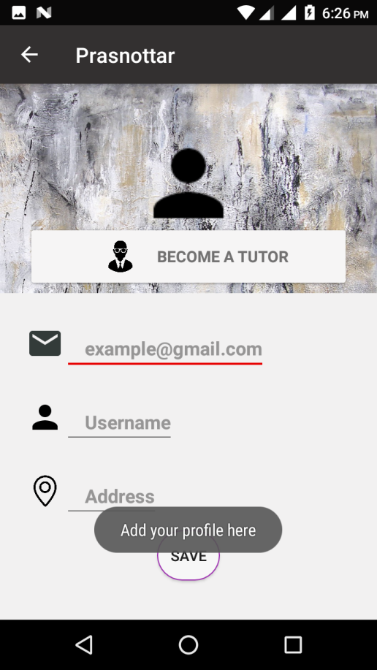

Figure : Profile

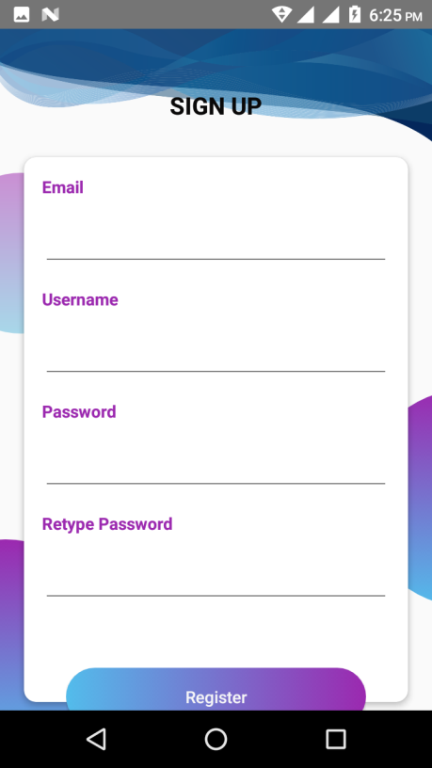

Figure : Sign Up

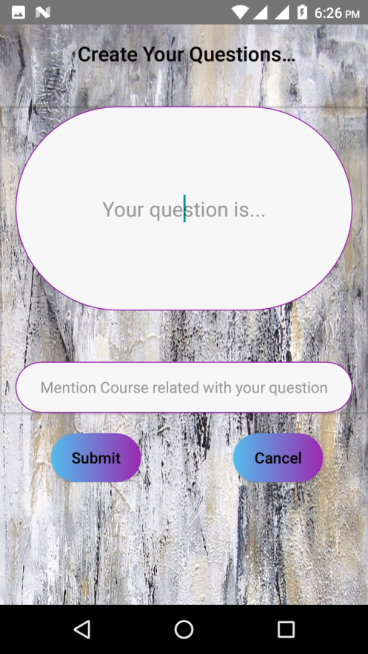

Figure : Create Question

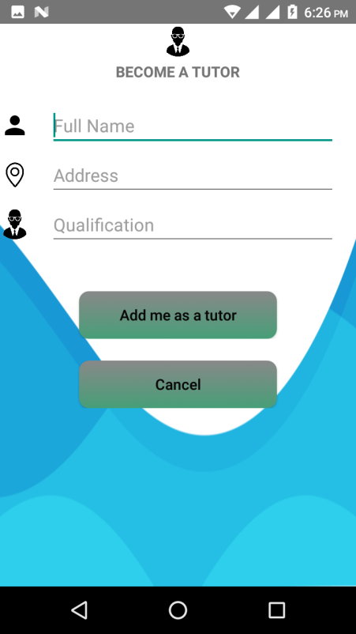

Figure : Add As Tutor

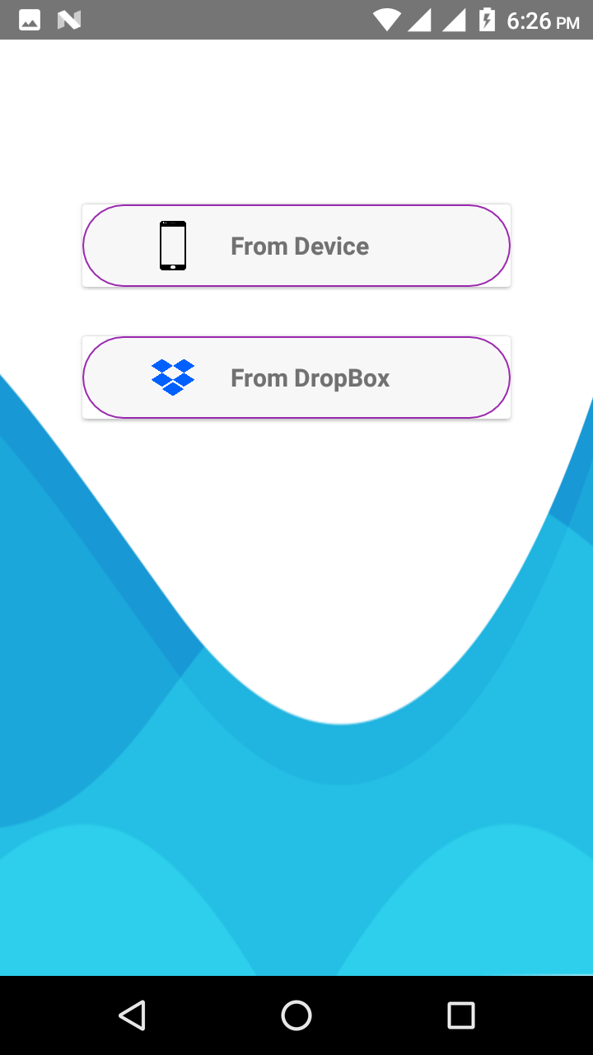

Figure : Add Note