# ACKNOWLEDGEMENT

It is an at-most privilege to express our sincere regards to the project supervisor, Dr. Amit Srivastava for his valuable guidance and encouragement throughout the duration of the project. We deeply express our sincere thanks to him being the project supervisor for encouraging and allowing us to present the project on the topic “Smart Clinic and Lab System” at our department premises for the partial fulfillment of the requirements leading to the award of the Bachelors in Engineering in Information Technology.

We take this opportunity to thank all the lecturers who have directly or indirectly helped our project accomplishment. We are highly obliged to them for providing us this opportunity to carry out their ideas and work during the project period and helping us to gain the successful completion of the project. We would like to thank Dr. Madan Kadariya, HOD of IT department for his support during our study as well as project development period. We also like to thank Dr. Roshan Chitrakar and the whole IT department for the support we have been provided during this project development period. We would also like to thank Er. Bikash Silwal, Senior Developer of Karkalo Tech Pvt.Ltd for his guidance and valuable time .Also we would like to thank Lokanthali Wellness Clinic for providing us with their data support and sharing us their clinic work flow. We pay the respect and love to our parents and all other family members for their love and encouragement throughout our project development period. Last but not the least, we express our thanks to all our beloved friends for their cooperation and support.

# ABSTRACT

Smart Clinic and Lab System is developed to support and automate clinic’s daily operation. This system incorporates all the clinic operation starting from Employee, Department, Service, Tests, patient registration and other tasks until billing the patient such as appointment scheduling, and generate report as well. Key concept is focusing on minimizing problems like miscalculations and paper management that usually incurs while using the manual system. Employees and patient information will be more manageable and easier for retrieval along with storing and managing Patient’s Record, Laboratory Report, Generate Bills, and Doctor’s Management. This software enables doctors and clinic assistant to manage patient records and appointment and produce reports, whatever actions he has taken will also be saved in the database. The targeted user for this system is staff of the clinic, doctor and also the management. And after treatment, information about treatment is recorded into the system. Administrator of the software manage the roles of the users by limiting the accessibility to the system. The doctor and staff evaluate and also give their opinion to make the system more usable for the daily clinical operation. Overall, this system is able to support the daily clinic operation based on evaluation from real user and the system is able to perform the task efficiently with more accuracy.

**Keywords:** Patient, Registration, Test, System, Report.

# Table of Contents

ACKNOWLEDGEMENT i

ABSTRACT ii

Table of Contents iii

List of Tables v

List of figures vi

List of Abbreviations vii

1. Introduction 1

1.1 Problem Statement 2

1.2 Objectives 3

1.3 Significance of the study 3

1.4 Project Scope and Limitations 4

2. Literature Review 5

2.1 Quick Media Smart Clinic and Lab System 5

2.2 Online Smart Clinic and Lab System 6

3. Methodology 8

3.1 Evolutionary Prototyping 8

3.2 Requirements 10

3.3 Tools and Technologies used 10

3.4 Use Cases 12

3.5 Sequence Diagram 13

3.6 Class Diagram 15

3.7 Data Flow Diagram 16

4. Performance Analysis Methodology 17

4.1 The USE Method 17

5. Proposed Deliverable 18

6. Project Task and Time schedule 19

6.1 Project Schedule 19

6.2 Gantt Chart 21

7. Testing 22

8. Conclusion and Future Extension 27

9. References 28

# List of Tables

Table 1: Tools and Technologies used 10

Table 2 : Time Schedule 20

Table 3 : Gantt Chart 21

# List of figures

Figure 1: Evolutionary Prototyping 8

Figure 2 : Use Case Diagram 12

Figure 3 : Sequence Diagram For SCMS 14

Figure 4 : Class Diagram 15

Figure 5 : Level 0 DFD 16

Figure 6 : Level 1 DFD 17

Figure 7 : Flowchart of USE Method 18

# List of Abbreviations

CMS

Clinic Management System

DFD

Data Flow Diagram

GPU

Graphics Processing Unit

GUI

Graphical User Interface

HOD

Head of Department

IT

Information Technology

LAN

Locan Area Network

MVC

Model View Controller

OPD

Out Patient Department

PHP

Personal Home Page

SQL

Standardized Query Language

UML

Unified Modeling Language

# Introduction

Smart Clinic and Lab System is used by the doctor and clinic assistant. Clinic Registration System is developed to improve the clinic management and automates the workflow that happens in the clinic. It includes test registration, generate report and register new package and category. When the patient will visit on clinic, they will ask to provide their name, address, sex, age and type or problems. Patient will make registration first. After entering these fields, user have to register for OPD with selected doctor and they will get the receipt of registration. The user will find it useful because the system has benefits that can help the operation of the clinic. If the patient never registered before, patient information collected and stored in the database. However, if it is an existing patient the patient data is search-using their identification. Each registration form will have unique registration number or id, phone number of patients.

This will improve the record of the patient and save the time during the registration. The system makes record keeping more efficient and secure from an unauthorized people. The system also includes online appointment scheduling and management. At this time, patient is assigned to the doctor. Once the patient gets the treatment, the doctor will send the report including the medicine name or lab test. Then patient will go to the reception and register for lab test if required. The system also provides features as online payment methods as alternative payment for cash or cheque. Now patient gets bill receipt from reception and they give test from lab. When lab result came, laboratories Inputs all the results in the respected patient’s report.

Once the test result is uploaded in the system, patient can get their lab test result from the reception. Now they will go to the doctor with test result report. The doctor will prescribe medicines and suggestion to patient. For taking medicine user have to go to the pharmacy and buy all the required medicine. Only authorized user has the right to retrieve data of their own. This will secure the patient's information. The staff will view the report and complete the patient record. Besides that, it is easy for the management to maintain record about the patient. The time for retrieving the information needed will be less compare to the manual. When the bill will be provided to the user, it all provides all the details for each service which they have purchased. Under this bill they will get info on: - Report id, collection date, report date, total test and their result etc. Then the staff will update the patient profile and the patient record will be kept in database.

## Problem Statement

Smart Clinic is enhanced from the traditional paper-based management system that has been using in the clinic. Based on the previous system, the patient who comes to the clinic for the first time is registered via the system. The assistant assist the patient by write down the personal detail in a form. The patient gets the treatment and information about the treatment is record in a file. The system manages the activities in the clinic but the previous system has cause problems to the user. [1]

Problems of using paper to record down the records of patient:

* Only one copy, emergent consult problem
* Waste time to search the record
* Easy to lost record or duplicate record
* Waste money on purchase paper
* Waste space for store record

Smart Clinic is developed to overcome the problems. The system has few modules such as patient registration, appointment, lab test, patient record search, billing and reporting.

## Objectives

The Smart Clinic and Lab System is very beneficial for a clinic/doctor. The objectives of Smart Clinic and Lab System are:

* To develop a system that can replace manual system.
* To design a system that can overview all the transaction.
* To develop a software that increases our programming abilities.
* Generate medical report and keep electronic medical records (EMRs).
* To build a software that can control user accessibility.

## Significance of the study

The Smart Clinic and Lab System is very beneficial for a clinic/doctor. It will store complete patient record. The most important thing is it will make it easier for the retrieval of history information of the patient. The Smart Clinic and Lab System will improve clinic operation for both staff and the patient.

We can schedule the appointment for new patient in which we assign the date, time, department and doctor. If patient want particular doctor then we can search the doctors scheduling and available time for that doctor. We can also cancel the appointment of particular patient. For the staff, it will make it easy during registration process. If the patient is an existing patient, they can easily retrieve back the record of the patient.

For the doctor they can view history record of patient. In case, if the patient allergy with the certain medicine, the doctor will give an alternative medicine for the patient .we can view the doctor’s schedule .Here we can create the duty plan of doctor and edit or update the duty plan of particular doctor. Here we can add/delete the doctor to particular department. For the management, it will help them view the report operation of the clinic. The other thing is it will maintain the account for the clinic.

The system will be able to improve the workflow of the clinic starting from registration until billing to the patient. At the same time, it will maintain all the data that can be accessed anytime.

The report generated will help the owner of the clinic to view the summary daily operation of the clinic.

## **Project Scope and Limitations**

The scope for the system will involve staff, doctor and management of the clinic. The staff will register the patient and make an appointment. The doctor will diagnose the patients and give the medication while the Lab technician will manage and perform different tests like hematology, microbiology etc. there will be other staffs for billing and generating reports. Management can add departments, services and employees. Management will view the daily report of clinic operation. The communication between the staff is done using the local clinic network.

Even though the proposed Clinic System boasts certain special features there are some limitations also

* This system is designed only for a local network.
* Patient cannot make an appointment from internet sitting in his/her house.
* Patient cannot make payment via credit card, debit card etc.
* System do not provide pharmacy service.

.

# **Literature Review**

Clinics currently use a manual system for the management and maintenance of critical information. The current system requires numerous paper forms, with data stores spread throughout the hospital management infrastructure. Often information (on forms) is incomplete, or does not follow management standards. Forms are often lost in transit between departments requiring a comprehensive auditing process to ensure that no vital information is lost. Multiple copies of the same information exist in the hospital and may lead to inconsistencies in data in various data stores. The Smart Clinic and Lab System is designed for any clinic to replace their existing manual, paper based system. The new system is to control the following information; patient information, doctor information, staff and doctor schedules, and patient invoices. These services are to be provided in an efficient, cost effective manner, with the goal of reducing the time and resources currently required for such tasks. [2]

## Quick Media Smart Clinic and Lab System

This System is powerful, flexible, and easy to use platform. The system has multiple user access control for all system modules. QMSCMS enables us to develop our organization and improve its effectiveness and quality of work. [3] The main features of this system are:

* Patient Information System.
* Patient Transaction History.
* Inpatient & Outpatient Modules.
* Interactive User Access Level Accounts.
* Items & Services.
* Add Charges & Transactions.
* Multi-Currency, Language and No. Format.
* Consultants, Users and Department.
* Patient File Upload Management.
* Content Management System.
* Billing system.
* Cashier and payments.

## Online Smart Clinic and Lab System

Online Smart Clinic and Lab System is a web-based clinic practice management software designed to easily manage a clinic business anywhere and anytime we need, with the aid of a computer and Internet. It is a very user-friendly, feature-packed software solution that offers superior performance and reliability. It is specifically designed to handle all of our clinic management needs. Solver Online Smart Clinic and Lab System is ideal for practices of any size, from solo doctors to enterprise class health networks.[4] The main features of this system are:

* Useful for General Practitioners, Surgeons, Gynecologist, Small to big hospital, Nursing homes, and all Physicians.
* Generate Prescriptions.
* Easy to use patient visit details (OPD/IPD) modules.
* Family wise patient records management. Various Predefined Certificate.
* Billing and account manager for your accounting needs.
* Built in backup and restore facilities.
* Multi-user and LAN compatible.

.

# Methodology

Every project follows a standard set of procedure for software development. Based on the literature study and the requirement analysis the standard methodology adopted for creating Smart Clinic and Lab System is Evolutionary Prototyping.

## **Evolutionary Prototyping**

Evolutionary prototyping is a life-cycle model in which the system is developed in increments so that it can readily be modified in response to end-user and customer feedback. Evolutionary prototyping also called as breadboard prototyping is based on building actual functional prototypes with minimal functionality in the beginning. The prototype developed forms the heart of the future prototypes on top of which the entire system is built. Using evolutionary prototyping only well understood requirements are included in the prototype and the requirements are added as and when they are understood.[5]

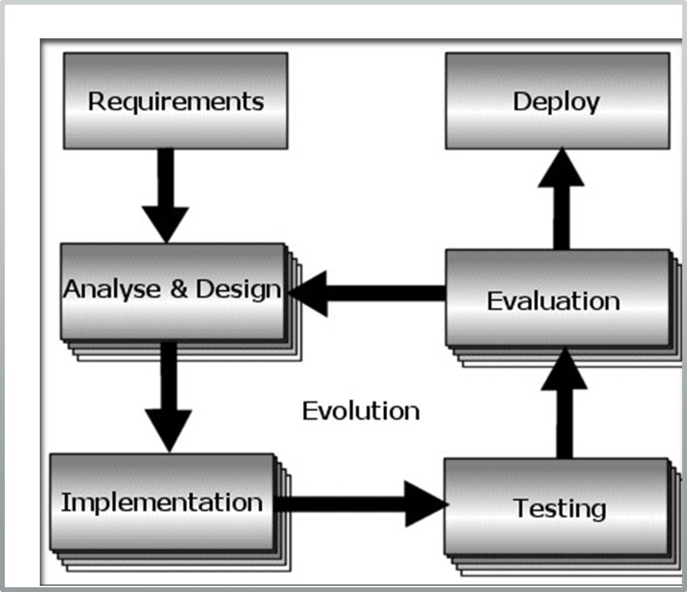

Figure 1: Evolutionary Prototyping

**The steps involved in this model are:**

* **Requirement stage:** This stage involves researching and analyzing the requirements for the project to develop a specification and formal list of requirements that the project. It will involve looking at several previous projects to establish the key aspects of functionality that we wish to incorporate into our own project.
* **Analysis and Design stage:** After the requirements stage is complete the requirements will be analyzed and an initial design will be created. In the early stages of the project the design will be rather flexible concentrating mainly on the simulation aspects of the project development. Later on we anticipate that design will become more detailed as iteration 1 is completed and giving us a stable framework for the extension to visualization in iteration 2.
* **Implementation stage:** Implementation is the stage where the physical design of the program is translated into code. Each specification developed during the last stage will be implemented into the overall program structure. If any problems with the design are discovered the project will return to the design stage and create a revised design. The process will then continue checking that each of the previously implemented features can be satisfied within the new design framework.
* **Testing stage**: During the testing stage each function implemented in the implementation stage is checked against its specification to ensure that it performs the correct action.
* **Evaluation stage**: This stage will be used to examine whether the prototype that has been developed fulfills all the requirements of the project. If the prototype doesn’t fulfill these requirements the process will continue with a further iteration. If the prototype fulfills all the requirements then it will stop the cycle of iteration and continue onto the next stage.
* **Deployment stage**: Deployment is the process in which the program has reached completion and is ready for deployment into its prospective environment

## **Requirements**

Operating system: Windows 7, 8, 10; Mac OS, Linux

GPU: Graphics card with DX9 or DX11 with feature level 9.3 capabilities.

Additional platform development requirements:

Apache Web Server, Database system MySQL, Browser (Chrome) .

## Tools and Technologies used

The tools and technologies being used for documentation, designing and developing Smart Clinic and Lab System are listed below in table :

|  |  |
| --- | --- |
| **TOOLS** | **PURPOSE** |
| Gliffy | For creating UML diagrams. |
| Xampp 5.6.31 | For creating local Web server. |
| Laravel 5.4 | PHP Framework used for development. |
| Adobe Photoshop | Designing GUI. |
| Sublime text 3.0 | Used for Text Editor. |
| Bitbucket | Version Control (Git) |

**Table 1: Tools and Technologies used**

**Framework:**

**Laravel** is a free, open-source PHP web framework, created by Taylor Otwell and intended for the development of web applications following the model–view–controller (MVC) architectural pattern. Some of the features of Laravel are a modular packaging system with a dedicated dependency manager, different ways for accessing relational databases, utilities that aid in application deployment and maintenance. Laravel is a web application framework with expressive, elegant syntax. We believe development must be an enjoyable, creative experience to be truly fulfilling. Laravel attempts to take the pain out of development by easing common tasks used in the majority of web projects, such as authentication, routing, sessions, and caching.

Laravel aims to make the development process a pleasing one for the developer without sacrificing application functionality. Laravel is accessible, yet powerful, providing powerful tools needed for large, robust applications. Benefits of Laravel over other PHP Framework are:

* Its simple and quick.
* Setup and customization process is incredibly easy.
* Stress free coding as it keeps all the SQL codes in separate model files.
* The pre-loaded packages like Laravel Socialite, Laravel cashier, Laravel elixir, Laravel eloquent etc. make the development process easier saving the time of both the developer and the owner.
* There are pre-enabled tools to protect from injection and xss attacks, which help the developers save their time from complex coding for site security.

## Use Cases

A use case diagram at its simplest is a representation of a user's interaction with the system that shows the relationship between the user and the different use cases in which the user is involved. A use case diagram can identify the different types of users of a system and the different use cases.

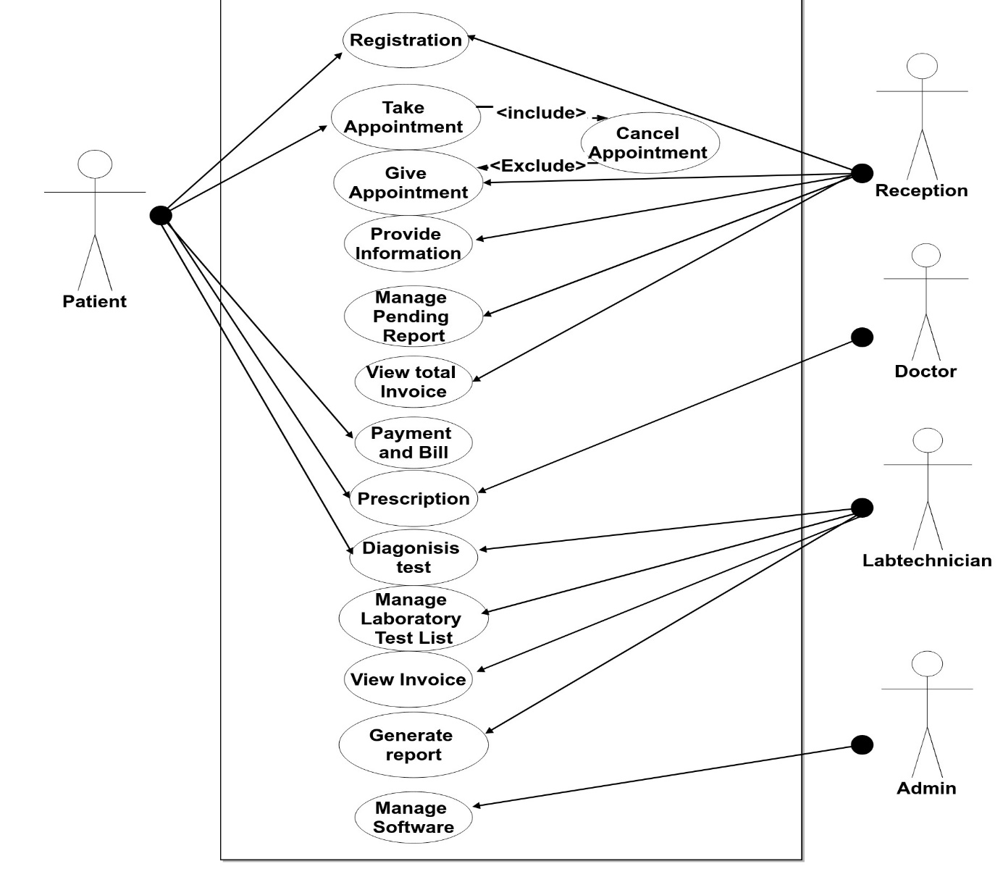

Figure 2 : Use Case Diagram

## Sequence Diagram

A Sequence diagram is an interaction diagram that shows how objects operate with one another and in what order. It is a construct of a message sequence chart. A sequence diagram shows object interactions arranged in time sequence.

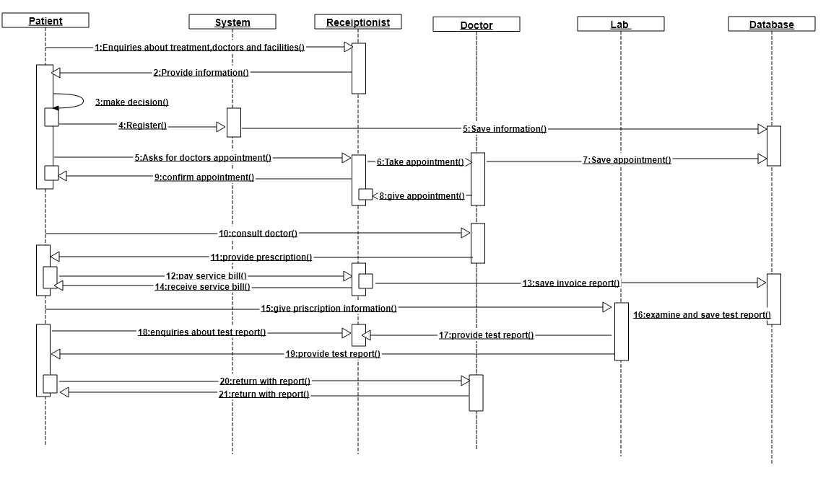

Figure 3 : Sequence Diagram For SCMS

## Class Diagram

In software engineering, a class diagram in the Unified Modeling Language (UML) is a type of static structure diagram that describes the structure of a system by showing the system's classes, their attributes, operations (or methods), and the relationships among objects.

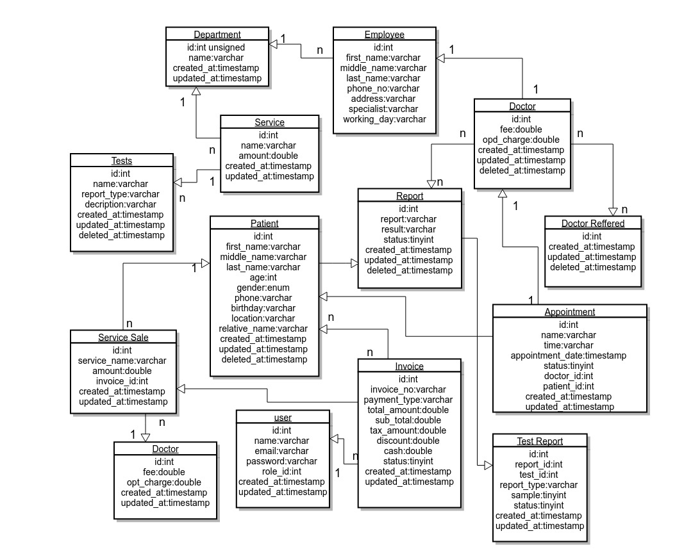

Figure 4 : Class Diagram

## Data Flow Diagram

A data flow diagram (DFD) is a graphical representation of the "flow" of data through an information system modeling its process aspects. A DFD is often used as a preliminary step to create an overview of the system without going into great detail, which can later be elaborated. DFDs can also be used for the visualization of data processing (structured design).A DFD shows what kind of information will be input to and output from the system, how the data will advance through the system, and where the data will be stored .

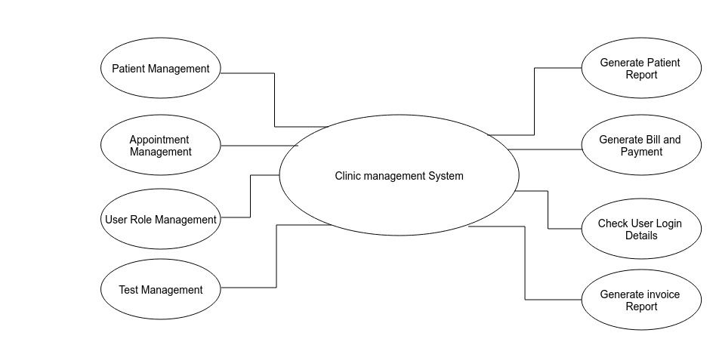

Figure 5 : Level 0 DFD

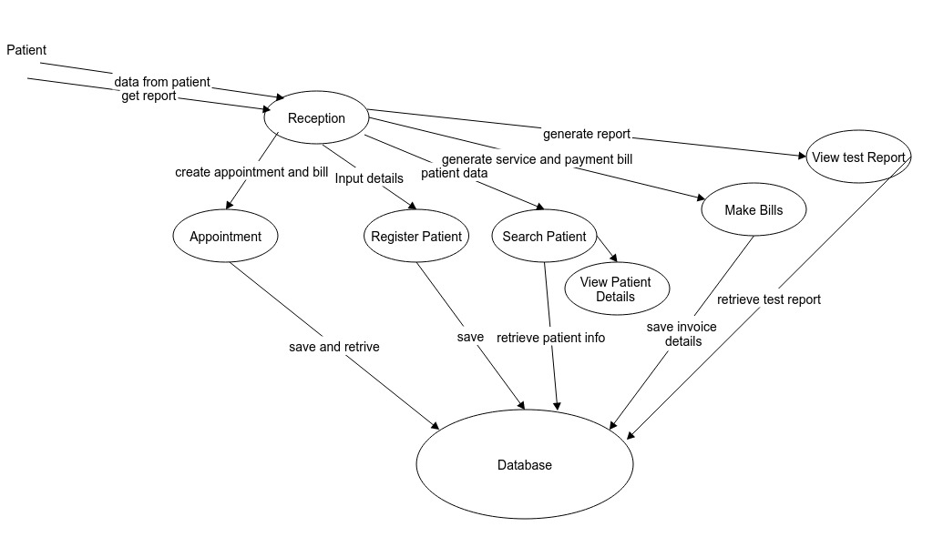

Figure 6 : Level 1 DFD

# Performance Analysis Methodology

A performance analysis methodology is a procedure that you can follow to analyze system or application performance. These generally provide a starting point and then guidance to root cause, or causes.

## **The USE Method**

The Utilization Saturation and Errors (USE) Method is a methodology for analyzing the performance of any system. It directs the construction of a checklist, which for server analysis can be used for quickly identifying resource bottlenecks or errors. It begins by posing questions, and then seeks answers, instead of beginning with given metrics (partial answers) and trying to work backwards.The USE Method identifies problems which are likely to be system bottlenecks. Unfortunately, systems can be suffering more than one performance problem, and so the first one you find may be a problem but not the problem .Each discovery can be investigated using further methodologies, before continuing the USE Method as needed to iterate over more resources.

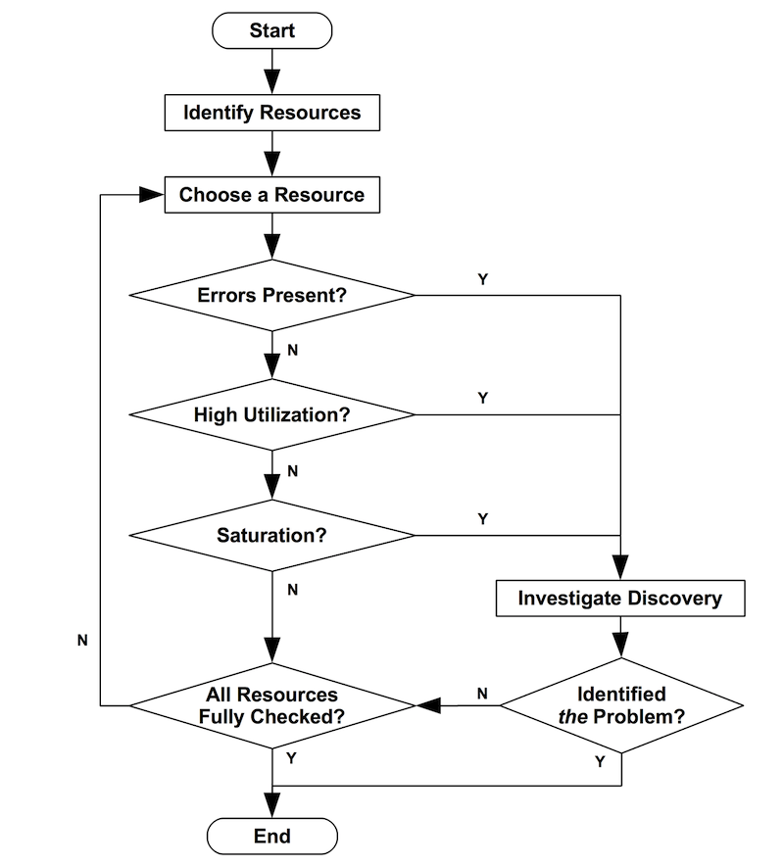

Figure 7 : Flowchart of USE Method

The USE Method is a simple strategy you can use to perform a complete a check of system health, identifying common bottlenecks and errors. The strength of USE is its speed and visibility. [6]

# Proposed Deliverable

This section presents the major outputs and deliverable for each of the phases used in above analysis methodology in the system. This section presents outputs of different phases for example output of initiation phase, planning phase and so on. The major deliverable of our project are:

* System can review all the registered patient details.
* System can review previous test detail of patient.
* Our system can generate the test report of any patients.
* System will provide invoice details.

# Project Task and Time schedule

The project schedule has been designed as per requirements and constraints involved. This project is scheduled to be completed in about 2 months. Requirement analysis have been given more emphasis. Research and database management is done first and well documented. Debugging and Testing is to be done prior to the completion of the project.

## **Project Schedule**

Table 2 : Time Schedule

|  |  |
| --- | --- |
| TASK | APPROX. DURATION( in days) |
| Requirement Analysis and Specification | 8 |
| Undertake Analysis of the System | 8 |
| Design System | 14 |
| Produce Requirement Specifications | 9 |
| Testing and Debugging | 8 |
| Test System Modules | 4 |
| Overall System Test | 5 |
| Develop Documentation | 4 |

## Gantt Chart

Table 3 : Gantt Chart

|  |  |  |  |  |  |
| --- | --- | --- | --- | --- | --- |
| Month  Task | Oct 2018 | Nov 2018 | Nov 2018 | Dec 2018 | Dec 2018 |
| Requirement Analysis |  |  |  |  |  |
| Analysis of the System |  |  |  |  |  |
| Design System |  |  |  |  |  |
| Procedure Requirement and Coding |  |  |  |  |  |
| Testing and Debugging |  |  |  |  |  |
| Test System Modules |  |  |  |  |  |
| Overall System Test |  |  |  |  |  |
| Develop Documentation |  |  |  |  |  |

# Testing

We are using two types of software testing technique.

* **Black Box Testing:**

The technique of testing without having any knowledge of the interior workings of the application is called black-box testing. The tester is oblivious to the system architecture and does not have access to the source code. Typically, while performing a black-box test, a tester will interact with the system's user interface by providing inputs and examining outputs without knowing how and where the inputs are worked upon. Various black box testing result are shown below:

* **Login Authentication:**

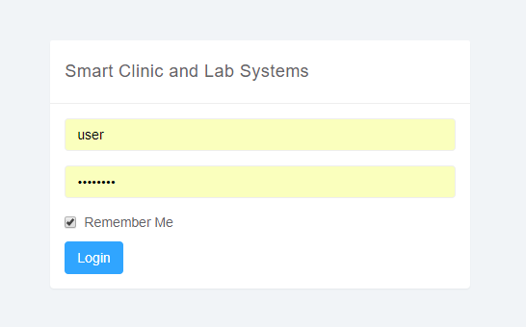

* **Register New Patient:**

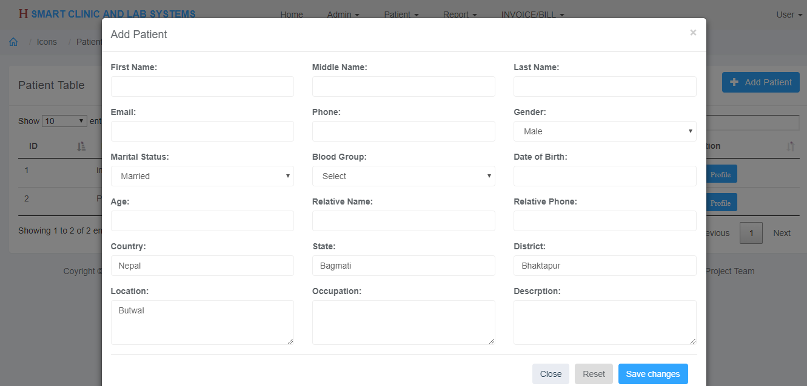

* **OPD Invoice:**

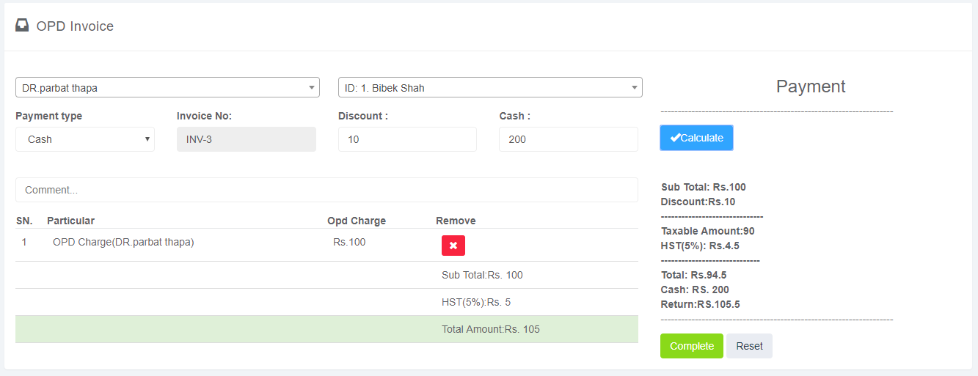

* **Payment Bill**

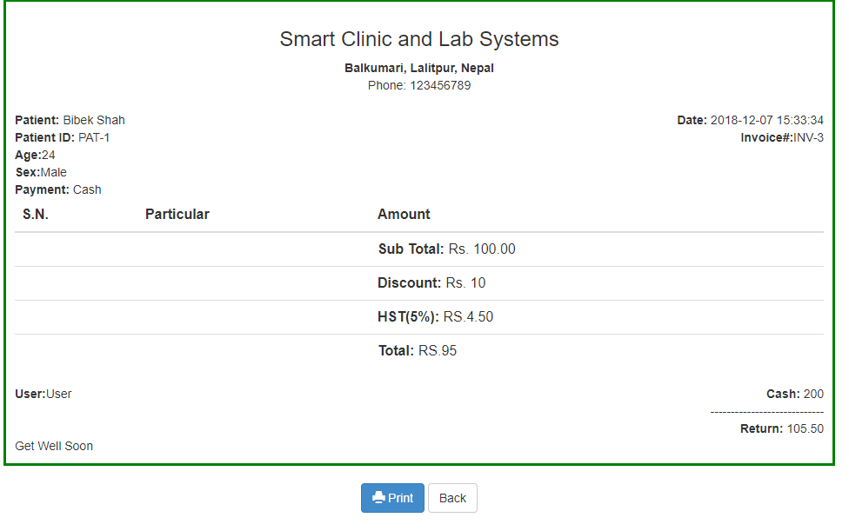

* **Test Result Entry:**

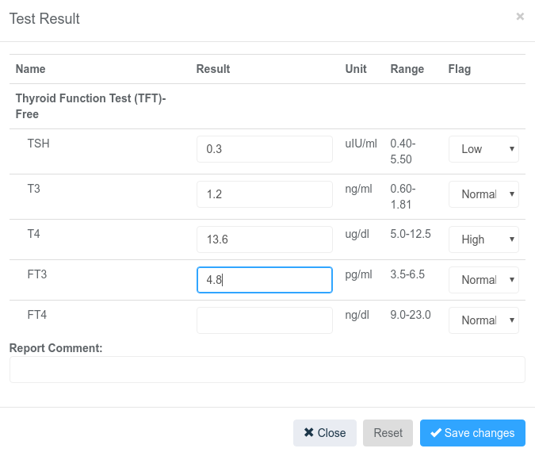

* **Report Generation:**

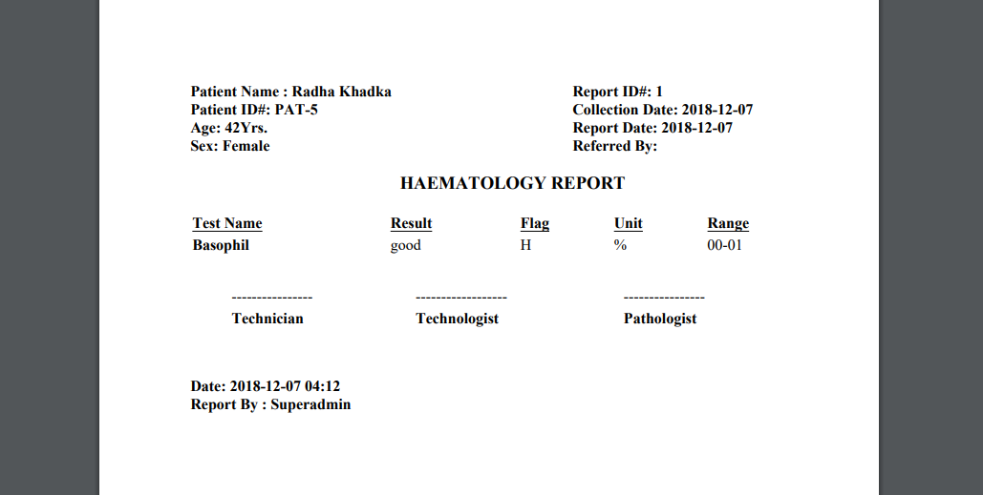

* **Grey Box Testing:**

Grey-box testing is a technique to test the application with having a limited knowledge of the internal workings of an application. Mastering the domain of a system always gives the tester an edge over someone with limited domain knowledge. Unlike black-box testing, where the tester only tests the application's user interface; in Grey-box testing, the tester has access to design documents and the database. Having this knowledge, a tester can prepare better test data and test scenarios while making a test plan.

# Conclusion and Future Extension

The whole systems activities are divided into three major parts like patients, doctors, and admin. Each one has their own role to perform and system respond accordingly. The project “Smart Clinic and Lab System” is for computerizing the working in a clinic. It is a great improvement over the manual system. The software takes care of all the requirements of an average Clinic and is capable to provide easy and effective storage of information related to patients that come up to the clinic. Patients can take an appointment for the particular doctor. It generates test reports and also provides the facility for searching the details of patients. It also provide the billing facility. This system was tested by Black box testing and Grey box testing methods.

The Future extension of Smart Clinic and Lab System includes:

* We can enhance this system by including more facilities like pharmacy system for the stock details of medicine in the pharmacy.
* We will host the platform on online servers to make it accessible worldwide.
* We will provide Blood Bank Information from our system.
* We will add payment services for card users.
* Patients can login and make an appointment from internet sitting in his/her house.

# References

[1] S. Indhumathi, G. vijayabaskar (2015)http://nevonprojects.com/clinic-management-system/.

Accessed on 18/09/2018.

[2]Laravel offical documents @ https://laravel.com/docs [L](https://sites.google.com/site/ignoubcafinalyearprojects/project-report/clinic-%20management-system-project-report)aLa.

Accessed on 10/12/2018.

[3] <https://codecanyon.net/item/quick-media-hospitalclinic-management-system/12088123>[.](https://codecanyon.net/item/quick-media-hospitalclinic-management-system/12088123.Accessed%20on%2013/11/2017)

[Accessed on 10/01/2018](https://codecanyon.net/item/quick-media-hospitalclinic-management-system/12088123.Accessed%20on%2013/11/2017).

[4]<http://afiinfotech.com/online_clinic_management_system_software>.

Accessed on 11/11/2018.

[5]KennethE.Lantz.https://books.google.com.np/books/about/The_Prototyping_Methodology.html? id=-SgnAAAAMAAJ&redir_esc=y. Accessed on 18/09/2018.

[6] http://www.brendangregg.com/methodology.html.

Accessed on 12/04/2018.