# Acknowledgement

This project “TechBazaar: The Online Shopping Store” has been completed not only by the team members but also from joint efforts of many individuals. It has been very pleasure for us to acknowledge and contribution that were very important and supportive throughout the project.

We would like to express our sincere gratitude to the Department of Information Technology for providing us such an opportunity and motivation for the final year project. And also we are grateful to the department for making us undertake the Major Project to fulfill the requirements of Bachelor’s Degree in IT Engineering.

Working on this project was a source of immense knowledge to us. A special gratitude we would like to give to our final year project supervisor, **Er. Himal Acharya**, whose contribution in stimulating suggestions and encouragement, helped us to coordinate our project. It would be privilege to thank **Dr. Roshan Chitrakar** (Associate Professor, NCIT) for the support for completion of project.

Also we would not forget to thank our teachers and classmates who have been knowingly and unknowingly the part of this project and lent support and views during the entire development time.

# Abstract

**“TechBazaar”** is an Online Shopping website. It is a platform where customer can directly buy the electronic items from anywhere through internet connection on a system. The online shopping system presents an online display of an order cut of time and associated delivery windows for items elected by the customer. It gives different electronic items which can be selected by the customer by seeing items description. Customer requirements are gathered and products are updated according to their requirements. Collaborative filtering helps user to assist to select the similar products what user had previously chosen. Add to cart function helps customer to remember their choice of products unless they buy the products, the user choice are remembered by the system. Cash on product delivery is possible throughout the system. Eye catching and mind catching user interface is designed through HTML and CSS in the java platform. User Sign Up and Login is possible, for the protection of user credential MD5 algorithm has been implemented which is the most popular cryptographic hass function. This project reduces lot of work load for customer as well as owner. It would make searching, viewing and selection of a product easier. Online Shopping System can help to manage goods, products and services online by choosing the listed products from online shopping store website. Buying of products online, customer can choose different products based on categories, delivery services and covering the disadvantages of the existing system and making the buying easier and efficient. The prime focus of this project is to develop a web-based application to improve the service to the customers and which in turn increases the sales and profit.

Keywords-website, shopping, products.

Contents

Acknowledgement i

Abstract ii

List of Figures v

List of Table vi

List of Abbreviation vii

1 Introduction 1

2 Problem Statement 2

3 Objectives 3

4 Significance of Study 4

5 Project Scope and Limitations 8

5.1 Scope 8

5.2 Limitations 8

6 Literature Review 9

6.1 Alibaba 9

6.1.1 Smart Product Search and Recommendation at Alibaba 9

6.2 Amazon 10

6.2.1 Amazon.com recommendation 10

6.3 Flipcart 11

6.4 Daraz 12

7 Methodology 13

7.1 Software Development Life Cycle 13

7.1.1 Analysis Phase 13

7.1.2 Design Phase 14

7.1.3 Coding Phase 14

7.1.4 Testing Phase 14

7.2 Collaborative Filtering Process 14

7.2.1 User Rating Score Data Unit 15

7.2.2 The Formation of Neighbors 16

7.2.3 Cosine Vector Similarity 16

7.2.4 Implementation of Collaborative Filtering process 17

7.3 System Design 20

7.4 Tools Used 26

7.4.1 Software Requirements 26

7.4.2 Hardware Requirements 26

8 Snapshots 27

8.1 User Interface 27

8.2 View Products 28

8.3 Sign Up 29

8.4 Login 30

8.5 Admin Perspective 31

8.6 Staffs Perspective 32

8.7 User Perspective 33

9 Results and Discussion 34

9.1 Output 34

9.2 Problem Faced 34

9.3 Limitation 34

10 Conclusion and Further Enhancement 35

10.1 Conclusion 35

10.2 Future Enhancement 35

11 Project Task 36

11.1 Schedule and Work Breakdown 36

12 References 37

# List of Figures

Figure 1: Incremental Model 13

Figure 2: The Collaborative Filtering Process 15

Figure 3: User Item-Rating Matrix 15

Figure 4: Item Based Similarity Computation 16

Figure 5: Flowchart User Perspective 20

Figure 6: Flowchart Admin Perspective 21

Figure 7: Use Case Diagram 23

Figure 8: ER Diagram 24

Figure 9: Class Diagram 25

Figure 10: Sequence Diagram 26

Figure 11: User Interface 28

Figure 12: View products 29

Figure 13: Sign Up Form 30

Figure 14: Log in Form 31

Figure 15: Admin Perspective 32

Figure 16: Staffs Perspective 33

Figure 17: User Perspective 34

Figure 18: Gantt Chart 37

# List of Table

Table 1: Sample Data 17

Table 2: User Item-Matrix 18

Table 3: Item-Item Similarity Matrix 19

Table 4: Software Requirements 27

Table 5: Work Breakdown Schedule 37

# List of Abbreviation

**CF:** Collaborative Filtering

**IBCF:** Item-Based Collaborative Filtering

**MD5:** Message- Digest 5

# Introduction

In the world of Internet and technology, almost everything is just a click away from the people. A person sitting on his chair in front of a computer can access all the facilities of the Internet. Unlike traditional commerce that is carried out physically with effort of a person to go and get products, e-commerce makes it easier for human to reduce physical work and to save time. The central concept is to allow the customer to shop virtually using the Internet and allow customers to buy the items of their desire from the online store.

Online shopping is a form of electronic commerce which allows consumers to directly buy goods or services from a seller over the Internet using a web browser [1]. Customers can shop online using a range of different computers and devices, including desktop computers, laptops, tablet computers and smart phones.

An online shop evokes the physical analogy of buying products or services at a regular retailer or shopping center; the process is called business-to-consumer (B2C) online shopping. Online stores typically enable shoppers to use "search" features to find specific models, brands or items. Online customers must have access to the Internet and a valid method of payment in order to complete a transaction.

Online Shopping was introduced 40 years ago and, to this day, continues to grow with new technologies, innovations, and thousands of businesses entering the online market each year [2]. The convenience and user experience has improved exponentially since its inception in the 1970s. It all began when Michael Aldrich invented online shopping. Using videotext, a two way message service, it revolutionized businesses. In 1979 Aldrich connected a television set to a transaction processing computer with a telephone line and created what he coined, teleshopping, meaning shopping at a distance. The mid-nineties to 2000s saw major advancements in the commercial use of the Internet. The largest online retailer in the world Amazon, launched in 1995 as an online bookstore. The growing use of the Internet, tablet devices, and smart phones coupled with larger consumer confidence will see that online shopping will continue to evolve and expand.

# Problem Statement

Travelling to various shops at various places is a costly and time consuming. TechBazaar focuses on facilitating the customers by providing them a platform where they can buy electronic items of their desire from anywhere through internet. It emphasizes to improve the services to the customers by providing them different categories of electronic items from where they can select their desired ones and can take any amount of time to do their shopping.

# Objectives

The main objectives of this project are to: -

1. To allow customers to shop virtually using the Internet.
2. To make most of the electronic items available to the customers in the same space.
3. To save customer's time of going to different stores for a single item.

iv. To recommend similar items to the customer.

# Significance of Study

This Project is applicable in the field of E-commerce for buying varieties of electronic items.

* **Search:**

The Search in this web application will allow the customers to search the products in this application. We will be using a text box in which the customer can enter one or more words to search for. The words entered by the customers will search in the products name. The text entered by the customer can be searched in two ways:

* All-words search: The phrase entered by the customers will be split into words, causing a search for products that contain every word entered by the customer.
* Any-words search: Products must contain at least one of the entered words.

Search results will be displayed in the search results page that contains the list of products that matched with the searched word, the search result page will employ custom paging. The search result will be sorted according to the ratings of the products. The words matching to the product name is given more priority.

* **Custom Paging:**

There can be large number of products, instead of showing all the products in a single page it is useful to let the customers browse them page by page, with a predefined number of products per page.

* **Custom Shopping Cart**:

Shopping cart allows the customers to add the products to the cart that they would like to purchase. Custom shopping cart keeps the record of the shopping cart or order info into the database. To implement the custom shopping cart, we will built the shopping cart page.

The customers visiting this application will be able to add the desired products to the shopping cart, remove the products from the cart, and update the quantity of products in the cart. In the shopping cart page, the customer will be able to see the products full description with total amount. Customers can add the products to the shopping cart using the "add to cart" button.

* **Product Recommendation:**

One of the most important advantages of an Internet store compared to physically structured store is the capability to customize the web application for each customer based on his or her preferences or based on data gathered from other customers with similar preferences. If web application knows how to suggest additional products to customer in a clever way, he or she might end up buying more than initially planned. In this web application we have implemented a simple but efficient product recommendation system. They are described briefly below:

* **Collaborative Filtering:**

For each customer, recommender systems recommend items based on how similar users liked the item. Let’s say Alice and Bob have similar interests in video games. Alice recently played and enjoyed the game Football. Bob has not played this game, but because the system has learned that Alice and Bob have similar interests, it recommends this game to Bob. In addition to user similarity, recommender systems can also perform collaborative filtering using item similarity (Users who liked this item also liked X.)

* **Content Based Recommendation:**

If Companies have detailed metadata about each of your items, they can recommend items with similar metadata tags.

* **Product Comparison:**

Product comparison is the process of comparing similar products before deciding which one to buy. Products comparison is very necessary to choose the best alternative. While buying a specific product, customers go through many items and choosing one of them may be difficult as they have to go to each and every product thoroughly. By the help of comparison, the customers will find it easier to choose among the products.

* **Security:**

The internet is thriving and online security is becoming more and more important as thousands of new web-application pop up every day.

To implement better security in user password, the user password will be hashed using salt password. Salt password is a randomly generated string. The salt password is then combined with user password and then hashed. One of the major advantages of using salt password is that an attacker would not be able to create a rainbow table of hashed values, because it would take too much time and space. The hashing algorithm we will be using is:

* **MD5 algorithm**: MD5 (Message-Digest algorithm 5) is a most popular Cryptographic Hash Function which is 128 bit encryption algorithm. This is way One-Way Encryption. MD5 was designed by Ronald Rivest in 1991
* **Custom Sign Up and Sign In:**

Sign up in this application allows the customer to make their account. In this web application we will be implementing custom sign up. Using the custom sign up will keep the record of the customer who visit the site. The information that the customers have to enter is Name, Email, Address and Password. After the customer has successfully signed up the customer can then sign in.

* **User info user control:**

User info user control is the custom made control that displays the information of the customer, if the customer is currently signed in. If the customer has not signed in then the user info will display, "Welcome Guest". When the customer has signed in then it will display the name of the customer, and will show the sign out option also.

* **Admin Content Management:**

Admin are the users who manage the content of the web application, they have the access to edit, update or delete the content in this application. There are numbers of things that the admin can perform, some of them are:

* Manage the category of the products that is by adding, editing and deleting the categories.
* Manage the products in this web application.
* Manage orders.

# Project Scope and Limitations

## Scope

There are several scopes that need to be proposed for the project:

1. Online shopping of various electronic items.
2. Make the searching, viewing and selection of products.
3. Recommendation of Products.
4. Shopping Carts.

## Limitations

1. Cannot Fulfill Online Payment Transaction Gateway.
2. Recommendation is based on rating of products.

# Literature Review

## Alibaba

Alibaba is a Chinese e-commerce, retail and technology conglomerate that provides sales services via web portals. It specializes in e-commerce businesses which are based on the internet and is the largest online business-to-business trading platform in the world especially for small business [3]. It was founded in 1999 and is headquartered in Hangzhou, China. This website is more known in China and Asia and it provides its customers with different features such as the ability to compare between products, quick checkout, secure payment and fast deliver of products to their homes. Alibaba is lack of enough attention upon large enterprises market. So far, most of Chinese e-commerce businesses aim to provide service by commodity publication and transaction platform which is suitable for middle and small businesses as they need e-commerce platform to expand their market. But large enterprises have different demands with small and middle businesses because they have fixed customers and sales channel but face the troubles of strategies adjustment. However, Chinese market environment is actually dominated by many large corporations. Hence, how to make B2B e-commerce mode adapt to their demand is a major problem so far.

### Smart Product Search and Recommendation at Alibaba

Some search and recommendation engines use only historical data on what you’ve bought in the past to determine what products you might be waiting today. This is why, if you have just purchased, say a wristwatch you are likely to be served up nothing but product recommendation for wrist watch sometimes for the exact model you just bought.

To make search and recommendation more relevant and holistic, Alibaba has developed software it calls the E-commerce Brain. This system uses real time online date to build model for predicting what customer want, models that through AI are constantly updated for each individual to reflect not only past and recent purchase but also a range of online activities such as browsing, book marking, commenting and other action.

Crunched by algorithms, this data allows the E-commerce brain to determine correlations between content consumption and purchasing behavior. This generates a wider range of recommendations for not only products that consumers have shown an interest in previously, but also for the related products and related information.

## Amazon

Amazon is known as the most popular and ranked as the largest online retailer in the whole world and not just in the United States. It was founded in 1994 by Jef Bezos and is headquarter in Seattle, Washington, United States. It started as an online bookstore and quickly diversified to offer everything you need. It provides its customers with several features such as multiple easy payment methods, discounts, quick checkout, fast delivery and a wide range of items at good prices.

Amazon employs a multi-level e-commerce strategy. Amazon started by focusing on business-to-consumer relationships between itself and its customers and business-to- business relationships between itself and its suppliers and moved to facilitate customer-to-customer with the Amazon marketplace which acts as an intermediary to facilitate transactions [4]. The company lets anyone post-Amazon links and earn a commission on click-through sales, there is now a program which lets those affiliates build entire websites based on Amazon’s platform.

### Amazon.com recommendation

Recommendation algorithms are best known for their use on e-commerce websites, where they use input about a customer’s interests to generate the list of recommended items. Many applications use only the items that customers purchase and explicitly rate to represent their interests, but they can also use other attributes, including items viewed, subject interests and favorite articles. At Amazon.com, they use recommendation algorithm to personalize the online store for each customer. The store radically changes based on customer interest, showing programming titles to a software engineer and baby toys to a mother.

Most recommendations algorithm start by finding a set of customers who purchased an rated item overlapped the users purchased and rated items. The algorithm aggregates items from these similar customers, eliminates items the user has already purchased or rated and recommends the remaining items to the user.

**How it works**

Rather than matching the user to similar customers, the item-to-item collaborative filtering matches each of the user purchased and rated items to similar items, then combine those similar items in to a recommend list. To determine the most similar match for a given item, the algorithm builds a similar item table by finding items the customers tend to purchase together. We could build a product to product matrix by iterating through all item pairs and computing a similarity metric for each pair. However, many product pairs have no common customers and thus the approach is inefficient in terms of processing time and memory usage.

The following iterative algorithm provides a better approach by calculating the similarity between a single product and all related products.

## Flipcart

Flipcart is an online E-commerce portal that helps you in getting what you need be it a pen, Phone, T-Shirts etc delivered at your doorstep or sometimes in your hand. Filpcart is a Singaporean Company which operates on India and has its headquarters at aBangalore. It was founded in 2007 by Sachin Bansal and Binny Bansal.

The Bangalore based company has achieved tremendous success. Flipcart now has over 20million products in 70 categories sourced from all over the world. It has over 20,000 employees, 26 million registered users and over 8 million website visits per day. The company is by far the largest e-commerce firm in India and one of the largest websites in India as well [5].

**Recommendation System at Flipcart**

Recommendation play a pivotal role in being the ‘Online Shopping Assistant’ to user via helping them discover and narrow down relevant selection. ‘Similar products’ is one such Recommendation module on Flipcart that helps users discover products similar to the ones they have browsed. It has one of the highest conversion rated and is a significant contributor to the company’s units and revenue.

At Flipcart, they use a hybrid of content and collaborative filtering technique to generate ‘Similar product recommendation’. The content matching is done over product attributes and images in the catalog; and the collaborative filtering algorithm is applied over users browse data ( like product page views, wish list, add to cart etc. ) to find the most frequently co-browsed products for a given product. The ranked list of similar products based on relevancy is obtained from combining these multiple sources.

But relevance, by itself, is not the sole lever to help users make a purchase decision. They wanted to further help the user narrow down the selection by showcasing the ‘right’ products within the relevant set. Here are some of the signals which they incorporated in their ranking function to help achieve that.

## Daraz

Daraz is Asia’s fastest growing online marketplace, offering an unparalleled shopping experience in Pakistan, Bangladesh, Myanmar, Sri-Lanka and Nepal.Daraz hosts a wide assortment of consumer electronics, fashion, and beauty products, alongside a rapidly growing miscellany of general merchandise. Daraz is owned by CDC Group the UK Governments Development Finance Institution (DFI) focused on supporting and developing businesses in Africa and South Asia as well as Asia Pacific Internet Group (APACIG). It’s headquarter is located in Karanchi, Pakistan.

# Methodology

## Software Development Life Cycle

The framework we used for developing this project is Incremental model. This model combines linear sequential model with the iterative prototype model. New functionalities are added as each increment is developed. The phases of the linear sequential model are: Analysis, Design, Coding and Testing. The software repeatedly passes through these phase in iteration and an increment is delivered with progressive changes.

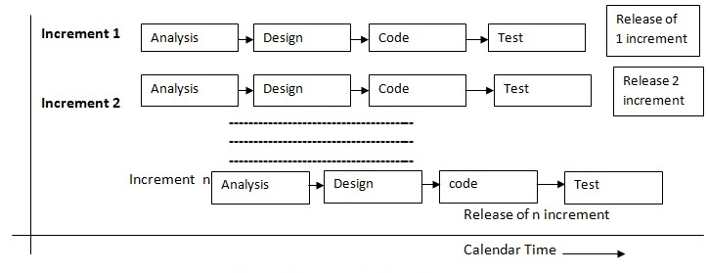

Figure 1: Incremental Model

### Analysis Phase

In this phase, analysis is performed in order to find out the requirements of the system. The outcome of this phase would be a SRS which is an acronym for “System Requirement Specifications”. Analysis of this proposed system was done. We analyzed that this proposed system is feasible in market. Customer requirements were gathered and analyzed and are hence incorporated in this system.

### Design Phase

In this phase, the SRS is translated into the system’s design. Flowchart, ER – Diagram, Use Case Diagram is developed. The proposed model is designed and is represented into the different system design.

### Coding Phase

In this phase, coding is done according to the design and a working system is developed by the end of this process. Coding is performed in JAVA platform called spring. HTML and CSS is performed in java framework for the user interface.JDBC with CRUD function is performed.

### Testing Phase

In this phase, the system will be tested. With each testing, a list of changes to the system developed is suggested and the changes will be applied to the software and the software would be delivered as a successive increment until a satisfying system is achieved.

The tools used for documentation, designing and developing UI testing are listed below in table 1.

## Collaborative Filtering Process

In a fundamental scenario, collaborative filtering (CF) processing can be mainly divided into three steps;

1. Collecting user ratings data matrix
2. Selecting similar neighbors by measuring the rating similarity and then
3. Generating prediction as seen in the following diagram.

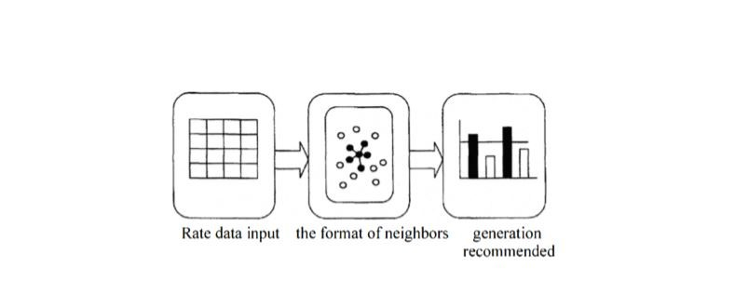

Figure : The Collaborative Filtering Process

Source: Y Lee, “RECOMMENDATION SYSTEM USING COLLABORATIVE FIL-

TERING at San Jose University. Master’s Project”, 2015

### User Rating Score Data Unit

Generally, input data in recommendation system based on the CF technology consists of user, item, and user opinions on observed items as a matrix m x n as shown in the following table. Symbol m symbolizes the total number of users and n symbolizes the total number of items. R(m,n) is the score of item in rated by user Um.

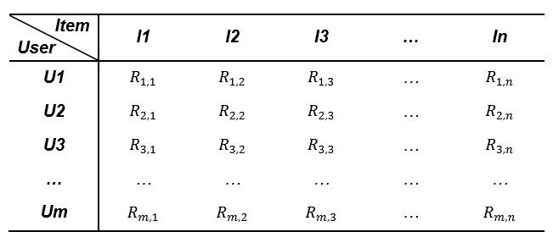

Figure : User Item-Rating Matrix

Source: Y Lee, “RECOMMENDATION SYSTEM USING COLLABORATIVE FIL-

TERING at San Jose University. Master’s Project”,2015

### The Formation of Neighbors

The CF approaches use statistical techniques to analyze the similarity between users and to form a set of users called neighbors. A set of similarity measures is a metric of relevance between two vectors. IBCF begins computing the similarity between co-rated items only as the value of two vectors. For example, as seen in [Figure 3.4], this item based similarity is calculated by looking into Item i and Item j rated by User 2, l, and n.

Each of these pairs are given by different users.

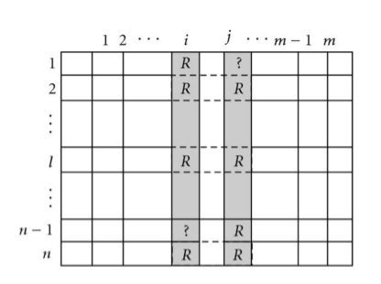

Figure : Item Based Similarity Computation

Source: Y Lee, “RECOMMENDATION SYSTEM USING COLLABORATIVE FIL-

TERING at San Jose University. Master’s Project”,2015

### Cosine Vector Similarity

Cosine vector similarity is one of the popular metrics in statistics. Since it notionally considers only the angle of two vectors without the magnitude, it is a very useful measurement with data missing preference information as long as it can count the number of times that term appears in the data. In the following formula, the cosine vector similarity looks into the angle between two vectors (the target Item i and the other Item j) of ratings in n-dimensional item space. R(k,i) is the rating of the target Item i by User k. R(k,j) is the rating of the other Item j by user k. n is the total number of all rating users to Item i and Item j.

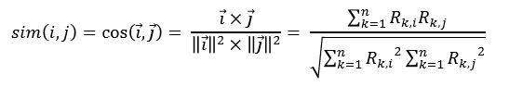

When the angle between two vectors is near 0 degree (they are in the same direction), Cosine similarity value, sim(i,j), is 1, meaning very similar. When the angle between two vectors is near 90 degree, sim(i,j) is 0, meaning irrelevant. When the angle between two vectors is near 180 degree (they are in the opposite direction), sim(i,j) is -1, meaning very dissimilar. In case of information retrieval using CF, sim(i,j) ranges from 0 to 1. This is because the angle between two term frequency vectors cannot be greater than 90 degrees

### Implementation of Collaborative Filtering process

Item based collaborative filtering is a model-based algorithm for recommender engines. In item based collaborative filtering similarities between items are calculated from rating-matrix. And based upon these similarities, user’s preference for an item not rated by him is calculated. Here is a step-by-step worked out example for four users and three items. Let’s consider the following sample data of preference of four users for three items:

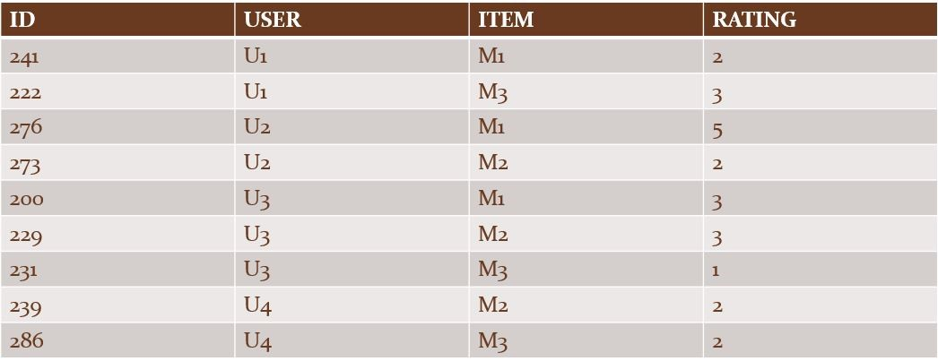

Table : Sample Data

Step 1: Writing the user-item ratings data in a matrix form. The above table gets rewritten as follows:

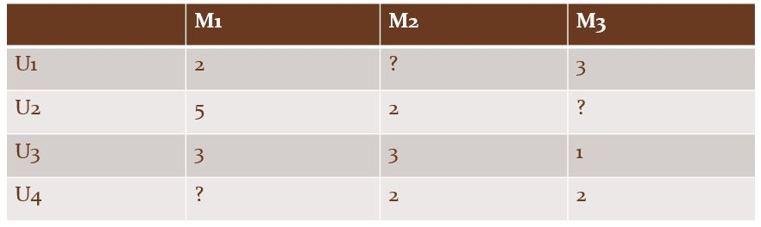

Table : User Item-Matrix

Here rating of user U1 for item M3 is 3. There is no rating for item M2 by user U1 and no user rating for item M3 by user U2.

Step 2: We now created an item-to-item similarity matrix. The idea is to calculate how similar an item is to another item. There are a number of ways of calculating this. We will use cosine similarity measure. To calculate similarity between items M1 and M2, for example, look at all those users who have rated both these items. In our case, both M1 and M2 have been rated by users U2 and U3. We created two item-vectors, V1 for item M1 and V2 for item M2, in the user-space of (U2,U3) and then find the cosine of angle between these vectors. A zero angle or overlapping vectors with cosine value of 1 means total similarity (or per user, across all items, there is same rating) and an angle of 90 degrees would mean cosine of 0 or no similarity. Thus, the two item-vectors would be,

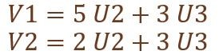

Using Cosine Similarity, we calculated how similar an item is to another item. We created two item-vectors, V1 for item M1 and V2 for item M2, in the user-space of (U2,U3) and then find the cosine of angle between these vectors.

The cosine similarity between the two vectors, V1 and V2, was calculated as:

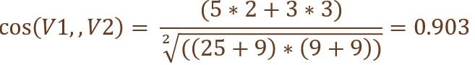

Similarly, cosine similarity measure between V2 and V3 was calculated to be 0.868 and between V1 and V3 be 0.78

Now the complete item-to-item similarity matrix was found to be: rewritten as follows:

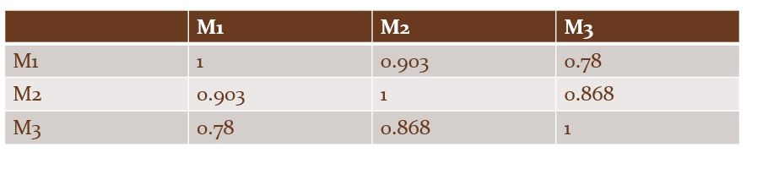Table : Item-Item Similarity Matrix

Step 3: For each user, we next predicted his ratings for items that he had not rated. We calculated rating for user U1 in the case of item M2 (target item). To calculate this, we just-calculated similarity-measure between the target item and other items that user has already rated. The weighing factor is the ratings given by the user to items already rated by him. Thus, the predicted rating for item M2 for user U1 would be calculated using similarity measures between (M2, M1) and (M2, M3) weighted by the respective ratings for M1 and M3:

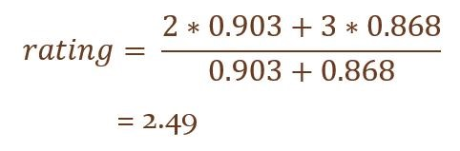

## System Design

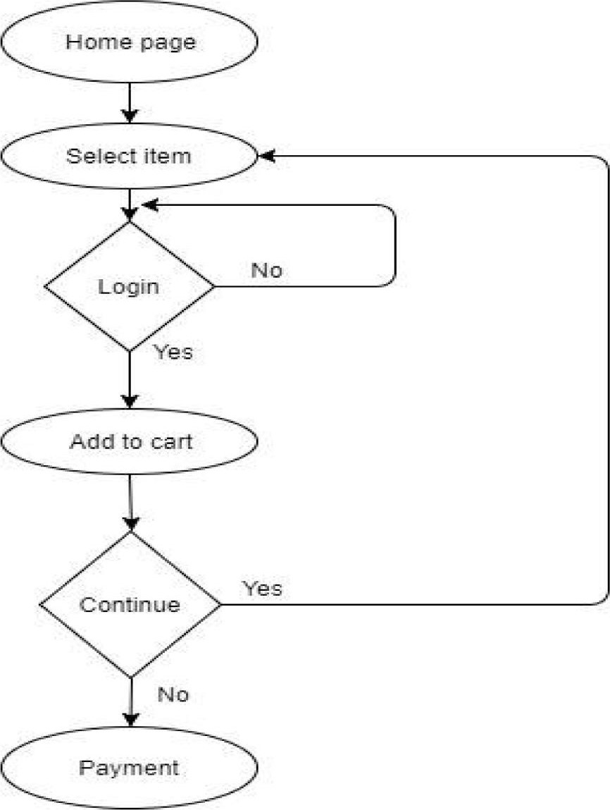

Figure 5: Flowchart User Perspective

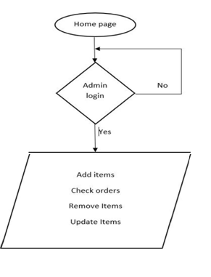

Figure 6: Flowchart Admin Perspective

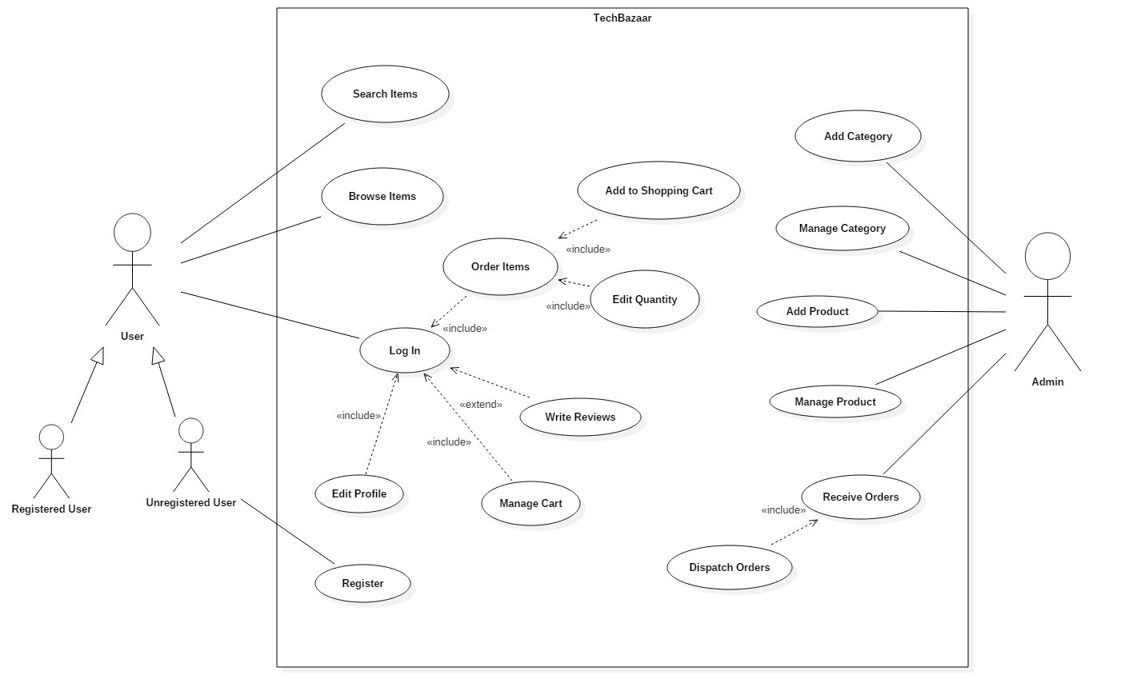

Figure 7: Use Case Diagram

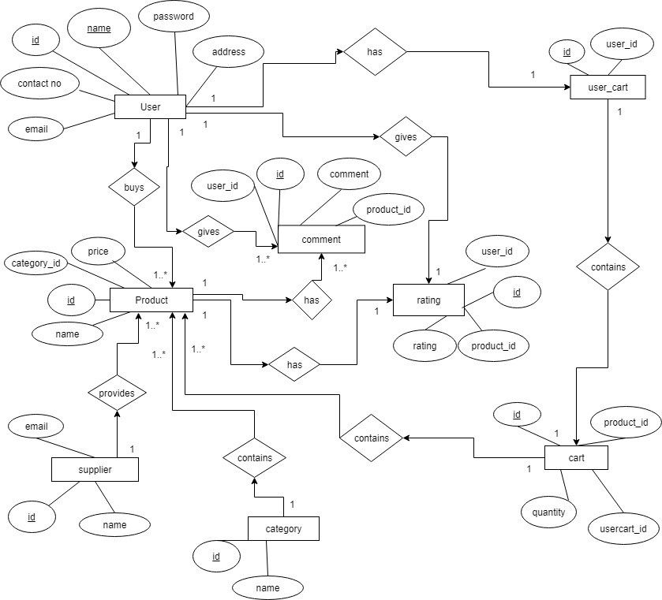

Figure 8: ER Diagram

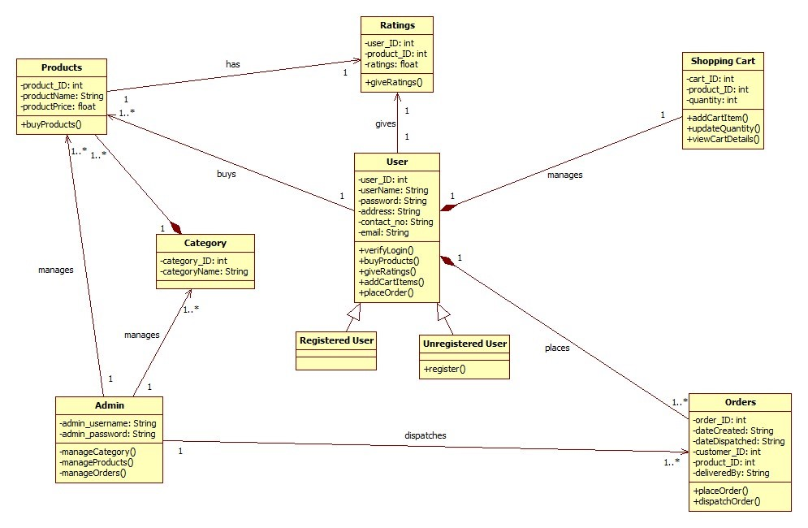

Figure : Class Diagram

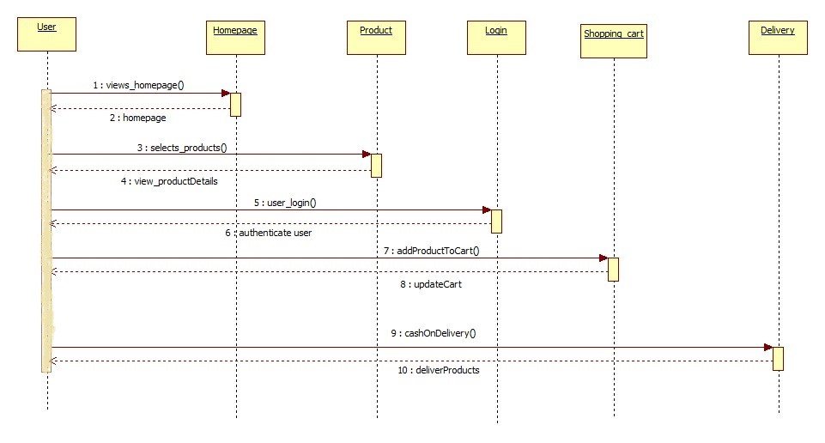

Figure : Sequence Diagram

## Tools Used

### Software Requirements

|  |  |  |
| --- | --- | --- |
| S.N | Purpose | Software/Platform |
| 1. | Operating System | Windows |
| 2. | User Interface | HTML,CSS |
| 3. | Client-side Scripting | JavaScript |
| 4. | Programming Language | Java |
| 5. | Web Applications | JDBC,Servlets,JSP |
| 6. | IDE/Workbench | Spring Tool Suite |
| 7. | Server Deployment | Tomcat |

Table : Software Requirements

### Hardware Requirements

* A fully functioning PC.

# Snapshots

## User Interface

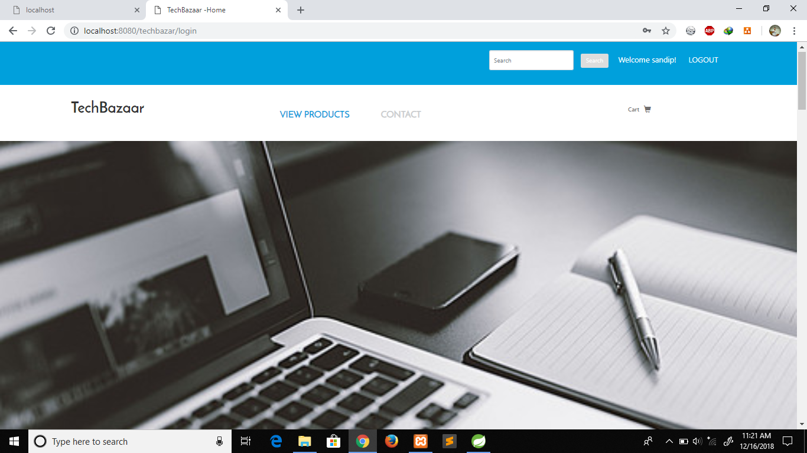

Figure 11: User Interface

The basic user interface of the system where the functions such as view products ,contact, login, sign up can be viewed.

## View Products

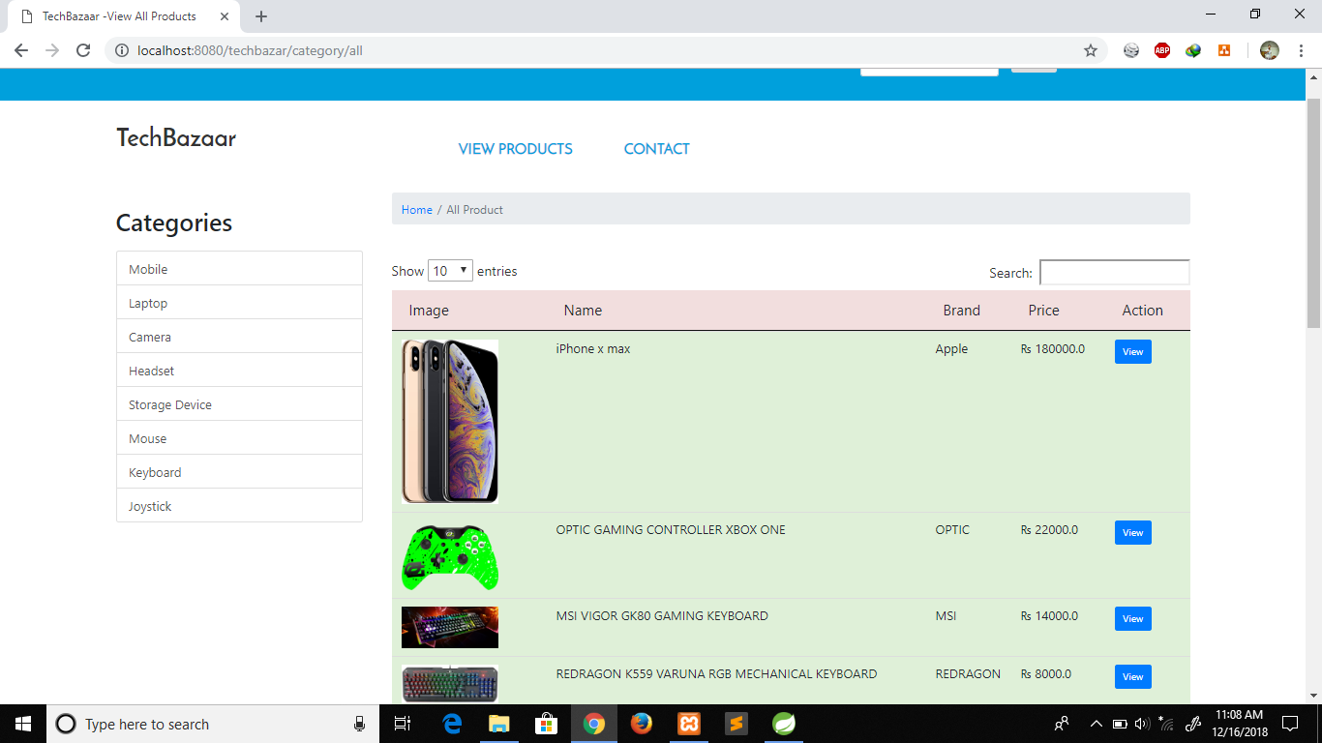

Figure 12: View products

The interface where user can view the products and the information regarding the products.

## Sign Up

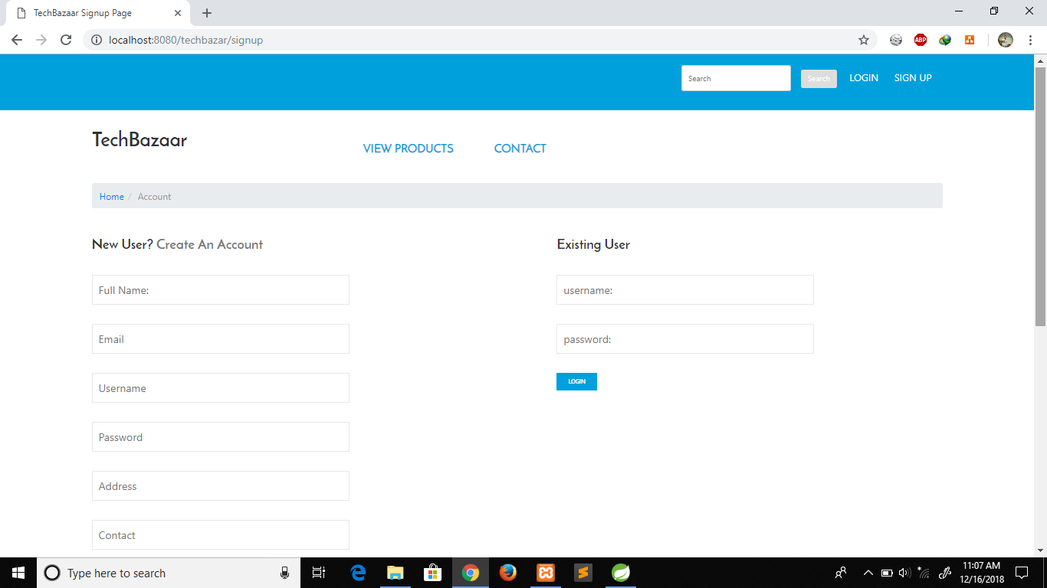

Figure 13: Sign Up Form

The interface where new user can sign up and existing user can sign in. For buying products user must log in.

## Login

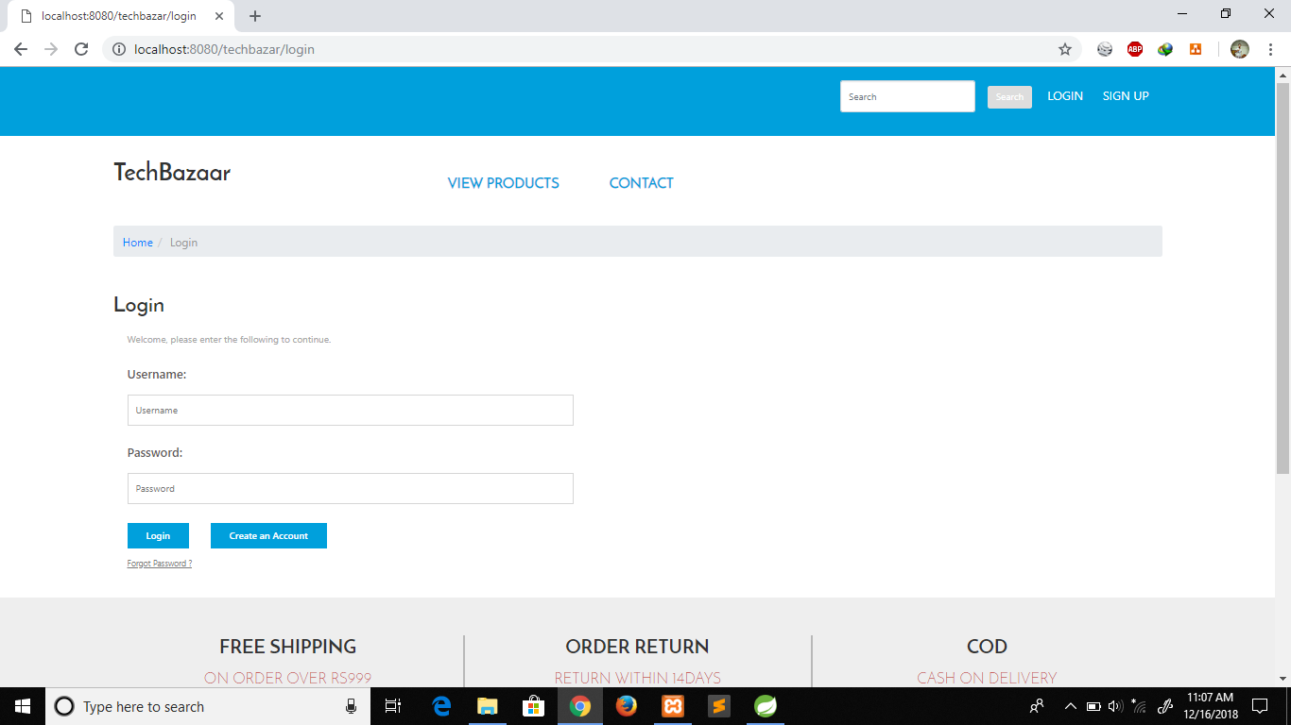

Figure 14: Log in Form

The interface where the existing user can log in to system. The users may be admin, staffs and the users recently registered.

## Admin Perspective

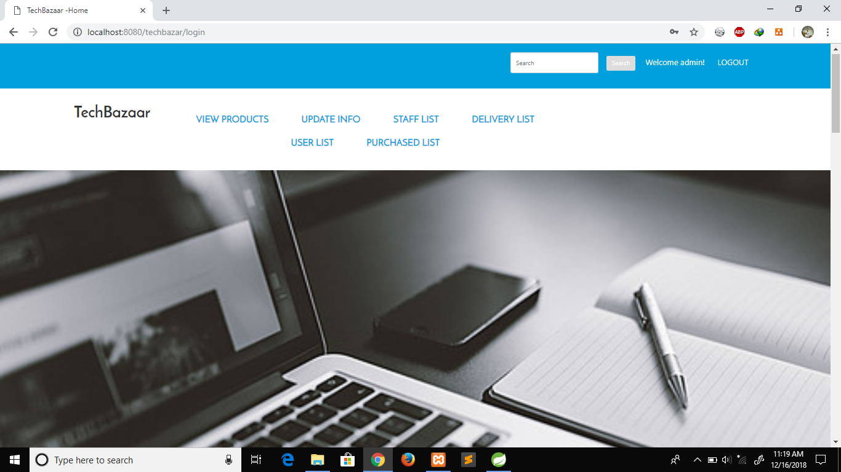

Figure 15: Admin Perspective

The interface of admin logon where viewing of products, updating the information, staff lists, delivery lists, existing user list and the purchased list can be viewed.

## Staffs Perspective

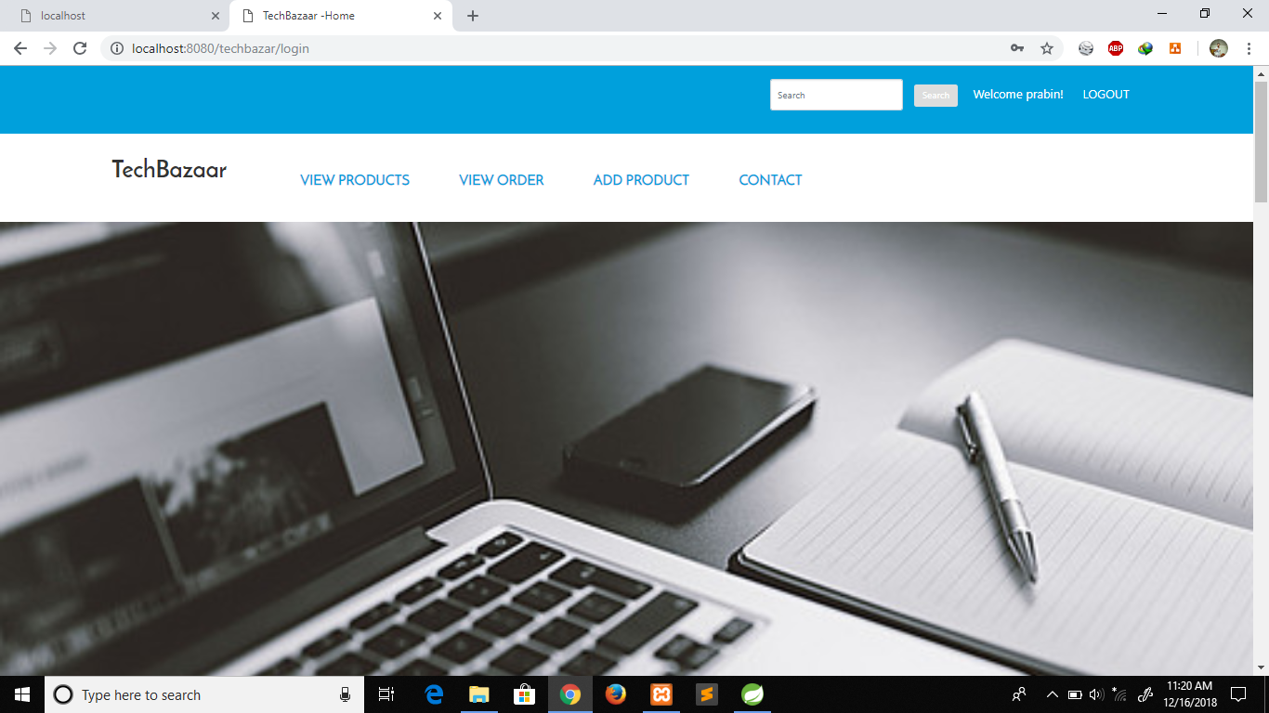

Figure 16: Staffs Perspective

The interface where staffs can view the products and the quantity available, view the order, add the new products.

## User Perspective

## user1.PNG

Figure 17: User Perspective

The registered user interface where the user can view the products. The user can add items to the shopping cart and view the shopping cart and the items kept on cart.

# Results and Discussion

## Output

“TechBazaar: An Online Shopping Store” is an online platform where different users can buy electronic items from anywhere they like via Internet. Here users can view products, add products to cart rate the products and leave comments about the products.

Spring Framework was used to create the project.

Item-Based Collaborative Filtering technique was used for Product Recommendation. Firstly, user ratings data matrix was created. Then similar were selected by measuring the rating similarity and finally prediction was generated using cosine vector similarity. For a user to place order to buy items, he/she must login to our website. After login is approved, they can place order by adding the items to their personal shopping cart. When the user places an order, the admin is notified and then the admin dispatches the order to a delivery person. The delivery person’s location is continuously tracked with GPS. The user can view the location of the assigned delivery person who is delivering their product.

## Problem Faced

Different problem occurred in different stages while we were working on our project.

The problems we faced are listed below:

* Data was not sufficiently available so dummy data was needed to be used.
* Creating appropriate database schema.
* Cold Start Problem
* Sparsity

## Limitation

There are some limitations in our project. They are as follows:

* No facility of Online Payment
* Recommendation is only based on user’s ratings.

# Conclusion and Further Enhancement

## Conclusion

The evolution of internet has affected all parts of life drastically. Also the field of shopping has not remained untouched. Technology has made significant progress over the years to provide consumers a better online shopping experience and will continue to do so for years to come. With the rapid growth of products and brands, people have speculated that online shopping will overtake in-store shopping. While this has been the case in some areas, there is still demand for brick and mortar stores in market areas where the consumer feels more comfortable seeing and touching the product being bought. However, the availability of online shopping has produced a more educated consumer that can shop around with relative ease without having to spend a large amount of time. In exchange, online shopping has opened up doors to many small retailers that would never be in business if they had to incur the high cost of owning a store.

Our projects “TechBazaar” is a small attempt to create an online platform where users can buy electronics items from anywhere through internet connection. Creating an online platform was success but it has its limitations. Nevertheless, it has been a huge learning experience doing this project. Also, this project would not have been possible without the hard work and utmost dedication from all the project members, and the guidance from our supervisor.

## Future Enhancement

It is not possible to develop a system that makes all the requirements of the user. User requirement keep changing as the system is being used. Some of the future enhancements that can be done to this project are:

* Addition of Online Payment service.
* Recommendation based on purchase history, viewed items, user behavior.
* Delivery Application (Android).
* Addition of Notification Feature.

# Project Task

## Schedule and Work Breakdown

|  |  |
| --- | --- |
| Task | People |
| Requirement analysis and specification | Prabin,Sandip |
| Undertake analysis of system | Prabin |
| Design system | Prabin, Sandip |
| Coding | Prabin |
| Testing and debugging | Prabin |
| Test system model | Sandip |
| Overall system test | Sandip |
| Documentation | Prabin, Sandip |

Table 5: Work Breakdown Schedule

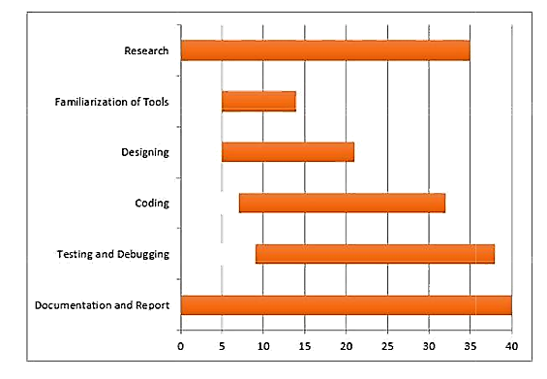

Figure : Gantt Chart

# References

1. G. Lee and H. Lin, "Customer perceptions of eservice quality in online shopping," International Journal of Retail & Distribution Management, vol. 33, no. 2, pp.

161—176, 2005.

1. M. J. Zuroni and H. L. Goh, "Factors Influencing Consumers' Attitude Towards E-Commerce Purchases Through Online Shopping," International Journal of Humanities and Social Science, vol. 2, no. 4, pp. 223—230, 2012.
2. Q. Hu, X. Wu, and C. K. Wang, "Lessons from Alibaba.com: government's role in electronic contracting," Info, vol. 6, no. 5, pp. 298—307, 2004.
3. Yue Li ; Nan Zheng ; Haining Wang ; Kun Sun ; Hui Fang, "A measurement study on Amazon wishlist and its privacy exposure," 2017 IEEE International Conference on Communications (ICC), pp. 1-5, 2017.
4. Gurneet Kaur, AbhinashSingla, "Sentimental Analysis of Flipkart reviews using Naïve Bayes and Decision Tree algorithm," International Journal of Advanced Research in Computer Engineering & Technology (IJARCET),vol 2, no. 5, pp. 1-6, 2016