A Major Project Final Report on

**VOODOO CHAT – ANIMATED ANDROID CHAT APPLICATION**

Submitted in Partial Fulfillment of the Requirements for

the Degree of **Bachelors of Engineering in Software and IT Engineering**

under **Pokhara University**

Submitted by:

**Anika Shrestha, 14702**

**Newana Tandukar, 14717**

**Prakriti Bhattarai, 14721**

**Pushpa Khanal, 14471**

Date:

**12/07/2018**



Department of Software and IT

**NEPAL COLLEGE OF**

**INFORMATION TECHNOLOGY**

Balkumari, Lalitpur, Nepal

# ACKNOWLEDGEMENT

We would like to express our gratitude towards all those people who guided for preparing this project, which was a great learning process for us. We have been provided with lots of support and suggestions by many people in the process of completing this project work.

We are heartily indebted to Assistant Prof. Dr. Roshan Chitrakar and our supervisor, Er. Nipesh Shrestha who have guided us for the project and gave up valuable suggestion and encouragement. Once again, we would like to thank all those people who gave their valuable support by helping us in this project which is a great learning experience. However, it would not have been possible without the kind support and help of many individuals. We would like to extend my sincere thanks to all of them. We would also like to extend my sincere thanks to all respected teachers and staffs at the department.

# ABSTRACT

Nowadays, the concept of using bots on every field is growing significantly. “**Voodoo Chat”** is an interactive conversational agent. This software program is designed for an intelligent conversation. This simulation program takes user input in voice format. For this purpose, many open source platforms are available; one of which is AIML. Artificial Intelligence Markup Language (AIML) is derived from Extensible Markup Language (XML) and is used to build up a conversational agent artificially. Here, we will be using “Program o”. Program o is an AIML interpreter for the generation of the responses of users input. This method will be used to develop an android application bot which will interact with user using voice responses.

**“Voodoo Chat”** contains an animated bot for user interaction. The animated bot will be developed using Blender. Blender is a 3D-creation suite and supports the entirety of 3D pipeline- modeling, animation, simulation, etc. The animated object, thus created will be used in our Android application to depict simulated emotions. Moreover, Blender uses OpenGL to provide a consistent experience.

***Keywords*:** *Voodoo, Chatbot, Android Chatbot, AIML, 3D Animation, 3D Bot*

TABLE OF C ONTENTS

ACKNOWLEDGEMENT ………………...……………………………………………………...i

ABSTRACT………………………………………………………………………………………ii

1 INTRODUCTION 1

2 PROBLEM STATEMENT 2

2.1 OBJECTIVES 2

2.2 SCOPE OF THE PROJECT 2

2.3 LIMITATIONS 2

2.4 SIGNIFICANCE OF THE STUDY 3

2.5 APPLICATION 3

2.6 CHALLENGES 3

3 LITERATURE STUDY 4

3.1 EXISTING SYSTEM 4

4 PROPOSED METHODOLOGY 5

4.1 SOFTWARE DEVELOPMENT PROCESS 5

5 REQUIREMENT ANALYSIS 7

5.1 Hardware  Requirement: 7

5.2 Software Requirement: 7

5.3 Functional Requirement: 7

5.4 Non-functional requirement: 7

5.5 Reason for using this hardware and software 7

6 TOOLS AND TECHNOLOGIES 8

6.1 SYSTEM DESIGN 9

i. Block Diagram 9

ii. Sequence Diagram 10

iii. Use Case diagram 11

iv. DFD Diagrams 12

v. Activity Diagram 13

7 IMPLEMENTATION 14

7.1 Algorithms Used: 14

7.2 PROPOSED PROJECT TASK AND TIME SCHEDULE 18

8 DELIVERABLES 19

9 CONCLUSION AND FUTUREWORK 20

9.1 Conclusion: 20

9.2 Future Scope: 20

10 REFERENCES 21

**LIST OF FIGURES**

Figure 1Incremental Model 6

Figure 2 Block Diagram 9

Figure 3Sequence Diagram 10

Figure 4 Use Case Diagram 11

Figure 5 DFD Level 0 12

Figure 6 DFD Level 1 12

Figure 7 Activity Diagram 13

# INTRODUCTION

Over the last few years, interactive bots have played a prominent role as human-computer chat interfaces. These bots are generally composed of three modules: the user interface, an interpreter, and a knowledge base. The interactive bot is a program that attempts to simulate conversation, with the aim of temporarily fooling human into thinking they are talking to another person. Basically, the bot is a conversational agent that interacts with user in a given subject using natural language.

The bots that have been deployed on the internet uses text, voice as well as sentiments as the input. Here, we have used the voice as user input. Text I/O is relatively effective as user can review for the input so that it can be rechecked if there are any mistakes. However, giving text input consumes time. So, the solution is to introducing voice interface with the speech recognition technology. By these methods, this bot application is very able to make conversation with the user.

# PROBLEM STATEMENT

Since the past few years, interactive bots are hyped. However, looking at the available bots there are very few bots that provide an entertaining user interface. And when it comes to chatting, people prefer

## OBJECTIVES

The general objective of our project is to develop an interactive conversational bot for an android application working to perform the following tasks:

* Create virtual companion for users with disorders like anxiety, depression, etc.
* Provide a fun interface to chat with
* Remove the need to physically interact with devices
* Provide immediate verbal feedback
* Remove the need to physically interact with devices

## SCOPE OF THE PROJECT

The intention for developing this project is to change the traditional way of bots with a simple chat UI. The purpose of this project is to

* Provide a virtual friend for people.
* Help give positive feedbacks
* Integrate some kinds of symbolic expressions (e.g. sad, happy, etc.) in animated bot

The project is developed as an android application, and it will work for as a virtual companion for people who have trouble reaching out. This project uses sentiment based – opinion analysis through facial recognition, which helps the bot to initiate the conversation with the user.

## LIMITATIONS

Although this product has various advantages but also have some limitations. Here, once the product has been fully developed, we may encounter various problems.  The system may not exactly give accurate response as required by the user. The leading causes for this problem are:

* Lack of adequate AIML files covering the wide chat scenario.
* The system may not able to accurately identify the emotional state of the user as conflicts between voice patterns and facial expressions may arise.
* The system may fail to interact with multiple voice input simultaneously.

## SIGNIFICANCE OF THE STUDY

* First and foremost, the system reduces the need of having to physically interact with mobile devices for an interactive session
* This system also eliminates the traditional way of viewing chatbots as a plain interface with introduction of an unconventional character.
* All-Text-No-Voice chatbots are quite mechanical. They require patience, time and voiceless understanding of the matter under discussion. There are still efficient chat robot services functioning on a good conventional far of text-based interface; however human conversations need a substantial voice support.
* Voice Interactive Chatbots provides a satisfactory and real experience such that you might think as if you’re having a conversation with a friend. Such solution is enriched with a voice that eliminates the usual feeling of talking to just a machine.

Besides, the project is important basically for designing based learning packages. And also, for implementing flow of knowledge of Artificial Intelligence and Pattern Recognition. The relevancies of the project multiply if any further modifications is done and the extravagant software development cycle with graphical properties could have its  presence in today’s software market.

## APPLICATION

Our application can be implemented to provide an interactive chat interface for people with mental disorders. Since, it is very difficult to share their emotions with people, our chat application can be of some help to people facing such challenges.

## CHALLENGES

Use of an animated chatbot with voice interaction rather than a text based chatbot is just too much of hassle. More than that, compared to GUI, much more problems arise while having a conversation based user interface. Some of the challenges that arise are:

* The voice chatbot requires voice messages to be saved, as well as rendering of the blender animation. Thus, large memory is required
* Moreover, blender animation is very difficult to import in android device as there may arise rendering problems due to incompatibility.

# LITERATURE STUDY

**Voodoo Chat** is an intelligent system when becomes aware of the user’s needs. Its knowledge is what gives the chatbot ability to handle various types of scenarios, relating to a conversation with utmost ease. It could be a wonderfully designed conversation built interface, which is smooth and easy to use. It could also be a natural language processing scheme to understand the meaning of the sentences, even when it is structured in a wrong way. We could use sentiment based - opinion analysis, to identify and determine if the interactions are positive or negative.

As Artificial Intelligence is taking a larger and larger role, it is mainly about having a visible foresight into things and experience to program our software to understand them. For interactive bots to actually be effective in user communications, they need to be designed with the bent of mind as that of a genuine humane experience with authentic brand voice. That proves that we are still in the early days of some general AI principles that is able to communicate freely.  .

## EXISTING SYSTEM

* **Mitsuku**: Mitsuku is one of the best AI chatbots around. It was considered by the judges of the all famous Turing competition to be the most human alike. You can basically talk with Mitsuku for hours and hours without even getting bored. It replies to all of your questions in the most human way and automatically tries to get your mood with the language you use with it.
* **Right** **Click**: It is a startup that introduced an artificially intelligent chatbot that is extremely powerful, that creates automatic auto-websites. It asks the user general questions during the conversation like “What industry do you belong to?” and “Why do you want to make this version of a website?” and creates customized templates as per the given answers. By replying to each of its queries and questions, the actual job of website creation is done in very limited time by it. This process is short but keeps the user engaged.
* **Melody**- **By** **Baidu**: This one lives inside the existing Baidu Doctor application. This application collects the medical information from people, and then passes it onto doctors in a form like application that makes it easier to use for diagnostic purposes, or to otherwise give responses to.
* **Microsoft’s** **Tay**: The poll that was conducted by Microsoft was run on twitter and also on its website, which showed us that the chatbot are easy to train. But not exactly in a sense truly that, it is easy to train them exactly as per the needs properly. [4]

# PROPOSED METHODOLOGY

## SOFTWARE DEVELOPMENT PROCESS

The framework we propose in development of this software is “incremental model”, i.e. a method for software development where the product is designed, implemented, and tested incrementally. This model combines the elements of waterfall model with iterative philosophy of prototyping i.e. multiple development cycles take place here, making the life cycle a multi-waterfall cycle. In Incremental model the whole requirement is divided into various builds.

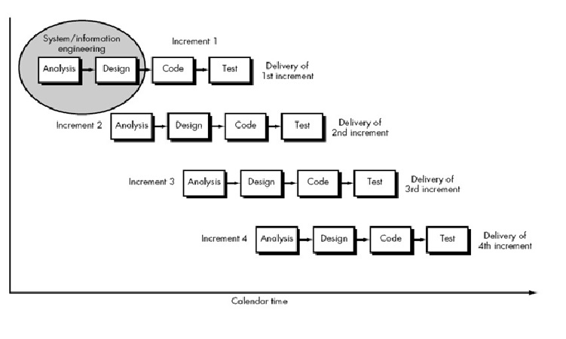

Figure 1Incremental Model

**1st Increment:** We developed a face detection module in the first increment. Here, we discussed, finalized and implemented how the face detection API is to be used and what emotions are to be rendered.

**2nd Increment:** On the second increment, we analyzed what our bot should look like. Also, we designed the module accordingly using Blender. On this increment, the development of our animated character was initiated.

**3rd Increment:** The 3rd increment is about creating the AIML patterns for the chatbot. Here, we apply the conversational patterns and develop the AIML files for the pattern recognition purpose. Also, along with-it basic user interface patterns will be added to the application. Also, the voice to speech and speech to voice translation for the patterns will be done.

**4th Increment:** Finally, on the fourth increment, the design is to be implemented and also, the integration of all the modules is to be done to deliver a final working application.

# REQUIREMENT ANALYSIS

## Hardware  Requirement:

* Pentium-IV (Processor) (also can be used in x64-based processor).
* Camera access for face detection
* Microphone/Speakers for voice input-output
* Android Smartphone to test the output of an application

## Software Requirement:

* Windows and linux based operating system for coding and testing
* Blender
* Android Studio
* GenyMotion
* Git for management of source code
* Star UML

## Functional Requirement:

* Chat Interface
* AIML files for patterns

## Non-functional requirement:

* **Performance Requirements :** The system performance is accurate and fast enough for users to interact .

## Reason for using this hardware and software

* **Android Studio :** The software is compatible with most operating system.
* **Blender :** The 3D animation is easier using blender
* **AIML :** Easier for pattern recognization

# TOOLS AND TECHNOLOGIES

To realize project successfully, it is necessary to select the right tools and technologies. Designs should be made with the end-configuration in mind. Which tools and applications can be used to build the applications/analytics stack and how to make the environment scalable enough for the final configuration? Tools and Technologies that will be used in this project are:

|  |  |
| --- | --- |
| TOOLS | PURPOSE |
| Android Studio | Official IDE for Android App Deelopment |
| GenyMotion | Emulator for Android Studio |
| Git | Manage Source Code |
| Blender | Create 3D Animation |
| Storage | Store AIML files |
| Android Smartphones | Test Software Application |

## SYSTEM DESIGN

We proposed the system that can provide virtual companion to people who has trouble reaching out in real world scenarios. The main aim of our project is to provide an interactive system with an animated UI for people to interact without having to physically input data to the system.

### Block Diagram

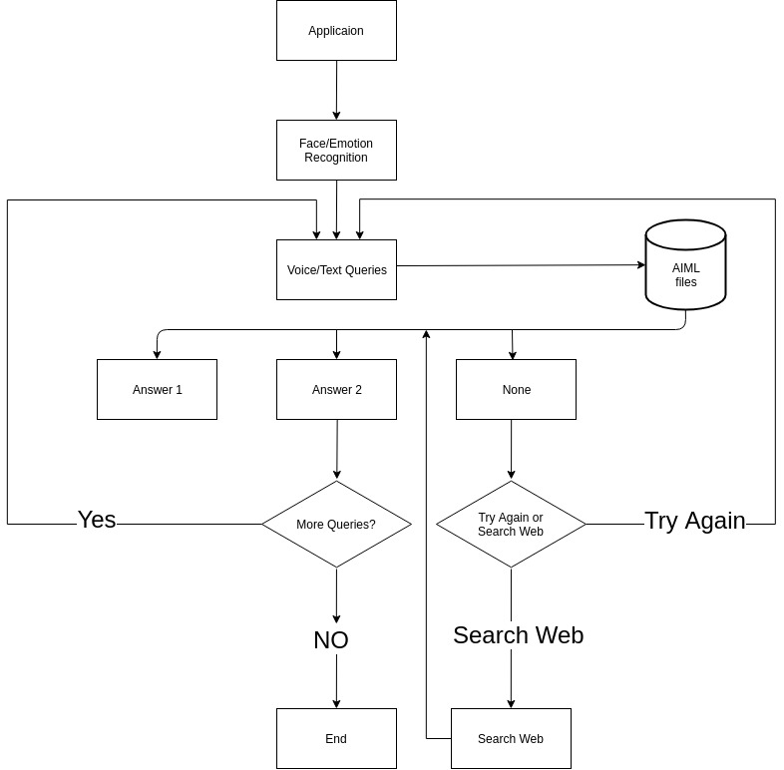

Figure 2 Block Diagram

### Sequence Diagram

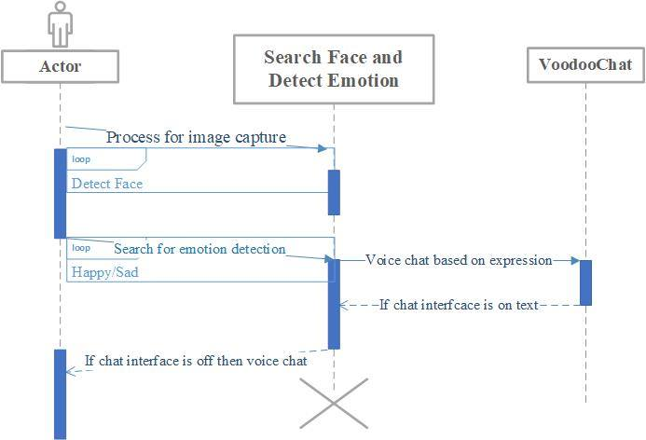

Figure 3Sequence Diagram

### Use Case diagram

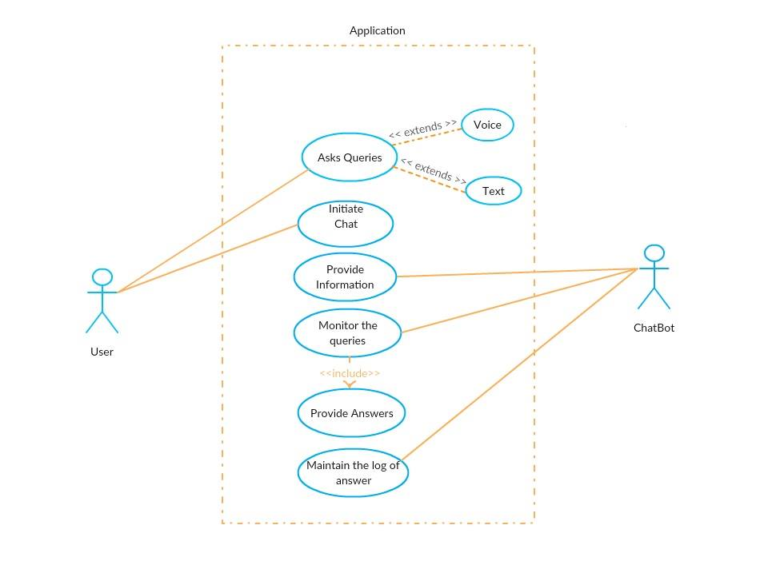

Figure 4 Use Case Diagram

### DFD Diagrams

#### DFD Level 0

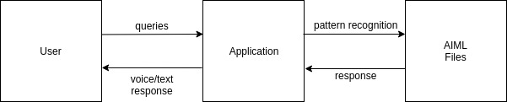

Figure 5 DFD Level 0

#### DFD Level 1

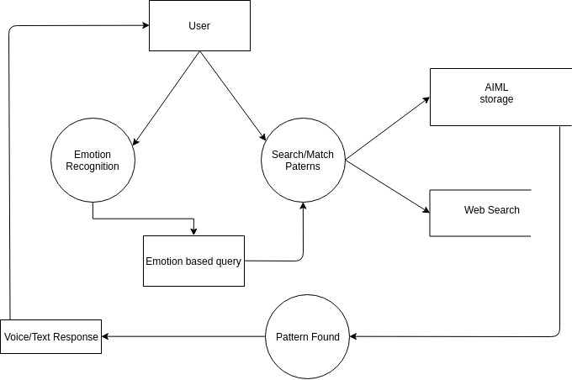

Figure 6 DFD Level 1

### Activity Diagram

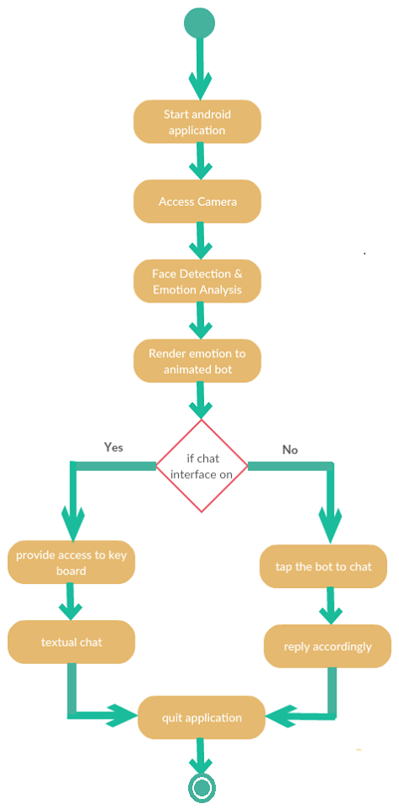

Figure Activity Diagram

# IMPLEMENTATION

## Algorithms Used:

1. **Face Detection:**

* **Knowledge-based methods**

They try to capture our knowledge of faces, and translate them into a set of rules. It’s easy to guess some simple rules. For example, a face usually has two symmetric eyes, and the eye area is darker than the cheeks. Facial features could be the distance between eyes or the color intensity difference between the eye area and the lower zone. The big problem with these methods is the difficulty in building an appropriate set of rules. There could be many false positives if the rules were too general. On the other hand, there could be many false negatives if the rules were too detailed. A solution is to build hierarchical knowledge-based methods to overcome these problems. However, this approach alone is very limited. It’s unable to find many faces in a complex image. Firstly, it tries to find eye-analogue pixels, so it removes unwanted pixels from the image. After performing the Face detection 13 segmentation process, they consider each eye-analogue segment as a candidate of one of the eyes. Then, a set of rule is executed to determinate the potential pair of eyes. Once the eyes are selected, the algorithms calculates the face area as a rectangle. The four vertexes of the face are determined by a set of functions. So, the potential faces are normalized to a fixed size and orientation. Then, the face regions are verificated using a back propagation neural network. Finally, they apply a cost function to make the final selection. They report a success rate of 94%, even in photographs with many faces. These methods show themselves efficient with simple inputs. But, what happens if a man is wearing glasses? There are other features that can deal with that problem. For example, there are algorithms that detect face-like textures or the color of human skin. It is very important to choose the best color model to detect faces. Some recent researches use more than one color model.

For example,

RGB and HSV are used together successfully [112].

In that paper, the authors chose the following parameters

0.4 ≤ r ≤ 0.6, 0.22 ≤ g ≤ 0.33, r > g > (1 − r)/2 …..(1.1)

0 ≤ H ≤ 0.2, 0.3 ≤ S ≤ 0.7, 0.22 ≤ V ≤ 0.8… (1.2)

Both conditions are used to detect skin color pixels. However, these methods alone are usually not enough to build a good face detection algorithm. Skin color can vary significantly if light conditions change. Therefore, skin color detection is used in combination with other methods, like local symmetry or structure and geometry but using knowledge based methods we can detect the landmarks and human facial structure with the probability.

**Probability:**

Some classifiers are build based on a probabilistic approach. Bayes decision rule is often used. The rule can be modified to take into account different factors that could lead to miss-classification. Bayesian decision rules can give an optimal classifier, and the Bayes error can be the best criterion to evaluate features. Therefore, a posteriori probability functions can be optimal. There are different Bayesian approaches. One is to define a Maximum A Posteriori (MAP) decision rule [66]:

p(Z|wi)P(wi) = max {p(Z|wj)P(wj )} Z ∈ wi (1.3)

where wi are the face classes and Z an image in a reduced PCA space. Then, the within class densities (probability density functions) must be modeled, which is

p(Z|wi) = 1 (2π) m 2 |Σi | 1 2 exp ( − 1 2 (Z − Mi) t X−1 i (Z − Mi) ) (1.4)

where Σi and Mi are the covariance and mean matrices of class wi . The covariance matrices are identical and diagonal, getting the components by sample variance in the PCA subspace. Other option is to get the within class covariance matrix by diagonalizing the within class scatter matrix using singular value decomposition (SVD). There are other approaches to Bayesian classifiers. Moghaddam et al. proposed on [78] an alternative to the MAP - the maximum likelihood (ML). They proposed a non-euclidean measure similarity measure, and two classes of facial image variations: Differences between images from the same individual (ΩI , interpersonal) and variations between different individuals (ΩE).

1. **Chatbot:**

Here, we’ve used AIML for our bot, which uses pattern matching to classify the text and produce a suitable response for the customers. Example:

<aiml version = "1.0.1" encoding = "UTF-8"?>  
 <category> <pattern> WHO IS ALBERT EINSTEIN </pattern>  
 <template>Albert Einstein was a German physicist. </template></category>  
 <category> <pattern>DO YOU KNOW WHO * IS</pattern>  
 <template>  
 <srai>WHO IS <star/></srai>  
 </template> </category>  
</aiml>

The machine then produces:

Human: Do you know who Albert Einstein is  
Robot: Albert Einstein was a German physicist.

Also, as for the text classification, an algorithm called “Multinomial Naïve Bayes” is used.

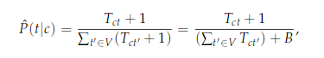

Here, this algorithm is chosen because each given set of sentences belonging to a class, and a new input sentence, we can count the occurrence of each word in each class, account for its commonality and assign each class a score. The class with the highest score is the one most likely to belong to the input sentence.

## PROPOSED PROJECT TASK AND TIME SCHEDULE

The time schedule has been designed as per the requirements. This project is scheduled to be completed in about two and half months. Requirement analysis has been given more emphasis. System Design is to be done first. Testing and Debugging is to be done along with the development of the project. Finally, documentation is done throughout the project.

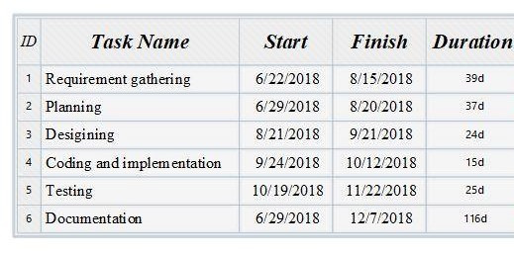

Figure: Showing planned duration for tasks

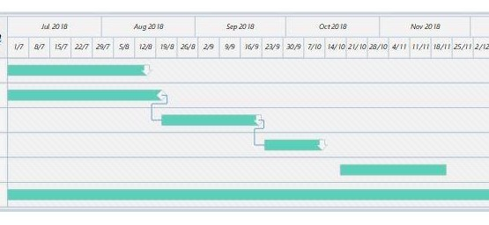

Figure: showing Gantt chart

# DELIVERABLES

The completion of our project allows the users to interact with the animated bot givin the traditional bots a unique approach. The project can deliver following:

* The virtual animated bots recognize the person’s emotions
* Help to overcome some sort of negative impacts that arise due to depression, anxiety, etc.
* Give positive feedbacks and responses while interaction
* Provide information about available doctors and medical help

Furthermore, the Android application creates an interactive environment for users, through the app can start expressing his/her feelings to the animated character in our app. However, this program is just an alternative approach for times when the users have a hard time reaching out to actual people around.

# CONCLUSION AND FUTUREWORK

## Conclusion:

Chatbots have the benefit that it can quite easily be used in any industry. Unlike other products where you have to do a lot of development and testing to change platforms, chatbots are relatively easy to switch. One has to just train the bot by giving the right conversation structure and flow to switch its current field or industry. Humans are bound to change of emotions. Chatbots, on the other hand, are bound by some rules and obey them as long as they’re programmed to. They will always treat a user in the perfect way no matter how rough the person is or how foul language the person uses. If implemented , this application will indeed contribute to welfare of any user that wants to interact with the system when they are feeling low.

## Future Scope:

This application cannot only be used by the people with with mental disorders but also be a fun and interacting tool in fields such as customer service. Also with the application of artificial intelligence and required neuron networks the application can revolutionize the traditional chat bots present today.

# REFERENCES

1. *https://en.wikipedia.org/wiki/Artificial_intelligence* [30-06-2018]
2. *https://www.pandorabots.com/docs/aiml/aiml-basics.html* [02-07-2018]
3. *https://en.wikipedia.org/wiki/Machine_learning* [29-06-2018]
4. Philip C. Jackson Jr, *“Introduction to Artificial Intelligence”* [June 2018]
5. [*https://en.wikipedia.org/wiki/Knowledge-based_systems*](https://en.wikipedia.org/wiki/Knowledge-based_systems) [October, 2018]
6. Oisin Muldowney, *“Chatbots: An Introduction And Easy Guide To Making Your Own”*
7. AIML BASED CHATBOT, International Journal of Emerging Trends in Engineering and Basic Sciences (IJEEBS) ISSN (Online) 2349-6967 [30-06-2018]
8. A General Summary of ChatBot – Public APIs [01-07-2018]