A Major Project Final Report on

**WILI (Wireless Lightings)**

Submitted in Partial Fulfillment of the Requirements for

The Degree of **BACHELOR OF ENGINEERING IN COMPUTER ENGINEERING**

Under Pokhara University

Submitted by:

**Pranav Joshi, 14349**

**Bijay Gurung, 14348**

**Shikshan Pathak,14347**

**Email: pranav.joshi44@gmail.com**

Under the supervision of

**Er. Shiva Hari Acharya**

Date:  
16th december 2018

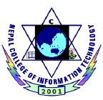

Department of Computer Engineering

**NEPAL COLLEGE OF**

**INFORMATION TECHNOLOGY**

Balkumari, Lalitpur, Nepal

Contents

ACKNOWLEDGEMENT iii

ABSTRACT iv

LIST OF FIGURES v

LIST OF TABLES vi

1 INTRODUCTION 1

2 LITERATURE REVIEW 5

2.3 Historical background 5

2.2 Review of related literatures 5

2.3 Review of existing systems 6

3 FEASIBILITY STUDY 7

3.1 FINANCIAL FEASIBILITY 7

3.2 TECHNICAL FEASIBILITY 7

4 RELATED THEORY 8

4.1 TECHNICAL DETAILS 8

4.1.1 Arduino Microcontroller 8

4.1.2 Dot net framework 9

4.1.3 Microsoft Visual Studio 10

5 PROJECT METHODOLOGY 11

5.1 BLOCK DIAGRAM OF PROPOSED SYSTEM 11

5.2 WATERFALL MODEL 12

5.3 WORKFLOW DIAGRAM FOR DESKTOP APP 13

5.4 WORKFLOW FOR MICROCONTROLLER 14

5.5 CIRCUIT DIAGRAM 15

5.6 SEQUENCE DIAGRAM 16

5.7 USECASE DIAGRAM 17

5.8 ACTIVITY DIAGRAM 18

5.9 CLASS DIAGRAM 19

6 IMPLEMENTATION PLAN 20

6.1 SCHDEULE (GANTT CHART) 20

6.2 HARDWARE AND SOFTWARE REQUIREMENTS 21

6.2.1 SOFTWARE 21

6.2.2 HARDWARE 21

7 EXPECTED OUTCOMES 22

8 PROPOSED DELIVERABLES 23

9 TASK DONE SO FAR 24

10 RESULTS AND DISCUSSION 25

11 Limitations and Future Works 26

11.1 Limitations: 26

11.2 Future Enhancements: 26

12 REFERENCES 27

# ACKNOWLEDGEMENT

We would like to thank Er. Shivahari Acharya, our project coordinator, for his valuable guidance and constant support and supervision in our project as well as providing necessary information regarding the project. We are equally grateful to our friends of Nepal College of Information and technology for their help for making this report. We would like to express our special thanks of gratitude to Dr. Roshan Chitrakar , professor of Nepal college of information and technology for his support, suggestions and encouragement for doing this project.

Finally, we would also appreciate suggestions for the further improvement in our project.

# ABSTRACT

Including a framework showing how to apply Internet technology progressively as skills and confidence grow, the project demonstrates the route from adapting materials to developing an online environment.While the cost of living is going up, there is a growing focus to involve technology to lower those prices. With this in mind the Smart office project allows the user to build and maintain a office that is smart enough to keep energy levels down while providing more automated applications. A smart office will take advantage of its environment and allow seamless control whether the user is present or away. With a office that has this advantage, you can know that your office is performing at its best in energy performance**.** It is quite difficult for individual office owners to operate one or more that one office and keep track of each office appliances individually. At such time we need an online solution for physical office appliances control. Here we propose use of technology for office appliance automation. This allows owner to control his/her office appliances through the internet using an easy to use GUI.  For this system demonstration our system uses an Arduino microcontroller for the purpose. Thus office automation system allows user to control his office remotely. This project is used for controlling office electrical appliances in order to make process easier and more comfort. Through this project we hope that the individual can control all the office appliances and saves the time of officer.

Keywords: Arduino microcontroller, GUI.

# LIST OF FIGURES

FIGURE 1: BLOCK DIAGRAM OF PROPOSED SYSTEM

FIGURE 2: WATERFALL MODEL

FIGURE 3: WORKFLOW DIAGRAM FOR DESKTOP APP

FIGURE 4: WORKFLOW DIAGRAM FOR MICROCONTROLLER

FIGURE 5: CIRCUIT DIAGRAM

FIGURE 6: USE CASE DIAGRAM

FIGURE 7: SEQUENCE DIAGRAM

FIGURE 8: ACTIVITY DIAGRAM

FIGURE 9: CLASS DIAGRAM

# INTRODUCTION

* 1. **BACKGROUND**

Present offices are increasingly shifting towards automation. Principle components of today’s offices automations are programmable controllers. In this leading modernization edge it is possible to achieve automation with the advancements of information and communication technologies. The smart office automation system is implemented in existing office area without making any major changes in the infrastructure .In order to aid the tedious work and to serve the mankind; today there is a general tendency to develop an intelligent operation. The “OFFICE AUTOMATION” is designed and developed to accomplish the various tasks in an adverse environment of an office. The intelligent uses Arduino microcontroller, Ethernet shield, Relays etc. This work is own to the technical advancement. This system can be applied effectively and efficiently in an expanded dimension to fit for the requirement of office applications. Microcontroller is the heart of the device which handles all the sub devices connected across it. It has flash type reprogrammable memory. It has some peripheral devices to make this project perform. It also provides sufficient power to inbuilt peripheral devices.

* 1. **PROBLEM STATEMENT**

It is quite difficult for individual office owners to operate one or more than one offices and keep track of each office appliances individually. People often wish to have automatic control over various electrical appliances in office like fan, light, computer and microwave oven. Being the one of different electrical appliances unknowingly can increase the cost of electricity which will be the problem for office owners. It is indeed a difficult proposition for the office owners, to keep a track of all the connected devices in the office space, more so, when there are multiple office spaces.

So, the need arises on an online control system, for the physical devices in the system. So, what is recommended is a Office Automation product. Thus, we as a “Office Automation” members want to build a major project that will help the office owners who are facing this problem either in a direct way or in an indirect way. This project will also help to save time and effort of the people, increase the efficiency of the appliances and create a better environment in office.

**1.3 OBJECTIVE**

* To design and implement an Office Automation System that is capable of controlling and automating most of the office appliances.

**Specific Objectives**

The specific objectives of this project are:

* To test the hardware and simulate functional circuit of Arduino microcontroller.
* To design, simulate and implement the transmitter and receiver section.
* To test the prototype module that control three bulbs, fan and a door.
* To display the status of switching.
  1. **SCOPE/APPLICATION**

As the computerized world is increasing day by day, proper management system in every sector is very important. This project is developed for keeping the track of all the electrical appliances in proper order. This system can also be used in home, college, industry etc.

These are the fields where this project can be used as listed below:

* It can be extensively useful for differently disabled and elderly peoples.
* It could be implemented in working areas like house, schools, restaurants etc.
* It can be adopted and enhanced for making smart offices.
* The applications for this project are in military, navigation, automobiles, aircrafts, fleet management, remote monitoring, remote control, security systems, teleservices etc.

# LITERATURE REVIEW

## Historical background

The term InternetofThingswas invented in 1999, initially to promote RFID technology

The popularity of the term IoT did not accelerate until 2010/2011 and reached mass market in early 2014.Smart office automation began in early 2000s.Since then it is a viable technology for consumers. Various technologies are used for wireless switching like Bluetooth, WI-Fi, Xbee, and GSM etc. according to the need. [1]

In 2014 designed a general-purpose controlling module designed with the capability of controlling and sensing up to five devices simultaneously. The server can communicate with many such modules simultaneously. The controller is based on Arduino microcontroller. The designed controller was deployed in a home automation application for a selected set of electrical appliances. [2]

## 2.2 Review of related literatures

Various existing system use cases of wireless home automation and various architectures or technologies related to home automation which includes Bluetooth protocols, Xbee modules and voice recognition chip. Shih-Pang Tseng et al. proposed Smart House Monitor & Manager (SHMM), based on the ZigBee, all sensors and actuators are connected by a ZigBee wireless network. They designed a simple smart socket, which can remote control via ZigBee. Also, pc host is used as a data collector and the motion sensing, all sensing data are transferred to the VM in the cloud. The user can use the PC or Android phone to monitor or control through the Internet to power saving of the house. In 2014, Nikhil Singh, Shambhu Shankar Bharti, Rupal Singh, Dushyant Kumar Singh, developed Remotely Controlled Home Automation System. They made server and android based Home automation system. [3].

## 2.3 Review of existing systems

To implement this concept, we have studied different investigated works and found following data. Since the use of automation system in the different offices and other industry will be much more efficient way to use, this system will be also demand by many officers. Many similar types of project were found on the internet and other books. But we have tried to implement this in little different way. The system implemented in Nevon projects was found to have limited service in their system. The system implemented in Nevon projects. [4] Had only the use of hardware devices but no any software. There was the involvement of only hardware i.e. it was control through the remote. There the office owner couldn’t check how many hours is these appliances are running per day and hence can be a great problem to owners to manage the daily usage of appliances. Moreover, Humaid Alshu’eili, Gourab Sen Gupta, Subhas Mukhopadhyaya (2011) has given a design of voice recognition based wireless home automation system in International conference on Mechatronics (ICOM).There was the use of the concept of voice recognition. Moreover, Ahmed Elshafee(2012) has given a design and implementation of a Wi-Fi based home automation system but he hadn’t used the concept of database i.e. the office owner couldn’t check the usage of running appliances in daily life. . There the office owner couldn’t check how many hours is these appliances are running per day and hence can be a great problem to owners to manage the daily usage of appliances. In this project there is the use of both hardware and software. Moreover, there is the use of the concept of database and hence the owner can check the daily running hours of the usage applications. In this way the owner can control or manage and keep the track of all the running appliances. Hence, this project has all the solution of drawbacks of the existing system. This project “IoT office automation” helps the office owners to run the office appliances successfully and smoothly. In addition to, this project helps to keep the track of all the running electrical appliances.

# FEASIBILITY STUDY

This project is highly feasible to the real world and can be realistically accomplished. The different types of feasibility studies that were analyzed before moving to the project are discussed below:

## 3.1 FINANCIAL FEASIBILITY

Economic justification is generally the “Bottom line” consideration for most under this, we checked if the system can be developed with the available funds. Though the system uses some hardware components but regarding the easier for officers, the system is cost-efficient.

## 3.2 TECHNICAL FEASIBILITY

Through this evaluation, we determined whether the technology needed for proposed system is available or not. All the technical resources used in this project are available. Simple application program will be used. Hence, this project is technically feasible.

**3.3 SCHEDULE FEASIBILITY**

The minimum time for the completion of this project is about three to four month whereas the maintenance and upgrades can take a month. Thus this system can be developed in the specified time.

**3.4 RESOURCE FEASIBILITY**

In resource feasibility, we studied how effectively we can take care of the available resources for the completion of the project. Since all the resources in this project are easily available, this project is feasible in terms of resources.

# RELATED THEORY

## TECHNICAL DETAILS

The technologies used in this project are:

### Arduino Microcontroller

Arduino is an open source computer hardware and software company, project and user community that designs and manufactures single board microcontrollers and microcontroller kits for building digital devices and interactive objects that can sense and control objects in the physical and digital world. The project's products are distributed as open-source Hardware and software, which are licensed under the [GNU Lesser General Public License](https://en.wikipedia.org/wiki/GNU_Lesser_General_Public_License) (LGPL) or the [GNU General Public License](https://en.wikipedia.org/wiki/GNU_General_Public_License) (GPL), permitting the manufacture of Arduino boards and software distribution by anyone. Arduino boards are available commercially in preassembled form, or as [do-it-yourself](https://en.wikipedia.org/wiki/Do-it-yourself) (DIY) kits.

Arduino board designs use a variety of microprocessors and controllers. The boards are equipped with sets of digital and analog [input/output](https://en.wikipedia.org/wiki/Input/output) (I/O) pins that may be interfaced to various expansion boards or [Breadboards](https://en.wikipedia.org/wiki/Breadboard) (shield*s*) and other circuits. The boards feature serial communications interfaces, including [Universal Serial Bus](https://en.wikipedia.org/wiki/Universal_Serial_Bus) (USB) on some models, which are also used for loading programs from personal computers. The microcontrollers are typically programmed using a dialect of features from the programming languages [C](https://en.wikipedia.org/wiki/C_(programming_language)) and [C++](https://en.wikipedia.org/wiki/C%2B%2B). In addition to using traditional compiler toolchains, the Arduino project provides an [integrated development environment](https://en.wikipedia.org/wiki/Integrated_development_environment) (IDE) based on the [Processing](https://en.wikipedia.org/wiki/Processing_(programming_language)) language project.

### Dot net framework

**.NET Framework** (pronounced *dot net*) is a [software framework](https://en.wikipedia.org/wiki/Software_framework) developed by [Microsoft](https://en.wikipedia.org/wiki/Microsoft) that runs primarily on [Microsoft Windows](https://en.wikipedia.org/wiki/Microsoft_Windows). It includes a large [class library](https://en.wikipedia.org/wiki/Class_library) named [Framework Class Library](https://en.wikipedia.org/wiki/Framework_Class_Library) (FCL) and provides [language interoperability](https://en.wikipedia.org/wiki/Language_interoperability) (each language can use code written in other languages) across several [programming languages](https://en.wikipedia.org/wiki/Programming_language). Programs written for .NET Framework execute in a [software](https://en.wikipedia.org/wiki/Software) environment (in contrast to a [hardware](https://en.wikipedia.org/wiki/Computer_hardware) environment) named [Common Language Runtime](https://en.wikipedia.org/wiki/Common_Language_Runtime) (CLR), an [application virtual machine](https://en.wikipedia.org/wiki/Process_virtual_machine) that provides services such as security, [memory management](https://en.wikipedia.org/wiki/Memory_management), and [exception handling](https://en.wikipedia.org/wiki/Exception_handling). (As such, computer code written using .NET Framework is called "[managed code](https://en.wikipedia.org/wiki/Managed_code)".) FCL and CLR together constitute .NET Framework.

FCL provides [user interface](https://en.wikipedia.org/wiki/User_interface), [data access](https://en.wikipedia.org/wiki/Data_access), [database connectivity](https://en.wikipedia.org/wiki/Database_connection), [cryptography](https://en.wikipedia.org/wiki/Cryptography), [web application](https://en.wikipedia.org/wiki/Web_application) development, numeric [algorithms](https://en.wikipedia.org/wiki/Algorithm), and [network communications](https://en.wikipedia.org/wiki/Computer_networking). Programmers produce software by combining their [source code](https://en.wikipedia.org/wiki/Source_code) with .NET Framework and other libraries. The framework is intended to be used by most new applications created for the Windows platform. Microsoft also produces an [integrated development environment](https://en.wikipedia.org/wiki/Integrated_development_environment) largely for .NET software called [Visual Studio](https://en.wikipedia.org/wiki/Microsoft_Visual_Studio).

.NET Framework began as [proprietary software](https://en.wikipedia.org/wiki/Proprietary_software), although the firm worked to [standardize](https://en.wikipedia.org/wiki/Software_standard) the software stack almost immediately, even before its first release. Despite the standardization efforts, developers, mainly those in the [free and open-source software](https://en.wikipedia.org/wiki/Free_and_open-source_software) communities, expressed their unease with the selected terms and the prospects of any free and open-source implementation, especially regarding [software patents](https://en.wikipedia.org/wiki/Software_patent). Since then, Microsoft has changed .NET development to more closely follow a contemporary model of a community-developed software project, including issuing an update to its patent promising to address the concerns.

.NET Framework led to a family of .NET platforms targeting [mobile computing](https://en.wikipedia.org/wiki/Mobile_computing), [embedded devices](https://en.wikipedia.org/wiki/Embedded_device), alternative [operating systems](https://en.wikipedia.org/wiki/Operating_system), and [web browser plug-ins](https://en.wikipedia.org/wiki/Browser_extension). A reduced version of the framework, [.NET Compact Framework](https://en.wikipedia.org/wiki/.NET_Compact_Framework), is available on [Windows CE](https://en.wikipedia.org/wiki/Windows_CE) platforms, including [Windows Mobile](https://en.wikipedia.org/wiki/Windows_Mobile) devices such as [smartphones](https://en.wikipedia.org/wiki/Smartphone). [.NET Micro Framework](https://en.wikipedia.org/wiki/.NET_Micro_Framework) is targeted at very resource-constrained embedded devices. [Silverlight](https://en.wikipedia.org/wiki/Silverlight) was available as a [web browser](https://en.wikipedia.org/wiki/Web_browser) plugin. [Mono](https://en.wikipedia.org/wiki/Mono_(software))is available for many operating systems and is customized into popular smartphone operating systems ([Android](https://en.wikipedia.org/wiki/Android_(operating_system)) and [iOS](https://en.wikipedia.org/wiki/IOS)) and [game engines](https://en.wikipedia.org/wiki/Game_engine). Core targets the [Universal Windows Platform](https://en.wikipedia.org/wiki/Universal_Windows_Platform) (UWP), and [cross-platform](https://en.wikipedia.org/wiki/Cross-platform) and [cloud computing](https://en.wikipedia.org/wiki/Cloud_computing) workloads.

### Microsoft Visual Studio

**Microsoft Visual Studio** is an [integrated development environment](https://en.wikipedia.org/wiki/Integrated_development_environment) (IDE) from [Microsoft](https://en.wikipedia.org/wiki/Microsoft). It is used to develop [computer programs](https://en.wikipedia.org/wiki/Computer_program), as well as [web sites](https://en.wikipedia.org/wiki/Web_site), [web apps](https://en.wikipedia.org/wiki/Web_app), [web services](https://en.wikipedia.org/wiki/Web_service) and [mobile apps](https://en.wikipedia.org/wiki/Mobile_app). Visual Studio uses Microsoft software development platforms such as [Windows API](https://en.wikipedia.org/wiki/Windows_API), [Windows Forms](https://en.wikipedia.org/wiki/Windows_Forms), [Windows Presentation Foundation](https://en.wikipedia.org/wiki/Windows_Presentation_Foundation), [Windows Store](https://en.wikipedia.org/wiki/Windows_Store) and [Microsoft Silverlight](https://en.wikipedia.org/wiki/Microsoft_Silverlight). It can produce both [native code](https://en.wikipedia.org/wiki/Native_code) and [managed code](https://en.wikipedia.org/wiki/Managed_code).

Visual Studio includes a [code editor](https://en.wikipedia.org/wiki/Code_editor) supporting [IntelliSense](https://en.wikipedia.org/wiki/IntelliSense) (the [code completion](https://en.wikipedia.org/wiki/Code_completion) component) as well as [code refactoring](https://en.wikipedia.org/wiki/Code_refactoring). [The integrated debugger](https://en.wikipedia.org/wiki/Microsoft_Visual_Studio_Debugger) works both as a source-level debugger and a machine-level debugger. Other built-in tools include a [code profiler](https://en.wikipedia.org/wiki/Profiling_(computer_programming)), forms designer for building [GUI](https://en.wikipedia.org/wiki/GUI) applications, [web designer](https://en.wikipedia.org/wiki/Web_designer), [class](https://en.wikipedia.org/wiki/Class_(computing)) designer, and [database schema](https://en.wikipedia.org/wiki/Database_schema) designer. It accepts plug-ins that enhance the functionality at almost every level—including adding support for [source control](https://en.wikipedia.org/wiki/Source_control) systems (like [Subversion](https://en.wikipedia.org/wiki/Subversion_(software)) and [Git](https://en.wikipedia.org/wiki/Git)) and adding new toolsets like editors and visual designers for [domain-specific languages](https://en.wikipedia.org/wiki/Domain-specific_language) or toolsets for other aspects of the [software development lifecycle](https://en.wikipedia.org/wiki/Software_development_lifecycle) (like the [Team Foundation Server](https://en.wikipedia.org/wiki/Team_Foundation_Server) client: Team Explorer).

Visual Studio supports 36 different [programming languages](https://en.wikipedia.org/wiki/Programming_language) and allows the code editor and debugger to support (to varying degrees) nearly any programming language, provided a language-specific service exists. Built-in languages include [C](https://en.wikipedia.org/wiki/C_(programming_language)), [C++](https://en.wikipedia.org/wiki/C%2B%2B), [C++/CLI](https://en.wikipedia.org/wiki/C%2B%2B/CLI), visual basic.NET,C#,javascript,typescript,XML,XSLT,HTML, And css.support for other languages such as python,Node.js and M among others is available via plug-ins.java(and j#) were supported in the past. The most basic edition of Visual Studio, the Community edition, is available free of charge.

# PROJECT METHODOLOGY

## BLOCK DIAGRAM OF PROPOSED SYSTEM

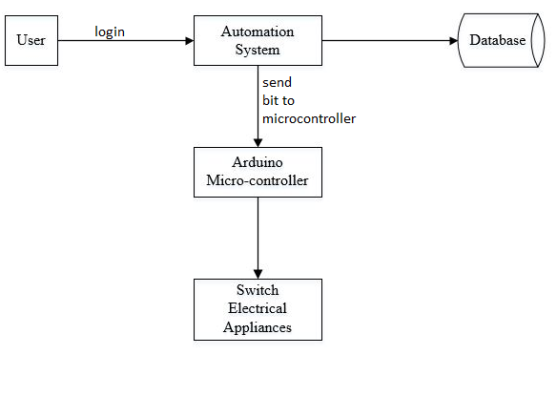 Figure 4.1:Block Diagram of proposed system

The above Block diagram is described below:

Arudino microcontroller is connected to the automation system that receives the bit from the automation system. A wifi modem is used to receive commands over the internet. The wifi module receives user commands over the internet. This information is then passed on to the microcontroller. The microcontroller now processes this data and switches the loads through relays. Also the database is used to store the information of running electrical appliances so the officer can check the information how many hours is the appliances are running out. It displays the status of the system on an computer screen

## WATERFALL MODEL

The Software Prototyping refers to building software application prototypes which display the functionality of the product under development but may not actually hold the exact logic of the original software.

Software prototyping is becoming very popular as a software development model, as it enables to understand customer requirements at an early stage of development. It helps get valuable feedback from the customer and helps software designers and developers understand about what exactly is expected from the product under development.

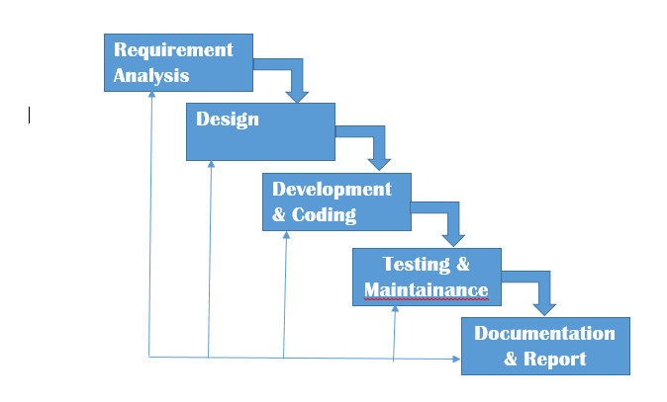

Figure 4.1 Waterfall Model

## WORKFLOW DIAGRAM FOR DESKTOP APP

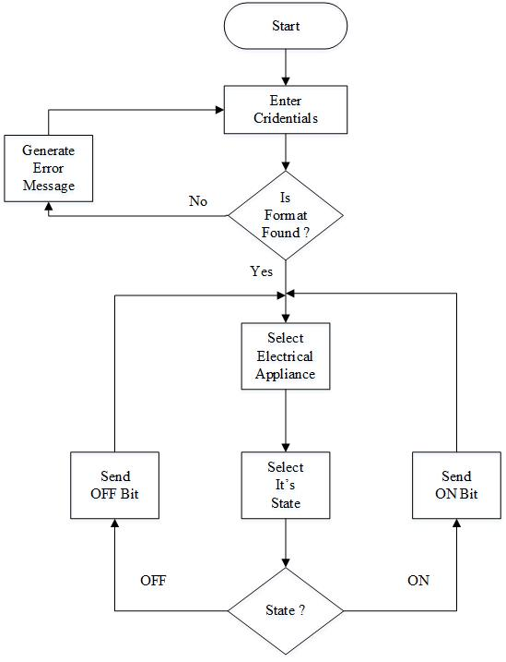

Figure 5.3: Workflow Diagram for desktop App

## WORKFLOW FOR MICROCONTROLLER

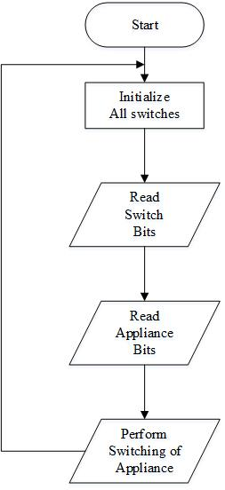

Figure 5.4: Workflow for microcontroller

## CIRCUIT DIAGRAM

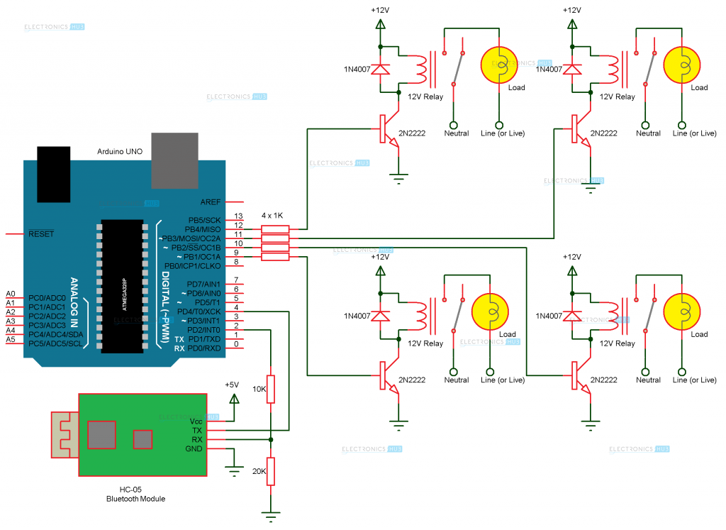

Figure 5.5 : Circuit diagram showing the interaction between software and hardware

## SEQUENCE DIAGRAM



Figure 5.6 : Sequence Diagram

## USECASE DIAGRAM

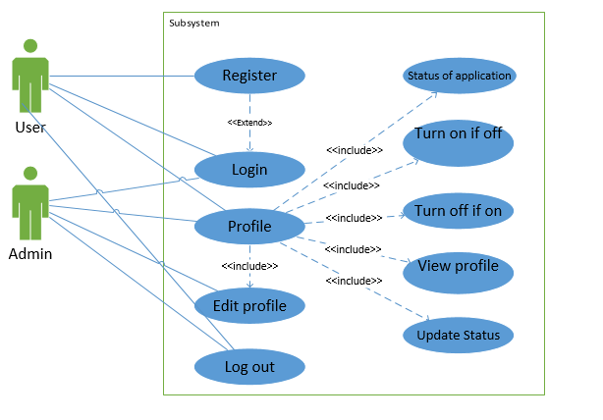

Figure 5.7 : Use case Diagram

## ACTIVITY DIAGRAM



Figure 5.8 : Activity Diagram

## CLASS DIAGRAM



Figure 5.9 : Class Diagram

# IMPLEMENTATION PLAN

## SCHDEULE (GANTT CHART)

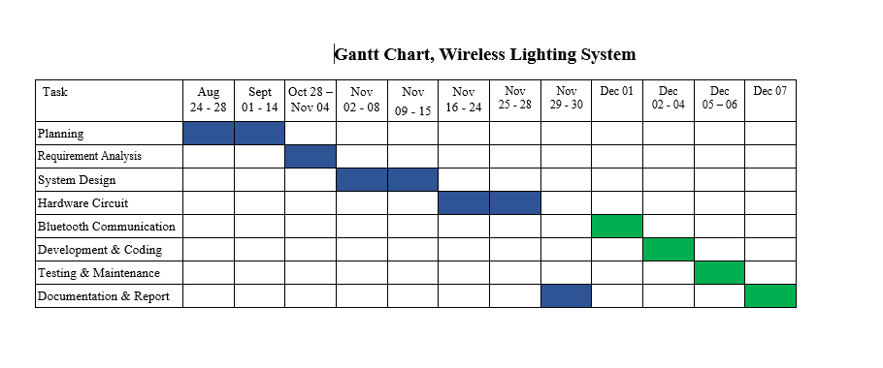

Figure 6.1: Gantt chart

## HARDWARE AND SOFTWARE REQUIREMENTS

### SOFTWARE

* Arduino software(IDE)
* Visual Studio 2015
* MS SQL Server

### HARDWARE

* rduino Microcontroller
* Ethernet Shield
* Relay
* Bulbs
* DC Motor
* Connecting Wires

# EXPECTED OUTCOMES

After the completion of this project we will be able to design and develop an Office automation system. We will be able to develop the local server that will maintain the SQL database of the running appliances. We expect that the schedule of running electrical appliances will be maintained in the database.

We expect that this project would help office owners to keep track of appliances in proper order.. We hope this project will reduce the human efforts and make the process easier and more convenient. The status of electrical devices can be monitored using internet.

# PROPOSED DELIVERABLES

* A detailed report on the WILI ( wireless lightings ) is to be provided.
* A complete working home automation project is to be delivered
* Database of the lighting equipments used is to be provided

# TASK DONE SO FAR

* All the documentation and report are completed .
* Connection between arduino , relay and the load are done.
* Simple design of the office automation is done

# RESULTS AND DISCUSSION

* During the development of the system, different research papers and articles, related to IOT, Automation system, Arduino microcontroller, Relay Module etc. were studied.
* Different methodologies were studied and the most feasible ones were chosen. The design of the project was found to be less impressive so the new designs are to be made.
* Connection in arduino was confusing so the more understandable circuit design are to be made.

# Limitations and Future Works

## Limitations:

* The system can only be used by the user who are in the same network.
* Connection of several user in the same network can decrease the efficiency to control the electrical appliances.

## Future Enhancements:

* Make the system applicable for big and large company.
* Use facial or fingerprints detection to identify the staff.
* Use different sensor to control the electrical appliances.
* Making a design easier to handle, such that many high load devices can be controlled at once.

# REFERENCES

[1] Ahmed ElShafee; Karim Alaa Hamed;”Design and Implementation of a Wi-Fi Based Home AutomationSystem”. International Journal of Computer, Electrical, Automation, Control and Information Engineering Vol: 6, No: 8, 2012

[2]Pavithra D, Ranjith Balkrishnan. “IoT based Monitoring and Control System for Home Automation”,Proceedings of 2015 Global Conference on Communication Technologies (GCCT 2015)

[3] Vaishnavi S. Gunge; Pratibha S. Yalagi,”Smart Home Automation: A Literature Review”. International Journal of Computer Applications (0975-8887)

[4]Luca Mainetti, Vincenzo Mighali, Luigi Patrono,” An IoT-based User centric Ecosystem for Heterogeneous Smart Home Environments”,IEEE ICC 2015 SAC-Internet of Things.