A Minor Project Final Report on

**News Portal**

Submitted in Partial Fulfillment of the Requirements for

The Degree of **Bachelor of Engineering in Information Technology**

Under Pokhara University

Submitted by:

**Surendra Bhandari (14484)**

**Aaviskar Pandey (14456)**

**Pradip Ranabhat (14491)**

Under the supervision of

**Er. Madan Kadariya**

Date:

Dec, 2018

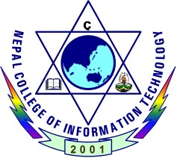

**Department of IT Engineering**

**NEPAL COLLEGE OF INFORMATION TECHNOLOGY**

Balkumari, Lalitpur, Nepal