

**FPT UNIVERSITY**

Software Development Project Document

**BIRD CAGE SHOP**

|  |  |
| --- | --- |
| Class | NET1710 |
| Mentor | Mr. Nguyễn Trọng Tài |
| Group member | Phan Quốc Khải  Nguyễn Phước Thiên Ân  Nguyễn Trọng Khang  Nguyễn Hữu Bảo  Bùi Ngọc Vân Sơn |

– Ho Chi Minh, Sep 2023 –

# **Table of contents**

**Table of contents** 2

Acknowledgement

Definition and Acronyms

Overview

1.Project Introduction

* 1.1Project Information
* 1.2Project Team
* 1.3 Introduction
* 1.4 Product Environment
* 1.5 Role Classification
* 1.6 Constraints:
* 1.7 Assumptions:

2. System Functions

* a. Screen Flow
* b. Screen Details
* c.User Authorization
* d. Non-Screen Functions

3. Common Requirements

4. Entity Relationship Diagram

**Acknowledgement**

We extend our sincere appreciation and gratitude to all those who have played a vital role in the successful completion of this project to establish a Bird Cage Shop.

We also extend our heartfelt thanks to our project mentor Mr. Nguyễn Trọng Tài, whose leadership, guidance, and support were essential in keeping the project on track and ensuring its success.

Our gratitude goes to the project team members: Phan Quốc Khải, Nguyễn Phước Thiên Ân, Nguyễn Trọng Khang, Nguyễn Hữu Bảo, Bùi Ngọc Vân Sơn who worked tirelessly to bring this project to fruition. Their dedication, professionalism, and teamwork were instrumental in achieving the project goals.

We would also like to acknowledge the feedback and contributions of the stakeholders and end-users, who provided valuable insights and recommendations, helping us to improve the quality of the store.

Finally, we would like to thank all others who have directly or indirectly contributed to this project's success.

Thank you all for your contributions, support, and unwavering commitment to this project.

Best Regards,

Project team.

# **Definition and Acronyms**

|  |  |
| --- | --- |
| **Acronym** | **Definition** |
| UC | Use Case |
| SC | Screen Description |
| ERD | Entity Relationship Diagram |
| API | Application Program Interface |
| Guest | The users who don’t need to login but can using the web application |
| Customer | The users who need to login to using more function |
| Manager | The users who need to login to manage product and **ensure the store's operations run smoothly and profitably.** |
| Admin | The users who need to login to manages the web application |

Table 1 – Definition and Acronyms

1. **Overview**
   1. **Project Introduction**
   2. **Project Information**

* Project name: BIRD CAGE SHOP
* Subject code: SWP391
* Software type: Web Application
  1. **Project Team**

|  |  |  |
| --- | --- | --- |
| **Full name** | **Email** | **Role** |
| Nguyễn Trọng Tài |  | Mentor |

Table 2 – Mentor

|  |  |  |
| --- | --- | --- |
| **Full name** | **Email** | **Role** |
| Phan Quốc Khải |  | Leader |
| Nguyễn Phước Thiên Ân |  | Member |
| Nguyễn Hữu Bảo |  | Member |
| Nguyễn Trọng Khang |  | Member |
| Bùi Ngọc Vân Sơn |  | Member |

Table 3 – Team members

**1.3 Introduction**

* The market for associated goods is expanding quickly as the practice of breeding and caring for birds gains popularity. The website development project "Bird Cage Shop" was started with the intention of assisting pet owners, particularly those who look after and rear birds.
* An online store called "Bird Cage Shop" will concentrate on goods and services for bird cages and their accessories. In order to help consumers locate the best items for the upkeep of their birds, we strive to offer them a convenient and dependable online purchasing experience.
* Detailed product information, including images and descriptions, will be provided on the website to help customers better understand the quality and features of the product before deciding to purchase. Besides, we will also provide guidance and advice on how to choose the right bird cage and how to care for their birds.
* We are committed to developing the "Bird Cage Shop" website with a focus on user experience, so that searching and shopping becomes an easy and enjoyable experience. At the same time, we will integrate secure online payment and door-to-door delivery to make shopping more convenient than ever.

**1.4 Product Environment**

The product environment of a website for user use is a multi-faceted context that encompasses various factors and conditions that influence the website's design, functionality, and overall user experience. Understanding this environment is crucial for the successful development and optimization of a website. Here are key elements of the product environment for a user-centrist website:

* **Browsers and Devices:** Compatibility with various web browsers (e.g., Chrome, Firefox, Safari) and devices (e.g., desktop, laptop, tablet, smartphone) to ensure a consistent user experience across platforms.
* **Content Relevance:** Ensuring that the website's content remains relevant and up-to-date, reflecting changes in user preferences and industry trends.
* **Feedback and Support:** Providing channels for user feedback and customer support to address issues, gather insights, and improve the overall user experience.

**1.5 Role Classification**

The application caters to multiple user roles, including:

* **Administrators:** Administrators possess complete control over the application, which includes user administration, access permissions, and system configuration. They have the authority to add, modify, or delete users, allocate permissions, and tailor settings to ensure the application runs smoothly.
* **Managers:** Managers usually hold supervisory positions within the application. They have the capability to supervise and oversee the actions of other users, monitor progress, and generate reports. Depending on the application's purpose, managers may also have specific tools or privileges related to their areas of responsibility.
* **Employees/Staff:** Employees or staff members are the primary users who engage with the application to carry out their everyday tasks. Their access and permissions are typically defined by their distinct job roles and duties. They employ the application to input data, manage tasks, and access pertinent information.
* **Customers/Clients:** In certain instances, the application might feature a customer or client portal. These users can log in to access their accounts, view their orders, make purchases, or engage with customer support features. Delivering a user-friendly and secure experience is crucial for this user segment.
* **Guest Users:** Depending on the application's structure, there could be guest users who can access limited functionalities or content without requiring registration. Guest users may encompass potential customers or visitors exploring the application.

**1.6 Constraints:**

* **Time Constraint:**

- The project must be completed within a time frame of 10 weeks from the project kickoff date. The project commencement date is 5/9 , and the final delivery date is 1/12 .

* **Technical Constraint:**

- **Front-end Framework:** The front-end of the web application will be developed using HTML, CSS, React.js

- **Back-end Framework:** The back-end of the web application will be implemented using Spring Boot framework (Java )

- **Version Control:** The web application’s source code will be managed using GitHub for version control and collaborative development

- **Integrated Development Environments (IDEs):** Development will primarily take place using **IntelliJ** for the back-end and **Visual Studio Code** for the front-end

* **Resource Constraint:**

- **Human Resources:** The project team is limited to **5 dedicated members**, and any changes to the team composition must be approved by the **project manager and project mentor.**

- **Communication and Collaboration Tools:** The project team will use **Discord, Google Meet, Code with me in IntelliJ** as the primary tool for communication, collaboration, and project management. **Discord, , Google Meet** provides text, voice, and video communication capabilities and offers features for real-time collaboration, discussions, file sharing and notification about git update. **Discord, , Google Meet** should be accessible and available throughout the project’s life-cycle

- **Testing and Quality Assurance Resources:** The project team will use **Postman** as the primary tool for API testing and quality assurance. **Postman** provides a comprehensive platform for designing, testing, and documenting APIs. It should be readily available and accessible for all relevant team members throughout the project’s life-cycle.

**1.7 Assumptions:**

* It is assumed that users have basic internet connectivity and access to modern web browsers.
* Users will have the necessary hardware and software to interact with the system effectively.
* Feedback submitted by members will be genuine and relevant to facility-related issues.

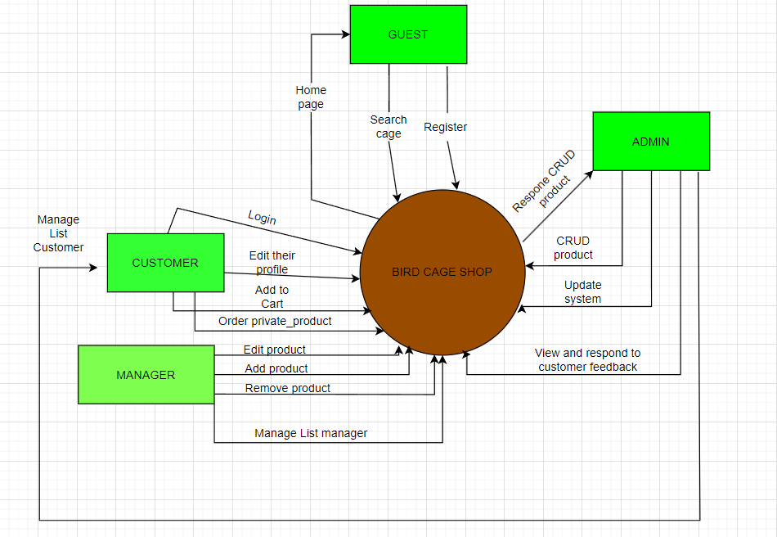

## **2. System Functions**

#### ***a. Screen Flow***

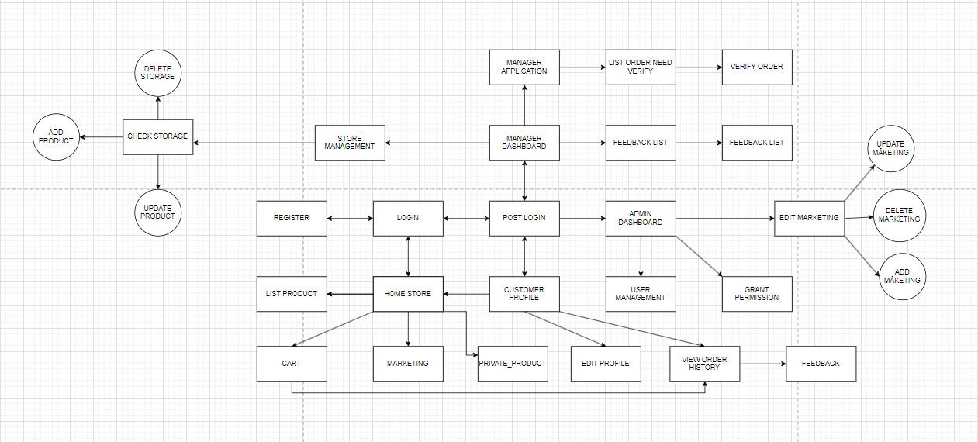

#### ***b. Screen Details***

|  |  |  |  |
| --- | --- | --- | --- |
| **#** | **Feature** | **Screen** | **Description** |
| 1 | Public Feature | Home Page | Show sliders, hot posts, featured products + the sider with the latest posts, static contacts/links  - Shown slider information includes its image and title; the user is redirected to the slider's backlink on his/her clicking  - Shown post information includes its thumbnail, title, brief-info; the user is redirected to the post's details on his/her clicking  - Shown product information includes its thumbnail, title, brief information; the user is redirected to the product's details on his/her clicking |
| Marketing | Articles, information, and news pages on related sales topics support the store's sales needs and are always hot topics to attract customers interested in the store's products which is for sale. |
| Products List | Show the products paginatedly (sorted by updated date) + the sider with the product search box, product categories, the latest products, and static contacts/links;  - Shown product information includes its thumbnail, title, brief information, original price, and sale price;  - The user is redirected to the product's details on his/her clicking on the product  - The user can choose to add the product to the cart or to feedback on the product by clicking the product's Buy & Feedback buttons responsively |
| Product Details | Show product details (including title, category, images, original price, sale price, and product details) + the sider with the product search box, product categories, the latest products, and static contacts/links |
| Cart | Show the cart details with list of the user's chosen products (including Id, title, price, quantity, total cost) and the total order price + the sider with the product search box, product categories, the latest products, and static contacts/links; The user can  - Change the quantity of each product: the total cost is automatically adjusted  - Choose to delete/remove product by clicking on the deleting icon  - Click the Choose More Product button to go to Products List page  - Click the Check Out button to go to the Cart Contact page  Please notes: the user's chosen products from the last browsing session are remained in his/her cart until s/he submit the cart. However, the product prices are updated with the latest prices in the system |
| Feedbacks | On receiving the bought products successfully, the receiver would receive a confirmation email with the guides to feedback on each of the received product; Beside, the user/receive could also give the feedback (on a specific product or general feedback) via the website; The user also call this screen from the system menu on the header;  The feedback information includes contact information (full name, gender, email, mobile), rated star, the attached images and the contact's free-format feedback  The page sider is also shown with the product search box, product categories, static contacts/links; |
| 2 | Common | User Login | 'This is a pop-up screen which allows the user to enter phone number & password to login; on this page, there are also options for user to register new information or reset the password for the case she forget it |
| User Register: | 'This is a pop-up screen which allows the user to register himself/herself to the system by inputing following information: full name, gender, email, mobile, and address; User then need to verify by clicking the link sent via email to him/her before being able to access the system |
| Change Password: | 'This is a pop-up screen which allows the user to change his/her password by inputting his current password as well as new password (twice) |
| User Profile: | 'This is a pop-up screen which allows the user to edit his/her profile information, including the registered ones & the avatar image. Please note that s/he is not allowed to change the email |
| 3 | Customer Feature | My Orders | 'Show the list of user's orders paginatedly + the sider with the product search box, product categories, the latest products, and static contacts/links  - Each order include below information: id, ordered date, product (first product name & number of other products if any), total cost, status;  - On clicking the link under the order id, user would be redirected to the Order Information page |
| Order Information | 'Show the order details, including the information as below + the sider with the product search box, product categories, the latest products, and static contacts/links  - The order id, order date, total cost, status  - The receiver information: full name, gendar, email, mobile  - This list of ordered products, each product include following information & the links/buttons that allow the user to re-buy or feedback: thumbnail, name, category, unit price, quantity, total cost  For the submitted orders, the user can choose to update (redirect the user to the Cart Details page for that) or cancel the order |
| 4 | Manager Feature | Manager Dashboard | 'Show statistics of posts, products, customers, feedbacks & the trend of new customers by day for the last 7 days (the start date & end date can be adjustable) |
| List Order Need Verify | 'After the customer has placed their order, a request is sent to the page manager for them to approve and start viewing the customer's order, calling, consulting, making requests, and waiting for the order to be delivered. Delivered exactly as both parties needed |
| Verify Order | 'After the order is confirmed by the manager, the customer will be notified of the time, location, and notes about the item until the bird cage is delivered. |
| Products List | 'Show the paginated list of products (include products' id, thumbnail, title, category, list price, sale price, featured, and status information):  - The user can filter the product by category, status or search by title, brief info  - Sortable by title, category, list price, sale price, featured, or status  - From each product, the user can choose to hide, show, view, edit it  - The page also have the button/link that allows the user to add new product |
| Private Product | Show a page which user can input as information, their favourite |
| Product Details | 'Show detailed product information (thumbnail, category, title, brief information, attached images, description, quantity, list price, sale price, flag to turn the featurning on/off, status), from that allow the user to input, view or edit them |
| Customers List | 'Show the list of customers / contacts paginatedly (include contacts' id, full name, gender, email, mobile, status):  - The user can filter the customers by status + search by full name, email, mobile  - Sortable by full name, email, mobile, status  - From each customer, the user can choose to add new, view or edit it |
| Customer Details | 'Show detailed customer/contact information (full name, gender, email, mobile, address, status), from that allow the user to input, view or edit them (except for the status which is generated automatically - contact, potential or customer)  Besides, the screen also shows the list of customer/contact changes history in the form of a table which includes following columns: email, full-name, gender, mobile, address, updated by, updated date |
| Feedbacks List | 'Show the list of feedbacks paginatedly (include feedbacks' contact full name, product name, rated star, status):  - The user can filter the feedbacks by status, product, rated star + search by full name, feedback content  - Sortable by full name, product name, rated star, status  - From each feedback, the user can choose to view or change it's status |
| Feedback Detail | 'Show the feedback details (contact full name, email, mobile, product, rated star, feedback, images status) from that allow the user to change its status |
| 5 | Admin Feature | Admin Dashboard | 'Show statistics of new orders (success, cancelled, submitted), revenues (total, by product categories), customers (newly registered, newly bought), feedbacks (average star: total, by product categories) & the trend of order counts (success, all) by day for the last 7 days (the start date & end date can be adjustable) |
| Users List | 'Show the paginated list of registered users (include users' id, full name, gender, email, mobile, role, status):  - The admin can filter the users by gender, role, status  - Allow the admin to seach users by full name, email, mobile  - The list is sortable by id, fullname, gender, email, mobile, role, status  - From each user, the admin can choose to view or edit it  - The page also have the button/link that allows the admin to add new user |
| User Details | 'Show detailed user information (avatar, full name, gender, email, mobile, role, address, status), from that allow the user to add new, view or edit user information  - After adding, new generated login password would be email to the new user  - The admin can only edit/update the role and status of the user |
| Settings List | 'Show the paginated list of settings (include settings' id, type, value, order, status):  - The admin can filter the setting by type, status  - Allow the admin to seach settings by value  - The list is sortable by id, type, value, order, status  - From each setting, the admin can choose to view, activate/deactivate, or edit it  - The page also have the button/link that allows the admin to add new setting |
| Settings Details | 'Show detailed user information (type, value, order, description, status), from that allow the user to add new, view or edit setting information |

#### ***User Authorization***

|  |  |  |  |  |
| --- | --- | --- | --- | --- |
| **Screen** | **Guest** | **Customer** | **Manager** | **Admin** |
| Home Page | **V** | **V** | **V** | **V** |
| Products List | **V** | **V** | **V** | **V** |
| Product Details | **V** | **V** | **V** | **V** |
| Cart Details | **V** | **V** | **V** | **V** |
| Cart Contact |  | **V** | **V** | **V** |
| Cart Completion |  | **V** | **V** | **V** |
| Feedbacks |  | **V** | **V** | **V** |
| User Login | **V** | **V** | **V** | **V** |
| User Register: | **V** |  |  |  |
| Change Password: |  | **V** | **V** | **V** |
| User Profile: |  | **V** | **V** | **V** |
| My Orders |  | **V** | **V** |  |
| Order Information |  | **V** | **V** |  |
| Manager Dashboard |  |  | **V** |  |
| List Order Need Verify |  |  | **V** |  |
| Verify Order |  |  | **V** |  |
| Products List |  |  | **V** | **v** |
| Private_Product |  | **v** | **v** | **v** |
| Product Details |  |  | **V** | **v** |
| Customers List |  |  | **V** | **v** |
| Customer Details |  |  | **V** | **v** |
| Feedbacks List |  |  | **V** | **v** |
| Feedback Detail |  |  | **V** | **v** |
| Orders List |  | **v** | **v** |  |
| Order Details |  | **v** | **v** |  |
| Admin Dashboard |  |  |  | **V** |
| Users List |  |  |  | **V** |
| User Details |  |  |  | **V** |
| Settings List |  |  |  | **V** |
| Settings Details |  |  |  | **V** |

#### ***d. Non-Screen Functions***

|  |  |  |  |
| --- | --- | --- | --- |
| **#** | **Feature** | **System Function** | **Description** |
| 1 | Usability | Design simple | Design based on UI UX, easy to use and view information. |
| 2 | Authorization | System authorization every roles in system | Implementation of authorization mechanism in the system, including the specify the role of logged-in user, his/her authorized page links (building the displayed menu items (in the front end) and preventing unauthorized access via enter the links directly) |
| 3 | Efficiency | Minimise users' actions on the screen so that they complete a task on the system as quickly as possible. | Helps minimise users' actions on the screen so that they complete a task on the system as quickly as possible.  For example, from 5 touches, down to 3 touches, you can order 1 product |

## **3. Common Requirements**

The common functions/screens used for all types of users, as listed below

- User Login: authenticate the user to give him/her to access authorized features later on

- Register: You will register with your account then it will be verified by gmail

- Forgot Password: In case you forget your password, you can forget it with your gmail account

- Profile: edit information such as email, password, add or delete a delivery address

## **4. Entity Relationship Diagram**

