**SOFTWARE ENGINEERING (CO3001)**

**STUDENT SMART PRINTING SYSTEM - SSPS**

**TASK 2: SYSTEM MODELING**

**CC01 - Group 3**

**\*\*\*\*\*\*\*\*\*\*\*\*\*\*\*\*\*\*\*\*\*\*\*\*\*\*\*\*\*\*\*\*\*\*\*\*\*\***

**Team members:** Lê Quang Khải - 2152659

Võ Hoàng Phúc - 2112060

Đặng Trung Kiên - 2152702

Phạm Đức Minh - 2152770

Lương Trần Công Danh - 2152459

Lê Huy - 2152584

**1) Activity diagram for specifying the printing properties**

The activity diagram above shows the process for specifying the printing properties by interacting with a student and the system. The system will let students to adjust the printer that will be used to print, the printing pages, the number of copies and the desired page format consecutively. After completing the specifications, student will press the print button and the system will check if the chosen printer is available or not; if it is not available, the system will show the error message. If the chosen printer is available, the system will continue to check the balance of the student’s paper account. If the amount of paper in the student’s account is in sufficient, the system will notify the error; else the system will continue to print out the desired copies.

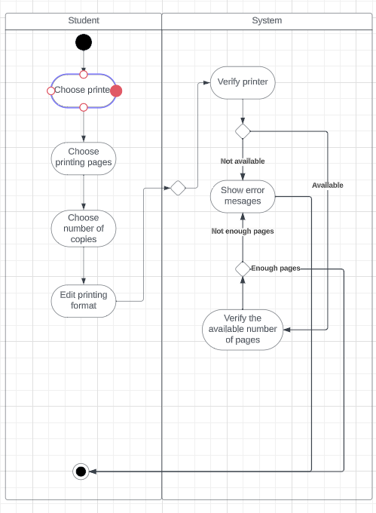

**2) Sequence diagram for specifying the printing properties**

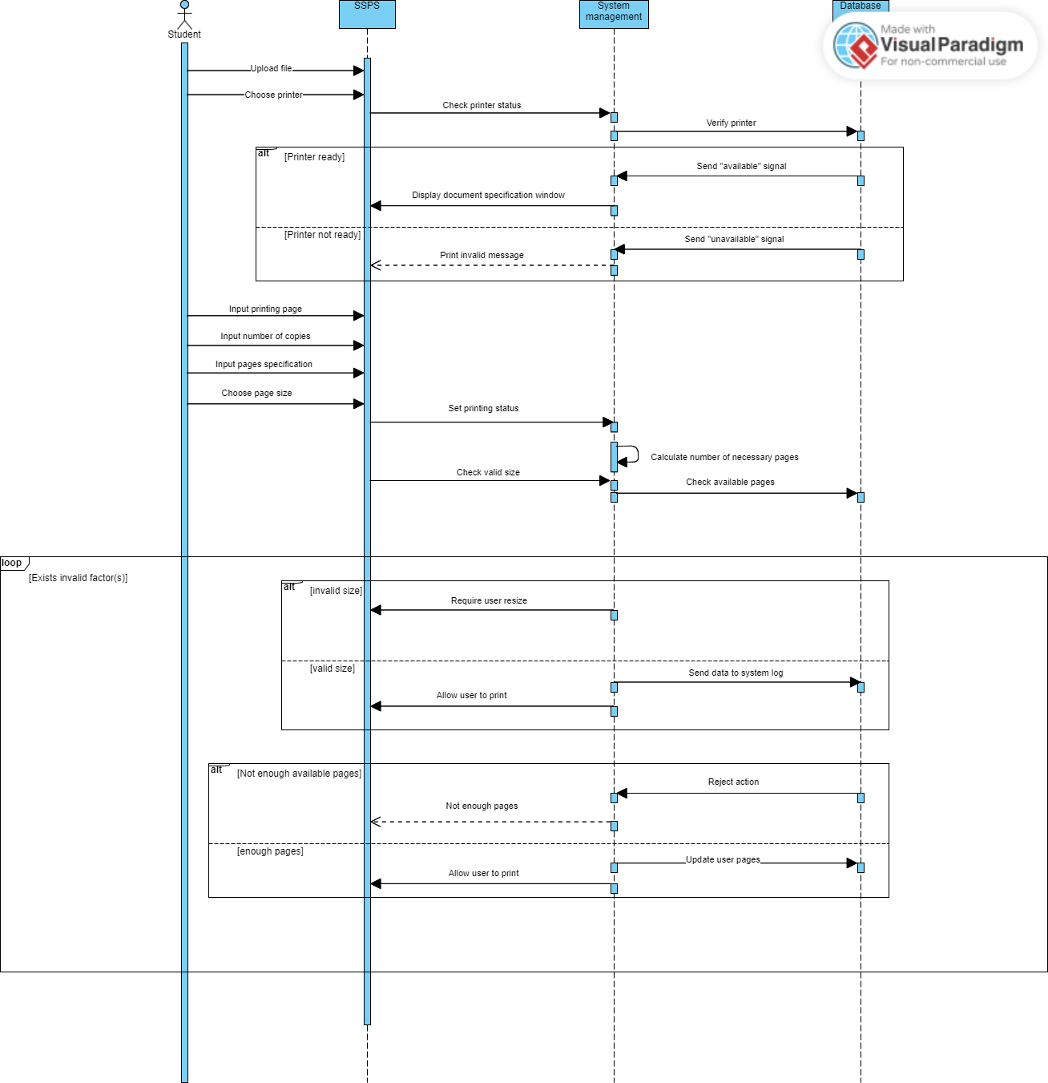

**3) Class diagram of the module for specifying the printing properties**

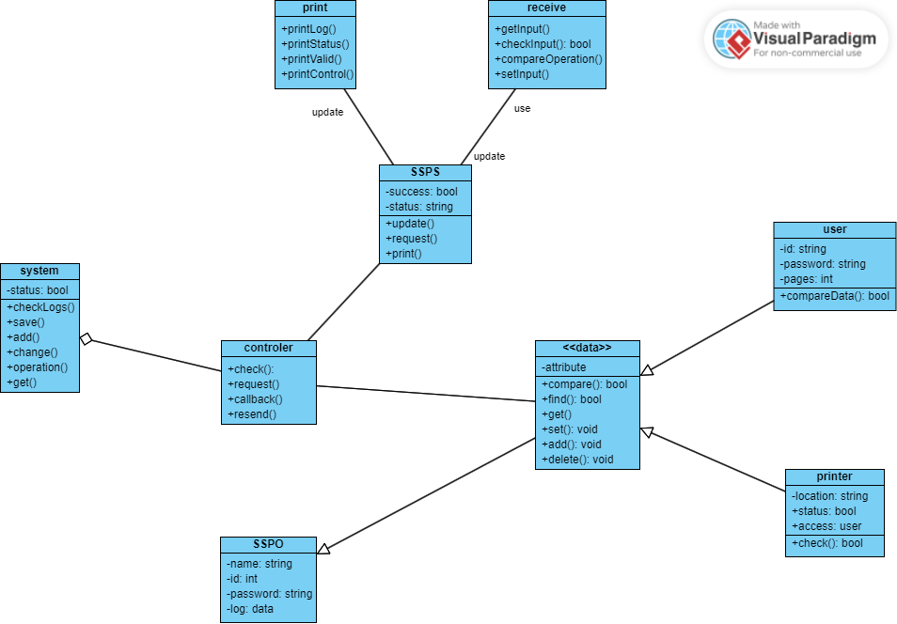

**4) MVP 1**

Choosing the class for logging in:

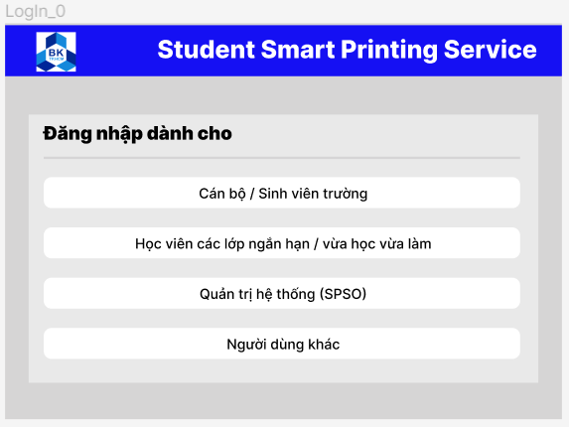

Log in:

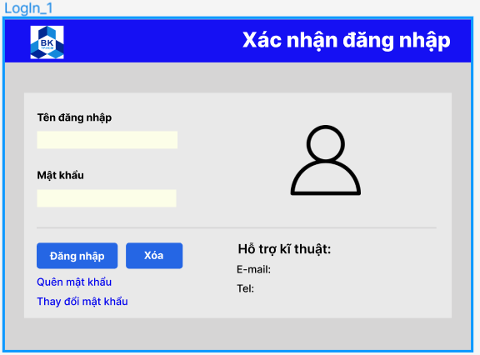

Choosing the file to print:

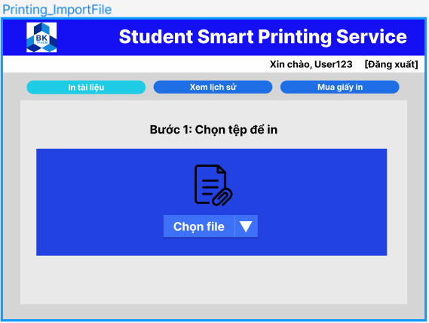

Configuring before printing the documents:

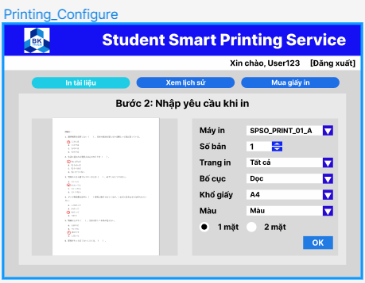

Viewing the printing log:

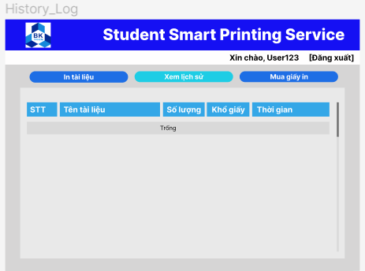

Buying printing pages:

