Class: CC01

Group: 3

Members:

- Lê Quang Khải

- Võ Hoàng Phúc

- Đặng Trung Kiên

- Phạm Đức Minh

- Lương Trần Công Danh

- Lê Huy

**STUDENT SMART PRINTING SYSTEM - SSPS**

**TASK 1: REQUIREMENT ELICITATION (continue)**

**1) Use-case diagram for the whole system**

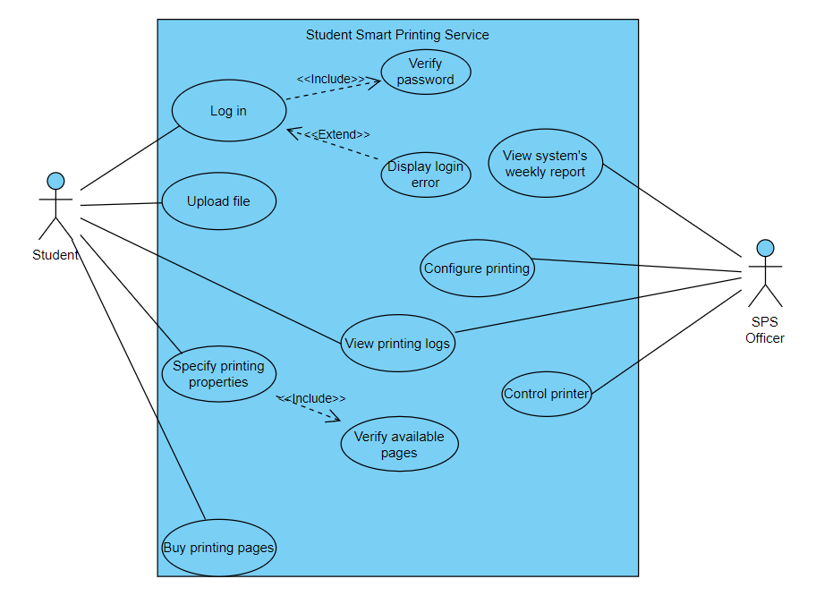

**2) Use-case diagram for specifying printing properties**

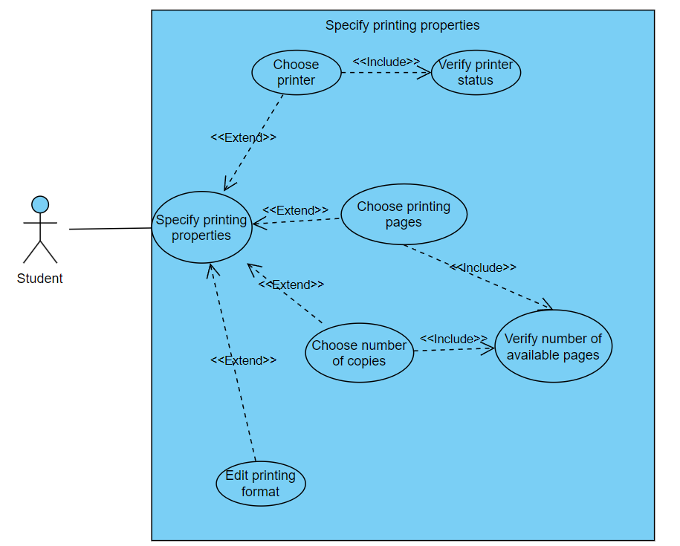

**3) Use-case description table**

|  |  |
| --- | --- |
| Use-case name | Specify printing properties |
| Actor | Student |
| Description | Student change or choose printing properties |
| Trigger | Click “Print Options” button |
| Normal flow | 1. System display all printing properties included of: - Default printer - Printing pages - Number of copies - Pages format 2. Student click on any option 3. System show changing options 4. Student clicks “Print” to start printer 5. System verifies pages and printer status 6. System send notification to SPS officer and return to main interface |
| Exceptions | At stage 5:   * If there is no available printer or page, system will show error message. |
| Alternative flow | None |