**SOFTWARE ENGINEERING (CO3001)**

**STUDENT SMART PRINTING SYSTEM - SSPS**

**TASK 2: SYSTEM MODELING**

**CC01 - Group 3**

**\*\*\*\*\*\*\*\*\*\*\*\*\*\*\*\*\*\*\*\*\*\*\*\*\*\*\*\*\*\*\*\*\*\*\*\*\*\***

**Team members:** Lê Quang Khải - 2152659

Võ Hoàng Phúc - 2112060

Đặng Trung Kiên - 2152702

Phạm Đức Minh - 2152770

Lương Trần Công Danh - 2152459

Lê Huy - 2152584

**1) Layered architecture of HCMUT_SSPS system**

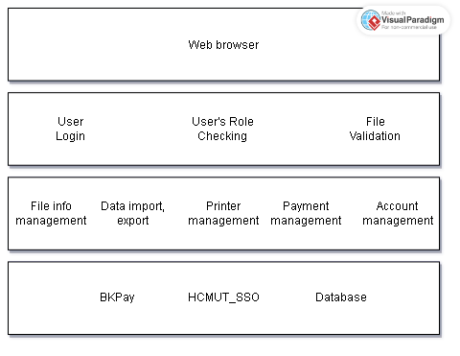

The Presentation strategy for the Student Smart Printing Service (SSPS) focuses on creating a user-friendly and intuitive interface accessible through the browser. It emphasizes simplicity and efficiency, allowing students to easily upload and manage their printing tasks, select printing options, and view their printing history. Implementing a clean and responsive design, the strategy aims to streamline the printing process, provide clear navigation, and offer a seamless experience. Prioritizing accessibility and a student-centric approach, the interface ensures clear communication of available printing pages, balances, and prompts for additional purchases, facilitating transparent and convenient interactions for all users.

The data storage approach for the Student Smart Printing Service (SSPS) revolves around a robust and scalable database management system capable of efficiently handling various types of data. It employs a structured approach to store and manage information related to printers, students, printing history, system configurations, and reports. Leveraging a relational database system, the design ensures data integrity, security, and consistency, enabling seamless retrieval and manipulation of data for various system functionalities. Emphasizing data normalization and appropriate indexing, the approach optimizes data storage and retrieval operations, facilitating quick access to relevant information while maintaining data accuracy and reliability. Additionally, the design incorporates regular data backups and implements security measures to safeguard sensitive information, ensuring the confidentiality and integrity of the SSPS data.

The API management strategy for the Student Smart Printing Service (SSPS) involves the implementation of a secure API gateway that facilitates seamless communication and interaction between different system components, external services. By adhering to industry-standard security protocols and authentication mechanisms, the strategy ensures secure data transmission and access control, safeguarding sensitive student information and system resources. The API management solution also includes comprehensive documentation, versioning, and monitoring tools to enable effective API lifecycle management, track usage patterns, and identify potential performance bottlenecks or security vulnerabilities. Prioritizing scalability and flexibility, the strategy enables the integration of new features, services, and technologies, fostering an extensible and adaptable ecosystem for the SSPS to meet evolving user requirements and technological advancements.

**2) Component diagram for printing module**

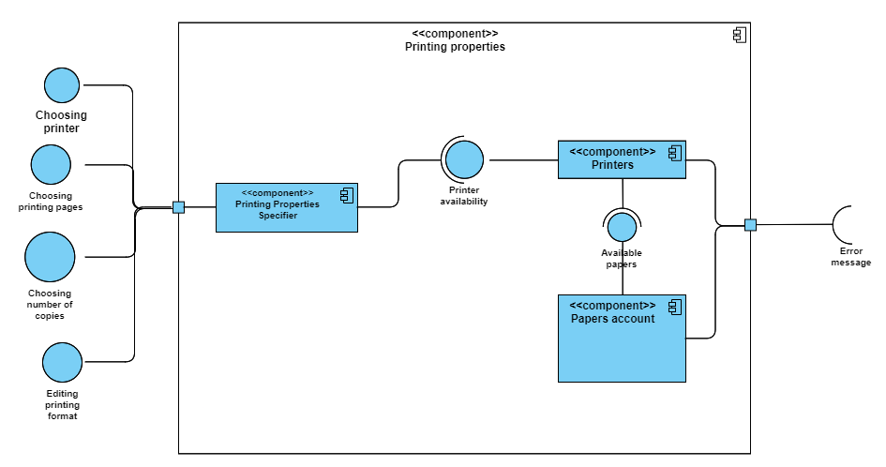

The Printing Properties module provides an interface of specifying printing properties. The main component in this module is Printing Properties Specifier and this component is dependent on two other components which are Printers and Papers account to successfully print the desired documents for students. The Printing Properties Specifier component will provide four interfaces which are: Choosing printer, choosing printing pages, choosing number of copies and editing printing format for the student to change the default properties. The Printers component will provide the interface for the Printing Properties Specifier to check if the printer is available at that time. If not, the Printers component will request for the error message interface, else, it will ask for the interface from the Papers account component to verify that the student’s account still has enough papers to print. If not, the Papers account component will also ask for the error message interface, else the system will begin to print out documents for the student.