**SOFTWARE ENGINEERING (CO3001)**

**STUDENT SMART PRINTING SYSTEM - SSPS**

**TASK 4: IMPLEMENTATION - SPRINT 1**

**CC01 - Group 3**

**\*\*\*\*\*\*\*\*\*\*\*\*\*\*\*\*\*\*\*\*\*\*\*\*\*\*\*\*\*\*\*\*\*\*\*\*\*\***

**Team members:** Lê Quang Khải - 2152659

Võ Hoàng Phúc - 2112060

Đặng Trung Kiên - 2152702

Phạm Đức Minh - 2152770

Lương Trần Công Danh - 2152459

Lê Huy - 2152584

**I. GitHub repository**

The repository for our project is named ‘HCMUT_SSPS---Sprint-1’. It was set up on October 31st 2023. This repository stores diagrams that describe the overall system and some of its important modules. It also has reports previously submitted to BKeL. Besides that, information about functional and non-functional requirements and stakeholders is stated as well.

To see the content, click on the link: <https://github.com/khaiBK21/HCMUT_SSPS---Sprint-1.git>

**II. Usability test with the user interface**

During system modeling, the research team developed MVP 1 for HCMUT_SSPS. In this section, we would like to use the user interface in MVP 1 to conduct a usability test. The following is all the steps that we have completed during our test.

*1) Recruit testers*

In this usability test, students learning at Ho Chi Minh University of Technology are our participants because they would be the main users of the smart printing service. We would also seek for people from a Facebook group that focuses on User Interface design since we believe that their knowledge on this field may prove to be useful for the revision of our system.

*2) Define tasks*

The tasks are listed in a questionnaire that we have made using Google Form. These tasks include:

- Choose the appropriate class of user: Click on either Staff/Student or Short-term learners to get to the Log in interface.

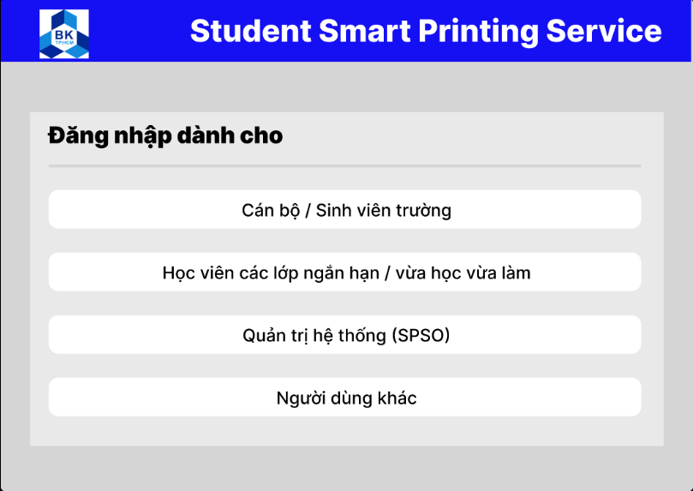

- Enter username and password to log in: When the user clicks on the text box for either username or password, the mouse pointer will appear. For this test only, by entering the key ‘T’, the box will be filled in.

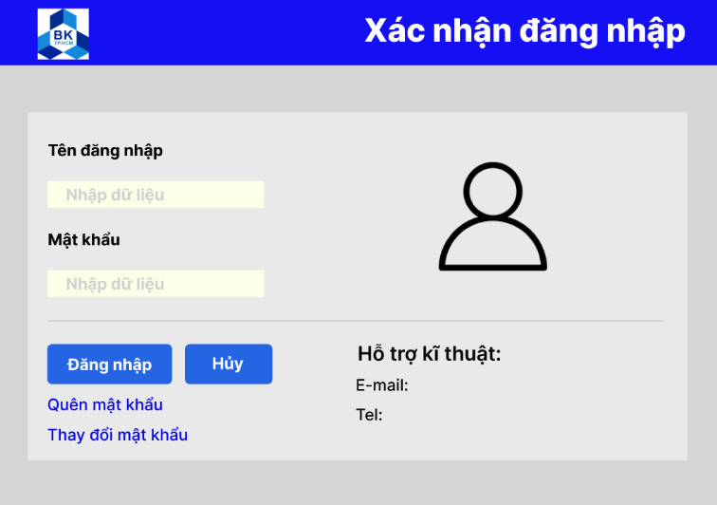

- Change the password: At the log-in screen, if you click at ‘Change the password’, the system will change to the screen ‘Change password’.

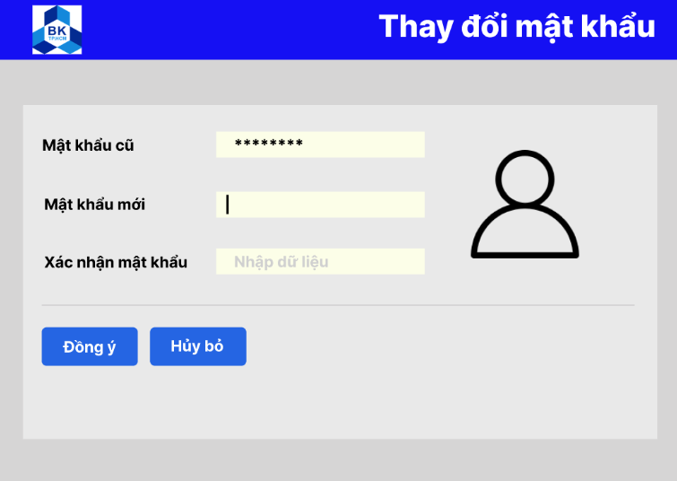

- Choose the file to print: Click on ‘Select file’ to upload a file that you want to print.

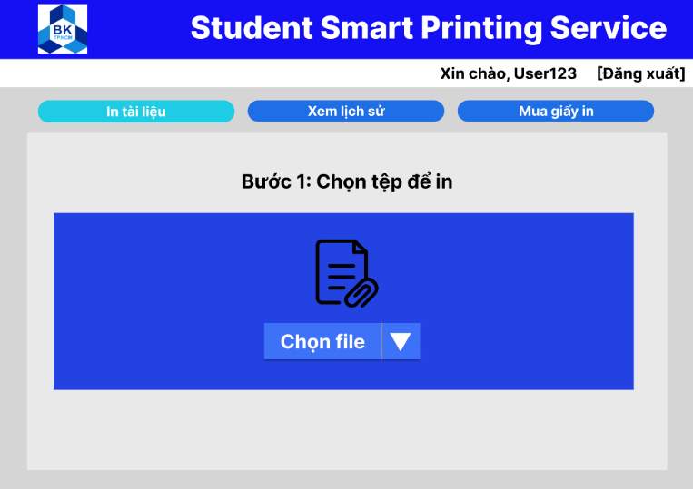

- Specify printing properties: In the screen below, there are properties that you want to specify to the system such as printer, number of copies, pages to print, etc.

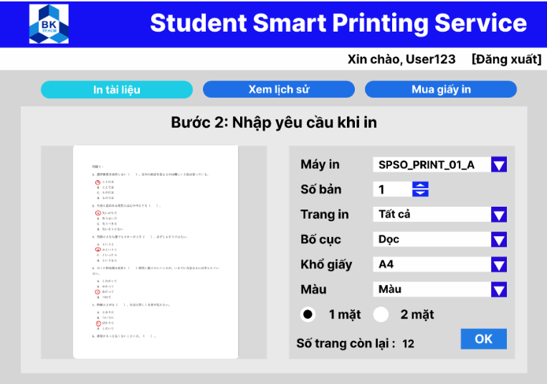

- See the printing log: Click on ‘See the history’ to see all the time when you print documents.

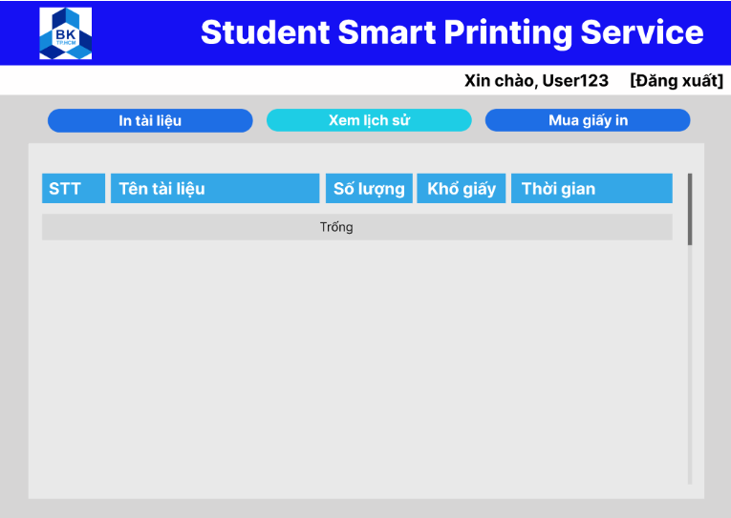

- Purchase printing pages: Click on ‘Buy printing paper’ to purchase pages in case you are out of paper.

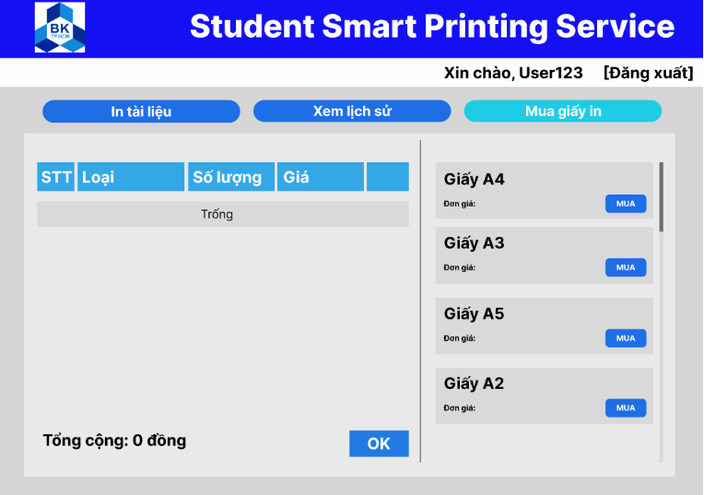

*3) Define test strategy*

For our usability test, we shall employ quantitative test strategy, which focuses on collecting metrics that describe the user experience because it is estimated that about 20 people will join the test and we do not want to waste too much time on checking every person’s single choice. We also use remote unmoderated tests, where participants complete the tasks on their own time, in order to allow flexibility for the testers.

*4) Conduct the test*

To conduct the test, we will first create a prototype based on our works in MVP 1. Then, we will make a questionnaire using Google Form with questions based on the tasks defined above. This way, we can obtain the testers’ opinion about the user interface for our system.

*5) Document feedback from testers*

Based on the questionnaire made for this test, we will summarize the overall opinion of testers about our design of user interfaces for the smart printing system.

**III. Result**

Throughout the usability test, we have obtained some notable results as below:

- For the ‘Choosing the user class’ screen, most participants have a positive view with the average score of 7.35 and the most popular scores are 8 and 9. The main recommendation for this screen from our testers is to change the color of the user interface.

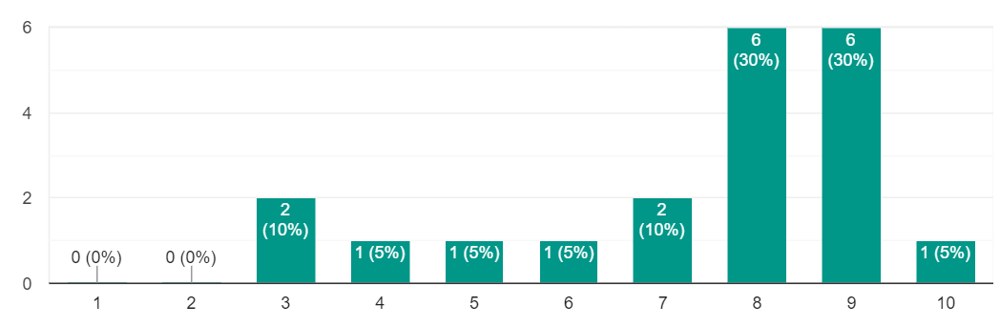

- For the log-in screen, the average evaluating score is 7.55, which means that testers generally consider this screen to be good enough.

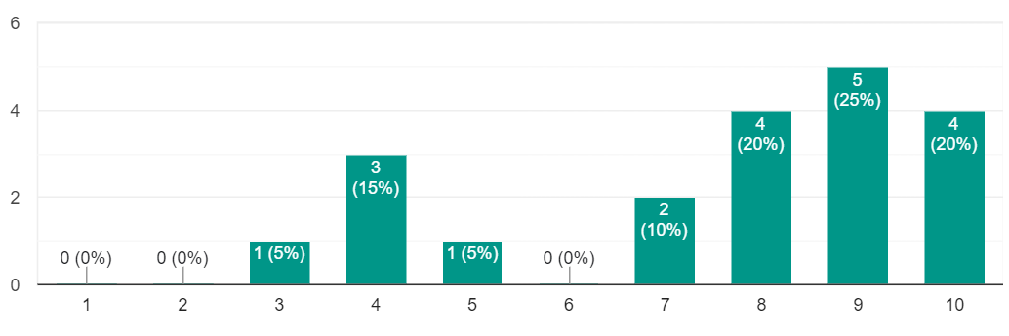

- For the ‘Change the password’ interface, most testers view it positively, with most scores being between 8 and 10.

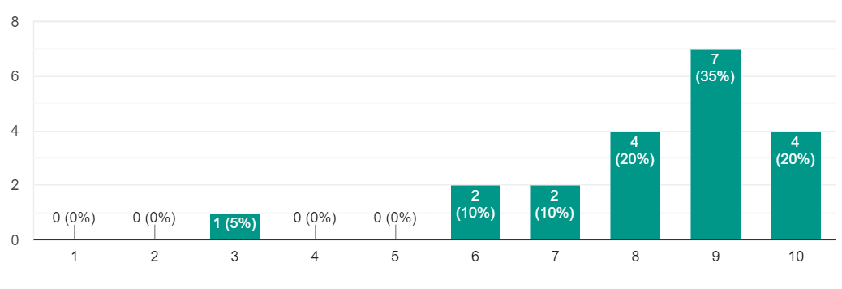

- For the feature of printing documents, the average score is 7.95. That figure indicates that the general consensus on the interface for this feature is positive. Some pieces of advice worth mentioning include telling the users the type of file that can be printed by the system and adjusting its appearance.

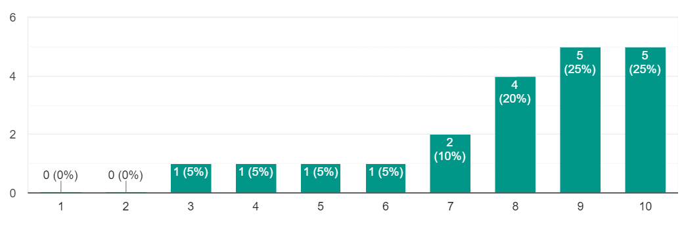

- For ‘See the printing log’ screen, in overall, testers have a positive outlook about the interface for this feature, with the most popular score being 4 and 5 out of the scale 1 - 5 and the average of 4.35. A notable recommendation is to add the column describing the printing status so that users can check whether the printing request has succeeded or not.

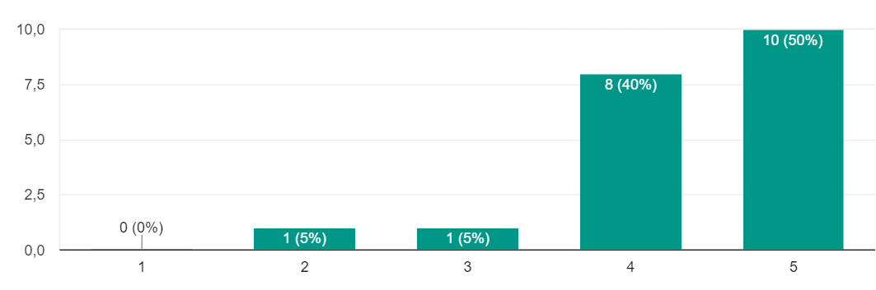

- The general consensus for ‘Purchasing printing pages’ screen is less positive then the previously mentioned screen even though it can still be seen that the former screen is well liked. In particular, the average score in the scale of 1 - 5 is 4.1. For recommendation, testers ask us to change the interface so as to enable batch selection, see the number of purchased pages, and make sure that interface satisfies the fact that one A3 piece of paper is equivalent to two A4 pieces.

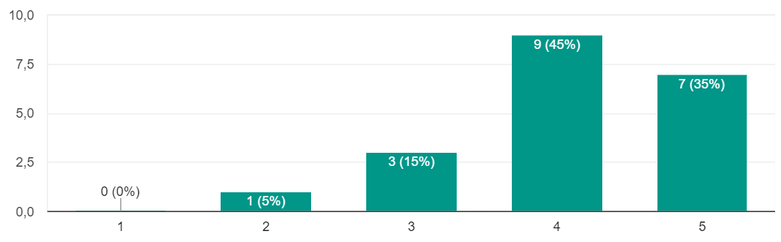

- Another thing to mention is that some participants advise us to add interfaces for administrators and security features as well as paying methods.

**IV. Solution**

Based on the result our group obtains and summarizes from the questionnaire, we would like to propose some ideas to improve the user interface for the smart printing service:

- First of all, add new interfaces for the functionalities used by the administrators at the university. This is our foremost priority in the coming period.

- Secondly, adjust the color scheme of the user interface. This would make the interface more pleasant to look at.

- Other adjustments to the system include allowing batch selection, showing printing status, restricting types of file to be printed, and so on.