**Evidence Question-10**

**Time:** 30 minutes **Total Marks:** 30

1. Create a folder in your desktop with current date and your ID.   
   Open that folder and complete 2 to 3 questions.
2. Create an excel file with your ID. Prepare the following batting score sheet.

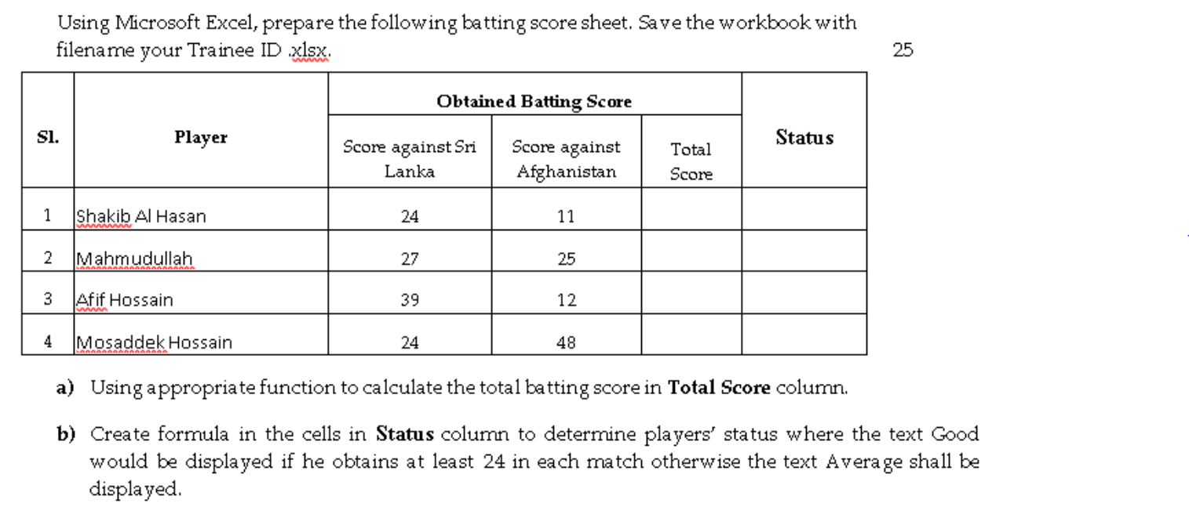

1. Do the work as instructed below

