**Evidence Question-6**

**Time:** 30 minutes **Total Marks:** 30

1. Create a folder in your desktop name it with current date and your ID.
2. Create a MS Word file with your ID. Prepare the below content as like as below. Insert page margin according to Left=1”, Top= 1.5”, Right=0.5” and Bottom=1”. Write down following sentences through justify alignment.

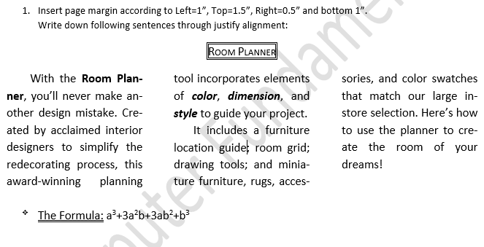

1. Create a MS Excel file name with your ID. Prepare the result sheet below.

