1. Create a folder in Desktop with you ID. Create a Word and Excel Document with your ID in that folder.
2. First compose below paragraph and format look like below

Bangladesh played ICC Cricket World Cup for the first time in the year 1999, when it came in one of the three ICC Trophy Qualifiers (the other two being Kenya and Scotland). By the next World Cup, it had become one of the test-playing nations of the world and thus, one of the contenders of the tournament as well.   
  
The team knocked out India in 2007 World Cup. Bangladesh also knocked out England in 2015 World Cup but facing defeat against India in Quarter final.

1. Write these symbols

💣 🕱 🖭 🕾 £

1. Type below word and give effect

IDB-BISEW IT Scholarship

1. Insert table and format as below

|  |  |  |
| --- | --- | --- |
|  |  |  |
|  |  |  |
|  |  |  |

1. Format Header & Footer like this document
2. Create Organization chart like below.

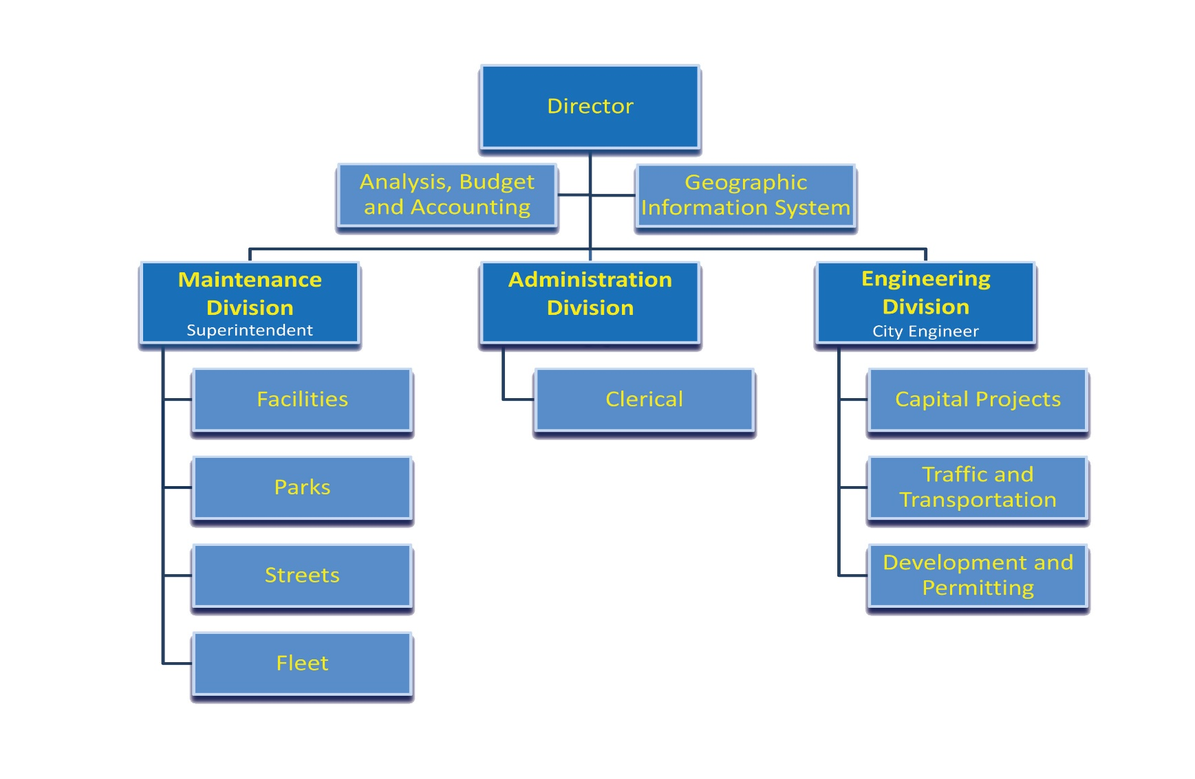

1. 20 is what percent of 2000? Show in Excel with formula.
2. Calculate 10% of 15,000/- in excel with formula.
3. Prepare below table in MS Excel. Calculate with Excel formula.

