HTML Evidence Exam-3

Q1. Create an html file named **account.html** which contains account entry form with

The following fields:

First name (text),

Last name (text),

Email (email),

Password,

Confirm Password

Gender (radio: male, female),

Hobbies (checkbox: Music, Sports, Travel, Movies),

Source of Income (dropdown list: Employed, Student),

Upload Profile Picture,

Age (number),

Biography (Textarea)

Q2. Create an html document named **table.html** to show the following information:

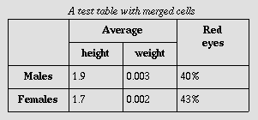

Q3. Create an html page **index.html** which contains two link items:

a.       Account

c.       Table

Using iframe show above pages in one iframe. Use div and make the menu in left side and content will be right side.