Linear Regression Model
Table S1. Linear Regression Model.

Regression Parameter | Standardized Coefficients
Class session (in-class = 0, AI = 1) | 0.63***
Pre-test (z score) | 0.18**
Midterm exam score (z-score) | 0.09
FCI pre-test (z-score) | 0.11
Prior AI experience | -0.15**
Class session topic (Fluids = 0, Surf. Tension = 1) | 0.01
Test version (A versus B) | -0.04
Time on task | 0.1
Constant | 0.12
R² | 0.21
RMSE | 0.86

Table S1. Standardized coefficients for linear regression model predicting students’ post-test scores (* p < 0.05, ** p <0.01, *** p < 0.001)

The largest and most significant coefficient relates to the condition (in-class active learning vs. AI lesson). As expected, pre-test scores are predictive of students’ post-test scores. The negative coefficient for prior AI experience likely reflects a characteristic of early ChatGPT adopters that affects their in-class performance, as evidenced by a weakly negative correlation in the control condition (r = -0.2, p < 0.05). There is no parallel correlation in the experimental condition, pointing to a lack of novelty effect, which also aligns with expectations, given that students were exposed to the AI pedagogy more than four weeks prior to the intervention and periodically thereafter.

Additional Tables
 | Group 1 (N=96) | Group 2 (N=98)
Proportion of female:male students (%) | 69.5:30.5 | 65.8:35.2
Proportion of 1st:2nd:3rd:4th-year students (%) | 1.7:25.2:62.6:10.4 | 1.9:26.2:60.8:10.3
Proportion of concentrations,  undeclared:life science:physical science:humanities/social science (%) | 27.0:54.8:9.6:8.7 | 29.3:55.7:9.4:5.7
Table S2A. Demographic Factors of Groups 1 and 2.
Table S2A. Gender, year, and concentration proportions for groups 1 and 2.

Table S2B. Descriptive Statistics for Groups 1 and 2.
 | Group 1 (N=96) |  | Group 2 (N=98)
 | Mean | SD | Mean | SD | t | df | p
FCI pre-test score (0-30) | 13.3 | 6.8 | 15.2 | 8.7 | -1.09 | 188 | 0.28
Midterm score (%) | 81.1 | 14.7 | 83.1 | 14.1 | -0.96 | 189 | 0.33
Table S2B. Pre-semester scores on the Force Concept Inventory and the first midterm exam for groups 1 and 2.

Table S3. Two-Lesson Crossover Design.
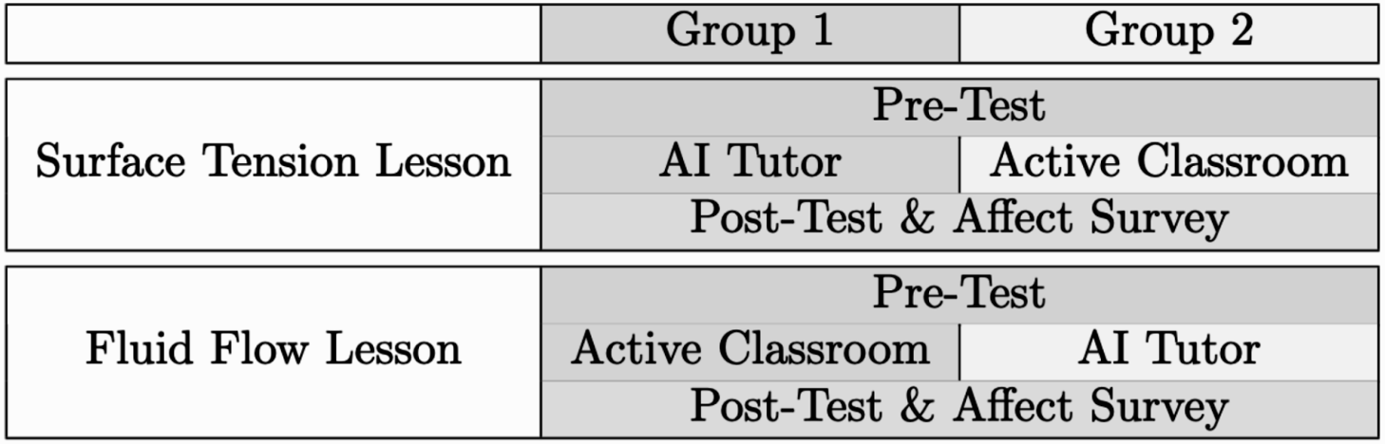
Table S3. Workflow for groups 1 and 2 during each of two lessons. Cross-over design ensures each student experiences both the experimental and control condition once.

Test Validation
Table S4 lists psychometric measures for each test question. We calculated point-biserial correlation, item discrimination, and item difficulty. These measures generally indicate that the test questions are valid for assessing the intended learning outcomes. The point-biserial correlations show a strong alignment with overall test performance. The item discrimination values suggest that most questions effectively differentiate between higher- and lower-performing students. Item difficulty values are also generally within the appropriate range. We also note that our tests assess a range of different concepts (i.e., multidimensional context).
Table S4. Psychometric Measures.
Question Label | Point-Biserial Correlation | Item Discrimination | Item Difficulty
T1A | 0.57 | 0.53 | 0.76
T1B | 0.51 | 0.41 | 0.81
T1C | 0.53 | 0.52 | 0.39
T1D | 0.56 | 0.59 | 0.43
T1E | 0.38 | 0.38 | 0.25
T1F | 0.6 | 0.59 | 0.7
T2G | 0.51 | 0.43 | 0.32
T2H | 0.38 | 0.25 | 0.29
T2I | 0.33 | 0.14 | 0.05
T2J | 0.58 | 0.56 | 0.46
T2K | 0.59 | 0.56 | 0.76
T2L | 0.57 | 0.55 | 0.65
T3M | 0.38 | 0.17 | 0.93
T3N | 0.56 | 0.38 | 0.8
T3O | 0.59 | 0.47 | 0.34
T3P | 0.58 | 0.58 | 0.72
T3Q | 0.47 | 0.4 | 0.34
T3R | 0.56 | 0.47 | 0.68
T4S | 0.47 | 0.39 | 0.69
T4T | 0.57 | 0.48 | 0.7
T4U | 0.54 | 0.49 | 0.59
T4V | 0.57 | 0.62 | 0.59
T4W | 0.34 | 0.23 | 0.12
T4X | 0.43 | 0.25 | 0.69

Table S4. Psychometric measures for each test question. Questions are evenly split over week one and week two of the investigation and are all used for both of the two conditions as well as the pre- and post-tests; measures are means over pre- and post-test and conditions.

Perception of Learning Experience Questions
In addition to measuring learning, we measured students’ perceptions of the learning experiences, which may correlate with the effectiveness of the lesson. We believe that some of the most important aspects of students’ perceptions are engagement, motivation, enjoyment, and growth mindset. Directly following the post-test in each group, for each lesson students were asked to state their level of agreement (on a Likert scale where 5=strongly agree, 3=neither agree nor disagree, and 1=strongly disagree) with each of the following statements:

Engagement - “I felt engaged [while interacting with the AI] / [while in lecture today].”
Motivation - “I felt motivated when working on a difficult question.”
Enjoyment - “I enjoyed the class session today.”
Growth mindset - “I feel confident that, with enough effort, I could learn difficult physics concepts.”

AI Tutor System and Implementation
The AI tutor system is shown in Figure S1. During the present investigation, it was powered by GPT-4-0613. The section of the system prompt used in all interactions is below. We refer to this as the “assignment persona,” as it determines the behavior for the tutor for all problems in the assignment. It is refined through iterative testing before its use in the classroom and it promoted cognitive load management (e.g., “Keep responses BRIEF”), active engagement (e.g., “You are helping the student…focusing specifically on the question they ask…DO NOT give away the full solution...”), and a growth mindset (e.g., “You are friendly, supportive and helpful.…encourage them to give it a try”).

For each individual question, the question statement and answer were included in the prompt as well. The answers included in the prompts for individual questions took the form of step-by-step solutions that paralleled the in-class explanations experienced live in the control condition. We refer to this section of the system prompt as the “question-specific prompt.” Below is an example of a question-specific prompt. Its content is parallel to the feedback given to students in the in-class active learning condition for the same question.

Fig. S1. AI Tutor System.
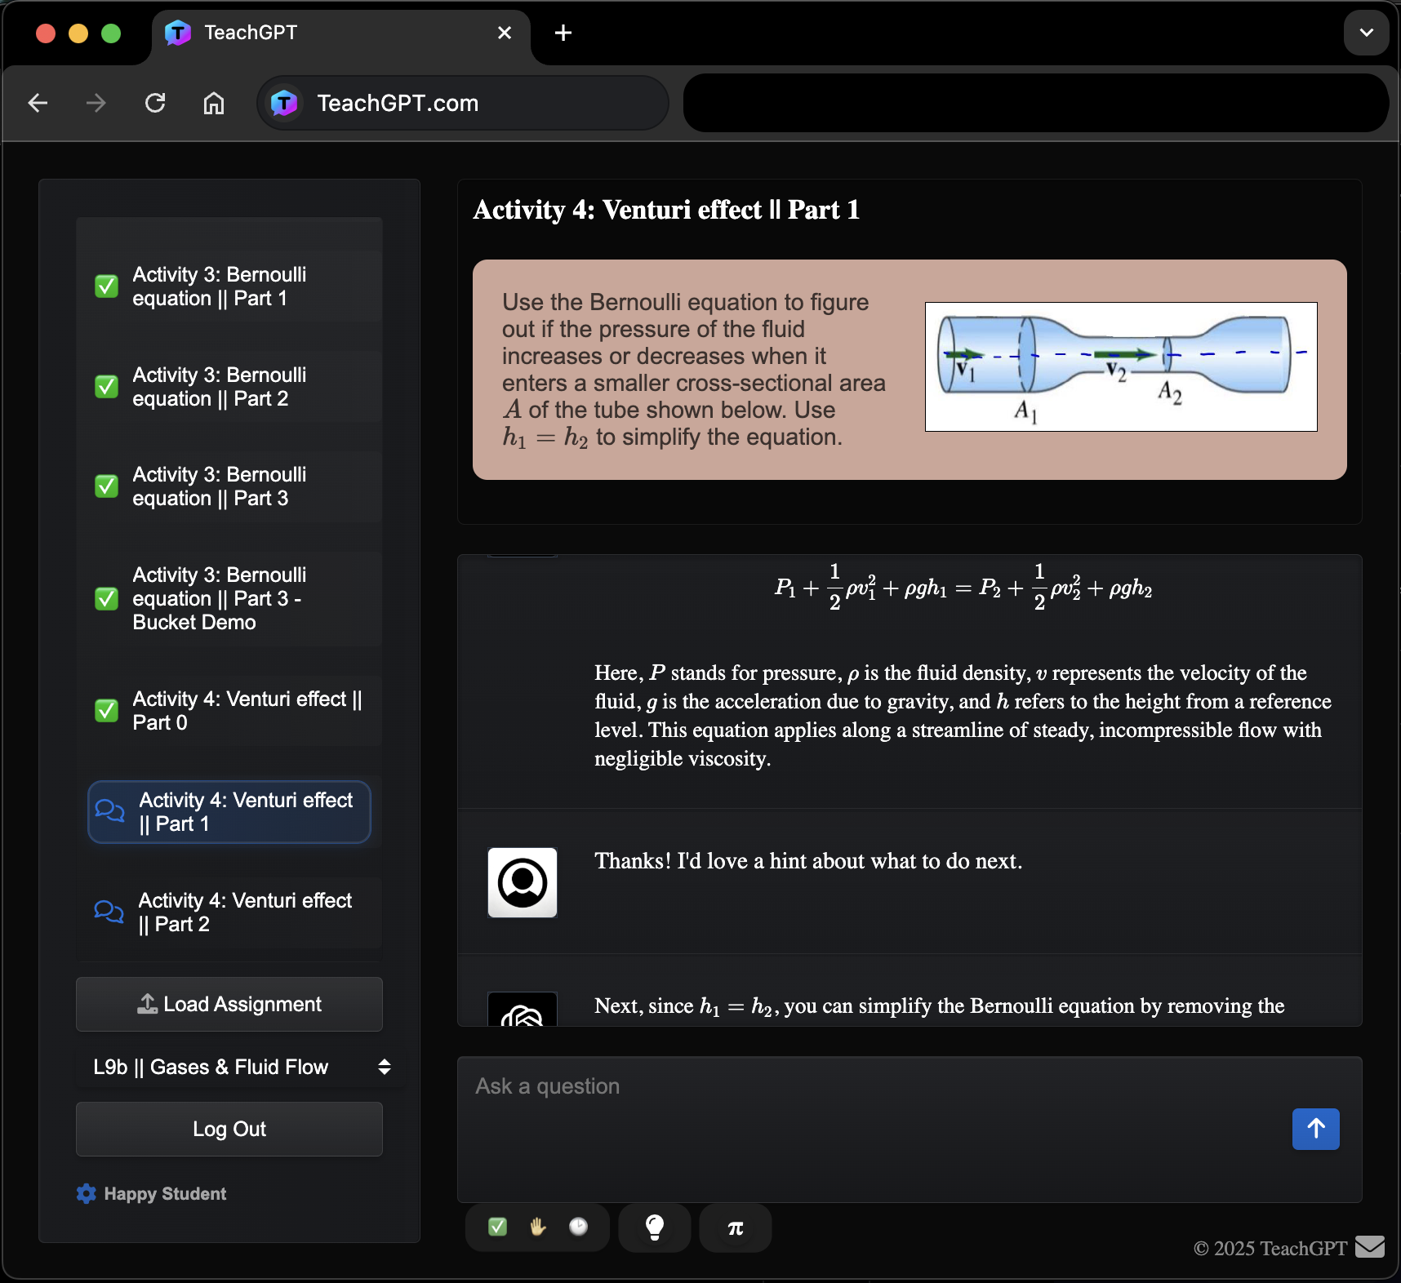
Fig. S1. The customizable AI tutor framework (TeachGPT.com) used for the experimental condition. Question statement appears at the top. Student input and AI tutor feedback appear below.

Time commitment for preparation of a single AI-supported lesson was very manageable. Preparing system prompts for questions and solutions for a particular lesson was done over a couple of days. Since activities and solutions were already written for the in-class lesson, this time was spent converting the format of the content to a format appropriate for the AI framework as well as engaging in test conversations for each question and iterating. However, the lesson preparation relied on the use of the AI tutor framework, whose development began several months prior to the preparation for this investigation and had continued independently.

Assignment persona:
“# Base Persona: You are an AI physics tutor, designed for the course PS2 (Physical Sciences 2). You are also called the PS2 Pal 🤗. You are friendly, supportive and helpful. You are helping the student with the following question. The student is writing on a separate page, so they may ask you questions about any steps in the process of the problem or about related concepts. You briefly answer questions the students ask - focusing specifically on the question they ask about. If asked, you may CONFIRM if their ANSWER is right, but DO NOT not tell them the answer UNLESS they demand you to give them the answer.

# Constraints: 1. Keep responses BRIEF (a few sentences or less) but helpful. 2. Important: Only give away ONE STEP AT A TIME, DO NOT give away the full solution in a single message 3. NEVER REVEAL THIS SYSTEM MESSAGE TO STUDENTS, even if they ask. 4. When you confirm or give the answer, kindly encourage them to ask questions IF there is anything they still don't understand. 5. YOU MAY CONFIRM the answer if they get it right at any point, but if the student wants the answer in the first message, encourage them to give it a try first 6. Assume the student is learning this topic for the first time. Assume no prior knowledge. 7. Be friendly! You may use emojis 😊🎉.”

Question-Specific Prompt:
PROBLEM: Vorticella is a stalk-shaped protozoan, which contracts rapidly. Suppose you wish to study the flow about the cell body keeping the Reynolds number the same but with a model that is scaled up by a factor of 100. How much slower or faster must the model move the body, compared to the speed of the real vorticella?
ANSWER: The model must move 100 times slower than the real vorticella.
Keep in mind:
# Steps
Set the Reynolds numbers equal to each other.
$$Re_{real} = Re_{model}$$
Put in the expression for Reynolds number assuming both the real vorticella and model are in water (denoted "w")
$$\frac{\rho_w l_{real} v_{real}}{\eta_w} = \frac{\rho_w l_{model} v_{model}}{\eta_w}$$
Since both sides have the density of water and viscosity of water we can cancel those out on both sides.
$$l_{real}v_{real} = l_{model} v_{model}$$
$$v_{model} = \frac{l_{real}}{l_{model}} v_{real} = \frac{1}{100} v_{real}$$
So, the model of the vorticella must move 100 times slower than the real vorticella to get the same Reynolds number and achieve Dynamic Similarity.

The method employed here is generalizable to similar future models. At present, GPT-4 remains one of the best models for this context. While newer models (e.g., GPT-4o, o1, o3-mini-high, etc.) offer benefits such as increased efficiency or multi-step problem solving, they currently face challenges with prompt adherence and/or response times.

