OOP LAB ASSIGNMENT

EMPLOYEE SALARY MANAGEMENT SYSTEM

1. Problem Description
A company employs multiple types of employees.
Each employee type has a different method for calculating income, but all employees share common information such as employee ID, full name, and base salary.
Students are required to build an Employee Management System using Object-Oriented Programming (OOP), strictly following the provided UML Class Diagram

2. Employee Types in the System
The system consists of three types of employees:

1. AdministrativeEmployee
- Has no additional attributes
- Income = base salary

2. SalesEmployee
- Has additional attributes:
  - salesRevenue – total sales revenue
  - commissionRate – commission rate
- Income = base salary + (salesRevenue × commissionRate)

3. Manager
- Has an additional attribute:
  - responsibilityAllowance – responsibility allowance
- Income = base salary + responsibility allowance

3. Personal Income Tax Rules
Personal income tax is calculated based on total income:
Income | Tax Rate
Below 9,000,000 | 0%
From 9,000,000 to 15,000,000 | 10%
Above 15,000,000 | 12%

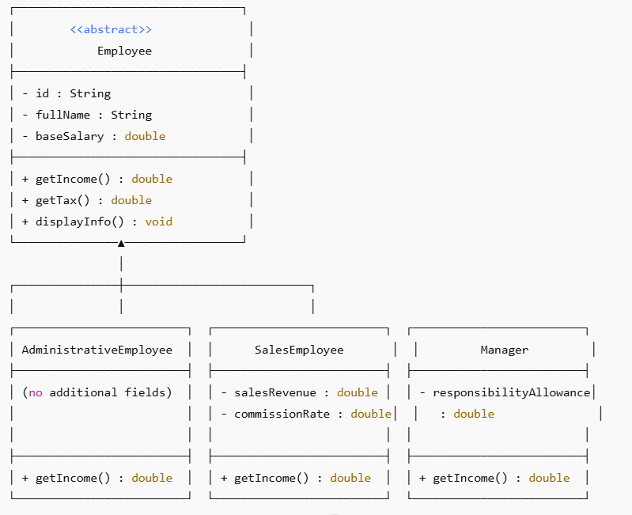

4. Program Functional Requirements
The program must support the following functionalities:
- Input a list of employees
- Display the employee list
- Search for an employee by ID
- Delete an employee by ID
- Update employee information
- Search employees by income range
- Sort employees by full name
- Sort employees by total income
- Display the top 5 employees with the highest income

