DEMO 1 - RAZOR
Step 01 — Tạo project Razor Pages
- Visual Studio → Create a new project
- Chọn ASP.NET Core Web App (Razor Pages)
- Đặt tên: RazorDemo_WebApplication
- Framework: .NET 8.0 (hoặc .NET 7/6)
- Authentication: None, tick Configure for HTTPS
- Create
Chạy thử: F5 → vào được trang Home là OK.
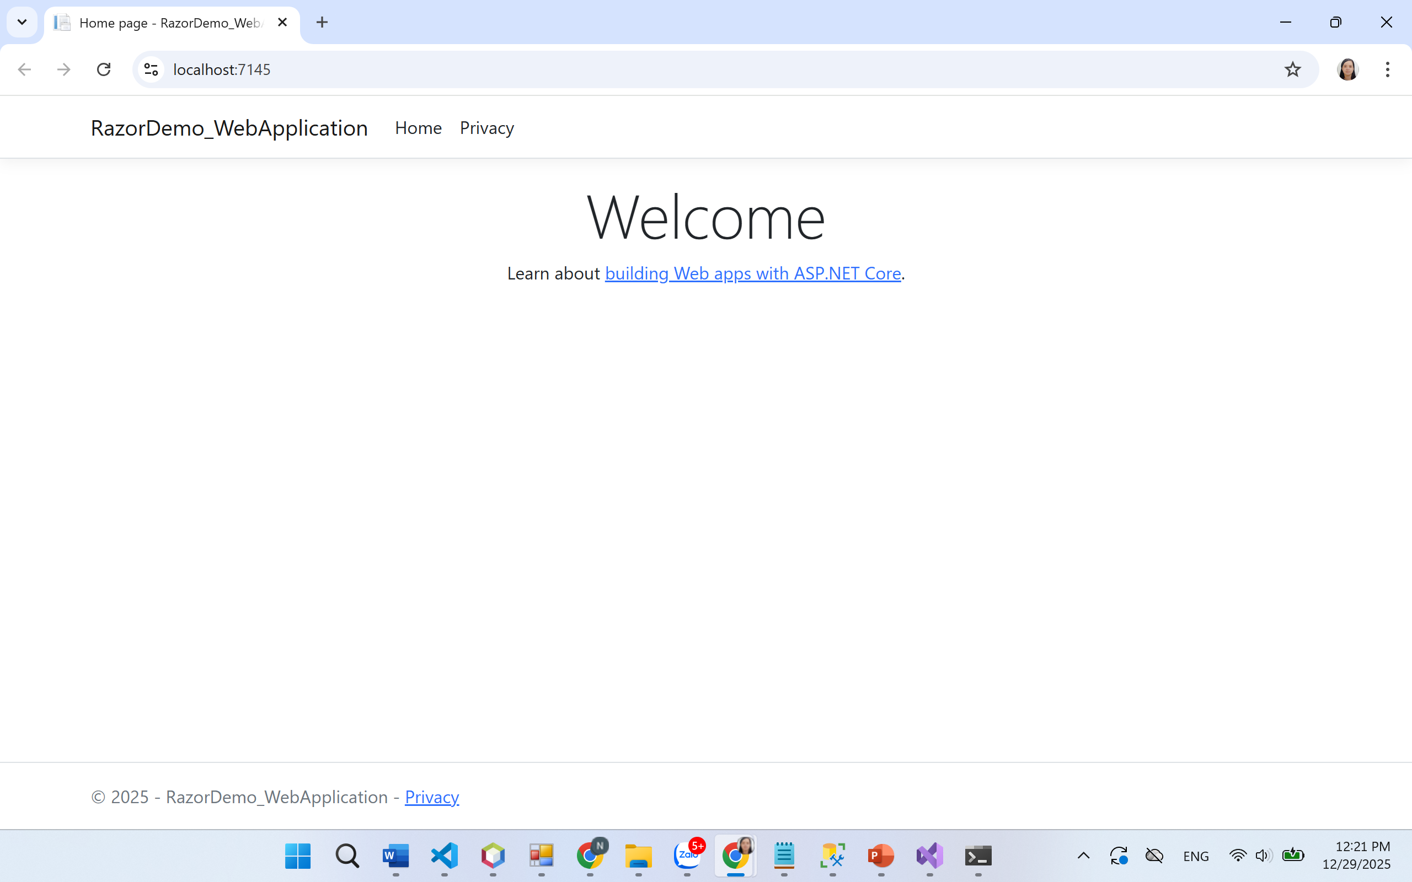

Step 02 – Model Blinding + Validation
Create Model Binding
- Right click project RazorDemo_WebApplication
- Add → New Folder → named: Binding
- Right click folder Binding
- Add → Class
- Create file: CheckNameBinding.cs
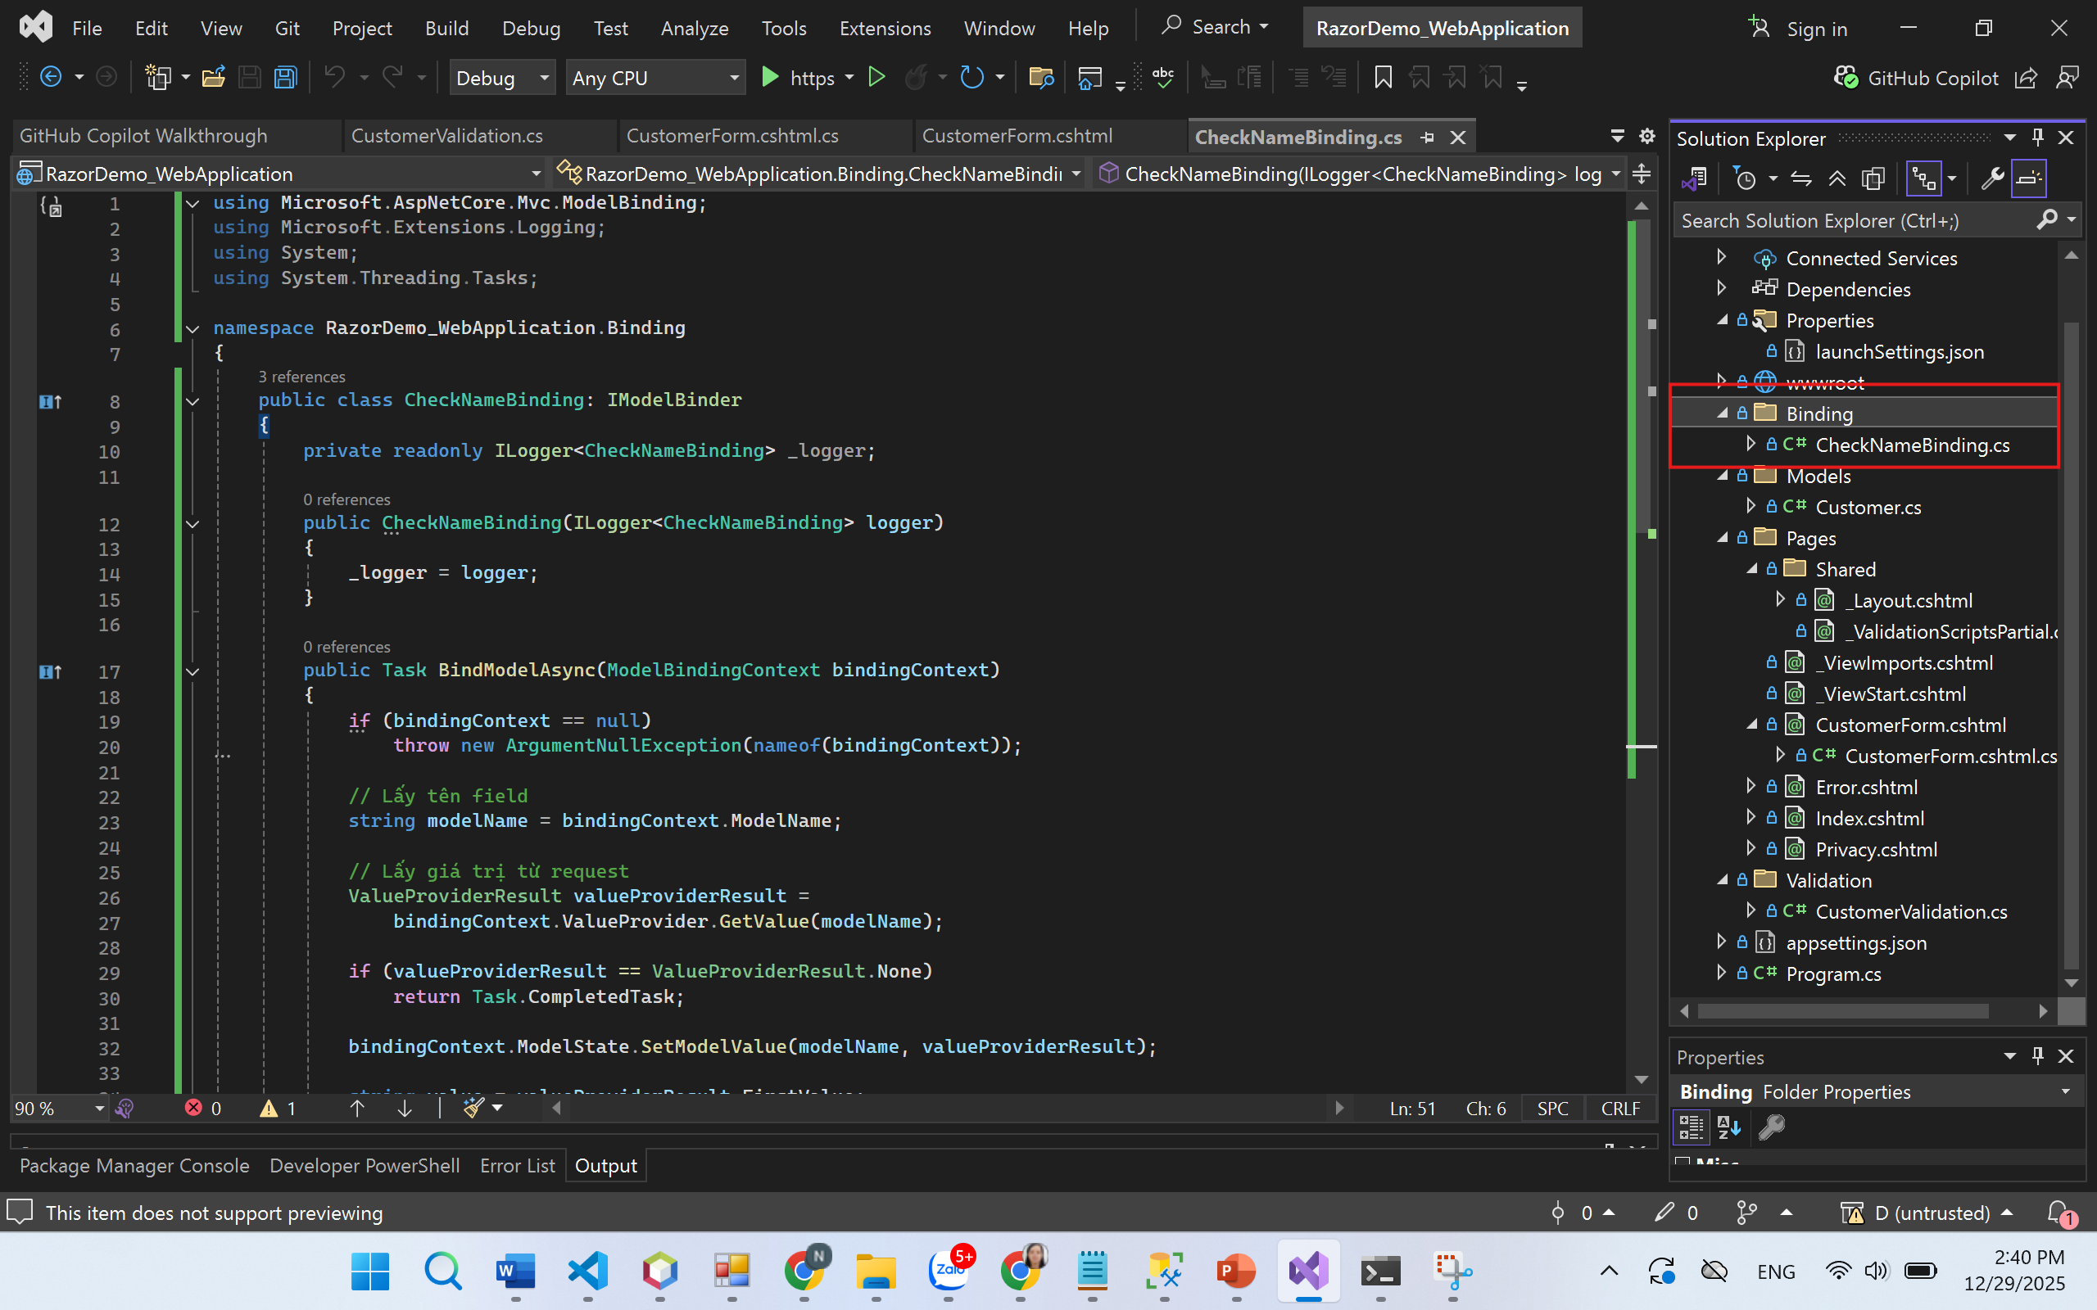
using Microsoft.AspNetCore.Mvc.ModelBinding;
using Microsoft.Extensions.Logging;
using System;
using System.Threading.Tasks;

namespace RazorDemo_WebApplication.Binding
{
public class CheckNameBinding: IModelBinder
{
private readonly ILogger<CheckNameBinding> _logger;

public CheckNameBinding(ILogger<CheckNameBinding> logger)
{
_logger = logger;
}

public Task BindModelAsync(ModelBindingContext bindingContext)
{
if (bindingContext == null)
throw new ArgumentNullException(nameof(bindingContext));

// Lấy tên field
string modelName = bindingContext.ModelName;

// Lấy giá trị từ request
ValueProviderResult valueProviderResult =
bindingContext.ValueProvider.GetValue(modelName);

if (valueProviderResult == ValueProviderResult.None)
return Task.CompletedTask;

bindingContext.ModelState.SetModelValue(modelName, valueProviderResult);

string value = valueProviderResult.FirstValue;

if (string.IsNullOrEmpty(value))
return Task.CompletedTask;

var s = value.ToUpper();

if (s.Contains("XXX"))
{
bindingContext.ModelState.TryAddModelError(
modelName, "Cannot contain this pattern XXX.");
return Task.CompletedTask;
}

bindingContext.Result = ModelBindingResult.Success(s.Trim());
return Task.CompletedTask;
}
}
}

Create custom validation CustomerValidation
- Create folder Validation
- Create file: Validation/CustomerValidation.cs
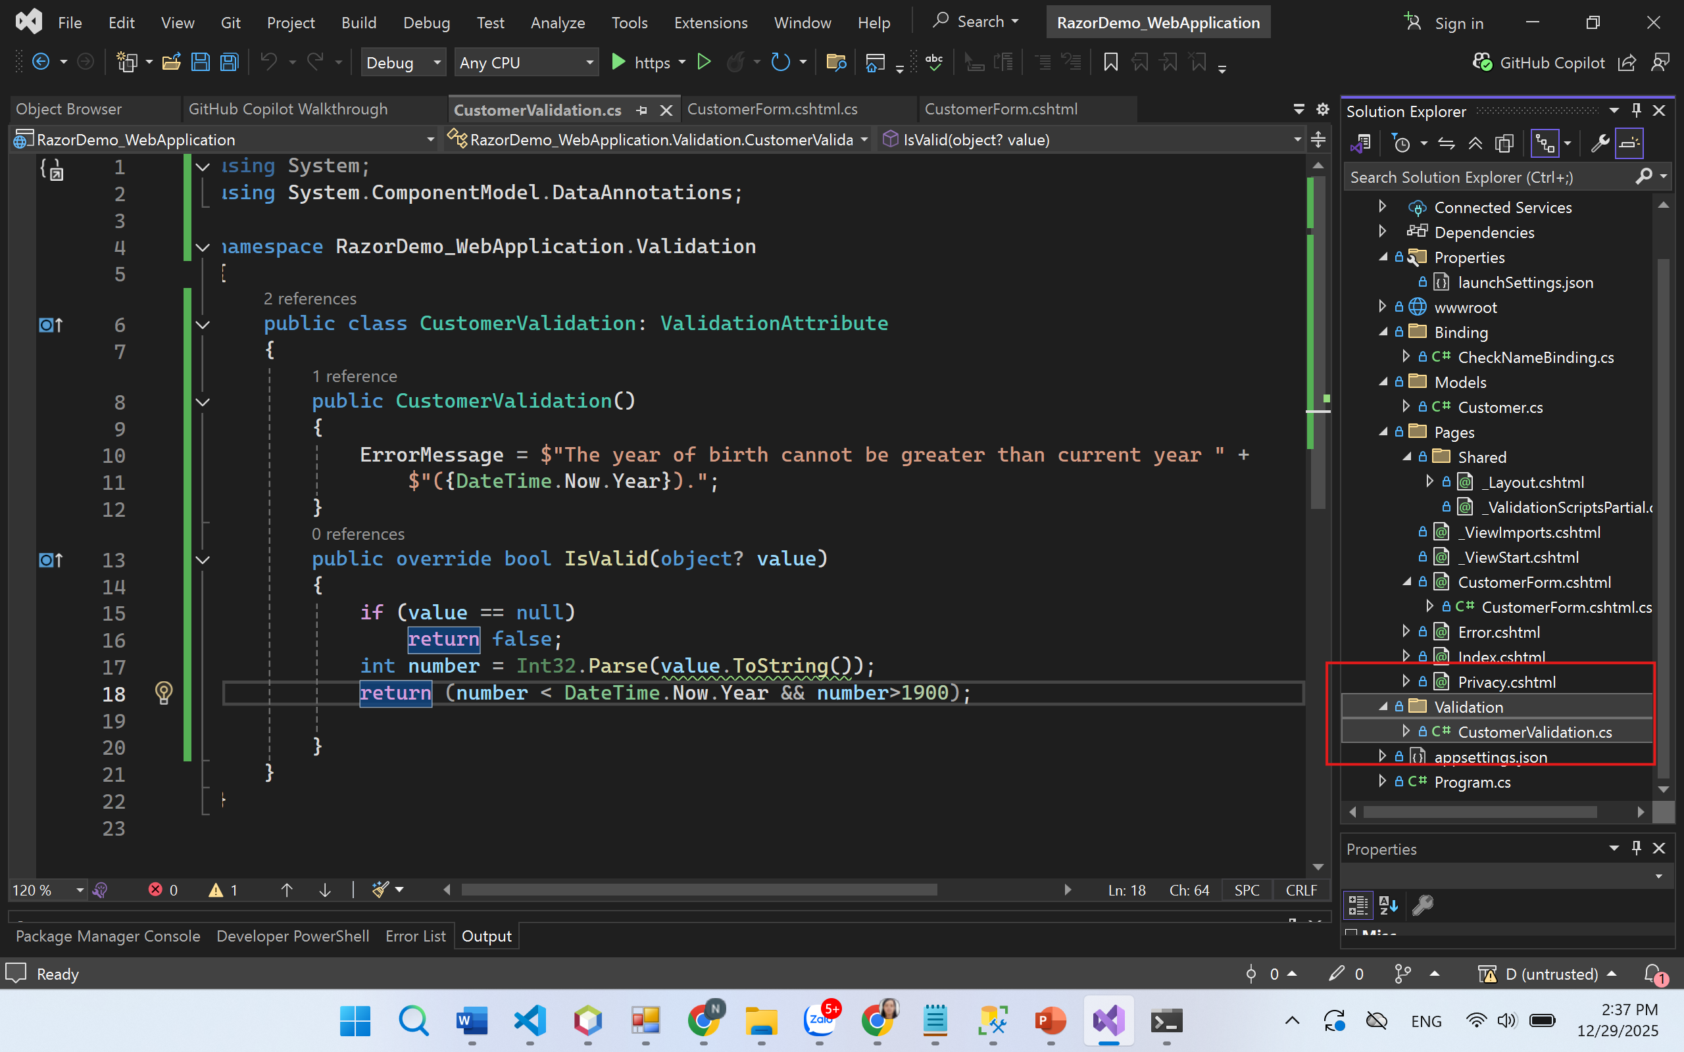
using System;
using System.ComponentModel.DataAnnotations;

namespace RazorDemo_WebApplication.Validation
{
public class CustomerValidation: ValidationAttribute
{
public CustomerValidation()
{
ErrorMessage = $"The year of birth cannot be greater than current year " +
$"({DateTime.Now.Year}).";
}
public override bool IsValid(object? value)
{
if (value == null)
return false;
int number = Int32.Parse(value.ToString());
return (number < DateTime.Now.Year && number>1900);

}
}
}

Step 03 — Model Binding (nhận dữ liệu từ HTTP request)
2.1 Tạo Model Customer
Tạo file: Models/Customer.cs
using RazorDemo_WebApplication.Validation;
using System.ComponentModel.DataAnnotations;

namespace RazorDemo_WebApplication.Models
{
public class Customer
{
[Required(ErrorMessage = "Customer name is required!")]
[StringLength(20, MinimumLength = 3, ErrorMessage = "Name length must be 3-20")]
[Display(Name = "Customer name")]
public string CustomerName { get; set; } = string.Empty;

[Required(ErrorMessage = "Customer email is required!")]
[EmailAddress(ErrorMessage = "Invalid email!")]
[Display(Name = "Customer email")]
public string Email { get; set; } = string.Empty;

[Required(ErrorMessage = "Year of birth is required!")]
[Display(Name = "Year of birth")]
[CustomerValidation]
public int? YearOfBirth { get; set; }
}
}

2.2 Tạo Razor Page “Empty” để nhập Customer
Pages → right click → Add → Razor Page… → Razor Page (Empty)
Đặt tên: CustomerForm
Nó tạo 2 file:
- Pages/CustomerForm.cshtml
- Pages/CustomerForm.cshtml.cs
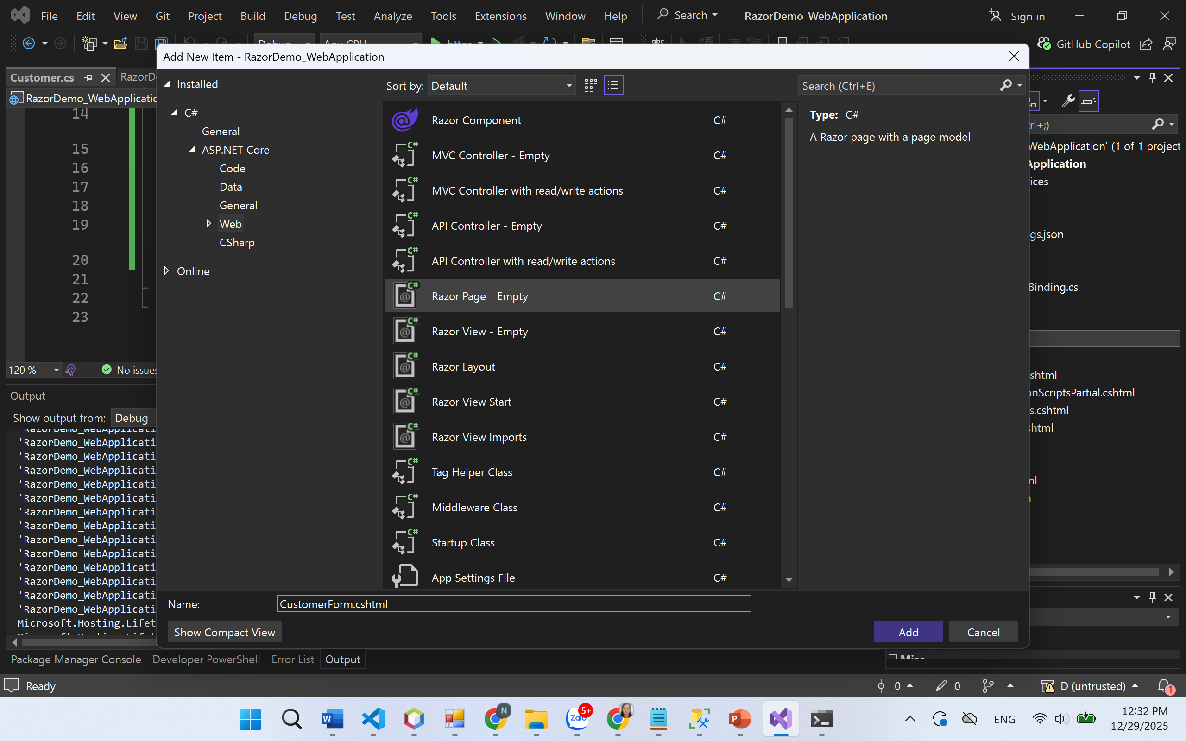
CustomerForm.cshtml.cs
using Microsoft.AspNetCore.Mvc;
using Microsoft.AspNetCore.Mvc.RazorPages;
using RazorDemo_WebApplication.Models;

namespace RazorDemo_WebApplication.Pages
{
public class CustomerFormModel : PageModel
{
[BindProperty]
public Customer CustomerInfo { get; set; } = new();

public string? Message { get; set; }

public void OnGet()
{

if (ModelState.IsValid)
{
Message = "Information is OK";
// nếu muốn clear form sau submit:
// ModelState.Clear();
}
else
{
Message = "Error on input data.";
}
}

}
}

CustomerForm.cshtml
@page
@model RazorDemo_WebApplication.Pages.CustomerFormModel
@{
}
<h3>Customer information</h3>

@if (!string.IsNullOrEmpty(Model.Message))
{
<div class="alert alert-info">@Model.Message</div>
}
<div asp-validation-summary="All" class="text-danger"></div>
<form method="post" class="mt-3">
<div class="mb-3">
<label asp-for="CustomerInfo.CustomerName" class="form-label"></label>
<input asp-for="CustomerInfo.CustomerName" class="form-control" />
<span asp-validation-for="CustomerInfo.CustomerName" class="text-danger"></span>
</div>

<div class="mb-3">
<label asp-for="CustomerInfo.Email" class="form-label"></label>
<input asp-for="CustomerInfo.Email" class="form-control" />
<span asp-validation-for="CustomerInfo.Email" class="text-danger"></span>
</div>

<div class="mb-3">
<label asp-for="CustomerInfo.YearOfBirth" class="form-label"></label>
<input asp-for="CustomerInfo.YearOfBirth" class="form-control" />
<span asp-validation-for="CustomerInfo.YearOfBirth" class="text-danger"></span>
</div>

<button type="submit" class="btn btn-primary">Send</button>
</form>

@section Scripts {
<partial name="_ValidationScriptsPartial" />
}

✅ Chạy: /CustomerForm
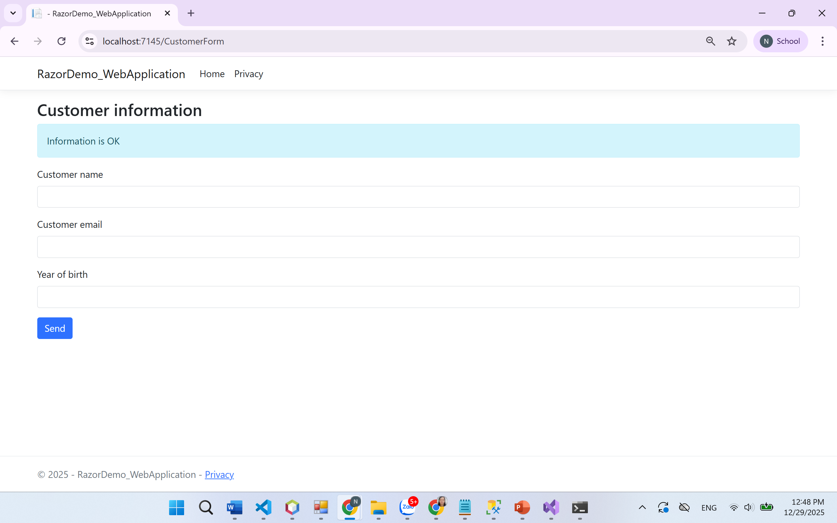
→ nhập sai sẽ hiện validation

Step 06 — Tạo Razor Page upload file (Empty)
Mục tiêu: upload nhiều file và lưu vào wwwroot/images.
6.1 Tạo Page UploadFiles
Add → Razor Page (Empty) → UploadFiles
UploadFiles.cshtml.cs
using Microsoft.AspNetCore.Mvc;
using Microsoft.AspNetCore.Mvc.RazorPages;

namespace RazorDemo_WebApplication.Pages
{
public class UploadFilesModel : PageModel
{
private readonly IWebHostEnvironment _env;
public UploadFilesModel(IWebHostEnvironment env) => _env = env;
[BindProperty]
public List<IFormFile> FileUploads { get; set; } = new();

public string? Message { get; set; }

public void OnGet()
{
}

public async Task<IActionResult> OnPostAsync()
{
if (FileUploads == null || FileUploads.Count == 0)
{
Message = "Please choose at least one file.";
return Page();
}

var imagesPath = Path.Combine(_env.WebRootPath, "images");
Directory.CreateDirectory(imagesPath);

foreach (var file in FileUploads)
{
if (file.Length == 0) continue;

// demo đơn giản: giữ nguyên tên (production nên random/clean tên)
var filePath = Path.Combine(imagesPath, Path.GetFileName(file.FileName));

using var stream = System.IO.File.Create(filePath);
await file.CopyToAsync(stream);
}

Message = "Upload OK!";
return Page();
}

}
}

UploadFiles.cshtml
@page
@model RazorDemo_WebApplication.Pages.UploadFilesModel
@{
}
<h3>Upload files</h3>

@if (!string.IsNullOrEmpty(Model.Message))
{
<div class="alert alert-info">@Model.Message</div>
}

<form method="post" enctype="multipart/form-data" class="mt-3">
<div class="mb-3">
<label class="form-label">Choose file(s)</label>
<input type="file" asp-for="FileUploads" multiple class="form-control" />
</div>
<button class="btn btn-primary" type="submit">Upload</button>
</form>

Chạy: /UploadFiles → chọn file → Upload
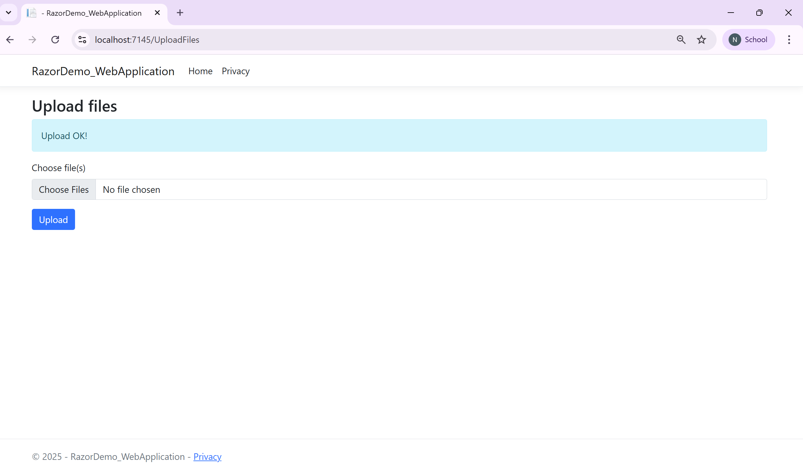
→ file nằm trong: wwwroot/images
