DEMO 2 – RAZOR PAGES WITH ENTITY FRAMEWORK (CRUD)
Step 01 — Tạo project Razor Pages
- VS → Create a new project
- Chọn ASP.NET Core Web App (Razor Pages)
- Tên: RazorPagesLab (hoặc theo bạn)
- Framework: .NET 8.0
- Auth: None → Create → F5 chạy thử OK

Step 02 — Add model: Student, Course, Enrollment
Tạo folder Models rồi tạo 3 class dưới đây
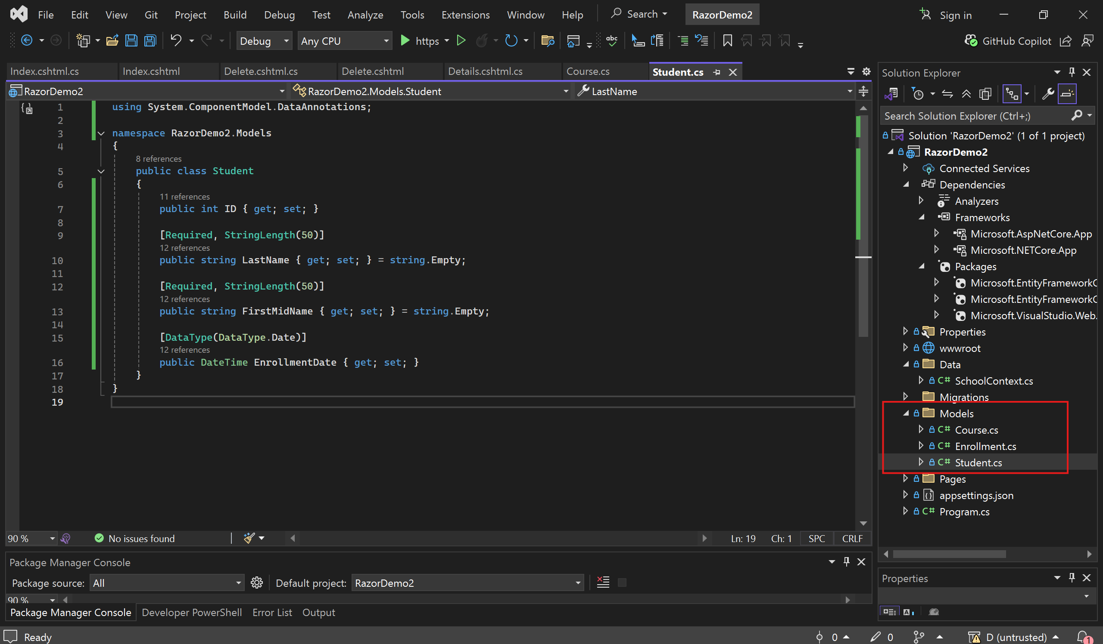
Models/Student.cs
using System.ComponentModel.DataAnnotations;

namespace RazorDemo2.Models
{
public class Student
{
public int ID { get; set; }

[Required, StringLength(50)]
public string LastName { get; set; } = string.Empty;

[Required, StringLength(50)]
public string FirstMidName { get; set; } = string.Empty;

[DataType(DataType.Date)]
public DateTime EnrollmentDate { get; set; }
}
}
Models/Course.cs
using System.ComponentModel.DataAnnotations;

namespace RazorDemo2.Models
{
public class Course
{
[Key] // dùng ID làm PK
public int CourseID { get; set; }

[Required, StringLength(100)]
public string Title { get; set; } = string.Empty;

[Range(0, 10)]
public int Credits { get; set; }
}
}
Models/Enrollment.cs
namespace RazorDemo2.Models
{
public class Enrollment
{
public int EnrollmentID { get; set; }

public int StudentID { get; set; }
public int CourseID { get; set; }

// Nav (để scaffold dễ hiển thị)
public Student? Student { get; set; }
public Course? Course { get; set; }
}
}

Step 03 — Cài NuGet packages (EF Core)
Vào Manage NuGet Packages for Solution → cài cho project:
- Microsoft.EntityFrameworkCore.SqlServer
- Microsoft.EntityFrameworkCore.Tools
- (khuyến nghị) Microsoft.EntityFrameworkCore.Design
Version nên khớp .NET (ví dụ .NET 8 → EF Core 8.x)
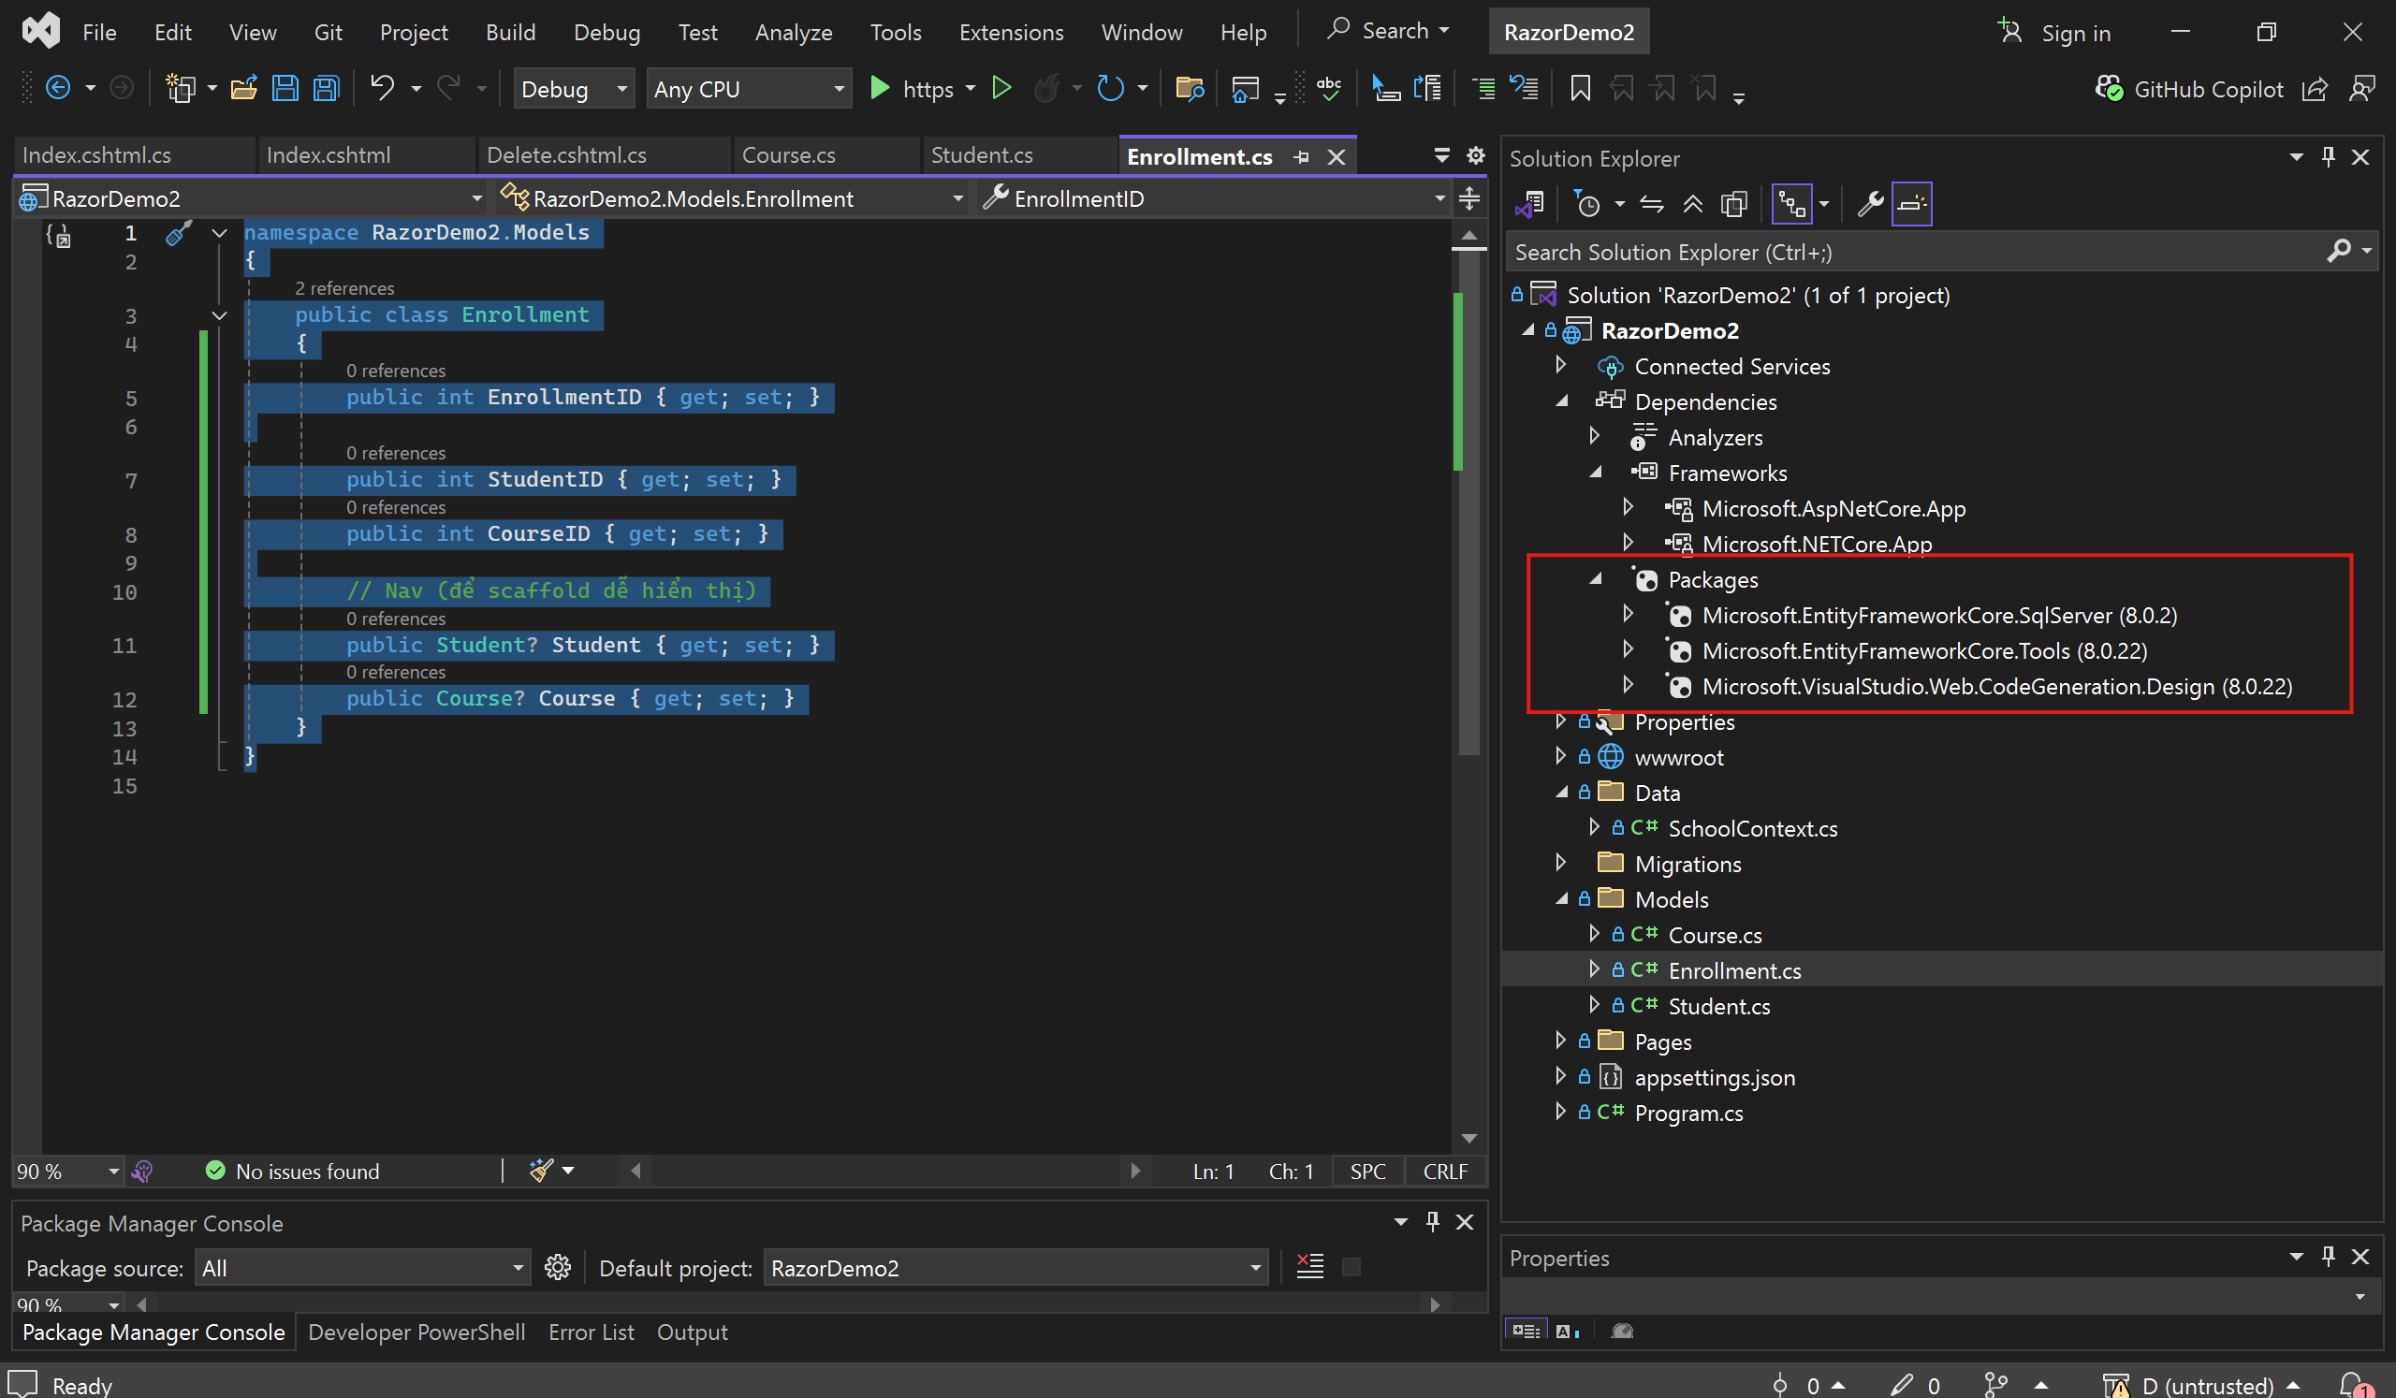

Step 04 — Add Connection String (appsettings.json)
Mở appsettings.json thêm:
"ConnectionStrings": {
"SchoolContext": "Server=(localdb)\\mssqllocaldb;Database=SchoolDB;Trusted_Connection=True;MultipleActiveResultSets=true"
}
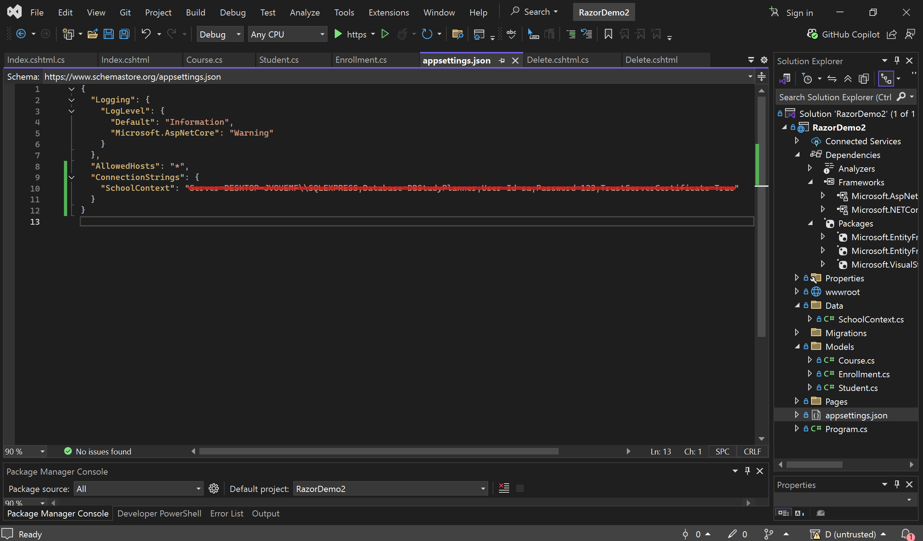

Step 05 — Tạo DbContext + đăng ký vào Program.cs
5.1 Tạo DbContext
Tạo folder Data, tạo file Data/SchoolContext.cs
using Microsoft.EntityFrameworkCore;
using RazorDemo2.Models;
namespace RazorDemo2.Data
{
public class SchoolContext: DbContext
{
public SchoolContext(DbContextOptions<SchoolContext> options) : base(options) { }

public DbSet<Student> Students => Set<Student>();
public DbSet<Course> Courses => Set<Course>();
public DbSet<Enrollment> Enrollments => Set<Enrollment>();
}
}
5.2 Sửa Program.cs
Thêm using + AddDbContext:
using Microsoft.EntityFrameworkCore;
using RazorDemo2.Data;
var builder = WebApplication.CreateBuilder(args);

// Add services to the container.
builder.Services.AddRazorPages();
builder.Services.AddDbContext<SchoolContext>(options =>
options.UseSqlServer(builder.Configuration.GetConnectionString("SchoolContext")));

var app = builder.Build();

// Configure the HTTP request pipeline.
if (!app.Environment.IsDevelopment())
{
app.UseExceptionHandler("/Error");
// The default HSTS value is 30 days. You may want to change this for production scenarios, see https://aka.ms/aspnetcore-hsts.
app.UseHsts();
}

app.UseHttpsRedirection();
app.UseStaticFiles();

app.UseRouting();

app.UseAuthorization();

app.MapRazorPages();

app.Run();

Step 06 — Tạo Database bằng Migration
Mở Tools → NuGet Package Manager → Package Manager Console
Chạy:
Add-Migration InitialCreate
Update-Database
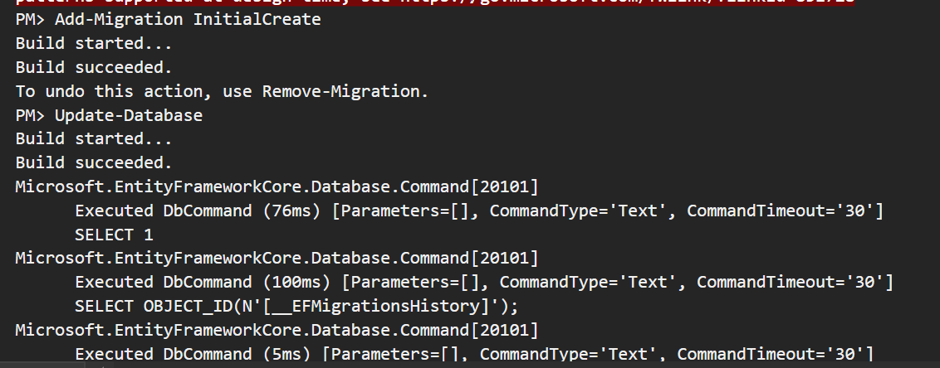
Nếu chạy lỗi:
- kiểm tra build project có lỗi không
- kiểm tra connection string
- kiểm tra package EF Tools/Design đã cài
Nếu gặp lỗi này:
Là do để dòng này không đúng vị trí builder.Services.AddDbContext<SchoolContext>(options =>
options.UseSqlServer(builder.Configuration.GetConnectionString("SchoolContext")));

Step 07 — Scaffold CRUD Student pages (tạo Pages/Students)
- Right click Pages → Add → New Scaffolded Item
- Chọn Razor Pages using Entity Framework (CRUD)
- Model class: Student
- Data context class: SchoolContext (Data/SchoolContext)
- Tick:
  - Reference script libraries
  - Use a layout page
- Add
Kết quả tạo folder:
- Pages/Students/Index.cshtml
- Create, Edit, Details, Delete
Chạy: /Students
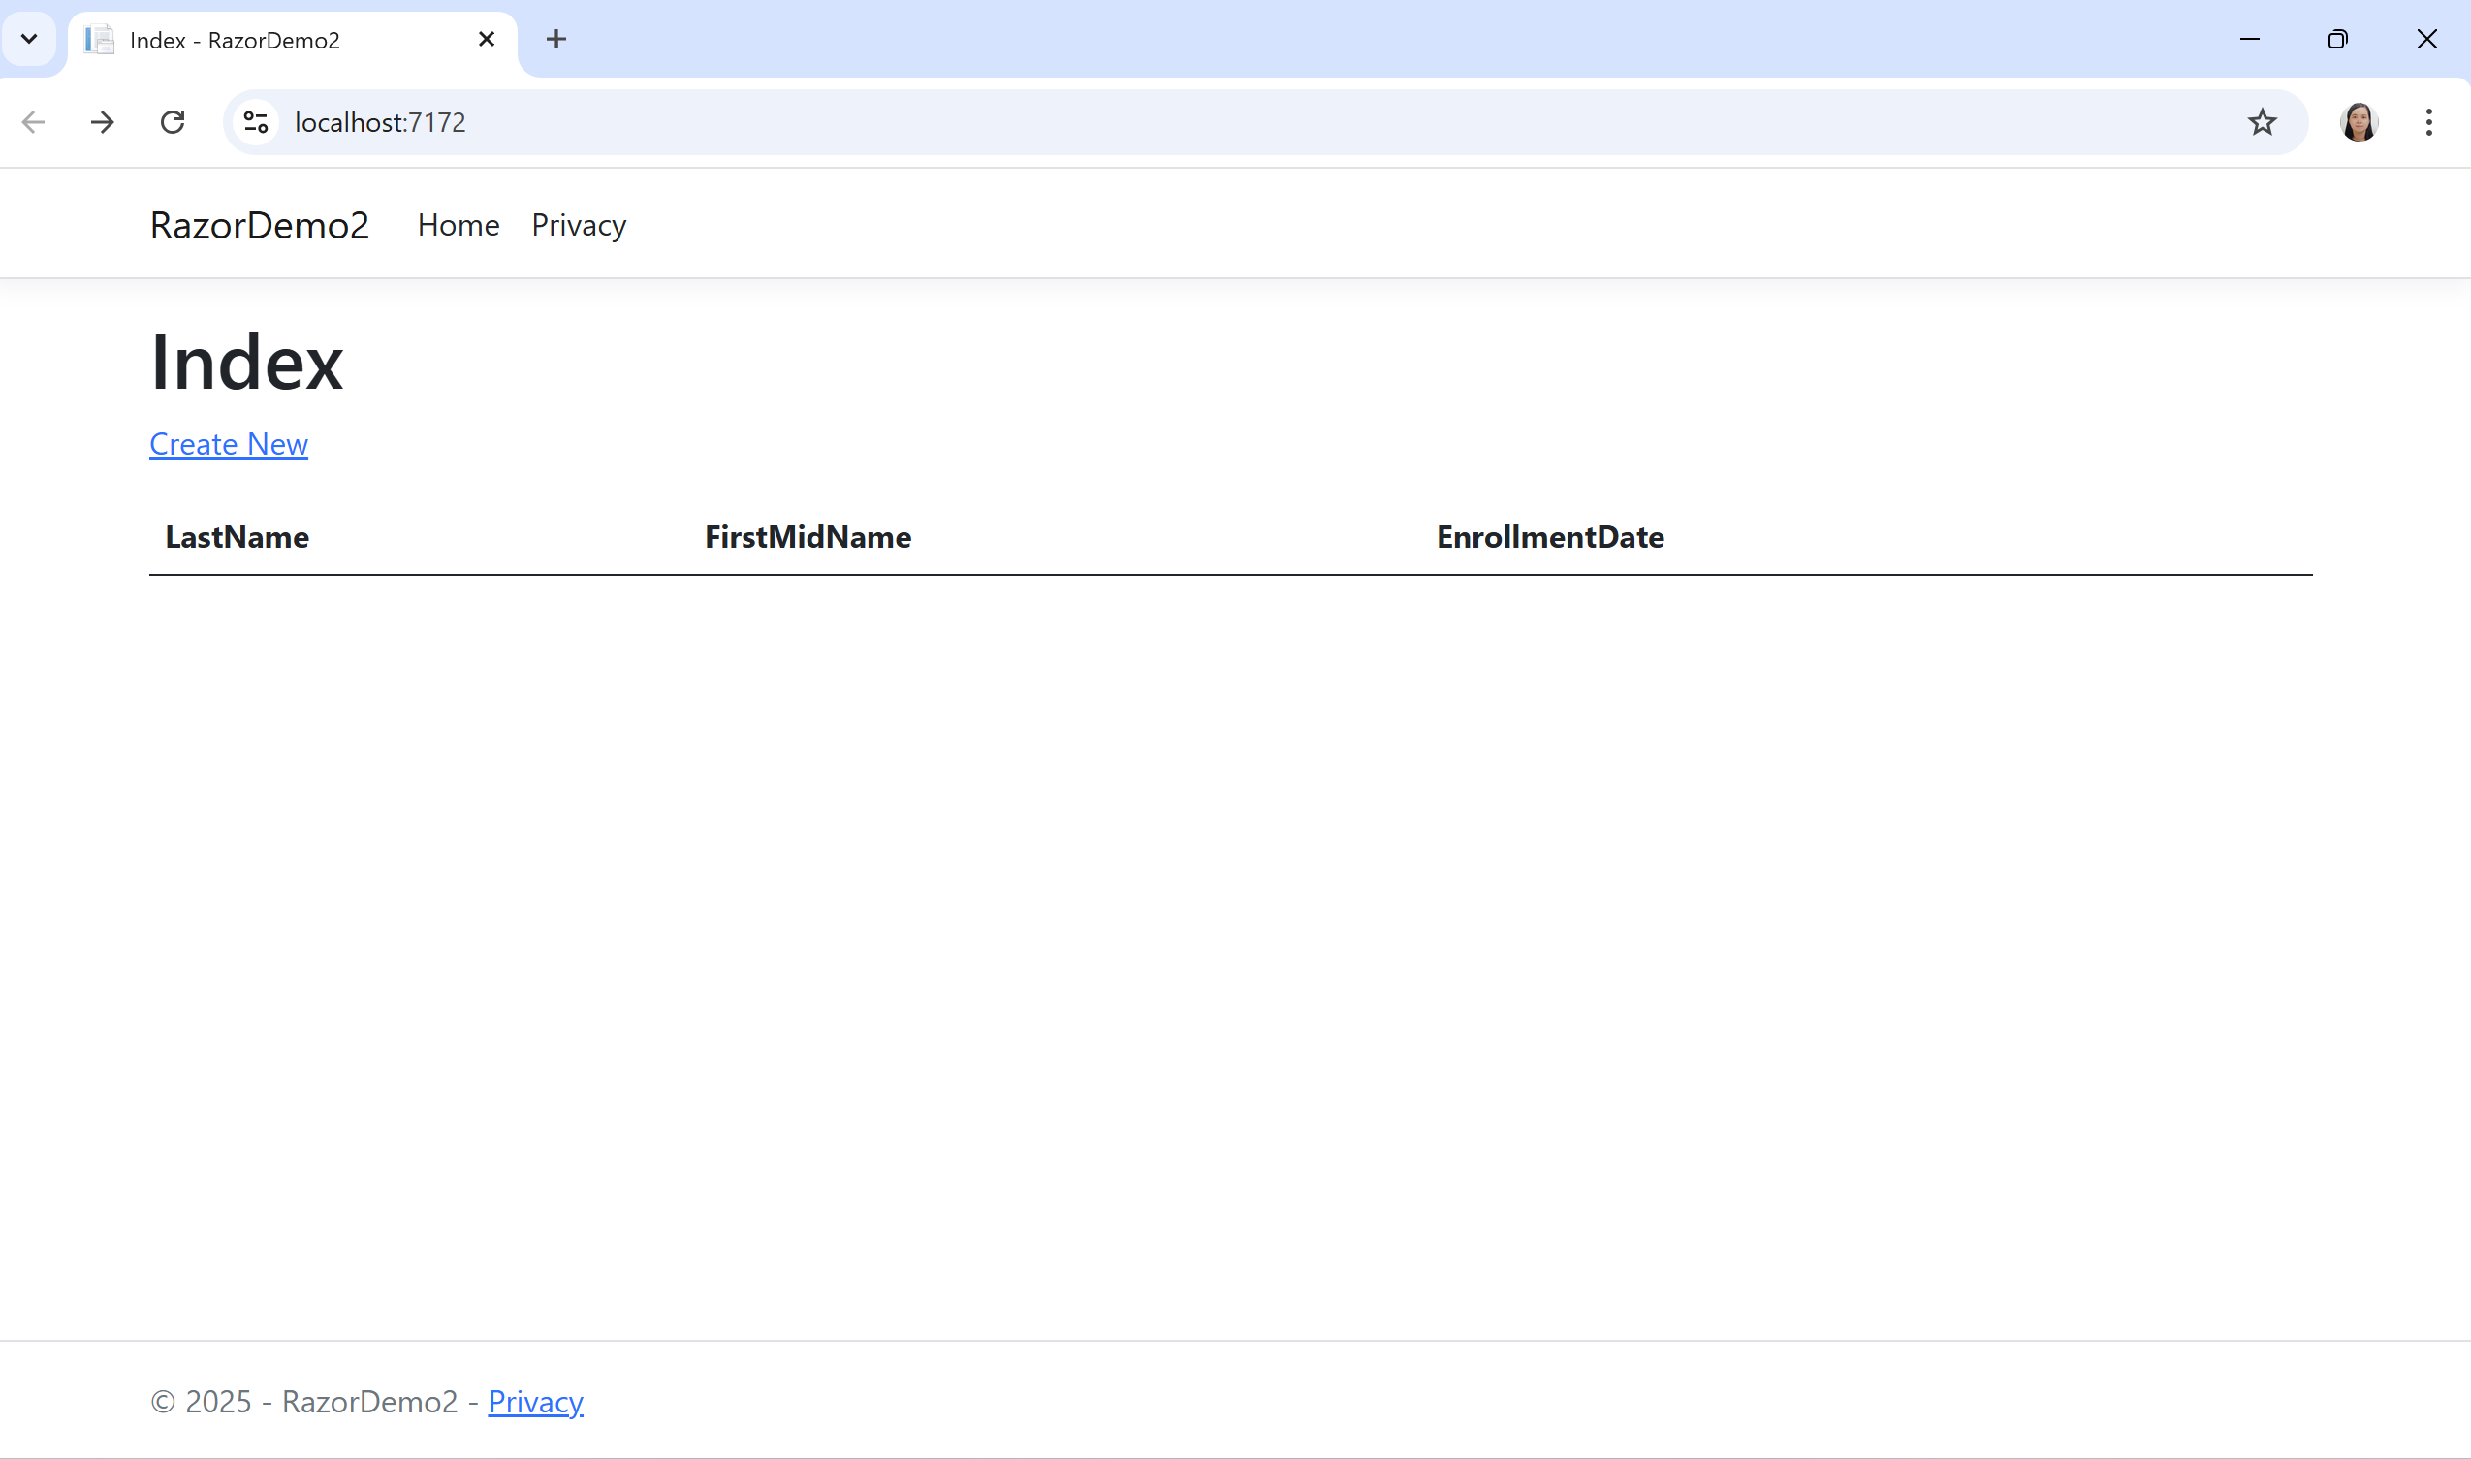
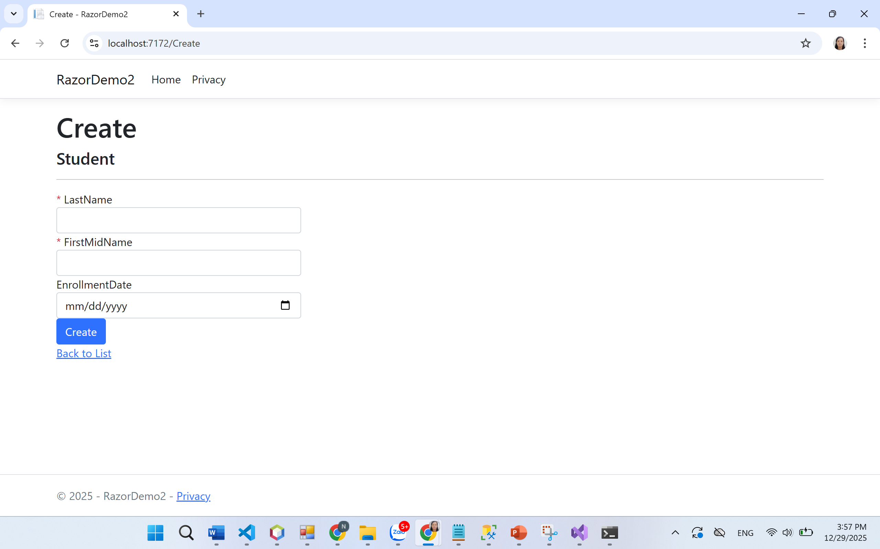
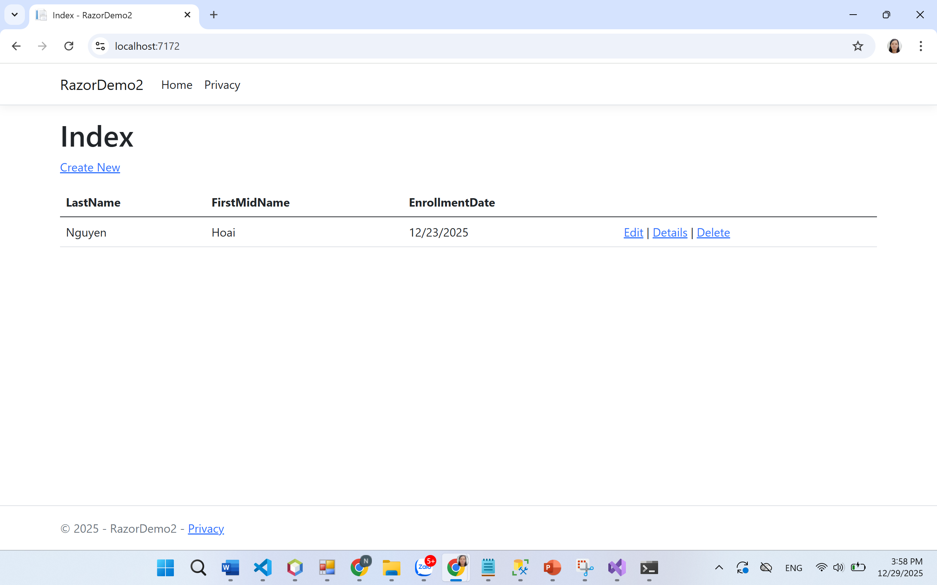

Chú ý: Muốn dữ liệu có sẵn danh sách Student
Tạo file Data/DbInitializer.cs:

using RazorPagesLab.Models;
namespace RazorPagesLab.Data
{
public static class DbInitializer
{
public static void Initialize(SchoolContext context)
{
if (context.Students.Any()) return;
context.Students.AddRange(
new Student { FirstMidName = "Carson", LastName = "Alexander", EnrollmentDate = DateTime.Parse("2019-09-01") },
new Student { FirstMidName = "Meredith", LastName = "Alonso", EnrollmentDate = DateTime.Parse("2017-09-01") },
new Student { FirstMidName = "Arturo", LastName = "Anand", EnrollmentDate = DateTime.Parse("2018-09-01") }
);
context.SaveChanges();
}
}
}
Gọi seed trong Program.cs sau app = builder.Build();:
using (var scope = app.Services.CreateScope())
{
var context = scope.ServiceProvider.GetRequiredService<SchoolContext>();
DbInitializer.Initialize(context);
}

