Structure server:
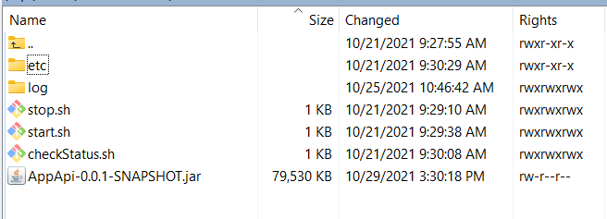

Note:
Build mvn:
mvn clean package -Dmaven.test.skip=true
Eg: file jar’s name is AppApi-0.0.1-SNAPSHOT.jar
-etc : include resource files: config.properties, application.properties, etc
-log : include log file
-stop.sh :
kill `ps -ef | grep AppApi-0.0.1-SNAPSHOT.jar | grep -v grep | awk '{print $2}'`
echo "$1 Stopped!!!"

-start.sh :

nohup java -jar -Xmx4096m -Xms512m ./AppApi-0.0.1-SNAPSHOT.jar > ./log/fullLog.log 2>&1&
echo "API started!"

=>config url log : ./log/fullLog.log

