# CHAPTER THREE

# METHODOLOGY

## 3.1 Introduction

Methodology describes actions to be taken to investigate a research problem and the rationale for the application of specific procedures or techniques used to identify, select, process, and analyze information applied to understanding the problem, thereby, allowing the reader to critically evaluate a study’s overall validity and reliability (Kallet, 2004). This section outlines the steps and procedures used in gathering information required for analysis, system features and requirements, design, implementation and testing methods of the Management Platform for Therapists and Families of Autistic Children.

## 3.2 Requirements Gathering and Analysis

The development of the management system required detailed information targeting the area of therapy for autism and its effectiveness as well as management by both therapist professionals and families of the patients.

### 3.2.1 Data Collection

Data used in outlining major systems requirements and features were collected via two means and information gathered from reviewing existing literature was also used in the analysis of the problem and outline of the system’s features and specifications.

1. Undocumented knowledge gathered from random questions sampling of the parents and guardians of children neurological and developmental disorders at the Child and Adolescent Clinic of the Neuropsychiatric Hospital, Aro, Abeokuta, Ogun State, Nigeria. It was gathered that a large percentage of the parents and guardians don’t have a proper and full knowledge of treatments and therapies being administered to their children and the medications and trainings are not crucially and extremely monitored for signs of progress or adverse effects. Inconsistency in administering therapy to the children as a result of forgetfulness or lax/ignorant attitudes was also observed.
2. A questionnaire was developed to obtain information from the therapist’s perspective and was sent to a known specialist of the Patrick Speech and Language Centre, Ikeja, Lagos. The information gathered further helped in outlining areas in which therapists needed active involvement from the families as well as constant open communication that should be established with all family members involved in the development of the child.

### User Specifications

There are two main users of the system: Therapist and Parent. The Caregiver is a sub-user to the Parent and they are both categorized as Families of the patient. The system flow is structured to focus on the patient (a non-user of the system).

Therapists’ core features are outlined below:

1. Account registration and verification: This includes the profile and professional information of the user and a verification of the account via email
2. Patient registration: This gathers information required about the patient and the parent/guardian’s basic information.
3. Yearly Planner creation: This specifies the current year of therapy and outlines monthly goals to be achieved as well as an activity list highlighted to be assessed and used by parents/caregivers daily.
4. Session reports creation: This includes details on the concluded therapy session and is accessible by parents/caregivers.
5. Progress Records creation: This outlines a report on the progress of monthly goals, also accessible by parents/caregivers.
6. Monthly Reports creation: This gives a detailed summary of the work done over the month, progress achieved and next course of action. It’s accessible to parents/caregivers.
7. Therapists also have access to observations records created by parents and caregivers.

Parents’ features are outlined below:

1. Registration and Login: This outlines the registration process that follow invitation/notification of addition to the platform by therapists and in the case of caregivers, invitation/notification of addition to the platform by parents.
2. Caregivers Account creation: Caregivers are registered by adding/creating accounts with this feature.
3. Observations Records creation: This includes details on concerns and observations on the patient and will be accessed by the therapist.
4. Parents also get access to all records and planner/activity list created by therapists.
5. Parents have access to configure/disable the ability of caregivers to have access to records from the therapists.

Caregivers’ features include verification after registration by parents, observation records creation and access to records and planner/activity list unless configured otherwise by parents.

### 3.2.3 Assumptions

The system is built upon the following assumptions:

1. The family have only one autistic child and at least one therapist.
2. The users of the system have access to internet and have email addresses and phone numbers.
3. The users can operate a smartphone or laptop.

### 3.2.4 Operational Requirements

The management system is a progressive web app that will be accessible on mobile phones as well as laptops and tablets, with JavaScript enabled browsers. It can also be added to a mobile screen as a shortcut similar to those of native mobile apps.

### Software Requirements

The User interface design will be implemented using HTML, CSS and a Vue-based template, to ease design of the different sections and ensure compatibility with some Vue features. The frontend development is based on the JavaScript language and a frontend JavaScript framework, Vue.js while the database and backend development is based on a custom API developed with Node.js, a server-side JavaScript runtime environment and Adonis.js, a Node.js framework.

## 3.3 System Modelling

System modeling is the process of developing abstract models of a system, with each model presenting a different view or perspective of that system (Sommerville, 2011). Models are used to help derive the requirements for a system, describe the system to engineers implementing the system and to document the system’s structure and operation (Sommerville, 2011). The system is modeled using Unified Modeling Language (UML).

### Use-Case Diagram

Use-case diagrams is a graphical representation of a user’s interaction with the intended system and also capture the dynamic behavior of the system. Use cases focus on the system behavior based on an external point of view. A use case describes an action that can be executed by an actor. An actor is an entity that interacts with the system through the use cases. The actors are outside the boundary of the system while the use cases are inside the system boundary.

Figure 3.1 and 3.2 show use diagrams for the main users of the system (Therapist and Families). The three actors are the therapist, parent and caregiver. The therapist is responsible for the creation of most reports which are also accessible to parents and caregivers. The parents and caregivers create observation records and also have access to the patient’s records.

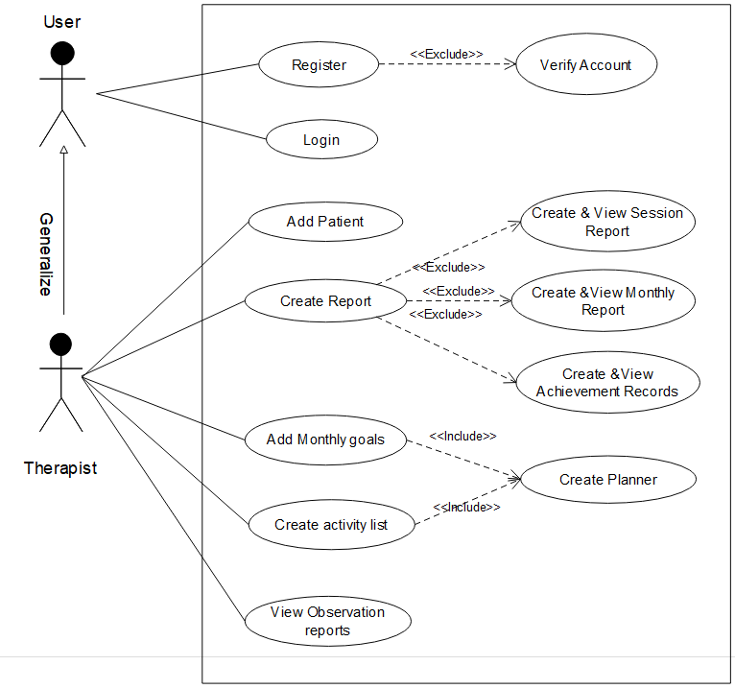

Figure 3.1: Use Case Diagram of a therapist actor.

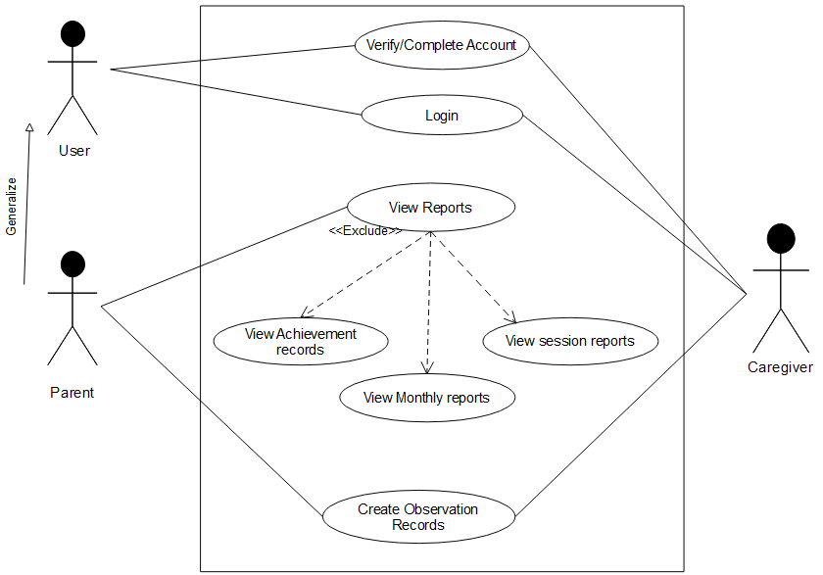

Figure 3.2: Use Case Diagram of parent and caregiver actors.

### Activity Diagrams

Activity diagram is a representation of the flow from one activity to another activity in the system. An activity is a function performed by the system and are associated with constraints and conditions.

Figure 3.3 show the activity diagram of the system, activities of the therapist user, parent and caregiver users and how they interacts with common states as well as conditions and constraints.

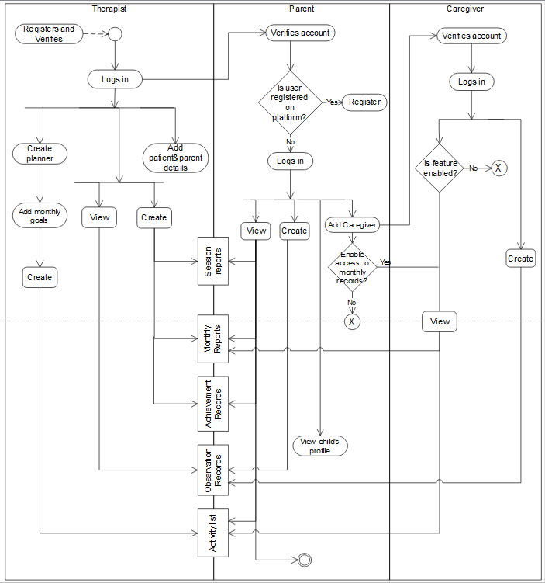

Figure 3.3: Activity Diagram

### Class Diagram

Class diagram is a graphical representation of the static view of the system and represents different aspects of the application. They are used to specify the common structure and behavior of a set of objects. Objects are instances of a class that can be created, modified or deleted during execution and they have attributes and relationships with other objects

Figure 3.4 shows the class diagram for the system.

## Testing

Testing will be carried out on a selected family with a female non-verbal autistic child and her therapist. The users involved will include the therapist, the mother and siblings of the child.

### Alpha-Beta Testing

The testing method will involve the therapist and family having a first interaction with the app, feedbacks will be noted and errors/bugs will be observed. This is called Alpha testing. The feedbacks and errors will be worked on and a second encounter with the app will be carried out. This is known as Beta testing.

The users’ satisfaction and perception of the app will be rated and analysed to get a conclusion on the overall usefulness of the app.