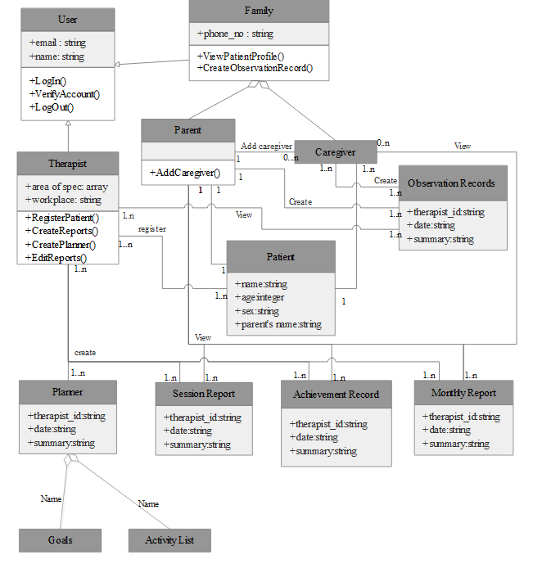

Figure 3.4: Class Diagram