**DEVELOPMENT OF A MANAGEMENT SYSTEM FOR THERAPISTS AND FAMILIES OF AUTISTIC PATIENTS**

**YUSUFF AIRAT OLAMIDE**

**CSC/2014/086**

# CHAPTER ONE

# INTRODUCTION

## General Overview

Autism spectrum disorders (ASD) are developmental disorders that affects communication and behavior. Autism is frequently interchanged with ASD but is however, only one of the four disorders categorised under ASD. Although it can be diagnosed at any age, it is described as a “developmental disorder” because symptoms generally appear in the first two years of life (NIMH 2018). Autism is a spectrum disorder because there are very wide variations in how it affects different people, hence there are several ways to treat and manage the disorder. This usually includes the use of medication and therapy.

There are several kinds of therapy that could help in the development of children living with ASD and the different types include:

1. Applied Behavioral Analysis (ABA),
2. Speech and language therapy,
3. Cognitive behavioral therapy,
4. Occupational therapy,
5. Social skills therapy and a host of others.

However, there are several issues that could hinder the success of therapy and the overall development of the patient. It has been discovered that there are barely any platforms that aid proper documentation of patients’progress by therapists or grants families of the patients, full access to these records. This could lead to disparity and inconsistency in the treatments being administered to the patients and ultimately, hinder the developmental progress of ASD patients.

This creates a need to develop a system that allows proper documentation of patient’s progress and details of therapy, grants full access of the documentation to families of the patients and also provides a communication platform for therapists and families of the patients where observations and concerns about the patients could be addressed.

## Statement of Problem

Management platforms to aid proper documentation of the developmental progress of autistic patients are not free and readily available for use by Nigerian therapists. Parents and caregivers of the autistic patients also do not have complete access to comprehensive details of the patient’s treatment and no platform to properly document their observations. This causes inconsistencies in the therapy being administered to the patient, hence greatly hindering the effectiveness of therapy and ultimately, the development of the patient.

## Aim

The aim of this project is to develop a management system that aids proper documentation of the developmental progress of autistic patients undergoing therapy.

## Objectives

The objectives of this project are to:

1. obtain necessary information about the different kinds of therapy used for the development of ASD patients.
2. carry out extensive literature review of existing works on therapy management platforms for autistic patients.
3. design the user interface and implement the system.
4. test the performance of the implemented system.

## Research Methodology

1. Necessary information needed to build the platform will be gathered through questions and feedbacks from families of ASD patients, questionnaire from therapists experienced in the fields of therapy peculiar to the project.
2. Existing platforms similar to the aim of the project as well as books and publications on speech and language, behavioral modification and social skills therapy will be reviewed. Books, articles and publications on autism and its related disorders will also be reviewed to gather more information.
3. The user interface of the platform will be designed using HTML, CSS3 and other tools that could facilitate an easy and more appealing design. A Vue-compatible template and Bootstrap will be used to design a visually appealing and user-experience-optimized interface. The front-end development will be implemented using the JavaScript language and a client-side javascript framework, Vue.js while the backend development will be implemented with a custom server/API built with Node.js.
4. The system will be tested by signing up therapists and other parties involved in the platform.

## Scope of Project

The management system focuses solely on tracking therapy progress of autistic patients. It will be available to use by therapists and family members with access to smartphones, proficiency in its use and an internet connection.

## Justification

Implementing this project will provide a life-saving solution to parents and guardians of children living with autism in Nigeria to better manage and care for their autistic patients. It will help improve the communication between the patient’s therapists and family relations, thus ensuring all developments and progress of the patients are well monitored and tracked. It also creates an avenue for family memebers to properly document daily observations and concerns about the patient.

## Contribution to Knowledge

The proposed technology will serve as a single solution that addresses and solves related problems in the management of patients’ therapy as well as its proper documentation. It will be a very useful tool for therapists and families to monitor their patients’ progress and for easier communication among everyone involved in the therapy process.

# CHAPTER TWO

# LITERATURE REVIEW

## 2.1 Background Study

Therapy plays a very important and crucial role in the developmental progress of children with ASD. This stresses the need to ensure that the different forms of therapy being undergone by these children is properly and delicately monitored, records of progress and concerns are well documented. Findings from therapists and parents of children with ASD at the Child and Adolescent Clinic of the Neuropsychiatric Hospital, Aro, Abeokuta, Ogun State reflect that therapy management for autism related disorders is done mainly through printed monthly reports of progress through the month and occasional verbal communication of programs and activities to engage the affected children.

The development of a platform that aids communication between the therapists and guardians of children with ASD and also serves as a management platform for proper documentation of the undergoing therapy, therefore addresses the problems and complications of inconsistent therapy and stunted progress.

## 2.2 Autism Spectrum Disorder (ASD)

Autism spectrum disorders (ASD) are a group of complex brain development disorders and covers conditions such as autism and Asperger syndrome (WHO, 2019). According to the World Health Organization(WHO), these disorders persist throughout the lifespan and are marked by the presence of impaired development in social interaction and communication and a restricted repertoire of activity and interest, with or without accompanying intellectual and language disabilities. Autism has been identified as one of the five Pervasive Developmental Disorders (PDD) (WHO, 2006).

The American Psychiatric Association (2013) also described ASD as a lifelong developmental disability characterised by difficulties in social interaction and social communication, and restricted and repetitive behavior. ASD is referred to as a spectrum disorder because there are several variations and no two persons is affected in the same way. The spectrum includes conditions such as Autism, Asperger’s syndrome, and Pervasive Developmental Disorder Not Otherwise Specified (PDD-NOS) (Dempsey and Foreman, 2001).

Statistics show that 1 in 160 children worldwide has an ASD (WHO, 2018) and local organizations estimate over 1 million children in Nigeria have autism-related disorders. Scientific evidence suggests that various factors, both genetic and environmental, contribute to the onset of autism spectrum disorders by influencing early brain development. Research has also found that ASD can sometimes be detected at 18 months or younger and by age 2, a diagnosis by an experienced professional can be considered very reliable (Lord et al, 2006). Diagnosis of young children comprises of general developmental screening as well as additional evaluation by several professionals like speech-language pathologists, neuropsychiatrists and pediatricians (NIMH, 2018). Older children and adults are similarly evaluated and diagnosed with more difficulty. In the current revised version of [Diagnostic and Statistical Manual of Mental Disorders (DSM)](https://www.psychiatry.org/psychiatrists/practice/dsm), all diagnosis carry an umbrella term “Autism Spectrum Disorder”.

There are several signs and symptoms that indicate a child has autism. They usually revolve around social communication/interaction behaviors and repetitive behaviors. The National Institute of Mental Health (2018) highlighted some of these as:

1. Making little or inconsistent eye contact,
2. Rarely sharing enjoyment of objects or activities by pointing or showing things to others,
3. Failing to, or being slow to, respond to someone calling their name or to other verbal attempts to gain attention,
4. Having facial expressions, movements, and gestures that do not match what is being said,
5. Having an unusual tone of voice that may sound sing-song or flat and robot-like,
6. Having trouble understanding another person’s point of view or being unable to predict or understand other people’s actions,
7. Repeating certain or unusual behaviors. For example, repeating words or phrases, a behavior called echolalia,
8. Having a lasting intense interest in certain topics, such as numbers, details, or facts,
9. Having overly focused interests, such as with moving objects or parts of objects,
10. Getting upset by slight changes in a routine,
11. Being more or less sensitive than other people to sensory input, such as light, noise, clothing, or temperature, etc

No cure exists for autism spectrum disorder (Tager-Flusberg and Caronna, 2007), and there is no one-size-fits-all treatment. Treatment of ASD will however, help reduce the symptoms and support development and learning. Early intervention helps in learning critical social, communication, functional and behavioral skills. Treatment usually is in form of therapy and medications.

Medications basically help control symptoms and reduce problems with irritability, hyperactivity, attention problems, and repetitive behavior amongst others. People with ASD may also be referred to doctors who specialize in providing behavioral, psychological, educational, or skill-building interventions.

## 2.3 Autism Treatment

Treatment for ASD should begin as soon as possible after diagnosis. Early treatment for ASD is important as proper care can reduce individuals’ difficulties while helping them learn new skills and make the most of their strengths (NIMH, 2018). As previously outlined, therapy and medication are mainly used in the treatment and management of autism. It should also be noted that autism has no cure and can only be managed.

[Timothy J. Legg](https://www.healthline.com/medical-team) (2018) outlined some medications used to control conditions associated with autism and they include:

1. **Antipsychotics.** These medications help with aggression, self-injury, and behavioral problems in both children and adults with ASD. The FDA [recently approved](https://www.accessdata.fda.gov/drugsatfda_docs/label/2009/020272s056,020588s044,021346s033,021444s03lbl.pdf) the use of [risperidone](https://www.healthline.com/health/risperidone-oral-tablet) (Brand name: Risperdal) and [apripiprazole](https://www.healthline.com/health/aripiprazole-oral-tablet) (Brand name: Abilify) to treat symptoms of autism.
2. **Antidepressants.** Although [researchers](https://iancommunity.org/cs/what_do_we_know/medication) aren’t sure whether antidepressants actually help with autism symptoms, they may be useful for treating [obsessive-compulsive disorder](https://www.healthline.com/health/ocd/social-signs), depression, and anxiety in people with autism.
3. **Stimulants.** Stimulants, such as methylphenidate (Ritalin), are generally used to treat ADHD, but they may also help with overlapping autism symptoms, including inattention and hyperactivity. A review (NIMH 2015) suggested that about half of children with autism benefit from stimulants, though some experience negative side effects.
4. **Anticonvulsants:** Some people with autism also have [epilepsy](https://www.healthline.com/health/epilepsy), so [anti-seizure medications](https://www.healthline.com/health/epilepsy/medications-list) are sometimes prescribed.

Alternative treatments are also administered and The National Center for Complementary and Alternative Medicine (NCCAM) in 2011, defined complementary and alternative medicine (CAM) as “a group of diverse medical and health care systems, practices, and products that are not generally considered to be part of conventional medicine”. It may include placing these children on special diets. Many parents have reported a reduction in autism symptoms when certain dietary interventions have been tried. These diets include the following:

1. Casein-free diet (casein is a protein found in milk; this diet eliminates milk and all by-products of milk).
2. Gluten-free diet (gluten is a protein found in many grains; this diet eliminates such grains).
3. Feingold diet (eliminates additives and chemicals).
4. Specific Carbohydrate diet (removes specific carbohydrates including all grains, lactose and sucrose).
5. Yeast-free Diet (eliminates yeast and sugar).

There are also several therapy approaches that help improve social functioning, learning, and quality of life for both children and adults with autism. Mark Bertin M.D in his article (2016) suggested that behavioral and speech language therapy are typically the foundation of intervention and that the most proven approach for children with autism is behavioral therapy.

### 2.3.1 Behavioral Therapy

Behavioral therapy is employed by therapists to reinforce wanted behaviors and reduce unwanted behaviors in children with ASD. It basically involves carefully observing current behaviors and then targeting specific ones for change. Geraldine Dawson, Chief Science Officer of Autism Speaks stated that early intensive behavioral treatments can help guide brain and behavioral development back toward a normal pathway (Dawson, 2008). There are several forms of behavioral therapy approaches which are effective and safe in their treatments, although costly and labor-intensive.

Applied Behavior Analysis (ABA) is the most studied and commonly used behavioral intervention and has been around for more than 50 years (Bertin, 2016). It is a highly structured, scientific approach that teaches play, communication, self-care, academic and social living skills, and can reduce problematic behaviors.It investigates environmental variables influencing socially important behaviors and uses those findings to implement interventions that will improve such behaviors(Cooper et al, 2007). There are different types of ABA approaches and they include:

1. **Discrete Trial Training (DTT):** It is the most deliberate and purest form of ABA. It involves teaching new skills in a controlled, step-by-step way (NIMH, 2017). The breaking of tasks and behaviors into several small steps increases the likelihood of achieving success with learning the skill.
2. **Positive Behavioral and Support (PBS)**: It is used to figure out why a certain problem behavior is being exhibited by the child. Changes that could make a correct behavior more positive for the child are enacted.
3. **Pivotal Response Training (PRT)**: Its aim is to improve "pivotal" skills, such as motivation and taking initiative to communicate and the training takes place in the child’s everyday environment.
4. **Early Intensive Behavioral Intervention (EIBI)**: It provides individualized, behavioral instruction to very young children with ASD and usually requires a large time.

Relationship Development Intervention (RDI) is a relatively new form of behavioral therapy that focuses on the social behaviors of the child. Activities are set and carried out usually by parents intensively. This therapy is more effective on younger children but also appears to work on older children.

Sensory Integration therapy is another form of behavioral therapy that is concerned with improving the sensitiveness to sensory stimuli that may be overwhelming to children with ASD. Stimuli like loud noises, bright lights and touches are usually worked.

Cognitive Behavioral therapy (CBT) is also another form of therapy used in reducing challenging behaviors like obsessions or emotional meltdowns and it helps in the regulations of emotions and impulse control.

### 2.3.2 Speech and Language Therapy

Speech-language therapy can help people with autism spectrum disorder (ASD) improve their abilities to communicate and interact with others (Paul, 2008). Speech and language therapists help to assess, diagnose, and support autistic people by working to enhance their communication skills, so that individuals with autism can effectively communicate their thoughts, needs and feelings (RCSLT, 2009). They can help improve their spoken or verbal skills as well as their non-verbal communication. Some children on the spectrum are non-verbal, hence therapists focus on the teaching of non-verbal communication skills like the use of hand signals or sign language and also the use of picture symbols.

It could also include improving on social skills and normal social behaviors like learning to make eye contact with other persons, sit and stand in close proximity with “strangers”.

## 2.4 Therapy Management

There’s still very limited understanding about ASD and its implications, hence the management and critical monitoring of a patient’s therapy is an area yet to be fully explored. Families are often criticised and isolated from their communities due to limited knowledge about the disorder. There’s a need to enlighten the communities to embrace these children and encourage their training and development by not excluding and isolating them. Parents and families are encouraged not to hide these children, rather seek all kinds of extensive care and treatments that could help improve their conditions. They are required to be fully involved in the trainings by the therapists as well as ensure close monitoring and tracking of the developmental progress of the children.

In recent times, a lot of technologies, with more focus on mobile technologies, have been built to manage and help in the management of several aspects of the lives of patients with ASD. These technologies span across several kinds of therapies, as well as location tracking, to help know the locations of ASD patients (especially non-verbal and severe autism patients) at all times. Although these technologies might be lacking in different areas, they each focus on a particular area and help improve conditions in that aspect.

## 2.5 Related Works

Hiong Voon et al (2015) worked on the design and development of a mobile communication platform, AutiSay, to be used by autistic children and their caregivers, parents, teachers and therapists. The aim was to make use of advanced mobile and ubiquitous technologies to develop a communication tool to improve the social communication of the autism child and therefore alleviate the quality of life for the child and those around him/her. Similar apps for autism in the communication category were reviewed as well as the limitations on which AutiSay was to improve upon. The app was designed based on the Picture Exchange Communication System (PECS) and a beta version was used to test and note areas of improvement. The feedbacks were used in the development of AutiSay and it had about four features available for use. The benefits were reviewed, from its portability, ease of customization and relatively inexpensive costs. However, it was recommended that other content options should be made available for adults with autism, in place of the pictures. The app was also developed only for iOS and was recommended that an android version be made available.

Eder et al (2016) developed an interactive mobile game application for autistic children. The app was named “Fill Me App” and was primarily focused on the identification of human body parts and a centralized database that could be accessed by parents and caregivers of the child for progress. Existing applications that were useful in the development of social skills and emotional connections were reviewed along with games that were built for education for children with ASD. The features of this game application included a scoring system for focus monitoring, eye-catching graphics, simple level of exercises, video tutorial and background music that coincide with the current educational teachings. Data on the attention span of children in different age groups was collected and analysed. It was concluded that the app was effective in improving the attention span of autistic children and keep them more motivated than traditional methods.

Meng Chun et al (2017) developed an interactive story books app (ISB) as a speech-language therapy tool for special needs children in Malaysia. It was designed for Malaysian children with cognitive disabilities and speech-language impairments. The app was developed using the Android platform and included three parts (ISB, speech exercise and animated songs). Although the speech technology in computer-assisted language learning is also widely used in Malaysia, this app is aimed at being a form of interactive entertainment, in which the player can explore, learn and practice by themselves. The platform was developed using JavaScript with a Graphical User Interface in HTML, hence it is platform independent and can run on all mobile operating systems. Information required to develop the app was gathered through the use of survey questionnaires on parents and children in the speech-language therapy area of a Malaysian clinic. The app was then evaluated by experts, parents and children on its usefulness and contribution to ease of learning. Conclusions showed that parents as well as therapist experts agreed the app was a speech-language therapy tool for the children and suggested on improvements.

Doenyas et al (2014) conducted a study in Turkey to teach picture sequencing skills to children with autism using a web-based iPad application. It was noted that the use of technological advancements has more effect in the training of autistic children. The application was designed to improve upon existing sequencing applications and five sequencing apps were reviewed along with their limitations. It was built based on ABA methods and hence had three different design conditions and two types of session. The app was web-based and built on HTML5 and CSS3, along with JavaScript/jQuery for compatibility on all platforms. Three Turkish boys with autism of age 4, 11 and 15 participated in the evaluation of the application. Results from testing showed that the app was more suitable if built in different versions for different age groups, identified the communication and vocabulary skill level of the child and provided a generalization check to ensure the child can communicate activities carried out on the app to third parties.

Soron (2017) discussed the different technologies that can be used to assist in the treatment of ASD. Mobile phone apps can be used to assist in the screening, providing interventions as well as of follow-ups of the patients. The development of a global technology based mobile hub of the sign- symptoms and challenging behavior of autism can also help to track the time trends, sociocultural and regional influence. A mobile-based text message service can also be used as an assistive device to help augment communication and keep the caregivers updated and trained at their convenient time remotely. It can also be very useful in tracking the signs and symptoms of the children. Another major technology solution is to provide an internet-based cognitive behavior therapy for caregiver’s anxiety and depression that they may develop in the course of the managing the children. Social media is also an explosive technology that can be used in assisting the treatment of autism by providing a platform for families of children with ASD to connect and share their experiences. Interactive computer games and programs can also help improve communication and social skills of children with ASD. Final conclusions highlighted that the use of mobile-based services has great potential in taking care of autism.

Won Kim et al (2017) examined the smartphone apps currently available for autism and the clinical evidence supporting its use and effectiveness. It was discovered that there were nearly 700 “autism apps” amongst about 95.1% were either no longer available, completely outdated or had no clear direct or indirect evidence supporting their benefits. It was concluded that there needed to be structural guidelines to follow as well as clinical evidence supporting its benefits before the development and release of any autism-related application.

Costa (2011) gave a brief summary of how robots can be used to help the treatment of ASD. A robotic project was developed with the goal of improving the social life of children with autism with a main focus on promoting their social interaction and communication. The advantages and disadvantages of the implementation was examined and discussed. The problems included tailoring the robotic activities to each child’s specific needs as ASD is a spectrum disorder and doesn’t affect any two persons in the exact same way. The specific adaptation could lead to complications in its use but the problem can be averted by specifying a wide range of activities. It was also highlighted that engaging in activities with the robot can promote isolation as the child plays alone. This contradicts the efforts being made to increase patient’s interaction with his/her environment. This can be averted by making use of the robotic tool, only as a third party between the patient and the therapist.

Vlachou and Drigas (2017) evaluated the use and effectiveness of mobile technologies for assessment and as treatment interventions for children and adults with ASD. They reviewed three prototype applications developed for the purpose of updating the assessment and diagnosis of children with autism (CWA), as well as the therapeutic interventions. They included The Walden Monitor, (a wearable prototype for recording observable data, with a head-mounted bullet camera based on a Tablet PC for the research assistant to capture the child’s data), Abaris (an Environmental Prototype for Recording Discrete Trial Data where therapists use a tablet application to customize the child’s daily therapy and to record data) and Care-Log (a distributable prototype for recording semi-structured data that consists of a mobile system using the configuration of capture and access devices designed to collect this information). Although found useful, it was concluded that these prototypes were not flexible enough to support the cyclical activities involved in caring for CWA and although different variations were made (including iPad mobile applications), they still fell short in terms of individualizing each user’s needs. Mobile tools for interventions were also reviewed and three major domains were analysed: Augmentative or Alternative Communication (AAC), Academics and Entertainment. It was concluded that mobile technology assessment tools were very important for initial diagnosis of autism and for updating assessments throughout a patient’s therapeutic intervention and that there was always space for further development.

Alzrayer and Banda (2017) outlined some guidelines for special education teachers to improve communication skills of students with autism by implementing tablet-based devices. It was outlined that research supports the use of tablets for improving communication skills in individuals with ASD and other developmental disabilities and that augmentative alternative communication (AAC) devices and methods were often used to address their communication needs. The following guidelines were recommended to special education teachers in the selection of an iPad/iPod and AAC app that meets the student’s requirements and assists in the implementation of the methods effectively: Assessment of the student’s related abilities, selection of a device and app, conducting a preference assessment, train using systematic instructional methods, collection of intervention data and evaluation of progress, program generalization and finally, teaching of operational skills. It was concluded that the implementations of these guidelines by teachers could have positive effects on students with ASD.

Fletcher-Watson et al (2016) evaluated a technology-based early intervention for social communication skills in preschoolers in a randomised controlled trial. The study evaluated 54 children who tried out the iPad apps. Results showed that there were no significant group differences in parent-report measures nor in a measure of parent–child play at follow-up. It was concluded that there were no significant benefits of playing the app on real-world social communication behaviours, although there were indications of positive impact.

Crespo and Martin (2017) reviewed several applications with Spanish versions focused on support for individuals with autism spectrum disorder. A systematic search was conducted to gather scientific publications that evaluated these mobile applications and data was extracted from these documents using bibliometric analysis. Results from search showed that there were applications available with and without Spanish versions, with the predominant language being English and from approach showed that the applications were categorized mainly as communication, learning, leisure support tools, emotions and social behavior, and resources for parents and professionals, with about 44% being multipurpose and learning being the most popular category. Results from platform perspective showed that most of these applications were developed for iOS platforms and from the price, age of use and scientific validation perspective, only 32% were free applications, about 71% were for individuals of all ages and only about 4% had scientific evidence to support them. It was concluded that the use of apps and mobile devices should be seriously considered when seeking to acquire communication and social skills, as well as social behavior improvements in people with ASD. It’s also recommended that more apps developed for these interventions should be more generalized in terms of language.

Chukwueloka (2016) in her dissertation thesis evaluated the attitudes of Nigerian mothers towards their autistic children. Information was gathered through the interviews of eight Nigerian mothers caring for their autistic children in South-Eastern Nigeria. The findings were interpreted in seven themes, one of which was a conclusion that Nigerian mothers recognize Autism as a developmental disorder and no exact cause for it, although attributed to genetic and environmental influences. Studies also showed that the mothers and immediate families of the children treated them with love and care, engaged and interacted with them as well as participated in their treatments. It was also found out that members of the community still viewed autism as “abnormal” and “spiritual” and that more efforts needed to be made on spreading awareness about the disorder. The participants also reported that they engage the children in different forms of therapy as treatment but there were also hindrances like inadequate specialist care, expensive treatments and no involvement from the government. Findings also showed that the mothers and families had challenges raising autistic children, as they exhibit behaviors that require patience and perseverance. It also showed that there was lack of assistance to provide quality care for these children. It was advised that measures should be put in place to ease these psychological burdens and that quality and affordable assistance services by professionals should be made readily available in the society.

Ann Baba (2014) wrote a paper on living and dealing with autistic children using a Nigeria family in the United States as a case study. The main aim was to examine how a family coped with living with and caring for an autistic child. Data was collected by observing participants and through semi-structured interviews. The findings showed seven key parental concerns and feelings: social stigma, readjustment of family plans, financial burden, and feeling of helplessness, fear of the future for children, fight for a cure, and a vision to create of an Autism Family Center. Analysis of results showed that the family had different coping mechanisms and although siblings will live longer with these special needs children, some tend to exhibit sense of withdrawal due to “courtesy stigma”, stigma by association to an autistic child. Results also showed that the family had reduced social interactions with other families and members of the community but they made efforts to educate people and the community about autism and get rid of the superstitious beliefs. It was highlighted that general outings were challenges but working collectively together and from a live-in nanny helped ease the challenges a little. Analysis also showed that both parents exhibited different concerns, one of which was worry about stigma while the other was keen interest in how to get better treatments for the autistic children.

Tilahun et al (2016) examined the stigma experiences, explanatory models, unmet needs, preferred interventions and coping mechanisms of caregivers of children with developmental disorders in a low-income African country. The country of study was Ethiopia and it was conducted in two public referral hospitals with specialist expertise in child developmental disorders. The study population included all available caregivers of children below the age of 18 and data was collected through the use of questionnaires structured into five parts of socio-demographic characteristics, family experience of stigma, explanatory model of illness, type of intervention used or desired and caregiver coping strategies. Results from demographics estimated that 4.9% of caregivers had one or more children with developmental disorders, on family experience of stigma, almost all participants cited one kind of stigma or the other and also cited a mixture of biological and spiritual factors as causes of the child’s condition. It was concluded that caregivers of children with ASD in Ethiopia face many challenges, including high levels of stigma and a lack of appropriate provision for their children.

Eseigbe et al (2015) researched on the level of knowledge of autism and its management amongst medical doctors in Nigeria. The study was limited to one state, Kaduna, Nigeria and a self-administered tool, the Knowledge about Childhood Autism among Health Workers (KCAHW) questionnaire, was used in assessing knowledge of autism among 175 medical doctors (participants) attending an annual scientific meeting in northwest Nigeria. Other parameters were socio-demographic and professional characteristics of the participants and challenges encountered in the management of autism. It was observed that specialists like pediatricians and psychiatrists had a better understanding of the disorder than general practitioners who were about 80% of the participants. Final conclusions showed that there is a significant gap in the identification and provision of health and social services for autism in Africa and the dearth of specialist services, cost of accessing care and poor caregiver perspectives were major challenges of management. It also highlighted the need to improve on the knowledge of childhood autism amongst medical doctors, hence increasing the level of madness.

Audu and Egbochuku (2010) investigated the existence of autism among primary school pupils in Benin metropolis and the implications of counselling. The study was as a result of parents and teachers having little understanding of the causes, symptoms and effects of the disorder. Research was done using survey questions to collect data from parents and teachers. Data gathered indicated that a lot of pupils in primary schools exhibit some symptoms of autism and boys were more afflicted than girls. It was also observed that guidance and counselling of pupils, especially those with learning disorders, fell short of expectations. Teachers misjudged and labeled pupils as either bright achievers or underachievers. Final conclusions also showed that autism difference in occurrence by age, awareness level of parents should be increased to prevent problems at home and school environments and guidance and counselling of these special kids should also be encouraged.

Dr A.I. Frank-Briggs (2012) reviewed the clinical features and management of autism as well as its challenges in Nigeria. It was highlighted that autism is a pervasive developmental disorder and can be distinguished by a myriad of symptoms. Patients with autism experience difficulties in social development and communication and also exhibit several abnormal behaviors which the Repetitive Behaviour Scale-17 Revised (RBS-R) categorized as stereotype behaviors, compulsive behaviors, sameness, ritualistic behaviors, restricted behavior and self-injury. Diagnosis is also done using popular diagnostic instruments like Autism Diagnostic Interview-Revised (ADI-R), a semi-structured parent interview, and the Autism Diagnostic Observation Schedule (ADOS) which uses observation and interaction with the child. Final conclusions show that although there are limited resources to educate people in Nigeria about autism, efforts should be made to create awareness about the disorder amongst parents and guardians and effectively manage the treatments whether in form of therapy or medications.

A systematic review of research on autism spectrum disorder by Amina Abubakar et al (2007) showed that there was a dearth of published works and information on the prevalence of autism in sub-saharan Africa. Findings showed that research carried out in this area were only found in two countries, Nigeria and South Africa and even these researches were estimated to be over a decade. Four databases were searched as well as the Google Scholar database for traces of overlooked researches. It was also discovered that there were few to no studies with validated screening and diagnostic measures. It was concluded that the current evidence base is too scanty to provide the required information, thus making it difficult to estimate the burden of ASD in this population, identify risk factors, or even plan effective intervention strategies.

Odunsi et al (2017) carried out research on understanding of ASD by Nigerian Teachers. A survey was carried out on mainstream urban and rural schools in Lagos state, Nigeria and results showed that over 50% of urban teachers and 70% of rural teachers had low level of understanding in ASD. It was concluded that there is an urgent need for improved professional education and training about the disorder and that educational interventions in ASD can have a transformative impact on the lives of children with ASD, their families and their teachers within this region.

Spain et al (2018) carried out a systematic review to establish a relationship between the core symptoms of ASD and social anxiety in individuals with ASD. Data was gathered from five databases and were extracted based on study designs, sampling frame, sample size, participant demographics in clinical and comparator groups, methods of ASD diagnosis, outcome measures employed, study results; and methodological considerations. The data was then analysed using a narrative approach and the study quality assessed using the quality assessment tool for quantitative studies. Results showed that ASD individuals do experience anxiety and worry about social interactions. The need to extend evidence base was recommended so that prevention, early detection, and targeted interventions for SA could be achieved.

Schaefer et al (2008) evaluated clinical genetics in identifying the etiology of autism spectrum disorders. Findings show that influences have resulted in a marked increase in the number of referrals to clinical geneticists for evaluation of persons with autism spectrum disorders. The primary role of the geneticist in this process is to define etiology, if possible, and to provide counseling and contribute to case management. Studies showed that genetics had a crucial role in autism related disorders and that males are 4 times more affected than females. Final suggestions on how to improve the study of clinical genetics were outlined, including referrals, counselling and follow-ups.

Cecilia Scott-Croff (2017) discussed the impact of diagnosis of autism spectrum disorder on nonmedical treatment options within the learning environment from the perspectives of pediatricians and parents. The research study captured the experiences of five parents and pediatricians of children on the spectrum. Results concluded that parents had little or no knowledge on the diagnosis of their children and there were little or no resources to shed more light on treatment options for these affected children. The results also indicated that the initial training received by the pediatricians was not enough to address the needs of the children diagnosed with autism and recommendations included hands-on training for parents, ongoing additional professional development for pediatricians, support groups for parents, and resources immediately available for parents at the time of diagnosis.

The American Academy of Child and Adolescent Psychiatry (AACAP) Committee on Quality Issues (CQI) (2014) published a practice parameter for the Assessment and Treatment of Children and Adolescents with Autism Spectrum Disorder. It targeted children and adolescents with ASDs and three assessment and four treatment recommendations were deduced. The treatment recommendations included behavioural, communication, educational and other interventions.

Bello-Mojeed and Bakare (2013) emphasized the importance of improving the treatment of children with ASD in low and middle-income countries by reinforcing non-specialist care providers. They outlined that although pharmacological interventions are easier to implement and used to correct behavioral problems like sggression or self-injury, they do not treat the core features of autism. It was noted that psychosocial interventions that encompasses all behavioral, educational, socialization skills/trainings could be effectively delivered by non-specialist care providers. The research however uncovered that there were scarcity of adequately trained care providers as well as necessary tools and facilities needed. Implementation of non-specialist care with sustainable facilities, adequate training and retraining of specialists as well as other recommendations were advised.

Ospina et al (2008) conducted a systematic review to summarize the evidence on the effectiveness of behavioural and developmental interventions for ASD. Searches and studies were conduct to observe the effects of a behavioural or developmental intervention in individuals with ASD. Data was abstracted based on randomization, therapeutic regimens, intervention providers, and treatment fidelity and analysis was conducted to classify and describe interventions that fall within the continuum of behavioural and developmental interventions for ASD. A review was carried out on the effects of the eight broad types of interventions for ASD (Applied Behaviour Analysis interventions, communication-focused interventions, contemporary developmental approaches, environmental modification programs, integrative programs, sensory motor interventions, and social skills development interventions). It was demonstrated that there was a lack of agreement on the clinically relevant effects of these interventions and there is no clarity on the most effective therapy to improve ASD children. Detailed review of each intervention led to the conclusion of including interventions that address the behavioural, social, and communication deficits associated with the disorder.

Lofthouse et al (2012) conducted a review of complementary and alternative treatments (CATs) for ASD. It was acknowledged that several therapy treatments as well as medications are known to improve AD symptons. However, the cost and availability of these options led to the review of other effective alternative treatments though the effectiveness remain unproven. Several kinds of CATs were being used by families of ASD patients in different countries, however the study highlighted 13 ingestible and 6 non-ingestible CATs with their descriptions, research support, limitations and possible clinical outcomes. The ingestible CATs included: Melatonin, B6 and Magnesium, Methyl B12, Multivitamin/Mineral Supplements, Folic Acid, Omega-3 Fatty Acids, Probiotics and GI Medication, Iron Supplementation, Chelation, L-Carnosine, Ascorbic Acid, Cyproheptadine and Immune Therapies. The non-ingestible CATs included: Massage Therapy, Acupuncture, Exercise, Music Therapy, Animal-Assisted Therapy (AAT) and Neurofeedback (NF).Final conclusions were that the authors could only recommend two ingestible CATs (melatonin and RDA/RDI multivitamin/mineral) and one non-ingestible CAT (massage therapy). It was also recommended to try these other CATs if the above mentioned were found to be ineffective: Ingestible CATs like B6 and magnesium, multivitamin/mineral, folic acid, omega-3, L-Carnosine, probiotics and GI medication, iron supplementation and chelation and the non-ingestible CATs were listed as CATs: Acupuncture, exercise, music therapy and animal-assisted therapy. It was also noted that N-Acetylcysteine (NAC) was an ingestible CAT with great potential for effectiveness.

Weston et al (2016) carried out a systematic review and meta-analysis on the effect of cognitive behavioral therapy (CBT) on people with ASDs. Studies have shown that CBT was effective on children and adolescents with anxiety disorders and social skills training. The main aim was to examine how CBT could be adapted for the treatment of actual ASD symptoms rather than affective disorders and to investigate the differences in the outcomes for children, adolescents and adults. Systematic searches were carried out on electronic databases and the obtained data was analysed for ASDs and for affective disorders. Results showed that there were little to no changes on the minimal effects of CBT on ASDs compared to affective disorders. These results could be as a result of the difficulties of ASD patients in reporting symptoms as they may be very confusing to them. It was also reported that there were a lot of limitations and assumptions made during the study, so the results might as well be inconclusive especially since it is not known whether CBT does truly have an effect on the treatment of ASD.

Batool and Ijaz (2015) conducted a study to evaluate the effectiveness of speech and language therapy for ASD. The study was conducted by evaluating two children with Asperger-like symptoms selected using purposive sampling technique from the Center of Mentally & Physically Affected Special Students, (COMPASS). The therapy training lasted six and half months and evaluation afterwards showed that the children showed some improvements in specific aspects of communication and understanding and hence therapy was found to be effective. However, this study does not prove effectiveness of the therapy on ASD children with autism or more severely related disorders on the spectrum.

Gee et al (2018) explored the role of occupational therapy in the treatment of children with ASD. It was outlined that occupational therapists address issues of ASD patients relating to adaptive behaviors, rest, sleep as well as social participation and that specific intervention techniques used for individuals with ASD included establishing new functional skills, modifying activity demands, creating healthy lifestyles, maintaining existing performance, and preventing future difficulties for clients at risk. They also explored the different therapeutic approaches that can be used by occupational therapists to assist in the growth and development of children with ASD. The approaches included: 1) Sensory processing treatment approaches like Ayres sensory integration intervention, sound-based interventions, weighted blankets and vests, 2) Task-oriented treatment approaches like Treatment and Education of Autistic and Related Communication-Handicapped Children (TEACCH) and Cognitive orientation to occupational performance (CO-OP), 3) Behavioral treatment approaches like Applied behavior analysis (ABA) and 4) Social-emotional treatment approaches like Developmental, individual difference, relationship-based model (DIR/Floortime). It was concluded that occupational therapists needed to be more involved in the training of children with ASD.

Vitásková and Kytnarová (2017) explored the impacts of a speech and language therapist in improving communication pragmatics of children with ASD. The assessment was aimed at comparing the responses of children with ASD to communication interventions compared to children with specific language impairments. The assessment material prepared for assessment of children’s pragmatic communication behavior was based on individually focused direct observation and performance testing, developed specifically for a speech therapist and intended primarily for children with ASD aged 5-18 years. Although research assumptions were that children with other disorders will perform better than children with ASD, the difference in results were found to be minimal and negligible. It was also concluded that age had a negligible effect on the effectiveness of the therapy despite results that some younger children had better performance than the older ones.

## 2.6 Overview of Project

The literature works reviewed showed that there was still need to educate and create more awareness about ASD and it also highlighted that mobile technology is now being used to aid development and progress of interventions in ASD patients. Although the technologies reviewed tackled specific areas of interventions, there was a lack of technology to provide full access to records of progress and trainings by therapists for parents and caregivers of children with ASD. There was also a lack of a communicative platform where records of observations and concerns by relatives could be logged for easy access by the therapists. Hence, this project will bridge the access and communication gap between therapists and caregivers of children with ASD.

# CHAPTER THREE

# METHODOLOGY

## 3.1 Introduction

Methodology describes actions to be taken to investigate a research problem and the rationale for the application of specific procedures or techniques used to identify, select, process, and analyze information applied to understanding the problem, thereby, allowing the reader to critically evaluate a study’s overall validity and reliability (Kallet, 2004). This section outlines the steps and procedures used in gathering information required for analysis, system features and requirements, design, implementation and testing methods of the Management Platform for Therapists and Families of Autistic Children.

## 3.2 Requirements Gathering and Analysis

The development of the management system required detailed information targeting the area of therapy for autism and its effectiveness as well as management by both therapist professionals and families of the patients.

### 3.2.1 Data Collection

Data used in outlining major systems requirements and features were collected via two means and information gathered from reviewing existing literature was also used in the analysis of the problem and outline of the system’s features and specifications.

1. Undocumented knowledge gathered from random questions sampling of the parents and guardians of children neurological and developmental disorders at the Child and Adolescent Clinic of the Neuropsychiatric Hospital, Aro, Abeokuta, Ogun State, Nigeria. It was gathered that a large percentage of the parents and guardians don’t have a proper and full knowledge of treatments. Also, therapies being administered to their children and the medications are not rextremely monitored for signs of progress or adverse effects, documentations are also not readily accessible. Inconsistency in administering therapy to the patients as a result of forgetfulness or lax/ignorant attitudes was also observed.
2. A series of questions were developed to obtain information from the therapist’s perspective and was sent to a known specialist of the Patrick Speech and Language Centre, Ikeja, Lagos. The information gathered further helped in outlining areas in which therapists needed active involvement from the families as well as constant open communication that should be established with all family members involved in the development of the child.

### User Specifications

There are three users of the system: Therapist, Parent and Caregiver. The Caregiver is a sub-user to the Parent and they are both categorized as Families of the patient. The system flow is structured to focus on the patient (a non-user of the system).

Therapists’ core features are outlined below:

1. Account registration and verification: This includes the profile and professional information of the user and a verification of the account via email.
2. Patient registration: This gathers information required about the patient and the parent/guardian’s basic information.
3. Yearly Planner creation: This specifies the current year of therapy and outlines monthly goals to be achieved as well as an activity list highlighted to be assessed and used by parents/caregivers daily.
4. Session reports creation: This includes details on the concluded therapy session and is accessible by parents/caregivers.
5. Progress Records creation: This outlines a report on the progress of monthly goals, also accessible by parents/caregivers.
6. Monthly Reports creation: This gives a detailed summary of the work done over the month, progress achieved and next course of action. It’s accessible to parents/caregivers.
7. Therapists also have access to observations records created by parents and caregivers.

Parents’ features are outlined below:

1. Registration and Login: This outlines the registration process that follow invitation/notification of addition to the platform by therapists and in the case of caregivers, invitation/notification of addition to the platform by parents.
2. Caregivers Account creation: Caregivers are registered by adding/creating accounts with this feature.
3. Observations Records creation: This includes details on concerns and observations on the patient and will be accessed by the therapist.
4. Parents also get access to all records and planner/activity list created by therapists.
5. Parents have access to enable/disable the ability of caregivers to have access to records from the therapists.

Caregivers’ features are outlined below:

1. Verification and Login: This outlines the registration process that follow invitation/notification of addition to the platform by parents.
2. Observations Records creation: This includes details on concerns and observations on the patient and will be accessed by the therapist.
3. Caregivers also get access to all records and planner/activity list created by therapists, unless feature is disabled by parent.

### 3.2.3 Assumptions

The system is built upon the following assumptions:

1. The family have only one autistic child and at least one therapist.
2. The users of the system have access to internet and have email addresses and phone numbers.
3. The users can operate a smartphone or laptop.

### 3.2.4 Operational Requirements

The management system is a progressive web app (PWA) that will be accessible on all devices with JavaScript enabled browsers. This includes mobile phones with all kinds of OS, laptops and tablets. It can also be added to a mobile screen as an app shortcut for ease of use, similar to native mobile apps.

### Software Requirements

The User interface design will be implemented using HTML, CSS and a template, to ease design of the different. The frontend development is based on the JavaScript language and a frontend JavaScript framework, Vue.js while the database and backend development is based on a custom API developed with Node.js, a server-side JavaScript runtime environment.

## 3.3 System Modelling

System modeling is the process of developing abstract models of a system, with each model presenting a different view or perspective of that system (Sommerville, 2011). Models are used to help derive the requirements for a system, describe the system to engineers implementing the system and to document the system’s structure and operation (Sommerville, 2011). The system is modeled using Unified Modeling Language (UML).

### Activity Diagram

Activity diagram is a representation of the flow from one activity to another activity in the system. An activity is a function performed by the system and are associated with constraints and conditions.

Figure 3.1 show the activity diagram of the system, activities of the therapist user, parent and caregiver users and how they interacts with common states as well as conditions and constraints.

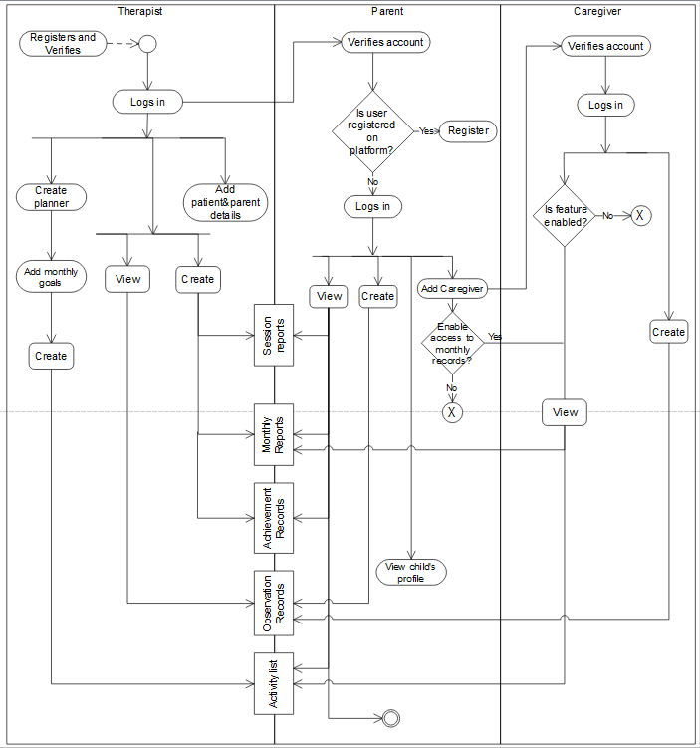

Figure 3.1: Activity Diagram

### Class Diagram

Class diagram is a graphical representation of the static view of the system and represents different aspects of the application. They are used to specify the common structure and behavior of a set of objects. Objects are instances of a class that can be created, modified or deleted during execution and they have attributes and relationships with other objects

Figure 3.2 shows the class diagram for the system.

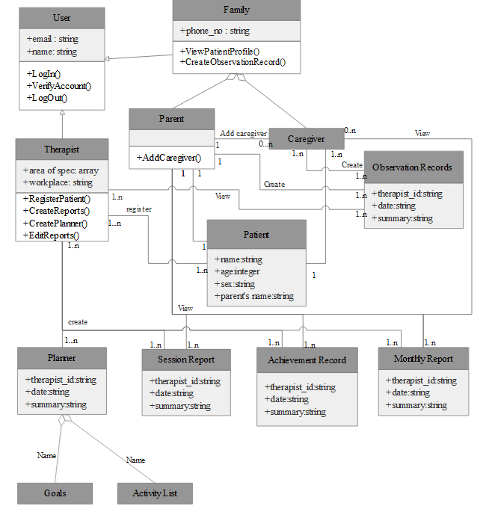

Figure 3.2: Class Diagram for the Proposed System.

## Testing

Testing will be carried out on a selected family with a female non-verbal autistic teenager and one of her therapists. The users involved will include the therapist, the father/mother and siblings of the patient.

### Alpha Testing

Alpha testing will be carried out after all basic features of the app has been implemented. Test runs will be made for different features by creating dummy accounts and user data. Implemented functionalities will be evaluated to ensure they were developed as intended and that the app is ready for deployment.

### Beta Testing

Beta testing will be carried after deployment and made available to the above specified users for a first interaction with the app. Feedbacks will be recorded and errors/bugs will be noted for correction. The users’ satisfaction and perception of the app will be rated to get a conclusion on the overall usefulness of the app.

# CHAPTER FOUR

# IMPLEMENTATION

### Use-Case Diagram

Use-case diagrams is a graphical representation of a user’s interaction with the intended system and also capture the dynamic behavior of the system. Use cases focus on the system behavior based on an external point of view. A use case describes an action that can be executed by an actor. An actor is an entity that interacts with the system through the use cases. The actors are outside the boundary of the system while the use cases are inside the system boundary.

Figure 3.1 and 3.2 show use diagrams for the main users of the system (Therapist and Families). The three actors are the therapist, parent and caregiver. The therapist is responsible for the creation of most reports which are also accessible to parents and caregivers. The parents and caregivers create observation records and also have access to the patient’s records.

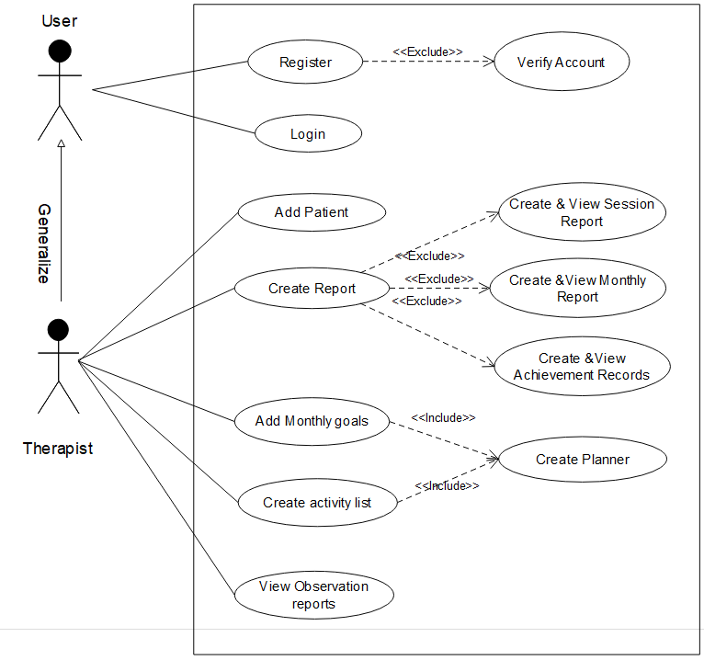

Figure 3.1: Use Case Diagram of a Therapist Actor.

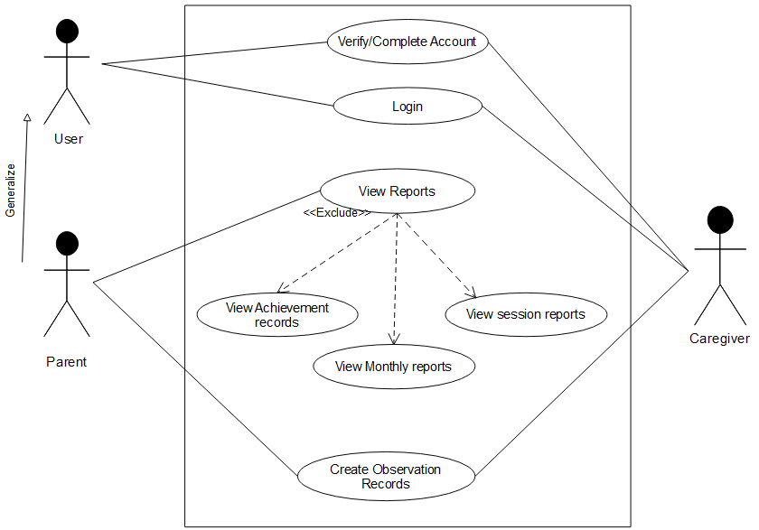

Figure 3.2: Use Case Diagram of Parent and Caregiver Actors.