Design and Development of a Patient-Specific Cranial Plate and Mold Using Medical Imaging and Additive Manufacturing Techniques
Case 01: Cranial Plate Design
1. Introduction
1.1 Cranial Defect
Cranial defects are discontinuities in the skull caused by trauma, decompressive craniectomy, tumor resection, congenital abnormalities, or infections. These defects can compromise brain protection, aesthetics, and patient quality of life. Restoration of the cranial vault is achieved through a surgical procedure known as cranioplasty. PMMA is commonly used because of its low cost, biocompatibility, and ease of fabrication.
1.2 Need for Patient-Specific Implant (PSI)
Conventional manually shaped implants often result in poor anatomical fit and longer surgical time. Patient-Specific Implants (PSIs) are designed directly from CT images and accurately match the patient's anatomy, leading to improved cosmetic and functional outcomes.
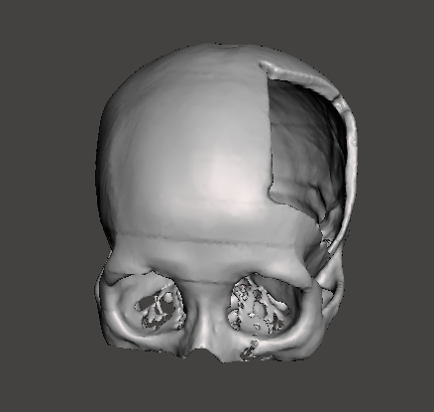

2. Objective
The objective of this case study is:
- To design a patient-specific cranial implant from CT data.
- To reconstruct the skull defect using mirror anatomy.
- To generate a mold for PMMA implant fabrication.
- To demonstrate a low-cost additive manufacturing workflow.
- Manufacturing of Titanium and Peek Plate

3. Materials and Software Used
Component | Software / Material
Medical Imaging | CT Scan (DICOM)
Segmentation | D2P / 3D Slicer
3D Reconstruction | D2P
Implant Design | Autodesk Meshmixer
Slicing | Cura
Additive Manufacturing Material | Ti-6Al-4V, PEEK.PLA
Printing Technology | SLM (Titanium), FDM/SLS (PEEK)

Approaches:
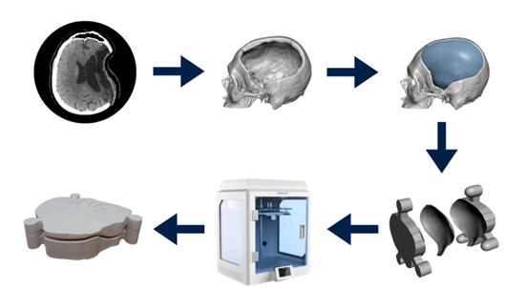
1. Patient-Specific PMMA Cranial Implant Using Mold-Based Manufacturing Approach:
Method:
STL Skull Model Import
↓
Mesh Repair (Inspector)
↓
Defect Boundary Selection
↓
Symmetry-Based Mirror Selection
↓
Boundary Smoothing
↓
Surface Separation
↓
Mirror Reconstruction
↓
Thickness Generation (3–5 mm)
↓
1 mm Skull Offset
↓
Boolean Difference
↓
Patient-Specific Cranial Plate Creation
↓
STL Export

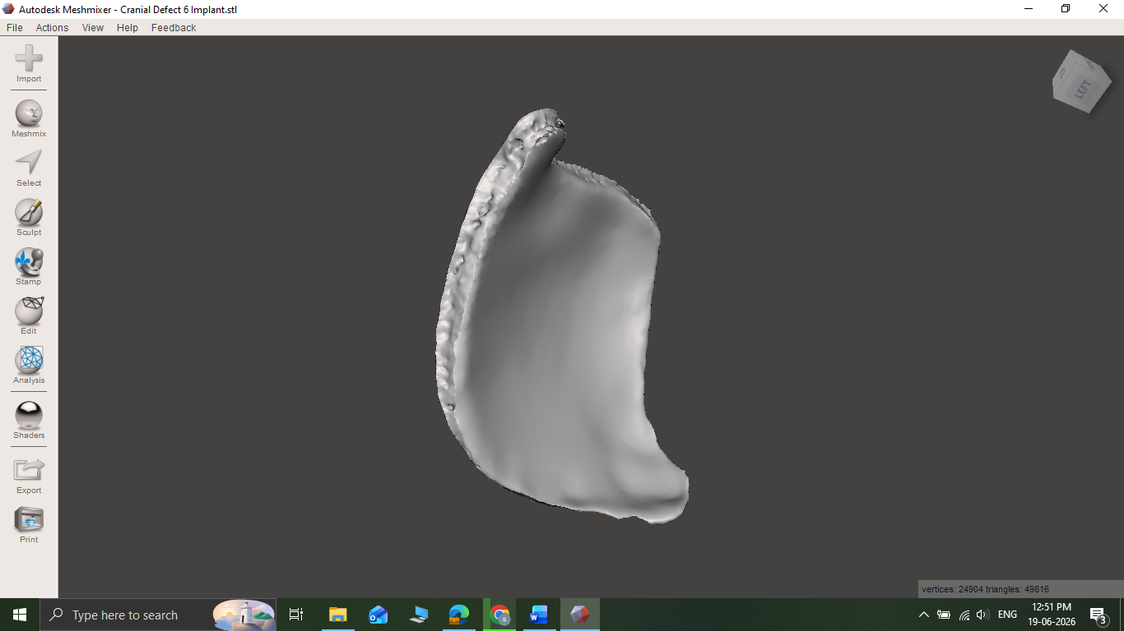
Result

B) Design Specifications of Titanium PSI Cranial Implant
Parameter | Specification
Implant Type | Patient-Specific Cranial Implant
Design Method | Mirror Reconstruction
Material | Ti-6Al-4V ELI
Implant Thickness | 3–5 mm
Central Region | Circular Perforations
Edge Region | Gyroid Lattice
Gyroid Width | 20–40 mm (2–4 cm)
Purpose of Gyroid | Bone Ingrowth & Osseointegration
Fixation Method | Titanium Screws
File Format | STL

Design Specifications of PEEK PSI Cranial Implant
Parameter | Specification
Implant Type | Patient-Specific Cranial Implant
Design Method | Mirror Reconstruction
Material | Medical Grade PEEK
Implant Thickness | 2.5–4.0 mm
Central Region | Circular Perforations
Edge Region | Gyroid Lattice
Gyroid Width | 10–20 mm
Purpose of Gyroid | Tissue Integration & Weight Reduction
Fixation Method | Titanium Cranial Screws
File Format | STL

