Muhammad Khairi Norizan

DS 301 Lab 1

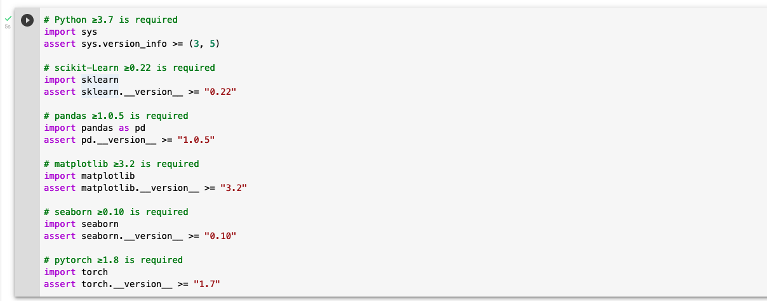

What do you plan to achieve from the course and the Data Science program?

To become someone with great skills in statistics and computer science who can interact and visualize data with other people. Also, to help organization to solve vexing problem by extrapolating and sharing insights

How would you rate your python programming skill (0 – 5 with 5 being fluent)?

I would say 3.