MySentimen (Alpha)

How to delete your MySentimen account and data.

Step 1 :
Make Sure you are logged in, your name should appear on the top right of the page.

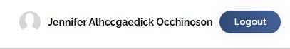

Step 2 :
Click on your name to enter the Profile Setting’s Page

Step 3 :
Click on the ‘Delete Account’ button and once the deletion is completed, you will be redirected to the home page

