Contents

**Introduction** 2

**Homepage Overview** 2

1. Search Functionality: 2

2. Shopping Cart and Checkout: 2

3. Registration: Users can access the registration page by clicking on the "Register". 3

4. Login: Registered users can access the login page by clicking on the "Login” link located on the website within the account section. 4

5. Menu: 5

**Shop page overview.** 6

1. Categories: 6

2. Products: 6

**About us page** 7

**Contact us page.** 8

**Erd diagram** 9

# 

# **Introduction**

kkfurniture.com – a place where you can find cool furniture. It’s an online store filled with all types of chairs, tables, beds, and more. Our website is designed to make shopping for furniture easy and fun. Customers can explore different categories of furniture, such as living room, bedroom, dining room, etc., either by clicking on the category links or using the search bar to find specific items.

# **Homepage Overview**

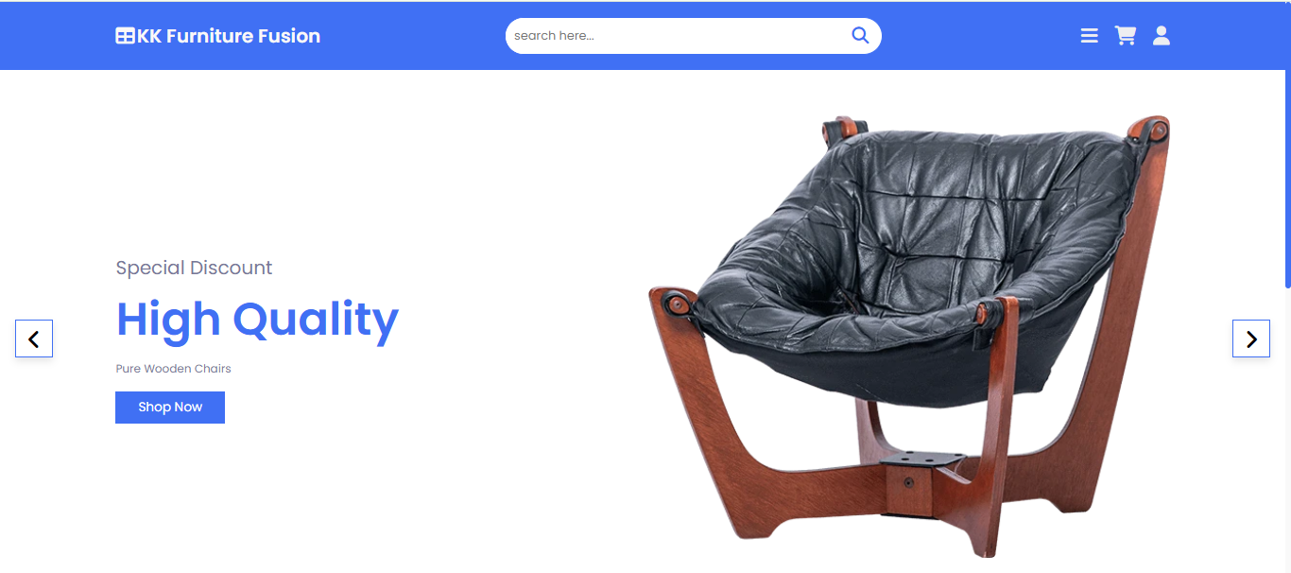

1. Search Functionality: To facilitate easy navigation and product discovery, we've implemented a search feature. Users can search for products using keywords.
2. Shopping Cart and Checkout: Our website features a seamless shopping cart and checkout process. Users can add products to their cart, update quantities, and proceed to checkout with ease. Multiple payment options are available, including credit/debit cards, PayPal, and other secure payment gateways. During checkout, users can enter shipping details.

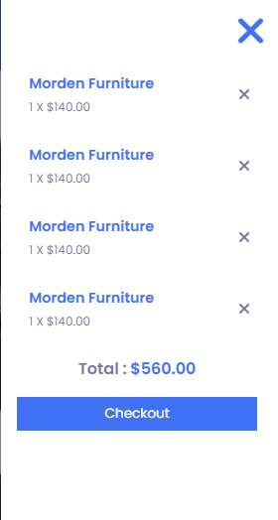

## Registration: Users can access the registration page by clicking on the "Register".

On the registration page, users are prompted to fill out a registration form. This form typically includes fields such as:

-First name, last name

-Email address.

-Password

-Confirm password.

-Address

-phone number.

Upon submitting the registration form, the system verifies the entered information for validity. This includes checking if the email address is unique or not.

## Login: Registered users can access the login page by clicking on the "Login” link located on the website within the account section.

On the login page, users are prompted to enter their registered email address and password into the respective fields.

**Authorization:**

Upon submission, the system verifies the entered credentials against the information stored in the database” phpMyAdmin”. This process ensures that the user is authorized to access the account.

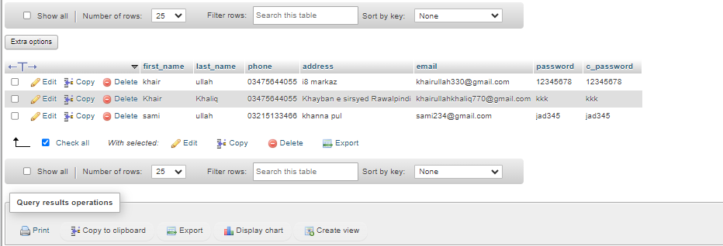

## Menu:

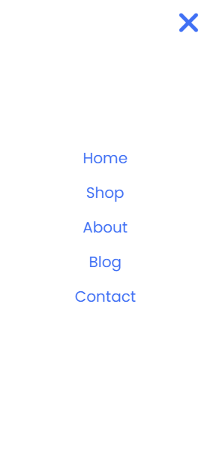

There is a page in the menu if user click any page It will redirect to this page.

# **Shop page overview.**

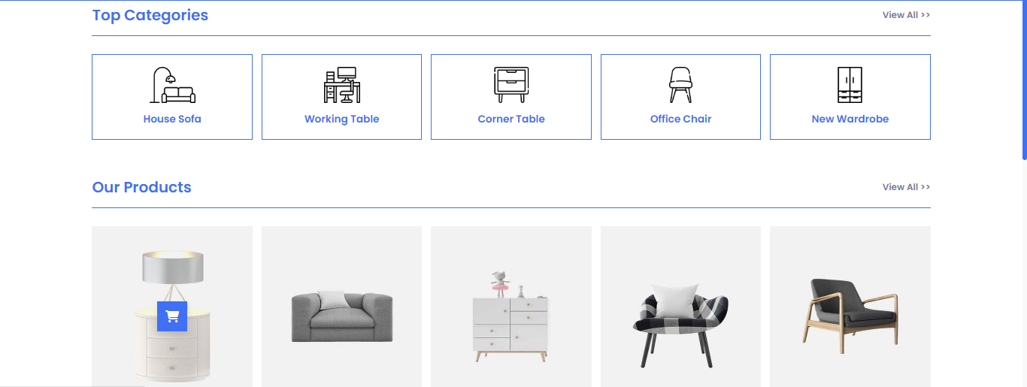

## Categories:

The website features main product categories that broadly classify different types of furniture. These main categories often include:

House sofa, Tables, chairs, wardrobe.

## Products:

Upon accessing the shop page, users are presented with a grid or list layout displaying various furniture products available for purchase. Each product listing typically includes:

-Product image: High-quality image showcasing the furniture.

-Product name: Clearly labeled name or title of the furniture item.

-Price: Displayed prominently to indicate the cost of each product.

-add to cart: user can add product into cart.

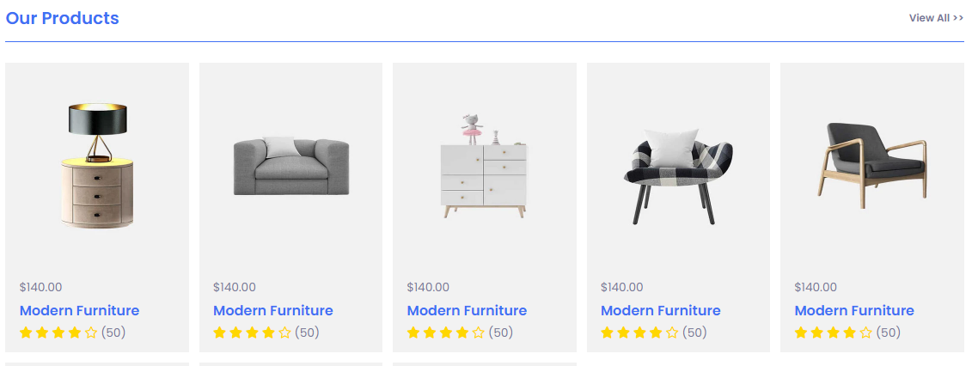

# **About us page**

The "About Us" page serves as a platform to introduce visitors to our furniture brand, its mission, values, and history. It provides users with insights into who we are, what we stand for, and why they should trust us as their furniture provider.

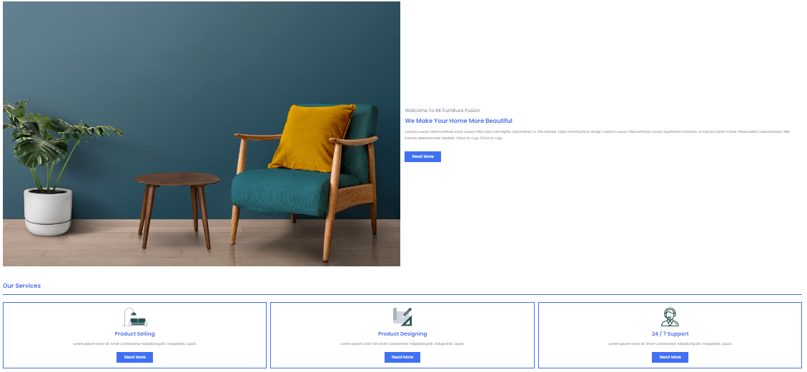

# **Contact us page.**

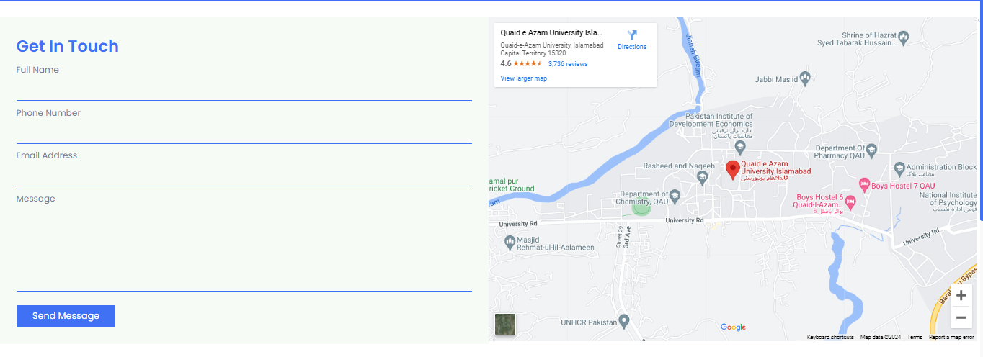

The contact page features a user-friendly contact form where visitors can submit inquiries, feedback, or support requests. The contact form typically includes fields for:

**Full Name:** Users can enter their full name.

**Email Address:** Users provide their email address for communication purposes.

**Message:** Users can type their message or inquiry in a text box.

**phone number.**

**Map Integration:** The contact page may feature an embedded map displaying our location. This interactive map allows users to visualize our physical address and get directions if they plan to visit our showroom or office.

# **Erd diagram**

