**🔍 Investigating High Cancellation Rate in Hotels 🏨**

**🔬 Research-based Analysis for Countering High Cancellation Rates. 📊**

______________________________________________________________

**Business Problem:**

In recent years, both Resort Hotel and City Hotel have faced significant challenges due to high cancellation rates, leading to issues such as reduced revenues and suboptimal room utilization. The primary cause of suboptimal room usage is the elevated cancellation rates, resulting in decreased revenue generation. Lowering cancellation rates is crucial for both hotels to enhance efficiency and revenue.

The data analyst's responsibility is to provide comprehensive business advice to address this pressing issue. The focus of this report is on analyzing hotel booking cancellations and identifying other factors unrelated to their business that may impact yearly revenue generation.

**Assumptions:**

1. Unusual occurrences (outliers) between 2015 and 2017 will not significantly impact the data.
2. The information is current and suitable for analyzing a hotel's potential plans efficiently.
3. No unforeseen negative consequences are expected if hotels implement advised techniques.
4. Cancellations result in vacant rooms for the booked duration, limiting potential earnings.
5. The suggested solutions are not currently in use by the hotels.
6. The primary factor influencing income effectiveness is booking cancellations.

**Research Questions:**

1. W Which features (variables) influence the cancellation of hotel bookings (room reservations)?
2. What strategies can enhance the efficiency of hotel booking (room reservation) processes?
3. In what ways can hotels receive support for pricing and promotional decision-making?

**Hypothesis:**

1. Higher prices contribute to an increased number of cancellations.
2. A lengthier waiting list correlates with higher customer cancellation rates.
3. The majority of clients opt for reservations through offline travel agents.

**Analysis and Findings:**

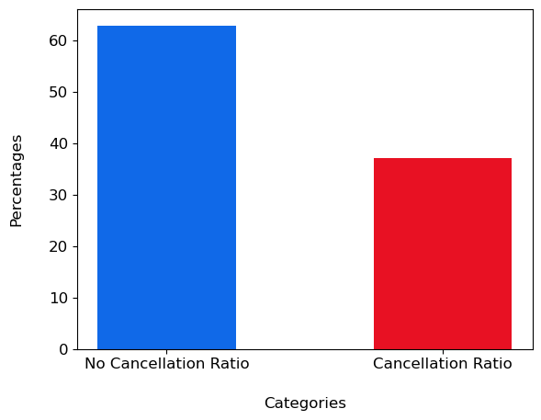

Bar Chart Graph (Reservation status: No-Cancellation | Cancellation)