Submitted by:
Khair ul wara Hussain (FA23-BAI-022)
Arhum Fareed (FA23-BAI-006)

Submitted to:
Dr. Muhammad Usman Yaseen

Crime Pattern Analyzer with Predictive Mapping
Programming for ArtificiAL INTELLIGENCE (aic270)

Project Overview
This project is a Python-based GUI application developed to analyze crime data from India and provide insightful visualizations and future predictions. It utilizes K-Means Clustering, Linear Regression, Label Encoding, and interactive visualizations via Tkinter and Matplotlib. The tool helps in understanding crime trends across cities and time, identifying hotspots, and predicting future crime patterns.

Objectives
- To analyze spatial and temporal crime patterns using machine learning.
- To visualize trends and distributions of crimes across different cities and months.
- To identify crime hotspots using K-Means clustering.
- To predict future hotspot cities and expected crime counts using Linear Regression.
- To allow filtering based on cities, crime types, and year ranges via an interactive GUI.

Technologies Used
Category | Tools/Libraries
Programming Language | Python
GUI | Tkinter
Data Handling | Pandas
Visualization | Matplotlib, Seaborn
Machine Learning | Scikit-learn (KMeans, LinearRegression)
Preprocessing | LabelEncoder (Scikit-learn)

Dataset
- Source: Kaggle - Indian Crime Dataset
- Important Fields Used:
  - City
  - Date of Occurrence
  - Crime Description
Preprocessing Steps:
- Dropped rows with null values in important columns.
- Converted date field to datetime format.
- Extracted Year and Month from the date.
- Label encoded city names to numeric values for clustering.

System Architecture
Modules:
- Data Cleaning and Preparation
- Encoding & Feature Extraction
- Clustering with K-Means
- Future Prediction with Linear Regression
- Visualization and GUI

Functionalities & Features
🔹 Crime Type Filtering
- Select a crime type and see its top 10 affected cities using a bar chart.
🔹 City Trend Analysis
- Analyze crime trend over years for any selected city using a line chart.
🔹 Clustering
- Apply K-Means Clustering on City_Code vs Year to identify 5 crime zones.
- Show clusters with a scatter plot along with a regression line.
🔹 Heatmap
- Show a heatmap of crime counts by city and year.
🔹 Top Cities
- Display top 10 cities with the highest crime occurrences.
🔹 Monthly Trend
- Show distribution of crimes across months using bar plot.
🔹 Predict Future Hotspot
- Predict the city likely to become a hotspot in 2025 using regression on City_Code vs Year.
🔹 Crime Count Prediction
- Predict number of crimes in any future year using Linear Regression on Year vs Crime Count.
🔹 Filter by Year Range
- Dynamic year sliders to filter and visualize crimes for a specific time range using a heatmap.

Machine Learning Models
🔸 K-Means Clustering
- Input Features: City_Code, Year
- Clusters: 5
- Purpose: To group cities and years into crime zones.
🔸 Linear Regression
- Model 1: Predicts City_Code (mapped back to City) for future hotspot city.
  - X: Year
  - Y: City_Code
- Model 2: Predicts total crime count for a given year.
  - X: Year
  - Y: Crime_Count

User Interface Design
Built with Tkinter, the GUI is simple yet functional. Key UI components include:
- Dropdowns for selecting city and crime type.
- Buttons for various actions like viewing charts, predictions, clusters.
- Sliders for filtering year range.
- Informational popups for predictions.
Design Highlights:
- Organized using LabelFrame for modular layout.
- Consistent color theme (#B0C4DE) for aesthetics.
- Responsive widgets and proper spacing.

Screenshots

- Main GUI Interface
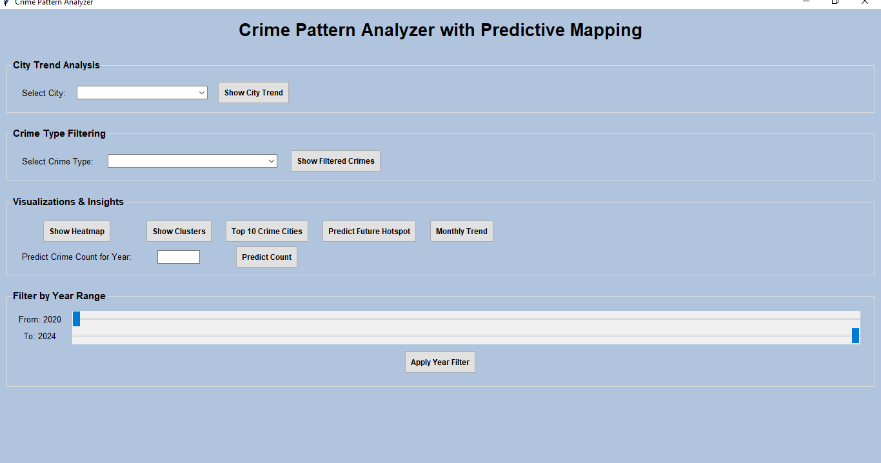

- City Trend Line Chart for all Cities
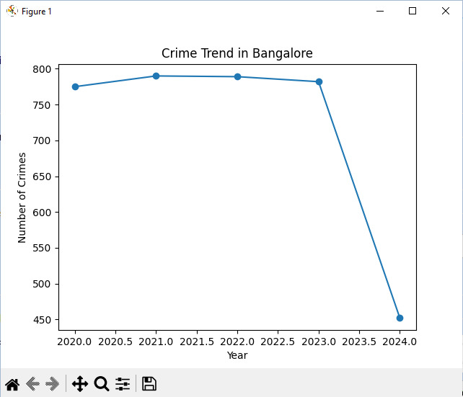

- Filtered Crime Bar Chart
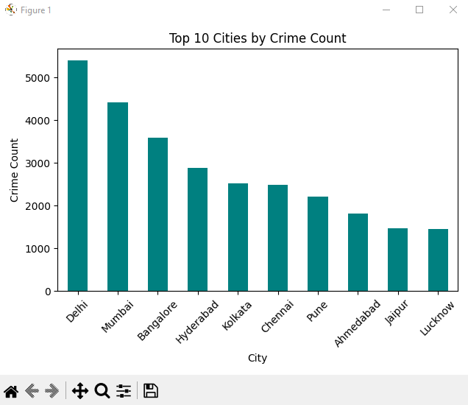
- Heatmap of Crimes by City & Year
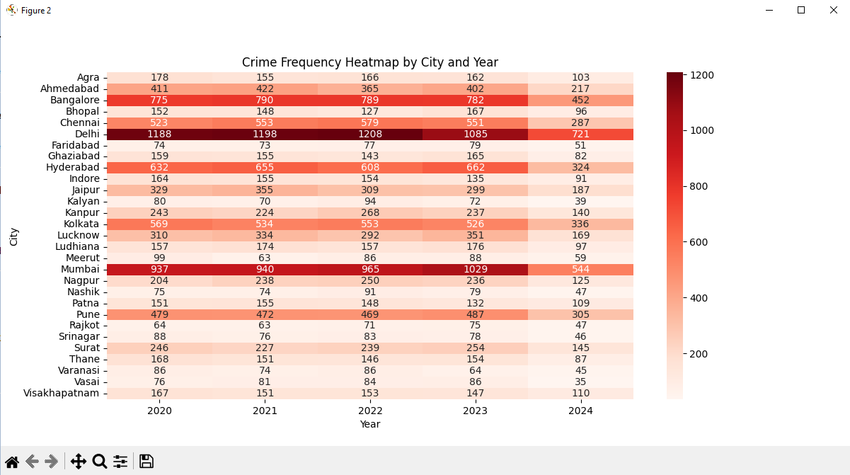

- K-Means Clustering Scatter Plot
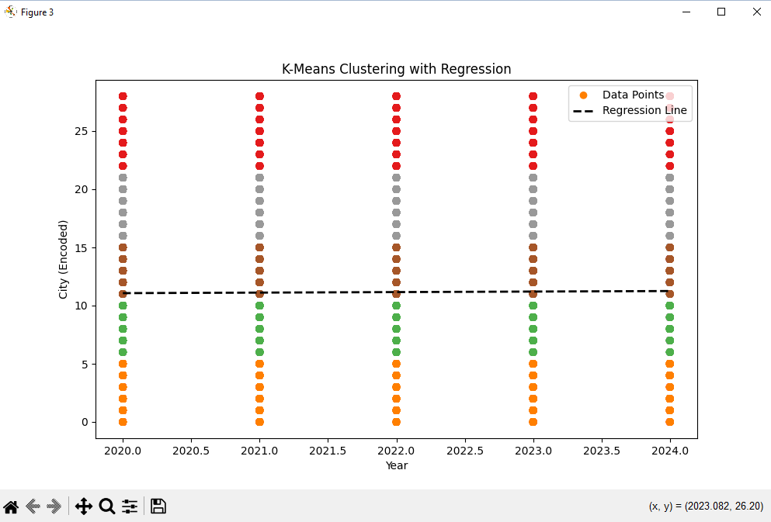
- Predicted Future Hotspot Dialog
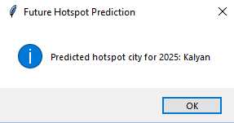

- Predicted Crime Count Dialog
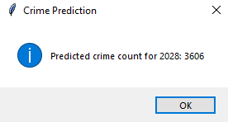

- Year Range Filtered Heatmap
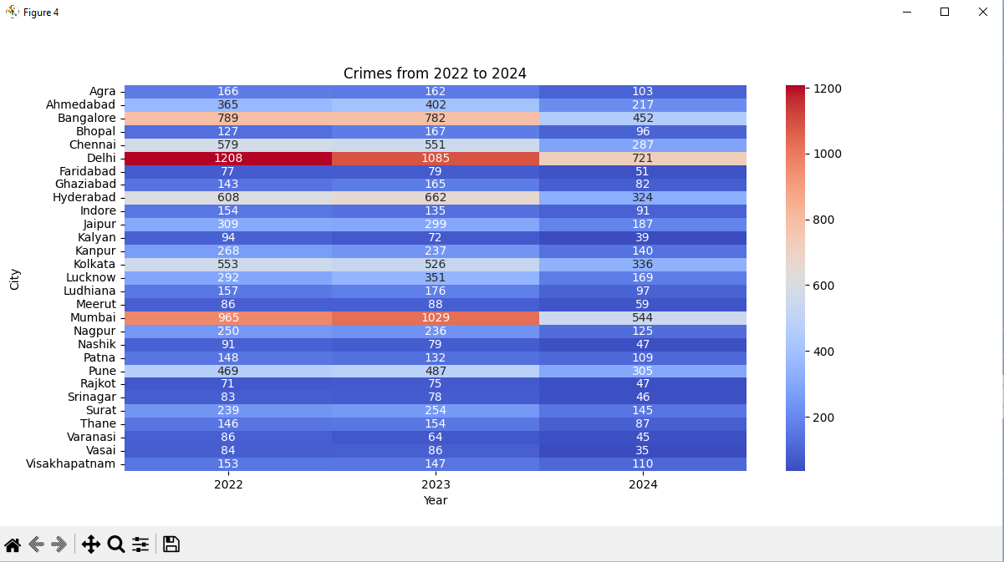
Challenges Faced
- Dealing with missing and inconsistent date formats.
- Label encoding cities for clustering while ensuring interpretability.
- Ensuring seamless GUI interaction with real-time data processing.
- Preventing model overfitting with limited temporal data.

Future Improvements
- Integrate geospatial mapping (e.g., using Folium or GeoPandas).
- Add time-series forecasting models (ARIMA, Prophet).
- Allow dynamic clustering (user-defined k value).
- Add crime severity levels and more granular features.
- Export results to PDF or Excel.

Conclusion
This project effectively utilizes machine learning techniques and interactive GUI design to extract meaningful insights from crime data. It enables users to:
- Understand historical crime patterns.
- Predict potential crime hotspots and counts.
- Filter and visualize data with ease.
Such tools can significantly assist law enforcement agencies and policy makers in proactive crime prevention and resource planning.

