**EMOTION TO EMOJI USING OPENCV**

**A PROJECT REPORT - II**

***Submitted by***

**SHAIK KHAIS MOHAMMED ALI**

***in partial fulfillment for the award of the degree of***

**BACHELOR OF TECHNOLOGY**

**COPUTER SCIENCE ENGINEERING**

***Under the supervision of***

**SYED ALI MEHDI**



**Department of Computer Science& Engineering**

**School of Engineering Sciences & Technology**

**JAMIA HAMDARD**

**New Delhi-110062**

**(2022)**

DECLARATION

I, **Mr. Shaik Khais Mohammed Ali** a student of B.TECH,**CSE (Computer Science Engineering),** (**Enrolment No: 2019-310-147)** hereby declare that the Project/Dissertation entitled **“Emotion to emoji using opencv ”** which is being submitted by me to the Department of Computer Science, Jamia Hamdard, New Delhi in partial fulfillment of the requirement for the award of the degree of **B.TECH**,**CSE (Computer Science Engineering),** is my original work and has not been submitted anywhere else for the award of any Degree, Diploma, Associateship, Fellowship or other similar title or recognition.

**(Signature and Name of the Applicant)**

**Date:**

**Place:**

Phone : 011

-

2605 9588 (12

Lines

)

Fax : 00

-

91

-

11

-

26059663

Email:

inquiry@jamiahamdard.edu

Website:

ww

w.jamiahamdard.edu



|  |  |
| --- | --- |
| **(Hamdard University)** |  |
| (*Declared as Deemed-to-be University under Section 3 of*  *the UGC Act, 1956 vide Notification No. F.9-18*/*85-U.3*  *dated 10.5.1989 of the Government of India)* | **HAMDARD NAGAR**  **NEW DELHI-110062** |

**Accredited by NAAC in ‘A’ Category**

**CERTIFICATE**

On the basis of the declaration submitted by **Mr. Shaik Khais Mohammed Ali** **(Enrolment No: 2019-310-147)** a student of **Bachelor of Technology** **(Computer Science & Engineering),** I hereby certify that the dissertation titled **“Emotion to emoji using OpenCV”** being submitted to the Department of Computer Science & Engineering, Jamia Hamdard, New Delhi in partial fulfillment of the requirement for the award of the degree of **Bachelor of Technology** **(Computer Science & Engineering),** is carried out by him under my supervision.

# Mr. Syed Ali Mehdi

**(Supervisor)**

**Dr. Farheen Siddiqui**

**Head, Department of CSE**

Table Of Content

|  |  |  |
| --- | --- | --- |
| **S.No.** | **Chapter Name** | **Page No.** |
| 01 | Abstract | 5 |
| 02 | Introduction | 6 |
| 03 | Reason for Project | 7 |
| 04 | Problem Statement | 7-8 |
| 05 | Objective | 8-9 |
| 06 | User Function Specification | 9 |
| 07 | Hardware Requirement | 10 |
| 08 | Technology used in Project | 10-15 |
| 09 | Data Flow Diagram (DFD) | 15-16 |
| 10 | Snapshots | 16-17 |
| 11 | Limitation | 17-20 |
| 12 | Conclusion | 20-21 |
| 13 | REFERENCES | 21-24 |

**Abstract**

Human facial expression with AI concept analyzing faces with computer vision tools and classify the expression by Fisherface classification and applying it to show what is the emotion. The face is captured (detected, recognized and analyzed) and emotion analysis is done to return output. The training phase uses Cohn-kanade Plus (CK+) data and train few days for training accuracy is higher where test accuracy is 0.5, for improvement the face expression dataset from Kaggle is used to train or Augmentation is applied which increases the score of model. The processing it an arbitrary number of faces per image simultaneously in real time, wherein appropriate emojis are superimposed over the faces. Recognized emotions: Neutral, Happy, Sad, Angry, Surprise and Fear. The project is in Python 3.9, OpenCV’s latest version 4.6 and used the required supportive hardware for recognition and processing data.

**Keywords:** Facial expression, Computer vision, Fisherface, Cohn-kanade Plus, Augmentation, Emotions.

**Introduction**

Facial expression is the not only to state the internal state of the person it tells how to act under condition so it can change their mood and nature of the conversation, a simple emoji can be used to show ones feeling very easily. Now with the OpenCV and cascades to extract features and trained to detect the faces with similar face features. Here the face is detected of any person then with the emotion detection model the emoji is shown on the face which matches with his face emotion. Fisherface algorithm is implemented to classify the 6 face and maximize the separation of classes this generates feature vector of facial image data then traits are used in training process, this fitted into traits of testing data using Euclidean formula. The input to the model's data is classified and the emoji is drawn on the face, the features of the emotion recognition model are drawn on the photos in an array. When the video is capture with webcam the face is located and emoji of appropriate size is showed on the face of anyone visible on the camera. Its loads emotions images from folder there are saved, it loads and uses the learnt model. Here the images are converted to Grayscale and resized, PIL’s image to NumPy array and back again to PIL’s image while training and drawing images. Facial expression recognition is a technique for recognizing facial expressions. A variety of techniques have been proposed to detect expressions such as happiness, sadness, fear, disgust, anger, neutrality, and surprise, but others are difficult to implement.

**Reason for Project**

In the project the person emotion are manifested through emoji’s, the digital image, icon type that used to express many things without text or speech. Recognizing faces and detecting emotions is not easy a task it takes lot of time and improvement in the technology and methods, as they provide numerous benefits to multiple fields. The data is processed by deleting old files and normalizing the images and extracting, there model use Fisherface function is imported from OpenCV and used for image training and identify the emotion, the . This helps in business to understand the customer satisfaction to improve which service, it helps to identify potential candidates for work, for mental health care diagnosis and understand type of peoples or used for fun face filter. So, it helps in market research, healthcare, entertainment, retail and automotive areas.

**Problem Statement**

The issues halting in face recognition are accuracy, privacy, reliability and efficiency. The faces and emotions are relying on clear, static images for best performance. But in reality, the cases are rare there would be error rate even for high-quality static pictures. This also depends on the race, ethnicity, gender, and age of a person being recognized when bias dataset or algorithms are used. Sometimes face can be detected even the face is cover with accessories like specs, earrings, makeup Face data secured to prevent misusing or hack the biometric details without permission. The trigger in gene evolution and improving technology the installation and cost for all the capabilities performance create global growth or restraints in market. Notable point the factors in facial recognition system such as expression, illumination, quality of unstructured data is less efficient and reliable compared to other biometric system.

**Objective**

The goal is to understand the implementation of the tools to recognize the expression of the face and to assign a suitable emoji that shows the emotion of person. Conveying the efficiency of the classification of emotion correctly to define the expression.

* The OpenCV with haarcascade using to detect the frontal face only, so it work when the face emotion can analyzed all the front features taken because of this increase the emoji imposition over the subject face either in real time or input image.
* The Fisherfaces given the trained emotion recognition model that is trained by finding, marking and classified with the dataset to use to identify the face feeling among the 7 emotions.
* Thus, computer vision algorithms do the mapping, analyzing, and confirming the identity of a face on a photo or a video. The webcam needs to be met the conditions for accurate classification. Augmenting on dataset to include off-center faces could have addressed this problem.

**User Function Specification**

To use the feature to find the emotion of the person the model should be complete. After it is prepared with face detection and emotion recognition model following can be done to execute.

* The face detection can be run with different input to see how it works, so in the same way the subject emotion are figured.
* Perform the face emotion recognition model with the webcam to capture the person, who come in front of the camera the model will try to detect the face.
* The face is detected when features mapped correctly as for the front face appears straight and well.
* The emoji is automatically appearing on the face of the person or multiple subjects that shows the accurate emotion that how their mood shows.
* Emotion recognition can be used to help us deal with our own emotions by giving us an insight into why we might be feeling a certain way. This can be useful in helping us to understand ourselves and become less self-conscious about our emotions.

**Hardware Requirement**

VRAM :2 GB

Hard disk: 10 GB

Processor: 2.8 GHz

Camera: 2.1 MP

Devices: can run on smartphone, computer, laptop, tablets.

**Technology used in Project and Explanation**

**About Python 3.9: **

Python 3.9 provides those backward compatibility layers, allowing Python project maintainers more time to support and the addition of Python 3.9 support. Aliases for Abstract Base Classes, such as collections, in the collection module. The improvements seen are boosts the performance without requiring any changes to existing code and its use has exploded in rapidly evolving areas such as data science and machine learning. Efforts are being made by the initiative to keep up with all of the increased demands.

Common data types are simple to use, and Python 3.9 makes it even simpler with new functionality for strings and dictionaries. Prefixes and suffixes can now be removed from strings using brand-new techniques, a task that formerly took a lot of manual labour. There are now two types of union operators for dictionaries: one updates the contents of one dictionary with information from another vocabulary. Python functions can be wrapped using decorators to have their behaviour changed programmatically. There decorators can now consist of any valid expression. Python 3.9 now includes two brand-new capabilities for type hints and type annotations. Type indications for collection contents in one. The flexible function and variable annotations are the second improvement to Python's typing mechanisms. This makes it possible to specify a type using metadata that may be checked beforehand (with linting tools) or at runtime by utilising the annotated type.

**About PyChram: **

PyCharm’s smart code editor provides first-class support for Python, it provides smart code completion, code inspections, on-the-fly error highlighting and quick-fixes, along with automated code refactoring and rich navigation capabilities The declaration, super method, test, usages, implementation, and more may all be accessed with a single click. Use safe renaming and deleting, extract methods, introduce variables, inline variables or methods, and other refactoring techniques to intelligently rework your code.

Use coding assistance and a GUI-based test runner to create and run your tests. With Python Profiler integration, you can fully control your code. Remote machines can be used to run and debug your application. It provides best-in-class code intelligence, graphs, array viewers, and many other features. Pandas, NumPy, Matplotlib, and other scientific libraries are all supported. On as many machines as you have, and use the same environment and functionality across all your machines, a fine-tuned workspace with customizable color schemes and key-bindings.

**About Kaggle:** 

There is no need to be a data scientist in order to compete on Kaggle. If you are familiar with basic programming concepts, you can create models and compete on Kaggle using a variety of programming languages. Additionally, you have access to a variety of tools and algorithms to help you build your models. Using R or Python for Data Science is the simplest method for competition. Datasets can be found on Kaggle's own website, as well as data from sites like Data.gov and GitHub. These datasets are freely available to anyone who wishes to compete. However, the datasets that are available will change as time progresses. For Face emotion dataset can upload a raw image and get score by classifying facial expression using python.

For 6 classes of expression - Surprise, Anger, Sadness, Disgust, Fear and Happiness , and one more is Neutral which have to predict class labels from an input image. This is machine learning technique uses Fisherface algorithm. It works by looking at the underlying structure of the face to recognize what emotions it is showing. We can predict from a known emotion that the face is showing by taking elements in the face that are common for that emotion and building a model for predicting this class label for new images that have not been Kaggle’s community of data scientists use their creativity and ingenuity in solving problems to find the most accurate classifier for the emotion of a given image. The model is evaluated by a panel of judges based on how well the predictions match the labels provided for each image. The models with the highest accuracy are then given awards from Kaggle.

**About OpenCV 4.6: **

OpenCV (Open-Source Computer Vision Library) is a software library for computer vision and machine learning is free to use and open for everyone. OpenCV was created to provide a common infrastructure for computer vision applications and to speed up the incorporation of machine perception into commercial products. Businesses can easily use and modify the code thanks to OpenCV. This forum exists to connect you with other OpenCV users and library maintainers for high-quality discourse and assistance.

* In **processing phase** the three step to harvest the dataset is done. First the old files in the database is deleted. The current data is uploaded for recognition of 7 emotions, face emotion recognition CK+ dataset from Kaggle is saved in source images file and the images are resized, converted to grayscale image named sequentially and saved in following folders of emotions. The extraction of images does the face detection to cropping and converting the image format. The harvesting process gets the neutral images and compared to other emotion face for each subject.
* Now the images are ready the **preparation phase** the model is trained. The data Training is made very easy. Here the 90 % of data is used for training and remaining for testing. Both are divided and labelled as the folder label are same to the corresponding emotion.
* The OpenCV’s **Fisherface classification** is used to linearly classify the labelled data there with reduction of dimension to reduce feature space, one may get better recognition rates as it tries to shape the landmarks to make it more reliable.
  + The data in each class are considered to be normally distributed for the purpose of computing the Fisherfaces. where *di*(x)=(x−*μi*)*T*Σ−1*i*(x−*μi*)+*ln*|Σ*i*|−2ln*Pi* are known as the discriminant scores of each class. The Bayes optimal solution is produced by the discriminant scores as defined.
  + minimizing within-class differences and maximizing between-class distances. Within class differences can be estimated using the within-class scatter matrix, given by S*w*=∑*Cj*=1∑*nji*=1(x*ij*−*μj*)(x*ij*−*μj*)*T*, where x*ij* is the *i*th sample of class *j* , *μj* is the mean of class *j* , and *nj* the number of samples in class *j* .
  + Likewise, the between class differences are computed using the between-class scatter matrix, S*b*=∑*Cj*=1(*μj*−*μ*)(*μj*−*μ*)*T*, where *μ* represents the mean of all classes.
* In the **main phase** it loads emotion recognition model from a file, shows a webcam image, recognizes face, and its emotion and draw emotion on the image. From the input device the faces are detected using haar cascade to detect frontal face located and normalized by converting to grayscale and resize, then PIL’s images are converted to array using NumPy and array to PIL’s image while drawing emoji on faces. The features of emotion recognition model are drawn to the images in array when the classified the input to the model’s data the emoji is drawn on the face in similar way for every image in array the emoticons are loaded to give accurate results, even the mood changes it gives the result according to the input.

**Data Flow Diagram (DFD)**

Diagram to graphically represent the whole project step-by-step:

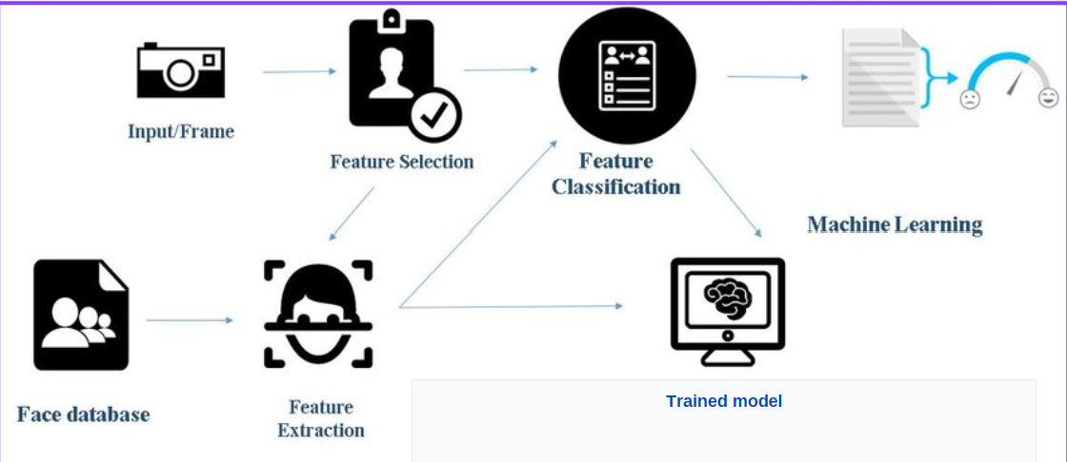

Figure: Processing and Preparing the model with dataset.

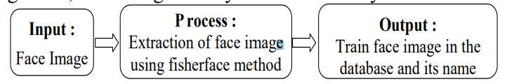

Figure: Training to classify emotions.

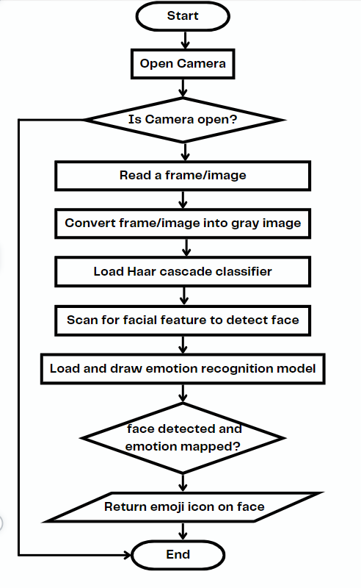

Flow: Main phase execution – working of the model.

**Snapshots**

1. Processing data

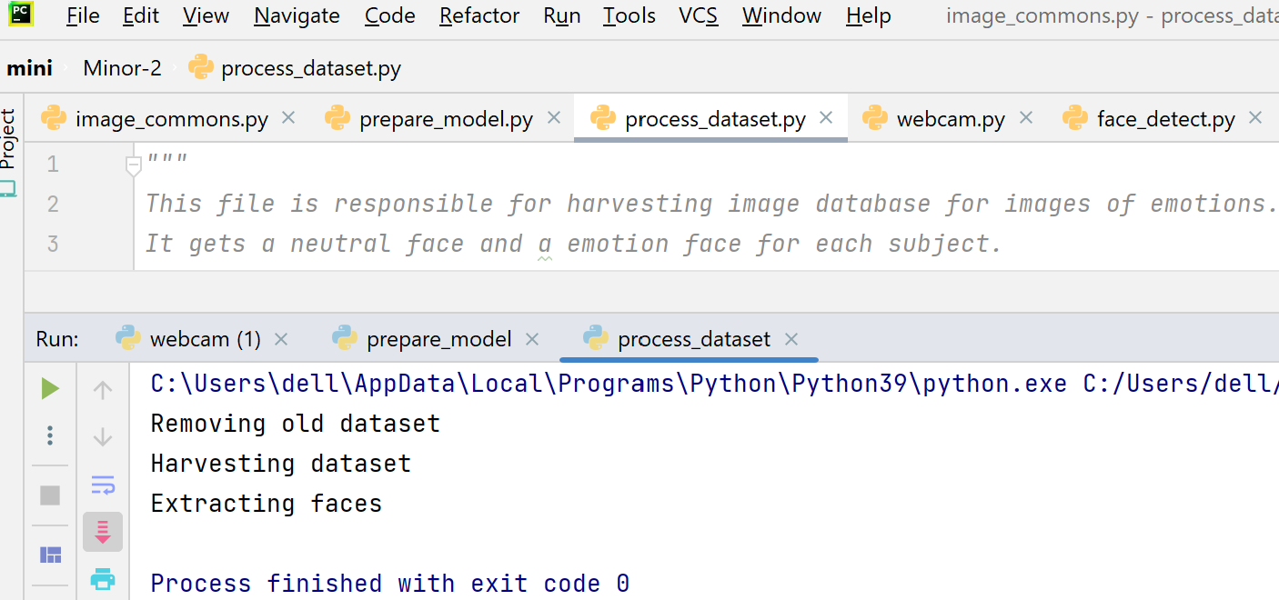

1. After processing from source images to emotion folders.

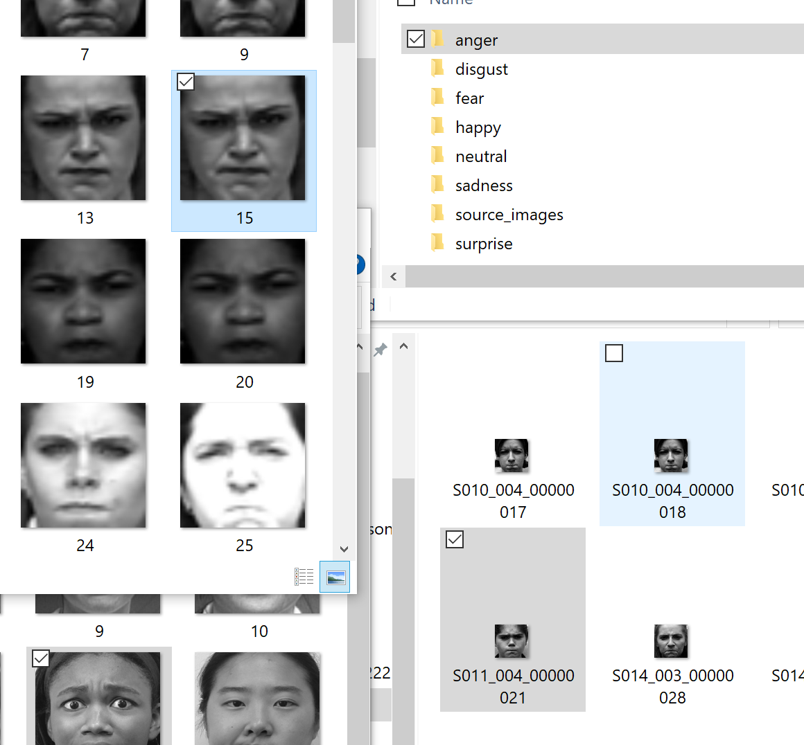

1. Prepare data and train the model, returning accuracy of model.

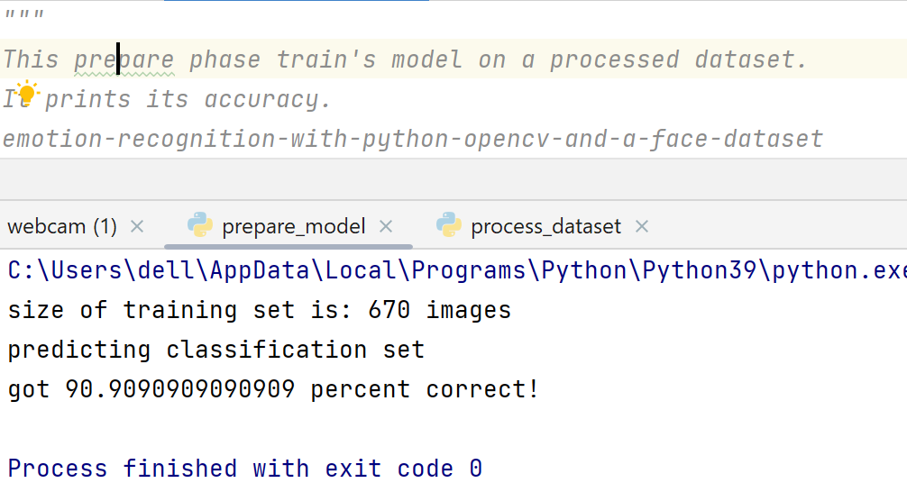

1. Working of face detection.

|  |  |
| --- | --- |
| Image A - |  |
| Image B - |  |

1. Working of the emotion recognition model. (7 emotions)

|  |  |  |  |  |
| --- | --- | --- | --- | --- |
|  | Sadness | Disgust | |  |
|  | Happy | Anger | |  |
|  | Fear | Surprise | |  |
| Neutral | |

1. Results show for multiple faces as input.

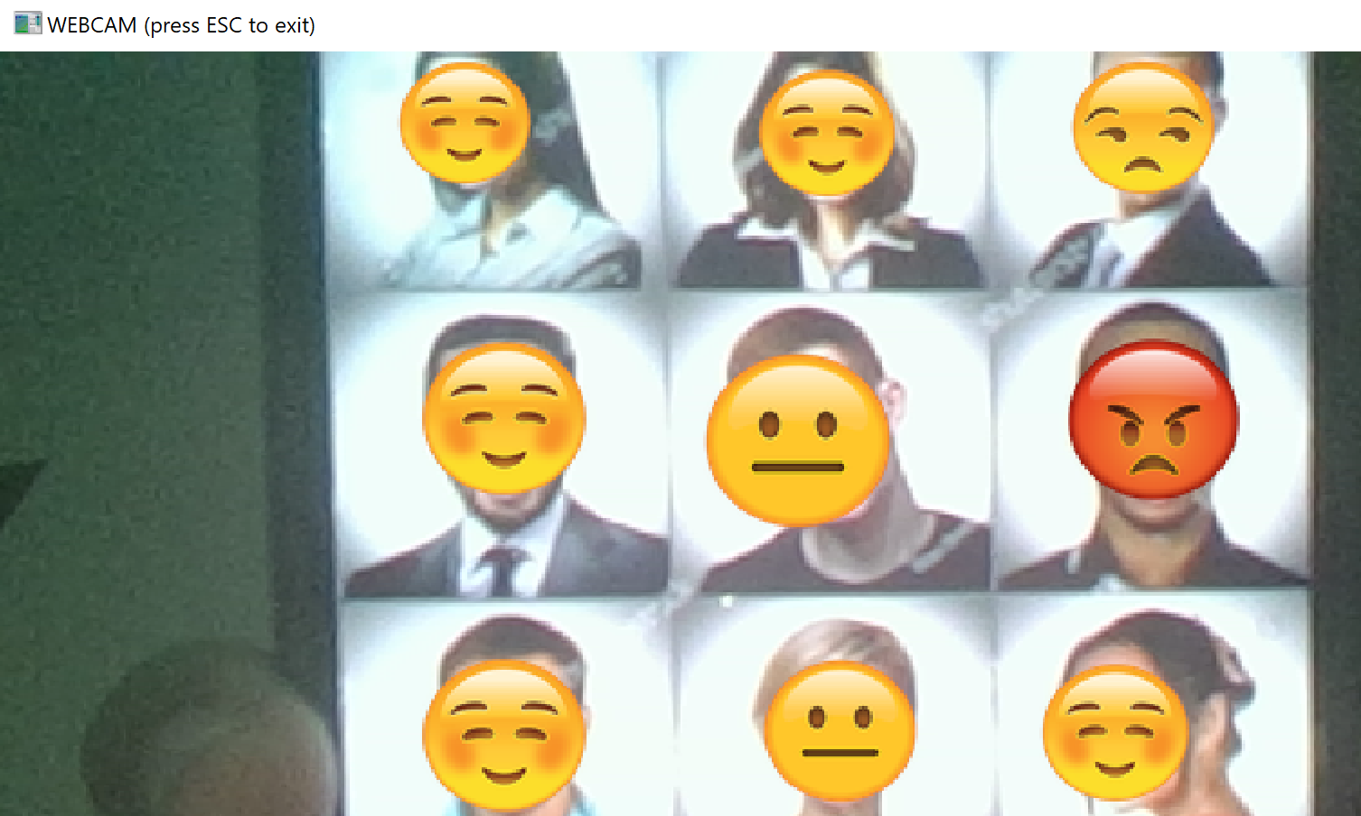

**Limitation**

* When compared to a digital camera, the quality of the scanned video is relatively poor. Like corresponding to around 2MP, a low-cost digital camera may capture 15MP for this difference is clear to see.
* Emotion recognition methods are more independent on human will and therefore might be perceived as a more reliable source of information on affective state of a user, however inconsistency rate is problem. limited number of participants and arbitrarily chosen metrics and thresholds.
* Due to the already small image size and the target's distance from the camera, it requires a lot of processing resources to scan an image for various face sizes. The identified face is only about 100 pixels wide. The majority of algorithms allow for the selection of a face-size range in order to decrease false positives during detection and speed up image processing.
* The recognition score is significantly influenced by the relative angle of the target's face. Any view other than a frontal view affects the algorithm's ability to build a face template. The directness and resolution of the image both affect how well any resulting matches are rated.

**Conclusion**

There is a lot of evidence that human emotions influence interactions with computers and software products. The implementation was successful, there is room for improvement in a number of important areas. Larger dataset should be created in order to improve the model's comprehensiveness. While we achieved > 90% accuracy in the perfect lighting, camera at eye level, subject facing camera with an exaggerated expression, any obstruction from that resulted in significant accuracy loss. Adjusting the brightness to the same level on all the images might have removed the requirement for providing jittered input images. As previously stated, deciding how to classify transition frames from neutral to fully formed expressions of emotion is a particularly difficult aspect, relatively slow frame rate rendered this solution unworkable. Regardless, our implementation appeared to reliably classify a subject's emotion. A running average would be required in future implementations that run at higher frame rates. Also, fully training the augmented images might yield substantial improvements in recognition, since the computation speed is relatively slow. Designers, producers, teachers, and students are all interested in the emotions that educational materials and tools elicit.

**REFERENCES**

<https://itrexgroup.com/blog/facial-recognition-benefits-applications-challenges/#header>

<https://www.techsciresearch.com/blog/future-of-facial-recognition-technology/105.html>

<https://www.analyticsvidhya.com/blog/2021/08/a-brief-introduction-to-linear-discriminant-analysis/>

<https://www.studocu.com/en-gb/document/maulana-abul-kalam-azad-university-of-technology/pattern-recognition/03-fisherface-pami97/36565460>

<https://www.infoworld.com/article/3543885/python-39-whats-new-and-better.html>

<https://www.researchgate.net/figure/Face-detection-and-emotion-recognition-using-machine-learning_fig1_322897107>

<https://www.studocu.com/in/document/dhempe-college-of-arts-and-science/computer-science/face-emotion-recognition-using-python-project-19nr1ao595/30962518>

<https://www.kaggle.com/code/vividharawat/human-emotion-detection-by-using-cnn>

<https://link.springer.com/chapter/10.1007/978-0-85729-932-1_19>

<https://opencv.org/opencv-face-recognition/>

Pulli, Kari; Baksheev, Anatoly; Kornyakov, Kirill; Eruhimov, Victor (1 April 2012). ["Realtime Computer Vision with OpenCV"](http://dl.acm.org/citation.cfm?id=2206309). *Queue*. **10** (4): 40:40–40:56. [doi](https://en.wikipedia.org/wiki/Doi_(identifier)):[10.1145/2181796.2206309](https://doi.org/10.1145%2F2181796.2206309).

<https://cseweb.ucsd.edu/classes/wi14/cse152-a/fisherface-pami97.pdf>

IEEE TRANSACTIONS ON PATTERN ANALYSIS AND MACHINE INTELLIGENCE, VOL. 19, NO. 7, JULY 1997 pages 711-720

D. Wu, X. Han, Z. Yang and R. Wang, "Exploiting Transfer Learning for Emotion Recognition Under Cloud-Edge-Client Collaborations," in IEEE Journal on Selected Areas in Communications, vol. 39, no. 2, pp. 479-490, Feb. 2021, doi: 10.1109/JSAC.2020.3020677.

J. Ye, R. Janardan and Q. Li, Two-Dimensional Linear Discriminant Analysis, Advances in Neural Information Processing systems (NIPS), 2004.

Ahlberg, J., Forchheimer, R.: Face tracking for model-based coding and face animation. Int. J. Imaging Syst. Technol. **13**(1), 8–22 (2003)

P. Abhang, S. Rao, B. W. Gawali, and P. Rokade, “Article: Emotion recognition using speech and eeg signal a review,” *International Journal of Computer Applications*, vol. 15, pp. 37–40, February 2011. Full text available

A. Kołakowska, A. Landowska, M. Szwoch, W. Szwoch, and M. R. Wrobel,´ *Human-Computer Systems Interaction: Backgrounds and Applications 3*, ch. Emotion Recognition and Its Applications, pp. 51–62. Cham: Springer International Publishing, 2014.

A. Dhall, R. Goecke, S. Lucey, and T. Gedeon, “Static facial expression analysis in tough conditions: Data, evaluation protocol and benchmark,” in *Computer Vision Workshops (ICCV Workshops), 2011 IEEE International Conference on*, pp. 2106–2112, Nov 2011.

S. Ouellet, “Real-time emotion recognition for gaming using deep convolutional network features,” *CoRR*, vol. abs/1408.3750, 2014.

H. Kong, L. Wang and E. K. Teoh, J.G. Wang and V. Ronda, A Framework of 2D Fisher Discriminant Analysis: Application to Face Recognition with Small Number of Training Samples, IEEE Conference on Computer Vision and Pattern Recognition (CVPR), pp. 1083-1088, 2005.

Bartlett, M., Littlewort, G., Frank, M., Lainscsek, C., Fasel, I., Movellan, J.: Automatic recognition of facial actions in spontaneous expressions. J. Multimed. **1**(6), 22–35 (2006)

Landowska, A., Brodny, G. and Wrobel, M. Limitations of Emotion Recognition from Facial Expressions in e-Learning Context. DOI: 10.5220/0006357903830389 In Proceedings of the 9th International Conference on Computer Supported Education (CSEDU 2017) - Volume 2, pages 383-389

Black, M., Yacoob, Y.: Recognizing facial expressions in image sequences using local parameterized models of image motion. Int. J. Comput. Vis. **25**(1), 23–48 (1997)