


Next Gen EMIX Solution Design Document

Next Gen EMIX Solution –Pilot of Generating GDW Extracts (Sales, Product MIX and Hourly Sales)
High-Level Design

Version 1.0
Tuesday, Feb 4, 2015

Document Reference:

Version | Date | Prepared by | Module | Document Name
V 1.0 | 2/04/2015 | Jalasutram Sambasiva | Next Gen EMIX –Pilot for Generating GDW Extracts | Next Gen EMIX –Pilot for Generating GDW Extracts
V1.1 | 2/13/2015 | Swathi Paladugu | Technical Flow Diagram, Process | Next Gen EMIX –Pilot for Generating GDW Extracts
V1.2 | 3/5/2015 | Swathi Paladugu | PMIX Rules | Next Gen EMIX –Pilot for Generating GDW Extracts

Change Log:

Date | Modified By | Description
2/04/2015 | Jalasutram Sambasiva | Initial draft
2/13/2015 | Swathi Paladugu | Amended the Technical Flow diagram, Technical Process
3/5/2015 | Swathi Paladugu | Amended PMIX rules document and other pointers

Contents

1.0 Overview 4

2.0 Scope 4

3.0 Basic Processing Flow 5
3.1 Out of Scope for the pilot: 5

4.0 EMIX Current Process Flow 6
4.1 Pilot Process Data Flow 7

5.0 Business Rules 8
5.1 Daily Sales: 8
5.2 Time Segment Sales: 10
5.3 Product Mix: 10

6.0 Design Artifacts for Pilot Process 11
6.1 Input Folder Location of the GZ file 11

7.0 Dependencies 12
7.1 Reference Files 12
7.2 Input/Out File Locations 12

8.0 Data Mapping document 13

Overview

The McDonald’s EMIX process validates and cleanses data for over 14,000 US restaurants nightly. It provides Sales, PMIX and Daypart data to multiple warehouses such as Global Data Warehouse, SMART System Integration, Happy Meal toy replenishment, HAVI Global Solutions and Restaurant Order Proposal. While it provides current pertinent information, it does not support new business initiatives, like Create Your Own Taste (aka BYB) and Holistic Value.

Challenges in the current application:
- Limited flexibility for future business needs
- ISP is the main source of data, which provides an aggregated daily summary of restaurant metrics
- Constraints on providing needed data to support business reporting on initiatives
- Legacy technology platform
- High turnaround time to make changes
- Limited resources that understand the application
- Lack of documentation

The proposed rewrite of final EMIX solution is expected to realize opportunities, listed below, for the McDonalds’ US business:
- Use detailed XML data as main data input to Market Analytics and TLD systems
- Leverage investments in Hadoop ecosystem
- Revise business rules / processes
- Improve timeliness of data delivery
- Enhance analytics/reporting capabilities
- Create application and architecture documentation

Scope
• Process the STLD and other XML files for 12,907 restaurants within current SLA timeframes.
- Note: I chose 12,907 b/c that’s 90% of the 14,341 restaurants that provided sales data in Dec ’14.
- Note: I chose 90% b/c I think that’s the required percent of restaurants to have been processed in order to deliver the NDS by 6 AM.

· Provide the following sales metrics into the GDW daily sales table
- Total sales dollars and transaction count (sales_typ_id_nu = 1)
- Total drive thru sales dollars and transaction count (sales_typ_id_nu = 2)
- Total front counter sales dollars and transaction count (sales_typ_id_nu = 3)
- Total product sales dollars (sales_typ_id_nu = 6)
- Total non-product sales dollars (sales_typ_id_nu = 7)
- Total coupons dollars and redeemed count (sales_typ_id_nu = 8)
- Total gift cards redeemed dollars and count (sales_typ_id_nu = 9)
- Total gift cards sold dollars and count (sales_typ_id_nu = 10)

· Provide the following sales metrics into the GDW hourly, and or daypart, sales table.
- Total sales dollars and transaction count (sales_typ_id_nu = 1)
- Total drive thru sales dollars and transaction count (sales_typ_id_nu = 2)
- Total front counter sales dollars and transaction count (sales_typ_id_nu = 3)
· Provide the following PMIX metrics into the GDW daily PMIX table
- Primary menu item number (i.e. STLD for secondary menu item numbers should be converted to their
Corresponding primary menu item number)
- Total units sold
- Units sold as part of a combo
- Units sold a la carte
- Units promoted
- Selling price
· STLD order information captured into an “order header” and “order detail” table that will support reporting on the following:
- Identifying which side items were chosen in Value Meals. For example, at Holistic Value restaurants identify the top 10 side item combinations that were chosen with the Holistic Value EVMs.
- Identifying the ingredients selected by the customer. For example, at Create Your Taste restaurants identify the number of times each ingredient was selected with a CYT menu item.

· The sales and PMIX data generated from the STLD closely matches the existing sales and PMIX data generated by EMIX.

Basic Processing Flow

The input to this process as part of the pilot is

- Receive the USA stores information as a zipped file in xml format.
- Hadoop MapReduce takes one day xml data from the gold layer (or the work layer) to process.
- Run the Next Gen MapReduce to process each record in the file. Each record refers to a different stores information received for that day.
- Provide the summarized orders for each store (as a pipe separated value file) to Global Data Warehouse which is a downstream system.

Out of Scope for the pilot:

- Sending data to HAVI
- Combo up down
- Any major current EMIX functionality

EMIX Current Process Flow

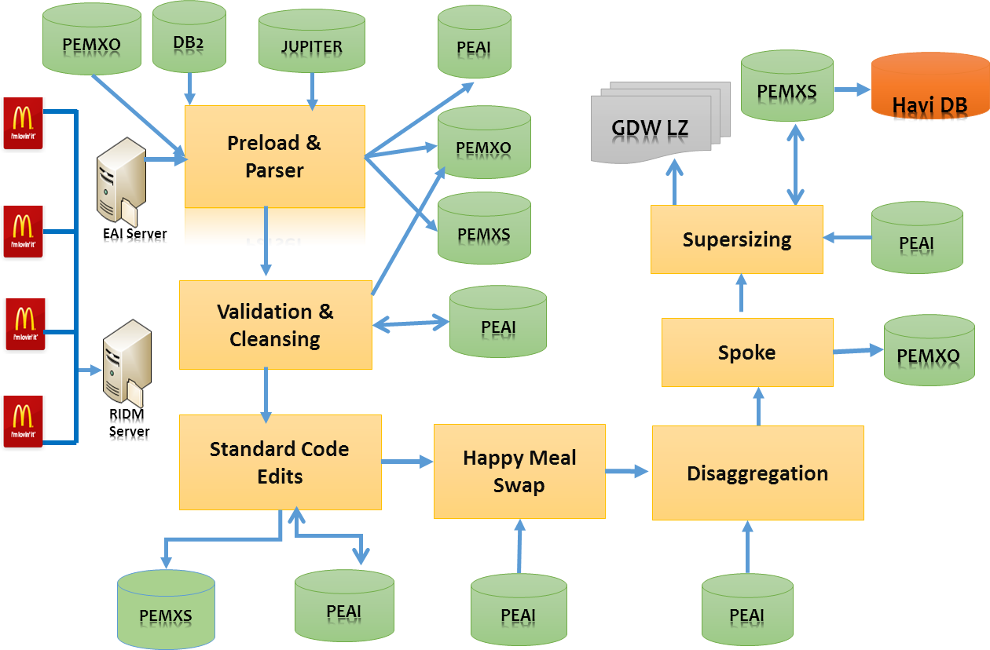

Pilot Process Data Flow

US TLD Files from
Hadoop Gold Layer

Reference Files
Distributed Cache

Sales
MapReduce Process

Product MIX

Hourly Sales

Business Rules

Daily Sales:

The Daily Sales is categorized into different Sale Type Categories:
- Total
- Drive Thru
- Counter
- Eat In
- Take Out
- Product
- Non-Product
- Coupons Redeemed
- Gift Certificates Redeemed
- Gift Certificates Sold

The values for Net Sales Amount, Transaction Count and Sold Redeemed Quantity are coming in the Tempsend daily sales file for various Sale Types.

In Tempsend, there is only Net Sales Amount coming from the market and hence the columns Gross Sales Amount and Tax Sales Amount are NULL for USA.

For Sale Type – Product, Tempsend don’t provide any Transaction Count and Sold Redeemed Quantity and hence they are not populated.

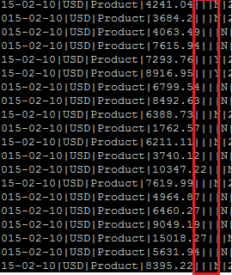

For Sale Type – Non-Product, Tempsend don’t provide any Transaction Count and Sold Redeemed Quantity and hence they are not populated.

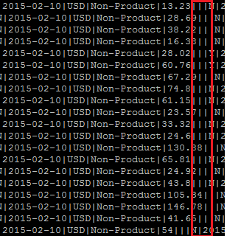

For Sale Type – Coupons Redeemed, Tempsend don’t provide Transaction Count but provide Sold Redeemed Quantity.

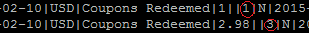

For Sale Type – Gift Certificates Redeemed, Tempsend don’t provide Transaction Count but provide Sold Redeemed Quantity.

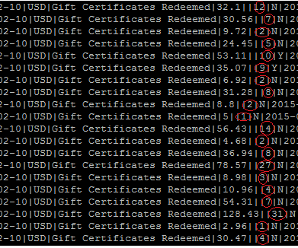
For Sale Type – Gift Certificates Redeemed, Tempsend don’t provide Transaction Count but provide Sold Redeemed Quantity.

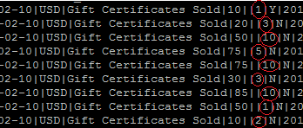

Time Segment Sales:
The Time Segment Sales is categorized into different Time Segment Type Categories:
- Hourly
- Half Hourly
- Quarter Hourly

The values for Net Sales Amount and Transaction Count are coming in the Tempsend Time Segment sales file (Hourly Sales) for various Sale Types.

Tempsend provide Time Segment sales file for only the Sale Types – Total, Counter, Drive Thru for USA.

Tempsend provide Time Segment sales file for Time Segment Types – Hourly and Half Hourly.

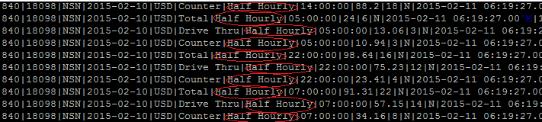

Product Mix:
The Product Mix is categorized into different Product Mix Type Categories:
- Total Sold
- Total Consumed
- Eat In
- Take Out
- Employee Meals
- Manager Meals
- Promo
- Waste

Tempsend provide Product Mix data for only the Product Mix Types – Total Sold and Promo for USA.

Some of important data the Tempsend provide is the Price Type , Menu Item Number, Daily Product Mix Price Amount, Units Sold as keyed in POS, Units Sold as part of Combination Menu Item, Total Number of Units Moved, Difference Between the Price of an item if purchased in a meal vs. ala carte, Price of Item as represented on POS, Source of the Product Mix on data.

Design Artifacts for Pilot Process
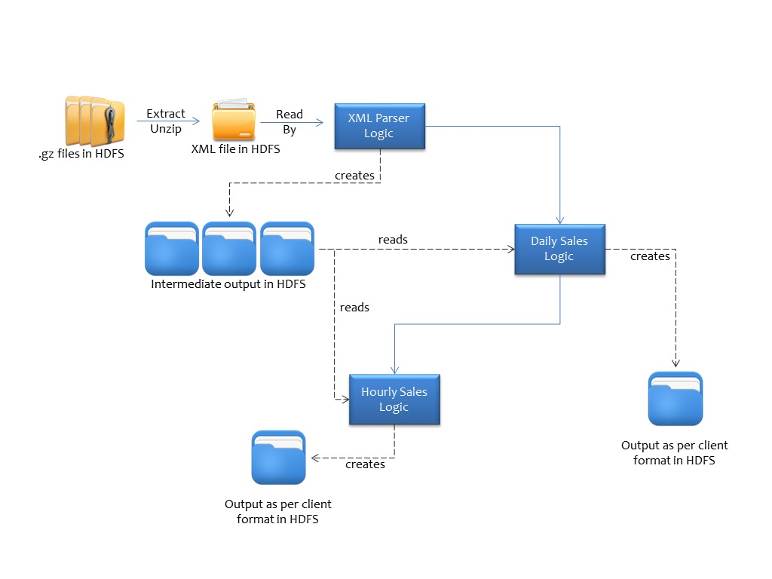
Pilot –Technical Flow Diagram

STLD XML Technical Process:
- Retrieve the orders of all Transactions like TRX_Sale of status only PAID, TRX_Refund, TRX_Overring.
- Retrieve the attributes like kind, totalAmount, Transaction, TimeStamp from the orders.
- Retrieve the Items of all the retrieved Orders.
- Retrieve the attributes like code,qty,level,totalPrice,qtyPromo from the items at level:”0”
- Retrieve the Tender under Tenders of all the orders.
- Retrieve the TenderName, TenderKind, TenderQuantity, FaceValue elements text content.

Daily Sales Technical Process:
- Read the xml attributes to process further
- If Kind is Manager* or Crew* of TRX_Sale then If totalAmount is not zero then Sum the TotalAmount ,Drive Thru, Counter sales and the Transaction Count of Total, Drive Thru, Counter
- Else Sum the TotalAmount,Drive Thru, Counter and Transaction count Total, Drive Thru, Counter
- If the order is TRX_Refund then deduct the TotalAmount , Drive Thru, Counter
- If the order is TRX_Overring then deduct the TotalAmount, Drive Thru, Counter and Transaction Count of Drive Thru, Counter
- For Gift Certificates Sold: Item codes retrieved from xml needs to be looked up in the list of ItemMapping.PSV
- If Item code exists add the totalPrice and qty that gives the total gift certificates sold amount and quantity.
- For Gift Certificates Redeemed: check if Tender Name is Gift Card
- Then Sum the Tender Quantity that gives the total Gift Certificates Redeemed quantity.
- Sum the Tender Amount that gives the total Gift Certificates Redeemed amount.
- Coupons Sold: TenderKind is 8 then sum the FaceValue and sum the Tender Quantity that gives the total coupons Sold amount and Quantity.
Issues:
- Data mismatch with Prod:
Action Taken: All the transaction POD’s like WalkThru, CSO except Drive Thru are calculated in Front Counter.

Sample Output File:
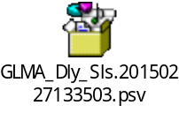

Hourly Sales Technical Process:
- Read the xml attributes to process further
- Capture the minutes and hours value from the TimeStamp
- Calculate the total, drive thru, Counter amount based on the segcode that falls.
Issues:
- Timestamp attribute is Empty String
Action Taken: Rejecting such records by if simple condition.
- Only Refund transaction at distinct segment are not picked up
Action Taken: Condition totalCount !=0 changed to totalAmount !=null
- In Time Segment data, we generated approx. 55 days of data. Approx. 40 stores have a mismatch with the data produced from our code vs. production data
Sample Output File:
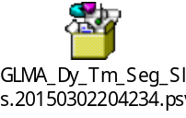
PMIX Technical Process:

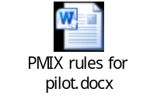
Issues:
- Duplicate DLY_PMX_PRC_AM
Action Taken: amount coming directly from lookup like 1$ converted into BigDecimal 1.00$
- Differences between Menu Item XML vs DB table data to get the Item price for combo sub items
Action Taken: collecting such codes of the particular stores and writing to errors file.
Store ID: 20816 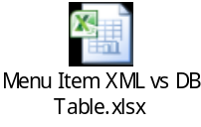
- menu Item do not have any item code level:1 in case of combo item is Generic Drink
Action Taken: Rejecting such records in this Pilot
Sample Output File:
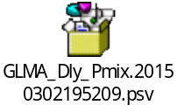

Input Folder Location of the GZ file
In the existing gold layer, for the country code (or Territory code=840 is for USA); need to process the STLD, DetailedSOS, MenuItem out of the 6 types.

Location/Paths:
/daas/gold/np_xml/DetailedSOS
/daas/gold/np_xml/MenuItem
/daas/gold/np_xml/Product-Db
/daas/gold/np_xml/STLD
/daas/gold/np_xml/SecurityData
/daas/gold/np_xml/Store-Db

For processing the STLD (say) file, for CountryCode=840
/daas/gold/np_xml/STLD:-
/daas/gold/np_xml/STLD/156
/daas/gold/np_xml/STLD/36
/daas/gold/np_xml/STLD/458
/daas/gold/np_xml/STLD/702
/daas/gold/np_xml/STLD/840

Need to process the previous day (Current date -1) folder only. If current date is 20150205
/daas/gold/np_xml/STLD/840(as on Feb-5):
/daas/gold/np_xml/STLD/840/20150126
/daas/gold/np_xml/STLD/840/20150127
/daas/gold/np_xml/STLD/840/20150128
/daas/gold/np_xml/STLD/840/20150129
/daas/gold/np_xml/STLD/840/20150130
/daas/gold/np_xml/STLD/840/20150131
/daas/gold/np_xml/STLD/840/20150201
/daas/gold/np_xml/STLD/840/20150202
/daas/gold/np_xml/STLD/840/20150203
/daas/gold/np_xml/STLD/840/20150204

Inside the /daas/gold/np_xml/STLD/840/20150204,
It contains a zip file
/daas/gold/np_xml/STLD/840/20150204:
/daas/gold/np_xml/STLD/840/20150204/STLD~840~20150204~0000001.gz

The hadoop process unzips the .gz(gun zip) file, to produce the input-xml-files(say) with-in it. MapReduce process has to process each of the input-xml-files.

Note: The input-xml-file, contains seven values and the last(or eighth) field contains the whole/actual xml as a String - received from the store.

Dependencies

Reference Files
Distributed cache files:

While processing the input xml, need to use the distributed cache files – called the reference files. Based on the Territory Code( or Country code – say 840 for USA), need to refer the corresponding values – like Currency, country, DayPart_ID, ORGTDA_CODE_VALUES from the below files:
Location:
/daas/distcachefiles

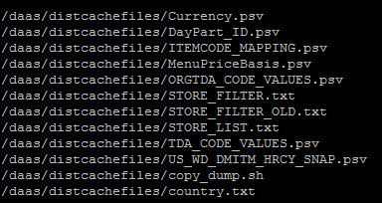

Input/Out File Locations
Input file for MapReduce:
Location: /daas/gold/np_xml/STLD/840/
For example:
/daas/gold/np_xml/STLD/840/20150204/STLD~840~20150204~0000001.gz

Output file from MapReduce:
Location: /daas/gold/np_xml/STLD/840/
For example:
/daas/gold/np_xml/STLD/840/20150204/STLD~840~20150204~0000001.gz

Data Mapping document
The attached document contains the mapping from the xml to the psv file. The sheet is a draft and could evolve.



