Spark download in MacOS.

Follow this link too…

<http://genomegeek.blogspot.com/2014/11/how-to-install-apache-spark-on-mac-os-x.html>

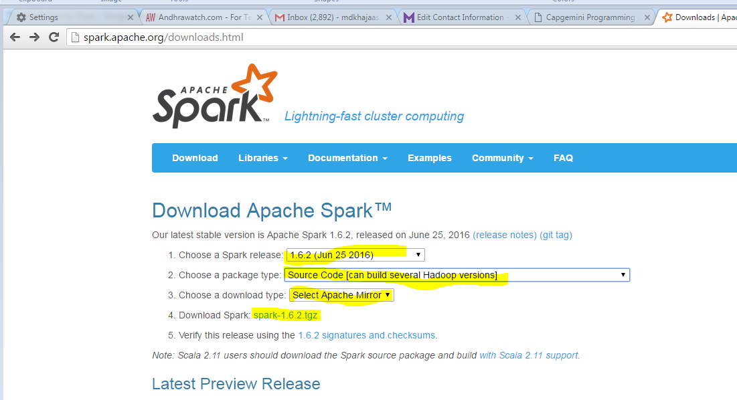

**Create folder: DevTools and put all in that folder, maven etc also**

**Cd /usr/local/spark … move here and unzip**

In mac, tar –zxvf spark----.tgz

Download apache maven now.

Go to <https://maven.apache.org/download.cgi>

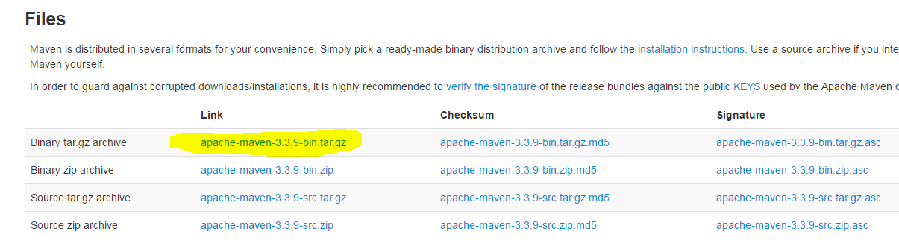

Sudo cd /usr/local move here and unzip it.

Add path variable for maven as shown below.

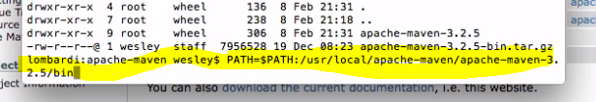

Echo $PATH.

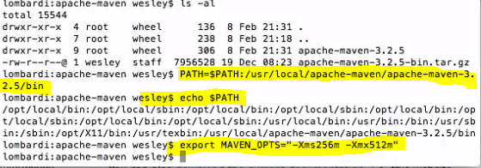

Download JDK and Building spark on MacOS.

<http://www.oracle.com/technetwork/java/javase/downloads/jdk8-downloads-2133151.html>

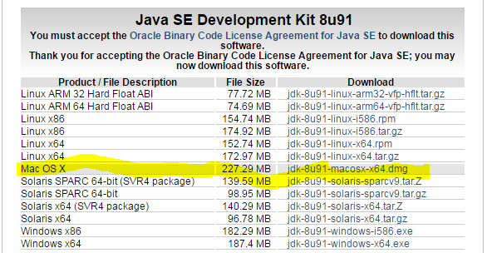

* Double click on the file after downloading, it will automatically JDK in macos.
* export java_home =/usr



* You will get errors when checking java –version but that’s fine as it is taking the path from system.

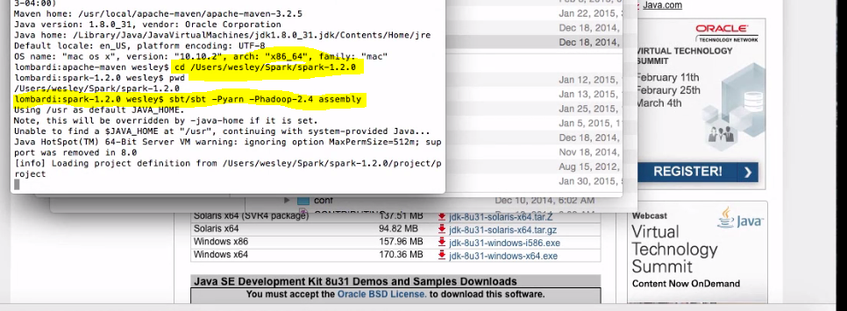

* Go to spark folder and type **sbt/sbt –p yarn –phadoop-2.X assembly**

It will take 10 minutes to download the package of spark with SBT.

After that do packaging for running our programs

* Sbt/sbt package

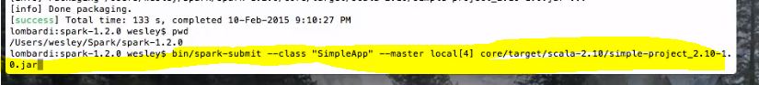

Check if you can submit spark submit after packaging sbt jar file. You can see path of the classes which came by default with spark installation.

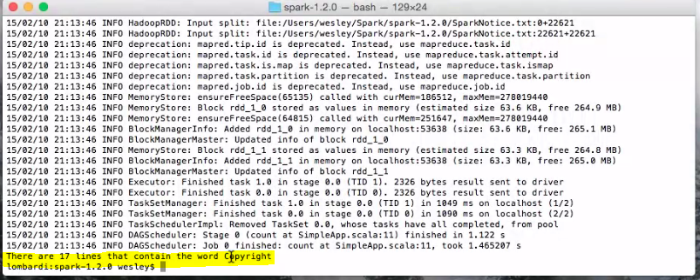

You should get output like this after running spark submit.

Follow this link too…

<http://genomegeek.blogspot.com/2014/11/how-to-install-apache-spark-on-mac-os-x.html>