A Knowledge Graph-Centric Multi-Agent Framework for Curriculum-Market Alignment and Learning Resource Construction

First AUTHOR1, Second AUTHOR2*, Third AUTHOR3
(1. affiliation, city, province, postcode; 2*. affiliation, city, province, postcode; 3. affiliation, city, province, postcode)
* Corresponding author
Abstract: Higher education courses increasingly face three linked challenges: teaching knowledge is fragmented across heterogeneous course materials, curricula evolve more slowly than labor-market skill demands, and the manual construction of supporting resources imposes substantial burden on instructors. To address these issues, we propose Lab Tutor, a knowledge-graph-centric multi-agent framework for intelligent curriculum resource construction and curriculum-market alignment. The framework organizes teacher-provided materials into a course knowledge graph, enriches that graph through textbook discovery and chapter-level skill extraction, aligns curriculum content with market-demand skills derived from job postings, and links identified skills to downstream learning resources under human-in-the-loop review checkpoints. We evaluate the framework through a Big Data course case study using four curriculum variants: transcript-derived knowledge only, transcript plus textbook skills, transcript plus market skills, and the fully enriched combination. In a small-sample held-out evaluation over graph-linked market-skill requirements from five held-out jobs, the fully enriched variant improved demand-weighted skill coverage from 0.2115 to 0.4231 and average job-fit score from 0.2467 to 0.4200 relative to the transcript-only baseline. The results indicate that market-skill enrichment explains most of the observed lift, while textbook enrichment provides complementary gains. These findings suggest that a knowledge-graph-centric multi-agent workflow can improve estimated curriculum-to-market alignment and better support skill-linked resource construction, while preserving instructor oversight at critical decision points.
Keywords: knowledge graphs; multi-agent systems; curriculum-market alignment; learning resource construction; higher education

1. Introduction
Higher education is under growing pressure to demonstrate that university learning still translates into timely, degree-relevant employment. Aggregate graduate employment indicators remain relatively strong in some regions, yet the transition from study to stable professional work has become increasingly fragile and uneven. Eurostat reports that the employment rate for recent tertiary graduates in the European Union reached 86.7% in 2024, but this favorable aggregate masks cross-country dispersion and does not eliminate mismatch between what programs teach and what employers require (Eurostat, 2025). In the United States, the picture is sharper for early-career graduates: the Federal Reserve Bank of New York reported unemployment of about 5.7% and underemployment of 42.5% for recent college graduates in 2025:Q4 (Federal Reserve Bank of New York, 2025). More broadly, international labor statistics continue to show that smoother education-to-work transitions cannot be taken for granted even when top-line employment remains comparatively strong (International Labour Organization [ILO], 2024). Together, these trends suggest that the higher-education challenge is no longer only access to education, but also the quality and timeliness of the education-to-work alignment it produces.
At the same time, the labor market is changing faster than conventional curriculum revision cycles. The World Economic Forum reports that employers expect 39% of workers' core skills to change by 2030, while artificial intelligence, big data, and cybersecurity remain among the fastest-growing capability areas (World Economic Forum, 2025). OECD research further shows that skill and qualification mismatch is associated with lower productivity, reinforcing that misalignment is not only an educational issue but also an economic one (Adalet McGowan & Andrews, 2015). These observations matter for universities because curriculum governance usually moves on a slower timetable than labor-market skill demand. When course revision relies primarily on periodic review, retrospective feedback, or local intuition, a curriculum can drift out of sync with the skills landscape during the lifetime of a single student cohort. In practice, this means that curriculum quality is no longer only about internal coherence or disciplinary completeness. It is also about whether a course can make its skill coverage legible, diagnosable, and updateable in response to external demand signals without forcing instructors into continuous manual redesign.
This pressure exposes three linked problems in current course design and resource construction. First, teaching knowledge is fragmented. Course content is distributed across lecture notes, transcripts, slides, books, and other files that are difficult to search, compare, and reorganize semantically. Second, curriculum-market alignment is weak because program revision often depends on lagging indicators such as retrospective feedback, faculty intuition, or infrequent external consultation rather than continuously updated labor signals. Third, teaching-resource construction remains expensive and labor-intensive. Instructors must identify suitable books, determine what additional skills deserve coverage, and curate external resources manually, all while the underlying skill landscape continues to move. These problems are tightly coupled: fragmented knowledge makes alignment harder, weak alignment increases the need for new materials, and manual resource construction scales poorly as knowledge changes faster.
Research in educational knowledge graphs, curriculum-skill mapping, and artificial intelligence (AI)-supported educational systems suggests that these challenges should not be treated separately. Knowledge graphs provide a structured way to represent heterogeneous course knowledge and support later retrieval, comparison, and recommendation (Abu-Salih & Alotaibi, 2024; Dang et al., 2021). Multi-agent systems offer a practical decomposition strategy for complex educational tasks that require distinct forms of reasoning, orchestration, and review (Guo et al., 2024). Human-centered governance guidance further emphasizes that educational AI systems should retain oversight and accountability at critical decision points rather than fully automate high-impact curricular judgments (UNESCO, 2023). Taken together, this literature suggests that the curriculum-market gap is best approached as a problem of structured knowledge organization, alignment, and governed action.
To address these challenges, we propose Lab Tutor, a knowledge-graph-centric multi-agent framework for intelligent curriculum resource construction. The framework uses a course knowledge graph as the common semantic substrate for organizing teacher-provided materials, aligning them with textbook and labor-market skills, and linking the resulting skills to downstream learning resources. Rather than treating documents, books, jobs, and resources as separate silos, Lab Tutor models them as interoperable entities connected through explicit relations among course chapters, concepts, skills, job postings, and recommended resources. The system is organized as a three-layer workflow: a knowledge foundation layer that extracts and structures course content, a knowledge alignment layer that integrates textbook and market-demand evidence, and a resource application layer that supports skill-linked learning pathways. Because educational use requires trust and traceability, the workflow retains human review checkpoints at critical decisions such as textbook approval, skill curation, and concept review (UNESCO, 2023).
We evaluate the framework through a Big Data course case study. Starting from transcript-derived course knowledge, we compare four curriculum variants: transcript knowledge only (KG), transcript knowledge plus textbook skills (KG + B_S), transcript knowledge plus market skills (KG + J_S), and the fully enriched variant (KG + B_S + J_S). The evaluation is intentionally framed as a curriculum-to-market alignment study rather than an employment-outcome study. It asks whether curriculum enrichment reduces the skill gap between a university course and relevant job requirements on a small held-out subset of Big Data-related jobs.
The central research question of this paper is: how can a knowledge-graph-centric multi-agent system organize fragmented course knowledge, align it with textbooks and labor-market skills, and support resource construction under human oversight? This paper makes three contributions. First, it proposes a knowledge-graph-centric multi-agent framework for intelligent curriculum resource construction. Second, it presents a unified alignment pipeline connecting transcript knowledge, textbook skills, market skills, and skill-linked learning resources. Third, it reports a Big Data case study showing that curriculum enrichment improves estimated curriculum-to-market alignment under a small-sample held-out evaluation.

2. Related Work
This section reviews the four research directions most relevant to Lab Tutor: educational knowledge graphs, AI-supported and multi-agent educational systems, curriculum-labor-market alignment, and educational recommendation. These directions are necessary because the paper does not contribute only a graph, only an alignment method, or only a recommendation workflow. Instead, it combines all of them into one teacher-centered pipeline. The purpose of this section is therefore twofold: to show which ideas are already well established in prior work and to clarify which combination of problems remains insufficiently addressed.
Research on knowledge graphs in education provides an important foundation for our work because it addresses the problem of fragmented educational content through structured semantic representation. Recent review literature argues that knowledge graphs are increasingly used in education for concept organization, learning support, curriculum analysis, and recommendation tasks (Abu-Salih & Alotaibi, 2024). System-oriented studies such as educational knowledge graphs linked to Wikipedia and course-centered graph systems show that heterogeneous educational artifacts can be normalized into entities and relations suitable for retrieval, analytics, and downstream applications (Dang et al., 2021; Li et al., 2024). These studies support the core premise that curriculum knowledge should not remain trapped inside disconnected files. At the same time, most prior educational knowledge-graph systems focus on graph construction, concept linking, or recommendation in isolation. They do not typically combine course-graph construction with textbook alignment, labor-market alignment, and instructor-governed resource construction inside one end-to-end workflow. This distinction matters because our framework is not only building an educational graph; it is using that graph as the coordination layer across multiple curriculum decisions that would otherwise remain separate.
The second relevant line of work concerns AI-supported and multi-agent educational systems. Earlier research in conversational intelligent tutoring systems argued that multiple agents are useful when educational tasks require distinct roles such as explanation, reflection, assessment, and dialogue management. More recently, the broader literature on large language model (LLM)-based multi-agent systems has provided a taxonomy for role decomposition, coordination, and controllability in complex AI workflows (Guo et al., 2024). Education-specific work on LLM-assisted educational knowledge graph creation further shows that generative models can support course modeling and graph augmentation when outputs remain auditable and human-validated (Jhajj et al., 2024). This literature supports the architectural logic behind using specialized agents rather than one monolithic model. However, most existing systems focus on tutoring, grading, or graph construction in isolation. They do not directly target curriculum-market alignment or the construction of skill-linked educational resource pipelines.
The third literature group focuses on curriculum-labor-market alignment. Here, recent work has made curriculum analysis more computable by linking course artifacts to explicit skills, job activities, and labor-market taxonomies. Course-Skill Atlas provides a large-scale dataset for inferring skills from course syllabi, while a PLOS ONE study connecting higher education content to workplace activities and earnings shows that curriculum artifacts can be mapped to external labor ontologies in a systematic way (Javadian Sabet et al., 2024; Chau et al., 2023). Work in educational data mining has also modeled curriculum profiles against job-market needs in data-intensive fields, demonstrating that the curriculum-job gap can be studied as an empirical comparison rather than only a qualitative concern (Gromov et al., 2020). This literature is especially close to our problem setting. Still, it usually emphasizes large-scale measurement, static curriculum analysis, or taxonomy linkage rather than a teacher-facing system that both diagnoses alignment gaps and connects them to concrete enrichment and resource-construction actions. Our framework therefore builds on this literature while shifting the emphasis from retrospective measurement toward curriculum intervention and resource support.
The fourth relevant area is educational recommendation and personalized support. Educational recommender systems have a substantial research history, and recent reviews emphasize both their practical value and their dependence on high-quality learner, content, and contextual representations (da Silva et al., 2023). More specialized work on ontology-based and semantic recommendation in e-learning argues that structured knowledge representations improve contextual relevance, resource matching, and learning-path generation (Rahayu et al., 2022). This literature aligns with our resource application layer, particularly the idea that recommendations are stronger when they are grounded in concepts and skills rather than in isolated keywords. However, most recommendation systems start from learner-resource interaction data or personalization logic after the educational content structure is already assumed. Our framework starts earlier by constructing and aligning the course graph itself before downstream resource support is produced.
In summary, prior work establishes that each ingredient of our framework is individually plausible: educational knowledge graphs can structure learning content, multi-agent workflows can decompose complex AI tasks, curriculum-market alignment can be studied through skills and labor evidence, semantic recommenders can support resource selection, and human oversight remains essential in educational AI (Abu-Salih & Alotaibi, 2024; Guo et al., 2024; UNESCO, 2023; Javadian Sabet et al., 2024; da Silva et al., 2023). However, the literature still leaves a practical and methodological gap. Existing work rarely combines all of these elements inside a single teacher-centered pipeline that begins with fragmented course materials, aligns them with textbook and market evidence, and then connects the result to actionable resource support under instructor review. Lab Tutor is positioned to address that gap, which is precisely why the present paper moves from related work into an integrated methodology and case study.

3. Methodology
This section explains the methodology behind Lab Tutor and why the framework is divided into distinct parts rather than treated as one monolithic workflow. The architecture is intentionally separated because the underlying educational problems are different in nature. Fragmented course materials must first be structured into a stable internal representation; external evidence from textbooks and labor markets must then be aligned against that representation; and only after those two problems are addressed can the system support resource construction in a traceable way. Organizing the framework into these parts improves interpretability, supports human review, and makes the later evaluation more meaningful because each layer solves a specific problem and can be examined separately.

3.1 Framework Overview and Design Principles
Lab Tutor is designed as a knowledge-graph-centric multi-agent framework for intelligent curriculum resource construction. The central design decision is to treat the course knowledge graph as the shared semantic substrate through which all downstream tasks communicate. Instead of allowing teacher-provided materials, textbooks, labor-market evidence, and learning resources to remain detached from one another, the framework represents them through explicit entities and relations centered on course chapters, concepts, skills, and resource links. This choice directly addresses the fragmentation problem described in the Introduction: if course knowledge remains trapped inside disconnected files, it is difficult to align, query, extend, or audit; if it is organized as a graph, later workflows can attach evidence, diagnose gaps, and surface targeted support.
The framework is organized into three layers because each layer addresses a different bottleneck in curriculum intelligence. The knowledge foundation layer transforms teacher-provided files into a transcript-grounded curriculum graph and therefore solves the problem of fragmented internal course knowledge. The knowledge alignment layer enriches that graph from two directions, textbook-derived skills and labor-market-derived skills, and therefore solves the problem of comparing internal curriculum content with external disciplinary and market evidence. The resource application layer uses the resulting skill banks to support downstream learning pathways such as readings and videos, and therefore solves the problem of turning alignment analysis into practical educational support. The system also follows two additional design principles. First, it uses role decomposition: major tasks are handled by specialized workflows or agent groups rather than by a single undifferentiated model call. Second, it preserves human governance: because textbook adoption, skill insertion, and concept normalization all have curricular consequences, the workflow pauses for instructor review at key decision points instead of fully automating these actions (UNESCO, 2023).
The course chapter scaffold plays a particularly important role in this design. Before textbook and market evidence are attached to the curriculum, the system constructs a teacher-owned chapter structure from extracted course materials. This means the curriculum graph is not driven by external books or job postings from the start; instead, it is anchored in what the teacher actually teaches. Later enrichment layers do not replace this scaffold. They map new skills and concepts into it. This design is important methodologically because it lets the system distinguish between the baseline curriculum and added enrichment, which in turn makes the four-variant evaluation interpretable.
Another key design principle is progressive enrichment rather than one-step generation. The system does not ask a model to generate a fully aligned curriculum from scratch. Instead, it first constructs the baseline course graph, then adds textbook-supported skills, then adds market-supported skills, and only after that links the aligned skill banks to downstream learning resources. This staged design makes the workflow more auditable, preserves provenance, and allows each added source of evidence to be evaluated independently in the case study.
At the graph level, this design is realized through a compact but expressive schema centered on COURSE_CHAPTER, CONCEPT, BOOK_SKILL, MARKET_SKILL, JOB_POSTING, and resource nodes. Chapters act as the stable curricular anchors; concepts preserve what the teacher materials explicitly cover; textbook and market skills act as enrichment layers; and job postings provide the evaluation-facing external demand context. Relations such as chapter-to-skill alignment, skill-to-concept prerequisites, and job-to-skill demand links allow the system to compare internal curriculum structure with external skill requirements without collapsing those sources into a single undifferentiated bag of keywords. This graph-centered data model is methodologically important because it preserves provenance: the system can distinguish whether a skill is transcript-grounded, textbook-supported, market-demanded, or introduced through downstream resource linkage. Figure 1 summarizes this three-layer framework and its main knowledge flows.
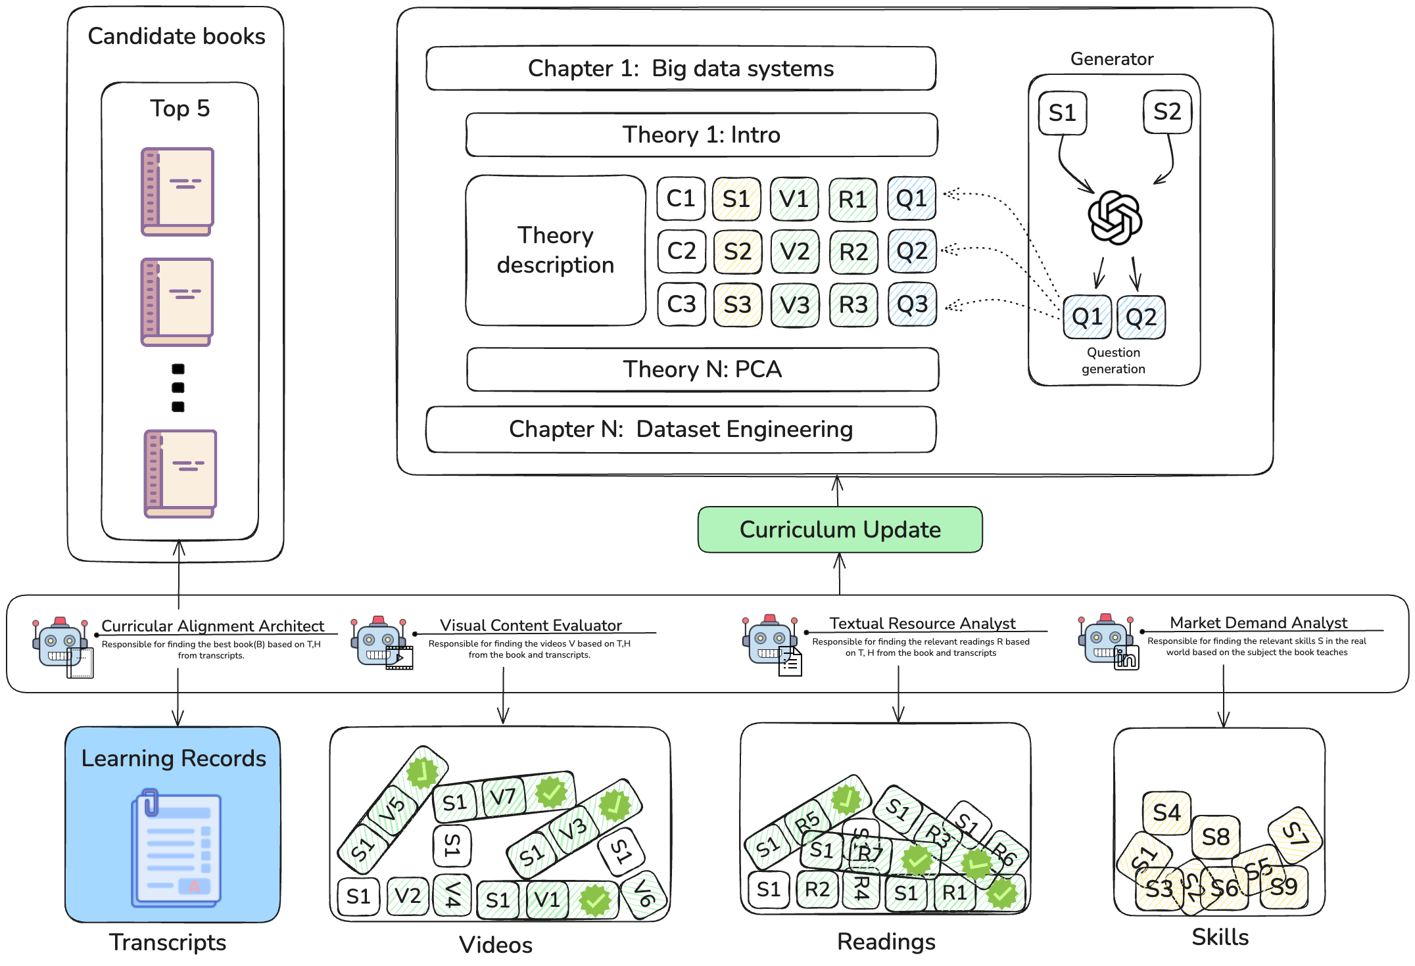
Figure 1
Three-layer framework and simplified system overview.

3.2 Task 1: Document Extraction, Concept Structuring, and Embeddings
The first task constructs the transcript-grounded course knowledge base. Teacher-uploaded materials are parsed and passed through structured extraction to identify document topics, summaries, keywords, and explicit concepts. Each extracted concept carries semantic provenance, including a normalized name, a definition-like description, and textual evidence from the source material. The extracted information is written into the graph as teacher-uploaded documents and concept mentions, creating a traceable record of which concepts originate from which course artifacts.
This stage is important for two reasons. First, it converts passive instructional files into a queryable curriculum memory. Second, it establishes the anchor against which later textbook and market skills are aligned. After extraction, embeddings are generated for both documents and concept mentions, creating a semantic retrieval substrate that later workflows can use for comparison, search, and evidence grounding. In practical terms, the output of Task 1 is not yet a market-aware curriculum; it is the teacher-owned baseline representation of what the course currently teaches.
This distinction between baseline representation and later enrichment is central to the evaluation design. If textbook and market information were fused into the curriculum from the start, it would be difficult to tell whether later improvements came from the graph representation itself or from added external evidence. By maintaining a transcript-derived baseline, Lab Tutor supports ablation across curriculum variants and makes it possible to compare how different enrichment sources change the coverage of held-out market requirements.

3.3 Task 2: Textbook Discovery and Curriculum Alignment
The second task is implemented by the Curricular Alignment Architect, which builds the book-side skill bank. The workflow begins by generating a diverse set of textbook-oriented search queries from the course context, then searching external sources in parallel to identify candidate books. Candidate books are deduplicated before scoring so that different listings of the same title do not distort ranking. The retained candidates are then evaluated through a multi-criteria process over topic coverage, structural alignment, scope and depth, publisher reputation, author authority, and recency.
$$S_{book}=0.30C_{topic}+0.20C_{struc}+0.15C_{scope}+0.15C_{pub}+0.10C_{auth}+0.10C_{time}$$ | Formula (1)
The implementation also supports an optional practicality blend S'_{book}=(1-W_{prac})S_{book}+W_{prac}C_{prac}, where C_{prac} captures the presence of labs, code examples, and exercises; however, the default workflow keeps W_{prac}=0, so practicality is retained as an explicit criterion without changing the ranking score unless configured otherwise. The workflow then pauses for teacher review so that only instructor-approved books continue into the extraction pipeline.
After book selection, the system resolves PDF acquisition, extracts chapter structure, and performs chapter-level analysis. The important distinction here is that raw PDF extraction and chunking are not themselves the final book-skill output. The book-side skill vocabulary is created in the agentic chapter-extraction stage, where individual chapters are analyzed in parallel to produce chapter summaries, practical skills, and prerequisite concepts. These outputs are written into the graph as BOOK_SKILL nodes and REQUIRES_CONCEPT relations. A separate mapping flow then aligns extracted BOOK_SKILL nodes to the teacher-created course chapter scaffold. This step is what makes textbook-derived skills curriculum-relevant rather than isolated book artifacts.
Methodologically, textbook alignment contributes a form of disciplinary enrichment. Unlike market signals, which emphasize current employer demand, textbooks contribute structured pedagogical coverage, chapter-level organization, and prerequisite coherence. For that reason, textbook-derived skills should not be interpreted simply as another source of “more skills.” They serve a different purpose: they deepen and organize the curriculum representation from within the discipline, which is why they remain useful even when the measured lift is smaller than that of market-derived skills in the case study. In practical curriculum terms, this layer helps answer whether the course is internally coherent and instructionally supportable, even before the market-facing question of whether it tracks external demand closely enough. Algorithm 1 summarizes the main textbook-side skill-bank construction workflow.
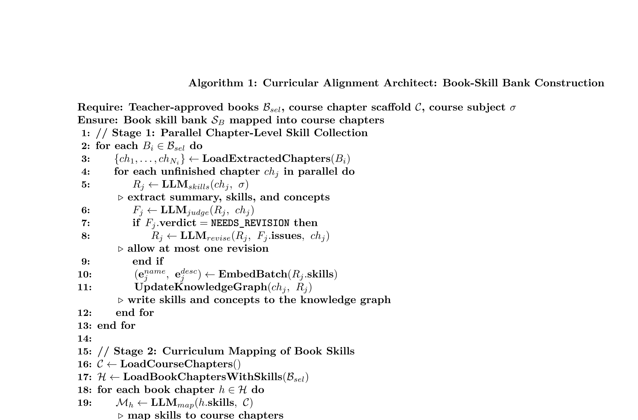

3.4 Task 3: Market-Demand Alignment
The third task is the Market Demand Analyst, which builds the market-side skill bank and serves as the main evaluated layer in the case study. The current implementation uses a coordinated multi-agent workflow centered on supervisory orchestration, curriculum mapping, and concept linking, together with parallel skill extraction. The process begins with job discovery from relevant search terms and external job platforms. Job postings are deduplicated and grouped so that the instructor can retain only roles genuinely relevant to the target curriculum. This human filtering step is important because curriculum alignment is meaningful only if the selected jobs correspond to the course domain rather than to a broad or noisy market sample.
Once a relevant job subset is selected, job descriptions are processed in parallel to extract concrete market skills. The resulting skills are aggregated, cleaned, frequency-scored, and mapped against the curriculum graph. For each candidate skill, the workflow determines whether the skill is already covered, partially covered, or better treated as a new topic need. Later stages remove redundancies relative to existing curriculum content and link retained skills to prerequisite concepts before inserting them as MARKET_SKILL nodes in the graph. This stage turns labor-market evidence into curriculum-relevant diagnostic output rather than a raw list of job terms. It also reduces a common problem in curriculum-market studies: noisy demand vocabulary. Raw postings often contain platform boilerplate, duplicated requirements, company-specific terminology, and weakly relevant skill mentions. By forcing extraction, normalization, deduplication, and chapter-aware mapping before insertion, the workflow narrows the distance between market language and curriculum language.
The output of this task supports two complementary uses. In teacher-facing analysis, it exposes where a curriculum appears strong, weak, or silent relative to selected job evidence. In the graph itself, it creates a reusable market-side skill bank whose relations to chapters, concepts, and job postings can support later recommendation and analysis tasks. This dual role helps explain why the market-demand workflow is central both to the framework's educational value and to the empirical evaluation in this paper. Algorithm 2 summarizes the main market-side skill-bank construction workflow.


3.5 Task 4: Resource Curation and Student Learning Support
The fourth task connects aligned skills to downstream support resources. In Lab Tutor, this is implemented through textual and video-oriented resource discovery workflows that build context from the graph. For each selected skill, the system constructs a skill profile using related concepts, chapter context, and course level, then generates targeted queries for readings and videos. The retrieval stage already applies modality-specific eligibility constraints: reading results exclude social platforms, shopping pages, generic video sites, paywalled resources, and homework-mill style domains, while the video workflow restricts retrieval to YouTube-based educational content. The surviving candidates are passed through semantic filtering and then ranked through a shared multi-criteria scoring function that combines recency, concept coverage, embedding alignment, pedagogy, depth, and a modality-specific quality factor.
$$S_{res}=0.15C_{rec}+0.25C_{cov}+0.15C_{emb}+0.20C_{ped}+0.15C_{depth}+0.10C_{extra}$$ | Formula (2)
Here, C_{extra} corresponds to source quality for readings and production quality for videos. Before final selection, the implementation also applies an embedding-based prefilter that keeps the highest-alignment candidates for detailed LLM scoring. After scoring, the pipeline applies a greedy coverage-maximizing selector with k=3, preferring resources that jointly cover the largest set of skill concepts while also enforcing at least two resource types when possible. This means the final reading and video recommendations are not chosen only by individual score, but by score-and-coverage tradeoff over the concept set attached to each selected skill.
This layer must be described carefully. In the current implementation, readings and videos are primarily generated through the student learning-path pipeline rather than through a fully mature teacher-side planning interface. For the purposes of this paper, the resource application layer is therefore presented as an implemented downstream use of the aligned skill banks, not as a claim that all teacher-facing resource workflows are already complete. This wording keeps the methodological account faithful to the current system while still showing how the framework closes the loop from “what should be learned” to “how it may be learned.”
This boundary is important because it keeps the paper from overclaiming maturity in the application layer. At the same time, the resource workflows still matter conceptually. They show that the alignment graph is not an endpoint used only for diagnostics. Instead, it can act as the semantic bridge from curriculum analysis to practical support for learning. In that sense, the resource application layer is a downstream consequence of the graph and skill-bank design rather than an independent module.

3.6 Human-AI Review and Quality Assurance
Human review is a core methodological commitment of the framework rather than an auxiliary feature. In the textbook workflow, teachers review ranked candidate books before adoption and can intervene when automatic retrieval yields weak results. In the market-demand workflow, teachers constrain job relevance, curate skill sets, and determine which skills should be retained for insertion. Concept-level review is also preserved where merge or linkage decisions may affect curriculum interpretation. Optional review can further be applied to downstream resource recommendations before they are treated as finalized support materials.
This design aligns with current educational AI governance guidance, which argues that trust, interpretability, and accountability are especially important in teaching and curriculum applications (UNESCO, 2023). Methodologically, these review points also reduce the risk that the final system output reflects only model fluency rather than curricular judgment. They also preserve a realistic division of labor: the system can accelerate retrieval, extraction, and comparison, but instructors retain authority over what counts as pedagogically appropriate curriculum change.

3.7 Big Data Case Study and Evaluation Design
We evaluate the framework through a Big Data course case study and frame the evaluation as a curriculum-to-market alignment study. The baseline curriculum representation, KG, is built from transcript-derived course knowledge and the teacher-owned chapter scaffold. We then construct three enriched variants: KG + B_S, which adds textbook-derived skills; KG + J_S, which adds market-derived skills; and KG + B_S + J_S, which combines both enrichment sources. This four-variant setup functions as an ablation-style comparison that lets us observe the relative contribution of different enrichment paths. Table 1 summarizes the main case-study dataset and split configuration.
Table 1
Big Data case study dataset summary.
Field | Value
Course | Big Data
Course chapters | 6
Uploaded transcript documents | 38
Approved books | 3
Raw job postings | 37
Retained job postings | 20
Dropped job postings | 17
Build jobs | 15
Held-out jobs | 5
Evaluated held-out skill instances | 26
The job dataset was collected from graph-linked search results and then filtered for relevance. In the current artifact, 37 raw job postings were gathered, 20 were retained, and 17 were dropped. The retained jobs were then split into 15 build jobs and 5 held-out jobs using a deterministic 0.25 test ratio. Across the held-out jobs, the paper-mode evaluation ultimately compares 26 graph-linked market-skill instances. Because the retained sample remains below the usual threshold for a stable benchmark, we treat this as a small-sample held-out evaluation rather than a definitive benchmark.
The evaluation compares the four curriculum variants against held-out market requirements. A methodological caveat is important here: persisted descriptions for the retained jobs are still empty in the current Neo4j graph. As a result, the paper-mode evaluation does not re-extract job skills from raw held-out job text. Instead, it evaluates each held-out JOB_POSTING through its already linked MARKET_SKILL nodes in the graph. Each skill instance is then judged as covered, partial, or missing relative to a curriculum variant, and these labels are mapped to numeric values of 1.0, 0.5, and 0.0 respectively. From these judgments we compute demand-weighted skill coverage and average job-fit score, with threshold-based success rates used only as secondary indicators. This setup is sufficient for comparing curriculum variants, but it should not be described as a fresh free-text extraction benchmark. Instead, it is better understood as a graph-backed held-out alignment evaluation over previously normalized market requirements.
The case study is designed to answer two core questions. First, to what extent does the transcript-only curriculum cover the skills required by relevant Big Data job postings? Second, how much do textbook-derived and market-derived enrichment improve estimated curriculum-to-market alignment? A third question remains interpretive rather than primary: what kinds of market skills remain weakly covered even after enrichment? Framing the study in this way helps keep the evaluation aligned with what the current artifact can actually support.

3.8 Alignment Metrics
We report two primary metrics and one secondary threshold indicator. Let J denote the held-out job set and let S_j denote the set of graph-linked market-skill requirements associated with held-out job j. For each curriculum variant v and each evaluated skill instance s, the structured evaluator returns a judgment y(v, s) in {1.0, 0.5, 0.0}, corresponding to covered, partial, and missing.
Demand-weighted skill coverage measures how much of the evaluated market-skill demand is supported by a curriculum variant:
Coverage(v)=s​ws y(v,s)s​ws | Formula (3)
where w_s denotes the demand weight of skill instance s in the graph-backed evaluation. This metric is appropriate as the main headline score because it aggregates alignment at the skill-instance level while preserving the intuition that more salient demand signals should matter more than rare ones.
Average job-fit score is computed in two stages. First, skill-instance scores are averaged within each held-out job:
JobFitj(v)=1|Sj|s∈Sj​y(v,s) | Formula (4)
These job-level scores are then averaged across all held-out jobs:
AvgJobFit(v)=1|J|j∈J​JobFitj(v) | Formula (5)
This second metric is easier to interpret from a curriculum-planning perspective because it captures how well a curriculum variant performs on a typical held-out job rather than on the skill pool as a whole. As a secondary indicator, we also report threshold-based success rates at 0.60 and 0.80 when useful, but these are treated as supportive rather than headline metrics because the held-out sample is small and the current artifact is better suited to relative comparison than to pass-fail benchmarking.
In summary, the methodology progresses from internal curriculum structuring to external evidence alignment and finally to downstream educational support. The layered design is not only an architectural preference; it is a problem-solving strategy. The knowledge foundation layer addresses fragmentation, the alignment layer addresses curriculum-market and curriculum-textbook mismatch, and the resource layer addresses the practical burden of turning alignment findings into usable support materials. Together, these methodological choices make it possible to diagnose curriculum gaps, enrich the curriculum with interpretable evidence, and evaluate the resulting variants in a controlled case study.

4. Results
This section reports what the methodology produces in the Big Data case study. It first compares curriculum variants quantitatively, then examines how gap closure happens at the skill level, and finally discusses the practical meaning and limitations of the observed improvements. The aim is not only to report scores, but also to show what kind of curriculum problem the framework is actually able to make visible and partially solve.

4.1 Curriculum-to-Market Alignment by Variant
The case study shows a consistent pattern: curriculum enrichment improves estimated alignment relative to the transcript-only baseline, and market-skill enrichment explains most of the measurable lift. The baseline KG variant achieved a demand-weighted skill coverage of 0.2115 and an average job-fit score of 0.2467. Adding textbook-derived skills alone raised coverage to 0.2692 and average job-fit to 0.2533. Adding market-derived skills produced a much larger improvement, increasing coverage to 0.4038 and average job-fit to 0.4100. The full variant, KG + B_S + J_S, achieved the best overall results, with coverage of 0.4231 and average job-fit of 0.4200. Figure 2 visualizes the variant-level trend, and Table 2 reports the main numerical results.
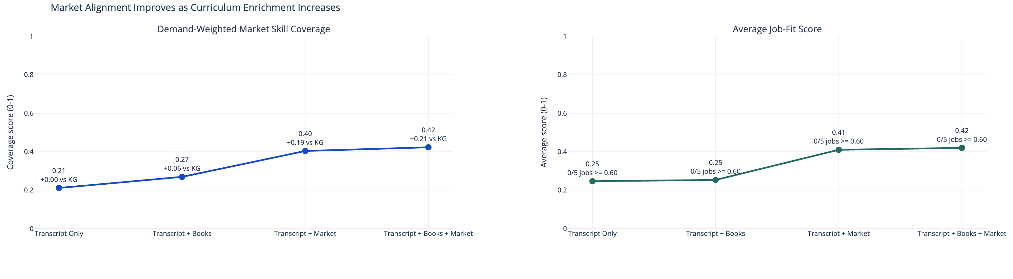
Figure 2
Market alignment improves as curriculum enrichment increases.
Table 2
Main experimental results.
Variant | Demand-weighted skill coverage | Average job-fit score | Success @ 0.60
KG | 0.2115 | 0.2467 | 0/5
KG + B_S | 0.2692 | 0.2533 | 0/5
KG + J_S | 0.4038 | 0.4100 | 0/5
KG + B_S + J_S | 0.4231 | 0.4200 | 0/5
These results support two immediate observations. First, transcript-derived course knowledge alone does not provide strong coverage of the evaluated market-skill requirements in the held-out set. Second, textbook enrichment and market enrichment are not interchangeable. Textbook enrichment adds modest gains relative to the baseline, but market enrichment produces the dominant improvement because it injects missing skill demand that is not strongly represented in the original course materials. The combined variant still outperforms KG + J_S, which suggests that textbook-derived disciplinary depth and market-derived labor relevance contribute in complementary ways.
The relative size of the gains is also informative. Compared with the transcript-only baseline, the full variant nearly doubles demand-weighted coverage and improves average job-fit by roughly seventy percent. By contrast, the move from KG to KG + B_S produces only a small improvement in average job-fit. This does not mean textbook enrichment is unimportant. Rather, it indicates that textbook evidence primarily strengthens structure, pedagogy, and prerequisite completeness, whereas market evidence directly addresses the specific external skills used in the evaluation. In other words, textbook enrichment improves curricular quality from the inside, while market enrichment improves measured external alignment.
Threshold-based success rates underline the same conclusion. In the current held-out split, no variant produced a job-fit success rate above the 0.60 threshold, which confirms that the case study should not be framed as evidence of complete job readiness. However, this absence of threshold success does not nullify the value of the observed improvements. The continuous metrics still show that enrichment substantially increases alignment relative to the baseline and that the combined variant is consistently strongest on the available evidence.

4.2 Skill-Gap Closure Analysis
The stacked-bar analysis shows how the improvement occurs. In the transcript-only baseline, 58% of evaluated market-skill instances remained missing and 42% were only partially covered, with no fully covered instances. Adding textbook-derived skills reduced the missing share to 46% and increased partial coverage to 54%, indicating that textbook supplementation helps narrow the gap but does not fundamentally close it. The strongest shift appears when market-derived skills are introduced: the KG + J_S variant reduced the missing share to 19% and increased partial coverage to 81%. The fully enriched variant retained the 19% missing share while introducing a small fully covered portion of 4%, with 77% partial coverage. Figure 3 shows this redistribution of covered, partial, and missing skill instances, while Table 3 should present representative examples of gap closure.
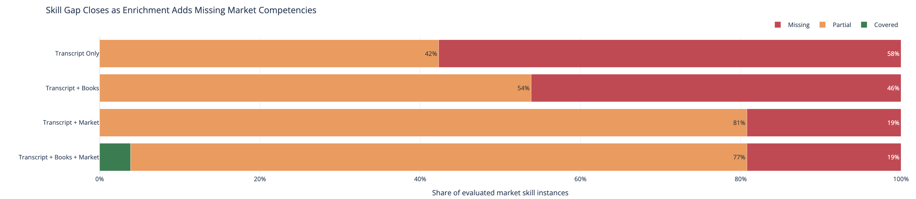
Figure 3
Skill gap closes as enrichment adds missing market competencies.
Table 3
Representative skill-gap closure examples.
Market skill | KG | KG + B_S | KG + J_S | KG + B_S + J_S | Note
Implement data quality checks, monitoring, and alerting | Partial | Partial | Partial | Covered | Only example that reaches covered in the full variant.
Implement data modeling for large-scale systems | Missing | Partial | Partial | Partial | Textbook and market enrichment both close the baseline gap.
Implement API design and development | Missing | Missing | Partial | Partial | Direct support appears only after market enrichment.
Build reusable frameworks and tooling for data engineering | Missing | Missing | Partial | Partial | Market layer exposes tooling-oriented data engineering needs.
Apply infrastructure as code practices | Missing | Missing | Partial | Partial | Shows cloud and DevOps pressure missing from the baseline course.
This pattern is substantively important. The main effect of enrichment in the current artifact is not a dramatic jump from missing directly to fully covered across the board. Instead, enrichment first transforms missing skills into partially supported skills by connecting them to new curricular evidence, prerequisite concepts, and aligned skill nodes. Given the small-sample held-out design and the proxy-based evaluation setup, this gradual movement from missing to partial should be interpreted as meaningful evidence of gap reduction rather than as proof of complete curricular sufficiency.
From a curriculum-design perspective, this intermediate movement is useful rather than disappointing. Many market requirements are compound competencies that blend tools, methods, and applied judgment. A curriculum rarely becomes fully aligned by adding a single concept or resource. More often, progress begins when the curriculum acquires partial semantic support for an external requirement: a missing technology receives conceptual grounding, a workflow becomes tied to prerequisite ideas, or a previously implicit topic is made explicit within a chapter. The current results are consistent with that pattern of incremental but interpretable alignment improvement.

4.3 Discussion and Limitations
From an educational perspective, the results suggest that alignment-aware curriculum enrichment can make hidden curriculum gaps more visible and more actionable. The transcript-only baseline reflects what the teacher-provided materials already express in the graph. The textbook-enriched variant adds disciplinary depth, chapter-level practical skills, and prerequisite structure. The market-enriched variant contributes the strongest observed lift because it directly injects labor-demand signals into the curriculum representation. The combined variant performs best overall, which supports the idea that course design benefits from both internal academic structure and external demand evidence.
At the same time, the case study should be interpreted with appropriate caution. First, the evaluation is a focused Big Data case study rather than a multi-course benchmark. Second, the held-out set contains only five jobs, so the results are best treated as a small-sample held-out evaluation. Third, the current paper-mode run evaluates held-out jobs through graph-linked MARKET_SKILL nodes because persisted job descriptions are empty for retained graph jobs. This means the current artifact is a held-out split over graph-linked skill proxies, not a fresh benchmark over raw job text. Fourth, the evaluation measures estimated curriculum-to-market alignment rather than real employment outcomes. It is therefore appropriate to claim improved visibility into skill gaps and improved estimated alignment, but not employability gains, hiring success, or causal labor-market impact on students.
These limitations also clarify the paper's future-work agenda. A stronger next step would be a larger held-out corpus with stored job descriptions, together with additional baselines and expert evaluation of the coverage judgments. Even with those limitations, however, the present case study is still useful: it shows that the framework can convert fragmented course materials, textbooks, and market evidence into a shared representation from which alignment differences across curriculum variants can be measured.
In this sense, the contribution of the case study is diagnostic rather than predictive. It shows that a curriculum graph can be enriched and compared against market-linked skill requirements in a way that exposes where the baseline curriculum is strong and where it remains incomplete. That diagnostic value is educationally significant even before the framework is validated at larger scale, because it gives instructors a structured basis for deciding what kinds of skills and resources deserve attention.

4.4 Implications for Curriculum Planning
The results suggest a practical interpretation of the framework for instructors and curriculum planners. The transcript-only graph can be viewed as a faithful representation of current course intent. Textbook enrichment then functions as a coherence layer: it surfaces prerequisite structure, chapter-level practice, and disciplinary breadth that may not be explicit in lecture transcripts alone. Market enrichment serves a different planning purpose. It highlights where the curriculum may need new examples, new tools, new case material, or even new chapter emphasis in order to speak more directly to contemporary external demand.
This division of labor matters for educational use. If market signals are treated as the only truth source, a curriculum risks becoming reactive and overly narrow. If textbook or internal course structure is treated as sufficient on its own, the curriculum may remain pedagogically coherent but drift away from current skill expectations. The current results support a more balanced position: a useful curriculum-planning workflow should preserve the teacher-owned conceptual scaffold, deepen it with textbook structure, and then selectively enrich it with external demand signals under human review.
The case study therefore supports Lab Tutor less as an auto-curriculum generator than as a structured curriculum intelligence system. Its most defensible contribution is helping instructors see what is already covered, what is weakly represented, and what may deserve targeted enrichment through readings, projects, examples, or supplementary learning resources. That type of visibility is valuable even in settings where institutions move slowly, because it turns curriculum revision from an opaque manual process into a more traceable and evidence-linked one. In summary, the results show measurable but still partial improvement: the framework does not solve curriculum-market mismatch completely, yet it does make the mismatch more explicit, more measurable, and more actionable for teacher-guided revision.

5. Conclusion
This paper presented Lab Tutor, a knowledge-graph-centric multi-agent framework for intelligent curriculum resource construction and curriculum-market alignment. The framework addresses three linked problems in higher education: fragmented course knowledge, slow response to labor-market change, and the high manual cost of building and updating instructional support materials. By organizing teacher-provided materials into a course knowledge graph, enriching that graph with textbook and market-derived skills, and linking aligned skills to downstream learning resources under instructor review, the framework provides a structured pathway from curriculum representation to actionable curriculum support.
The Big Data case study shows that curriculum enrichment improves estimated curriculum-to-market alignment relative to a transcript-only baseline. In the current small-sample held-out evaluation, the fully enriched variant achieved the strongest overall performance, with market-derived skills contributing most of the observed lift and textbook-derived skills providing additional complementary gains. These findings do not demonstrate employment outcomes, but they do show that a knowledge-graph-centric multi-agent workflow can expose and reduce curriculum-market skill gaps in a measurable way. Just as importantly, the case study suggests that curriculum intelligence is most useful when it remains teacher-centered: the graph makes hidden gaps visible, the enrichment layers make external demand comparable to internal course structure, and human review keeps curricular decisions accountable to educational judgment rather than model fluency alone.
Future work should strengthen the evidence base through larger held-out evaluations, richer job-text persistence, and broader multi-course validation. It should also continue improving the resource application layer so that alignment diagnostics and learning support become more tightly connected in practical educational use. In that sense, the present contribution is not a claim that curriculum-market mismatch has been solved once and for all. Rather, it is a demonstration that a knowledge-graph-centric multi-agent workflow can turn fragmented course materials, textbook evidence, and labor-market signals into a common, reviewable representation from which curriculum gaps can be analyzed more systematically and acted upon more responsibly.
Acknowledgement
Funding information or acknowledgement text will be added here if applicable.

References
Abu-Salih, B., & Alotaibi, S. (2024). A systematic literature review of knowledge graph construction and application in education. Heliyon, 10(3), e25383. https://doi.org/10.1016/j.heliyon.2024.e25383
Adalet McGowan, M., & Andrews, D. (2015). Labour market mismatch and labour productivity: Evidence from PIAAC data (OECD Economics Department Working Papers No. 1209). OECD Publishing. https://doi.org/10.1787/5js1pzx1r2kb-en
Chau, H., Bana, S. H., Bouvier, B., & Frank, M. R. (2023). Connecting higher education to workplace activities and earnings. PLOS ONE, 18(3), e0282323. https://doi.org/10.1371/journal.pone.0282323
da Silva, F. L., Slodkowski, B. K., da Silva, K. K. A., & Cazella, S. C. (2023). A systematic literature review on educational recommender systems for teaching and learning: Research trends, limitations and opportunities. Education and Information Technologies, 28(3), 3289-3328. https://doi.org/10.1007/s10639-022-11341-9
Dang, F.-R., Tang, J.-T., Pang, K.-Y., Wang, T., Li, S.-S., & Li, X. (2021). Constructing an educational knowledge graph with concepts linked to Wikipedia. Journal of Computer Science and Technology, 36(5), 1200-1211. https://doi.org/10.1007/s11390-020-0328-2
Eurostat. (2025, August 27). Employment rates of recent graduates. Statistics Explained. https://ec.europa.eu/eurostat/statistics-explained/SEPDF/cache/44912.pdf
Federal Reserve Bank of New York. (2025). The labor market for recent college graduates. https://www.newyorkfed.org/research/college-labor-market
Gromov, A., Maslennikov, A., Dawson, N., Musial, K., & Kitto, K. (2020). Curriculum profile: Modelling the gaps between curriculum and the job market. In Proceedings of the 13th International Conference on Educational Data Mining (EDM 2020) (pp. 610-614). https://educationaldatamining.org/files/conferences/EDM2020/papers/paper_59.pdf
Guo, T., Chen, X., Wang, Y., Chang, R., Pei, S., Chawla, N. V., Wiest, O., & Zhang, X. (2024). Large language model based multi-agents: A survey of progress and challenges. In Proceedings of the Thirty-Third International Joint Conference on Artificial Intelligence (IJCAI-24) (pp. 8048-8057). https://www.ijcai.org/proceedings/2024/0890.pdf
International Labour Organization. (2024). Global employment trends for youth 2024: Decent work, brighter futures. Executive summary. https://www.ilo.org/sites/default/files/2024-08/GET_2024_ExecSum_EN_0.pdf
Javadian Sabet, A., Bana, S. H., Yu, R., & Frank, M. R. (2024). Course-Skill Atlas: A national longitudinal dataset of skills taught in U.S. higher education curricula. Scientific Data, 11, Article 1086. https://doi.org/10.1038/s41597-024-03931-8
Jhajj, G., Zhang, X., Gustafson, J. R., Lin, F., & Lin, M. P.-C. (2024). Educational knowledge graph creation and augmentation via LLMs. In Generative Intelligence and Intelligent Tutoring Systems (pp. 292-304). Springer. https://doi.org/10.1007/978-3-031-63031-6_25
Li, Y., Liang, Y., Yang, R., Qiu, J., Zhang, C., & Zhang, X. (2024). CourseKG: An educational knowledge graph based on course information for precision teaching. Applied Sciences, 14(7), 2710. https://doi.org/10.3390/app14072710
Rahayu, N. W., Ferdiana, R., & Kusumawardani, S. S. (2022). A systematic review of ontology use in e-learning recommender system. Computers and Education: Artificial Intelligence, 3, 100047. https://doi.org/10.1016/j.caeai.2022.100047
UNESCO. (2023, September 7). Guidance for generative AI in education and research. https://www.unesco.org/en/articles/guidance-generative-ai-education-and-research
World Economic Forum. (2025). The Future of Jobs Report 2025. https://www.weforum.org/publications/the-future-of-jobs-report-2025/in-full/3-skills-outlook/
Author short bio
Author biographies will be added after the author list and affiliations are finalized.

