|  |
| --- |
| **Group No :**  **Group Member :**   1. Name ID 2. Name ID 3. Name ID 4. Name ID |

# Preparation

* In part 1, use Activity 2 Reference: SML Instruction Set, which can be downloaded from myCourseVille or the link below:  
  <https://www.mycourseville.com/sites/all/modules/courseville/files/uploads/2016_1/2110221/materials/sml_instruction_set.333.1471674877.pdf>
* In part 2 and 3, Use Brookshear Simple Machine Emulator to perform the indicated tasks <https://www.mycourseville.com/sites/all/modules/courseville/files/uploads/2016_1/2110221/materials/bme.333.1471675276.htm>
* Make a copy of this sheet. Answer the questions in the boxes given. After finishing, **save this file as a PDF** and **submit it to the assignment published on myCourseVille**.

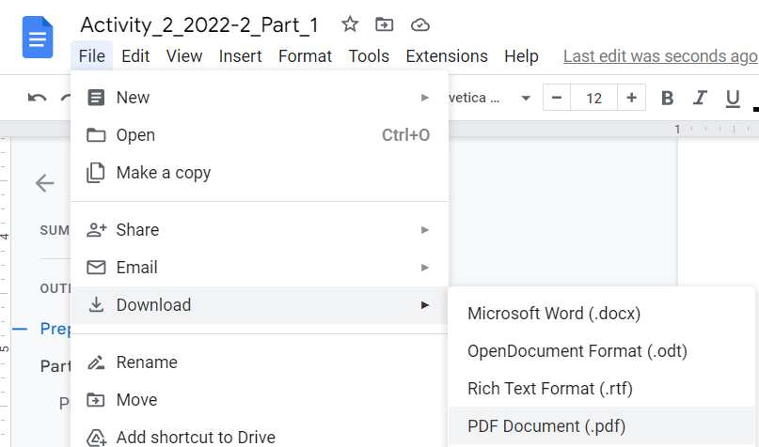

# Part 1 : SML Instruction

Once you finish this part, students must inform instructors or TAs for inspection.

## Program-A (3 Questions)

Suppose a CPU is started with PC=10 and the following values in cells 10-19 in memory.

|  |  |
| --- | --- |
| **Address** | **Content** |
| 10 | 22 |
| 11 | 36 |
| 12 | 25 |
| 13 | 0F |
| 14 | 83 |
| 15 | 25 |
| 16 | 33 |
| 17 | 20 |
| 18 | C0 |
| 19 | 00 |

### Question A.1 Decode the following instructions into English.

|  |  |
| --- | --- |
| 2236 | Load |
| 250F |  |
| 8325 |  |
| 3320 |  |
| C000 |  |

### Question A.2 What does this program perform?

|  |
| --- |
|  |

### Question A.3 What should be the content kept in the memory address 20 after the CPU finishes the execution?

|  |
| --- |
|  |

## Program-B (3 Questions)

Suppose a CPU is started with PC=20 and the following values in cells 20-31 in memory.

|  |  |  |  |  |
| --- | --- | --- | --- | --- |
| **Address** | **Content** |  | **Address** | **Content** |
| 20 | 11 |  | 2A | 22 |
| 21 | 30 |  | 2B | 01 |
| 22 | 20 |  | 2C | 32 |
| 23 | 05 |  | 2D | 31 |
| 24 | B1 |  | 2E | C0 |
| 25 | 2A |  | 2F | 00 |
| 26 | 22 |  | 30 | 04 |
| 27 | 00 |  | 31 | FF |
| 28 | B0 |  |  |  |
| 29 | 2C |  |  |  |

### Question B.1 Decode the following instructions into English.

|  |  |
| --- | --- |
| 1130 |  |
| 2005 |  |
| B12A |  |
| 2200 |  |
| B02C |  |
| 2201 |  |
| 3231 |  |
| C000 |  |

### Question B.2 What does this program perform?

|  |
| --- |
|  |

### 

### Question B.3 What should be the content kept in the memory address 31 after the CPU finishes the execution?

|  |
| --- |
|  |

*— THIS IS THE END OF PART 1 —*

## 