| **Group No :**  **Group Member :**   1. Name ID 2. Name ID 3. Name ID 4. Name ID |
| --- |

# Preparation

* In part 1, use Activity 2 Reference: SML Instruction Set, which can be downloaded from myCourseVille or the link below:  
  <https://www.mycourseville.com/sites/all/modules/courseville/files/uploads/2016_1/2110221/materials/sml_instruction_set.333.1471674877.pdf>
* In part 2 and 3, Use Brookshear Simple Machine Emulator to perform the indicated tasks <https://www.mycourseville.com/sites/all/modules/courseville/files/uploads/2016_1/2110221/materials/bme.333.1471675276.htm>
* Make a copy of this sheet. Answer the questions in the boxes given. After finishing, **save this file as a PDF** and **submit it to the assignment published on myCourseVille**.

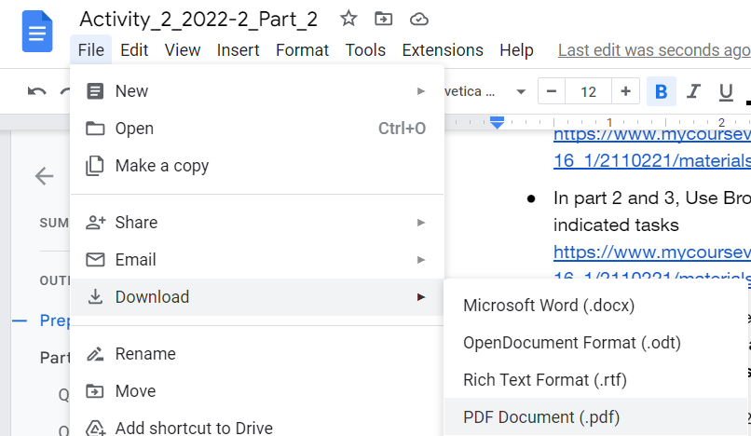

# Part 2 : Playing with Emulator (8 Questions)

Once you finish this part, students must inform instructors or TAs for inspection.

Suppose the CPU is started with PC=0 and the following values in cells 00-0F and F0-F2 in memory.

| Address | Content |  | Address | Content |
| --- | --- | --- | --- | --- |
| 00 | 10 |  | F0 | 02 |
| 01 | F0 |  | F1 | 03 |
| 02 | 11 |  | F2 | 05 |
| 03 | F1 |  |  |  |
| 04 | 12 |  |  |  |
| 05 | F2 |  |  |  |
| 06 | 23 |  |  |  |
| 07 | 01 |  |  |  |
| 08 | 54 |  |  |  |
| 09 | 03 |  |  |  |
| 0A | 55 |  |  |  |
| 0B | 41 |  |  |  |
| 0C | 56 |  |  |  |
| 0D | 52 |  |  |  |
| 0E | 57 |  |  |  |
| 0F | 66 |  |  |  |
| 10 | 37 |  |  |  |
| 11 | F3 |  |  |  |
| 12 | C0 |  |  |  |
| 13 | 00 |  |  |  |

Start the program using the “step” button until it completes the first machine cycle (fetch -> decode -> execute).

## Question 2.1 At this point, what is the value stored in:

| PC |  |
| --- | --- |
| IR |  |
| R0 |  |

## Question 2.2 Execute a single machine cycle again, Record the changes in the registers.

| PC |  |
| --- | --- |
| IR |  |
| R1 |  |

## Question 2.3 Execute a single machine cycle again, Record the changes in the registers.

| PC |  |
| --- | --- |
| IR |  |
| R2 |  |

## Question 2.4 Execute a single machine cycle again, Record the changes in the registers.

| PC |  |
| --- | --- |
| IR |  |
| R3 |  |

## Question 2.5 Execute a single machine cycle again, Record the changes in the registers.

| PC |  |
| --- | --- |
| IR |  |
| R4 |  |

## Question 2.6 What is the PC value when the program changes the value in Register 6?

|  |
| --- |

## Question 2.7 After the program ends, what value does the program store in memory cell F3?

|  |
| --- |

The value in memory cell F3 depends on what is initially stored in cells F0-F2; experiment by starting the machine with different values in those cells, trace the execution of the program step by step, and determine what is being computed

## Question 2.8 What is being computed?

|  |
| --- |

*— THIS IS THE END OF PART 2 —*

## 