m

Entwicklung einer progressiven Web-Anwendung am Beispiel eines Musiklernprogramms

Bachelorarbeit

Zur Erlangung des ersten akademischen Grades
Bachelor of Science B. Sc.

an der Fakultät Informatik
der Hochschule für Technik und Wirtschaft Dresden
im Bachelorstudiengang 042

eingereicht von:
Widjaja, Delvin geboren am: 29.08.1996 in Jakarta
eingereicht am:
1. Gutachter: Prof. Dr. Jörg Vogt
2. Gutachter: Prof. Dr. Robert Baumgartl

Erklärung über die eigenständige Erstellung der Arbeit

Hiermit erkläre ich, dass ich die vorgelegte Arbeit mit dem Titel

Entwicklung einer progressiven Web-Anwendung am Beispiel eines Musiklernprogramms

selbständig verfasst, keine anderen als die angegebenen Quellen und Hilfsmittel benutzt sowie alle wörtlich oder sinngemäß übernommenen Stellen in der Arbeit als solche und durch Angabe der Quelle gekennzeichnet habe. Dies gilt auch für Zeichnungen, Skizzen, bildliche Darstellungen sowie für Quellen aus dem Internet.

Mir ist bewusst, dass die Hochschule für Technik und Wirtschaft Dresden Prüfungsarbeiten stichprobenartig mittels der Verwendung von Software zur Erkennung von Plagiaten überprüft.

Dresden, 29.2.2020__ ____________________________
Ort, Datum Unterschrift Student/Studentin

Abstract
Deutsche Zusammenfassung

Abkürzungen

CSS | Cascading Style Sheet
HTML | Hypertext Markup Language
JS | Javascript
IDE | Integrated Development Environment

Table of Contents

Introduction 6
Web Applications 7
Progressive Web Applications 7
Front-end or client side 9
More about JavaScript 10
Back-end or server side 11
How a web application works 11
Application Programming Interface (API) 12
Browser APIs 12
Third-party APIs 12
Design Pattern 12
MV* Patterns 13
MVC 13
MVP 14
MVP or MVC (or no pattern at all) ? 15
Implementation 16
Project Description 16
Environment Setup 17
Libraries 18
Styling – Responsive Design 20
Hosting and Deployment 21
App – VanillaJS 21
App – Rhythm Input 22
App – Rhythm Tapping 24

Introduction

A few decades ago, the internet was only an idea. An idea where information can be obtained and accessed regardless where one lives. An idea where information could be viewable and available to the public. Using the internet as the medium, websites have been successfully serving these purposes.

Since the first website was created in 1991 by Sir Tim Berners-Lee, the number of existing websites worldwide has risen to more than one billion websites as of December 2019 [1], starting from the static websites (or the so called “Read-Only” web by the experts) to dynamic websites, where JavaScript was first presented in 1995 to add dynamic elements. As the internet became accessible to more people, mobile devices and smart phone have changed the way people use and think about the web. However, using the web on a mobile phone was often frustrating until in June 2007 the first iPhone was released starting the new era of web pages or single - page application (SPA). Furthermore, JavaScript has been changing its role from being just a scripting language of the web to a popular language for web application development.

This thesis has X chapters and focuses on the implementation of JavaScript for developing a web application using the example of a music learning program, that are compatible with every device and its varying screen display. Chapter 2 introduces web application, focuses on the required structural components and the architecture. Chapter 3 provides information about the implementation of developing a web application using only JavaScript, shows a demo of the final product and compares the complexity between building a web app in pure JavaScript and a framework, that designed to do this task. Chapter 4 summarizes and concludes this thesis

Web Applications

A web application is a software that runs in an internet browser. A web application provides a user interface and can perform a specific function to access, create, store and modify data. Web applications start of as simple websites, but as the user engages with them, they progressively acquire new powers. They transform from a website into something much more like a traditional, native app [4]. In other words, websites aren’t interactive for the users, whereas web applications interact directly with the users. Like websites, web applications don’t need to be downloaded since they are accessed through a network and can be run in web browsers, such as Google Chrome, Mozilla Firefox or Safari.

Progressive Web Applications

The name Progressive Web Application (PWA) was coined by Chrome Developer Alex Russel and -designer Frances Berriman. Progressive web apps are a new breed of web apps that combine the benefits of a native app with the low friction of the web [4]. Native application is just application, that is developed for user on a particular platform or device and must be downloaded from the Play Store or App Store, for Android and iOS devices, respectively.

As a web application, PWA has extra features that can’t be found in regular web applications, such as:
- Connectivity independent
Unlike regular web application, PWA can work with low-quality network and even offline.

- Easily installable
PWA can be easily added to desktop and requires no Store

- Native app-like feeling
PWA works like a native application, the user won’t feel the difference between PWA and Native application, because PWA has no URL bar or forward and backward banners, that can be found in web browsers.

Below is a picture, that covers all the extra features of PWA, comparing to Native and regular web applications.

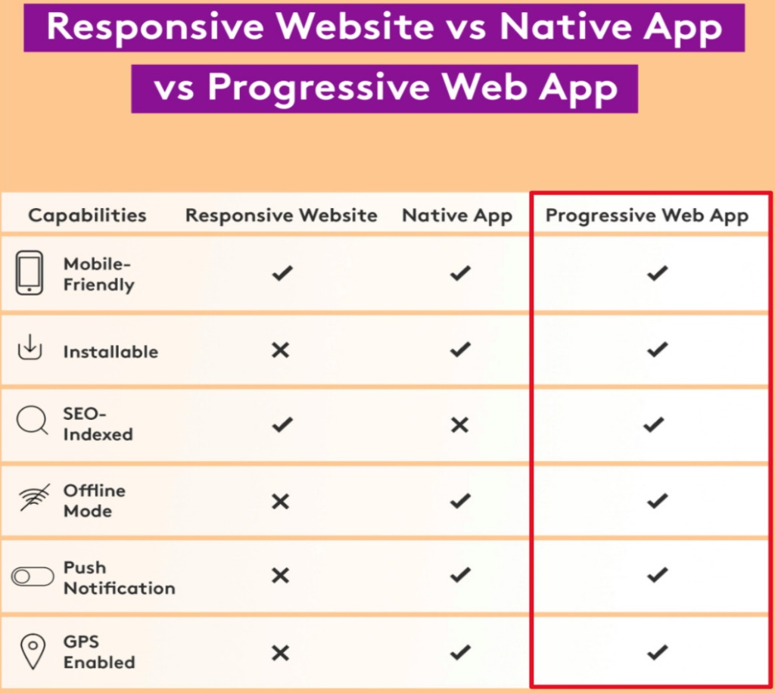
To develop a PWA with its features, there are some requirements to be fulfilled.
- The PWA must be served over HTTPS
HTTPS protects the PWA and its integrity. It prevents the intruders from exploit unprotected communications to trick the users into giving up sensitive information or installing malware [13].
- Pages are responsive on tablet and mobile devices.
- Web Application manifest should be available
This is a JSON file, that contains meta-data of the app, such as theme colour and icons. Basically, it provides all the information, how the PWA will look like after the user installed or added the PWA.
- PWA should have a Service Worker
It’s essentially a JavaScript file that runs separately from the main browser thread, intercepting network requests, caching or retrieving resources form the cache, and delivering push messages [14]. A common task for service worker it to provide offline capabilities for the PWA.

The requirement about manifest and service worker will be explained furthermore in the chapter Project Implementation.

Just like regular web applications, there are two main structural components to build a PWA, which are client and server sides, or technically it can be called frontend and backend, respectively.

Front-end or client side

Frontend or client side is sometimes considered as “web design”. Frontend is everything involved with what the user sees and converts data from the server to a graphical interface, using Hypertext Markup Language (HTML), Cascading Style Sheet (CSS), and JavaScript (JS).

HTML is the foundation of a web page, the standard markup language for creating web pages. HTML has an important role to describe the structure of a web page and consists of a series of elements, that tells the browser how to display the content [5]. This part where the browser interprets how the content is displayed called rendering.

CSS is a language for specifying how HTML elements are presented to the users, how they are styled on the screen. [6]. CSS enables Web authors and programmers to finely tune elements for publishing both online and across several different types of media, including print format [7].

JavaScript is a scripting or programming language that can implement complex features on web pages. JavaScript is the core for every dynamic and interactive functionality on the webpage. It can update and change both HTML and CSS. Besides that, in browser JavaScript has the power to react to user actions, send request over the network to obtain data. For the latter one, when used asynchronously, JavaScript can be used to send and receive all the required data to and from a server without refreshing the web page.

More about JavaScript

JavaScript has become so popular, that it becomes the standard programming language of the web. Stack Overflow is a website dedicated to developers, where they can ask and answer questions from other developers. This website makes a survey every year on which languages is the most commonly used as a programming language. As of 2019 JavaScript has been on the top of the list for the seventh year in a row. JavaScript’s easy learning curve and rising demand on JavaScript developers are another reason, why JavaScript is very popular. Besides its popularity and simplicity, JavaScript sometimes interpreted differently by different browsers, that it becomes a big disadvantage of using this language. Thus, the code must be run on various platforms before publishing.

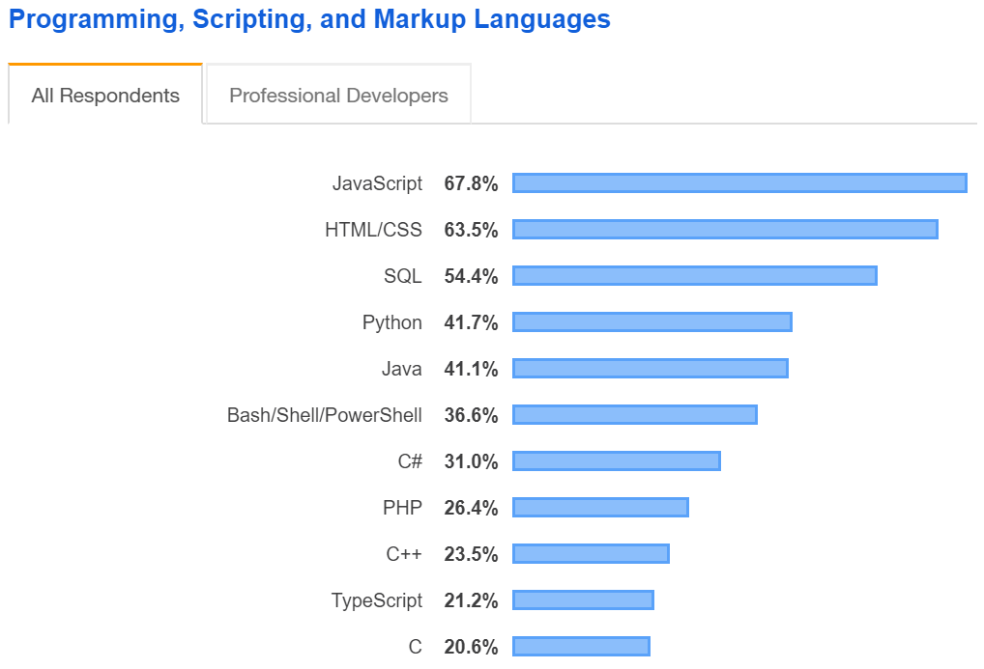
https://insights.stackoverflow.com/survey/2019#technology

Back-end or server side

Backend is how the site works, updates, and changes or what the user can’t see in the browser such as database and server. Typically, the backend is responsible for storing and organizing data and ensuring everything on the client-side work. The backend communicates with the front-end, sending and receiving information to be displayed as a web page. Java, Python and C are often used to be the backend, but since 2009 it has been possible to code the backend in JavaScript using NodeJS.

How web applications work

A web application consists of frontend and backend. The interaction between these two parts defines how the page would look like. Below is a diagram that explains how web applications work.

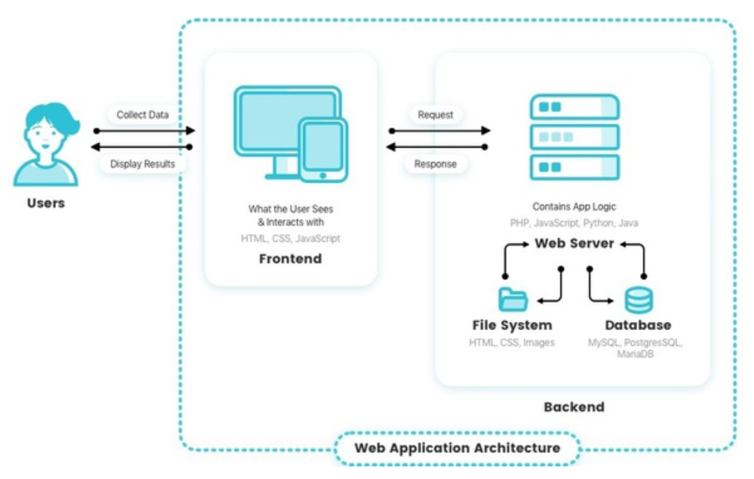
User accesses a web application via a web browser, and it triggers a request to the web server. After the server received the request from the user, the requested task will be processed – such as querying the database or processing the data, and the server ends the result back. The result is called a response. Eventually the data appears on the user’s display

Application Programming Interface (API)

An API is the interface that a software program presents to other programs, to humans, and, in the case of web APIs, to the world via the internet [15]. API consists of numerous elements, for example functions and tools, which can be used by the developers to build applications. Using APIs, the development of application can be accelerated because developers don’t have to implement the functionality needed themselves. The two categories of API in client-side JavaScript are Browser APIs and Third-Party APIs.

Browser APIs

Browser APIs are built into web browser and can expose data from the browser and surrounding computer environment and do useful complex things with it [16]. Example of the Browser APIs that available inside of browsers are the Browser Object Model (BOM) and Document Model Object (DOM). Another example is the Web Audio API, that will be explained later in the chapter Project Implementation

Third-party APIs

Third party APIs are APIs provided by third parties — generally companies such as Facebook, Twitter, or Google — to allow you to access their functionality via JavaScript and use it on your site [17]. An API developed by a third-party, for example Google Maps API will have regulations and requirements.

Design Pattern

In software engineering, a design pattern is a general repeatable solution to a commonly occurring problem in software design. In other words, it is a description or a template for how to solve a problem that can be used in many different situations [9].
Design pattern is important when it comes to maintaining and reuse the same code. A practical example in pattern is manipulating the Document Object Model (DOM) using JavaScript method document.getElementById(). This method can be used to get access the element with a specific id.

MV* Patterns

The two important architectural patterns are Model View Controller (MVC) and Model View Presenter (MVP)
Model – manages the data for the application and defines the business rules (or business logic) of how the data can be changed or manipulated.
View – The View is responsible for what’s presented to the user (the User Interface) and how users interact with the app. It displays the data provided by the Model
The * stands for a “wildcard”, which means it could be either a Controller or a Presenter.

MVC

MVC is an architectural design pattern that encourages improved application organization through a separation of concerns [10]. As the Model and View have been defined on the previous page, Controller can be understood as:

Controller: In the MVC pattern, the Controller is the one who is responsible for handling the incoming requests. The Controller also acts as the entry point to the application.
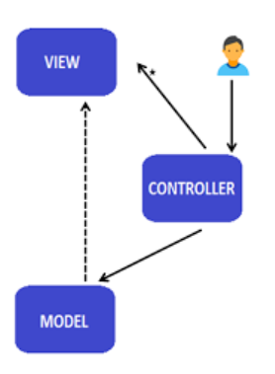

The View is what the user sees. As a user decides to make an action, the user sends a request to the Controller. The Controller forwards the request to the Model, where the data for a response will be processed and prepared here. Lastly the Model will “tell” the View to update its data corresponding to the new data.

The illustration below explains the interaction between user and the design pattern
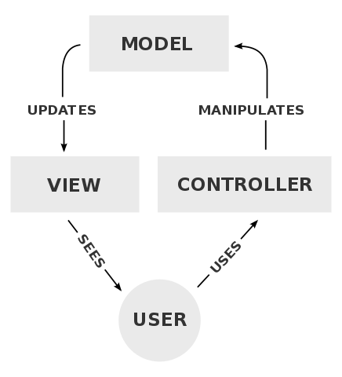
Wiki mvc interaction
In short, Model is the data and business logic. View is a User Interface and Controller is a request handler

MVP

Model-view-presenter (MVP) is a derivative of the MVC design pattern which focuses on improving presentation logic[10]
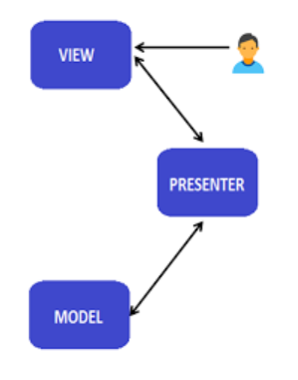
Presenter: The Presenter receives the user’s input from the View, process the data with Model’s help and pass the result back to the View. In short, it manipulates the Model and updates the View. In this pattern the only way for communication is only through the Presenter

MVP or MVC (or no pattern at all) ?

The only difference between MVP and MVC is the role of the Controller and the Presenter. As MVP is a derivation of MVC there are some points to considerate when deciding which design pattern to use:
- MVP is used in enterprise level application, where its necessary to reuse as much presentation logic as possible.
- Use MVP, when it comes to application with a very complex views and a great deal of User Interface, because all the logic can be encapsulated in a presenter, instead of in multiple Controllers in MVC

Another point to considerate is the unit testing. Unit testing is a piece of code (usually a method) that invokes another piece of code and later checks the correctness of some assumptions [9]. MVP would be a better option if unit testing must be performed, because the presenter can be used as a complete mock of the user-interface and so it can be unit tested independent of other components [10]

Implementation

Project Description

The project is to build a progressive web application with an example of a music learning program, that is compatible when run on mobile devices. This project was built using a reference to the application “Perfect Ear – Music Theory, Ear & Rhythm Training”, which will be called Perfect Ear through the entire paper. Perfect Ear application was developed by Aleksandr Osmanov and can be downloaded both on Android and iOS mobile phones. This app offers a lot of features for beginners and professionals in form of ear training, singing and rhythm training exercise.

This progressive web application was written only in JavaScript (VanillaJS) and later the feature Interval Identification will be compared with the app that was written in Angular 8, a JavaScript framework developed by Google.

There are three features that were written in VanillaJS:
- Rhythm Input
- Rhythm Tapping
- Interval Identification

For the simplicity aspect, this web application doesn’t have a server, neither using any server – side programming language. The data, that is needed to be transmitted, will be declared in an array variable.

Environment Setup

This application was developed on a laptop running Windows 10 operating system and GitHub was used for the version control. According to GitHub the project was written mostly in JavaScript.
https://github.com/khaldrago96/thesis_vf
The integrated development environment (IDE) used for the project is Visual Studio Code. Visual Studio Code offers an extension called Live Server, that is used to launch a development local server with live reload feature for static and dynamic pages.

During the development the project was developed on Google Chrome. Like any other modern web browsers, Google Chrome has a set of web developer tools built directly into the browser, called Chrome DevTools. Since the web application must be able to run in mobile devices, Chrome DevTools has a feature, that allows developers to preview the web application’s design on a variety of popular mobile devices. All pictures taken on this chapter were taken on mobile devices view using Chrome DevTools.
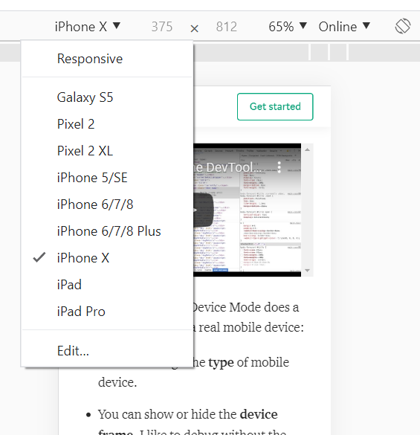
Chrome DevTools for previewing responsive design

This progressive web application is dedicated only to be run on Google Chrome on Android mobile devices for the full features of an installable PWA, since iOS doesn’t support a prompt message for install PWAs. Otherwise the app can be run on any other devices. More about responsive design found on chapter X

Libraries

While developing an app, developers tend to re-use the existing code to solve a problem, so that they don’t waste their time writing code that another developer has already written. Developers do that by using a JavaScript library. JavaScript library can be defined as a library of pre-written JavaScript which allows for easier development of JavaScript-based applications [18]. This project also uses a JavaScript library and a Web Audio API. Not to be confused, there are differences be
tween an API and a library.

As both terms have been defined (Definition of API on chapter X) below is the comparison between a library and an API
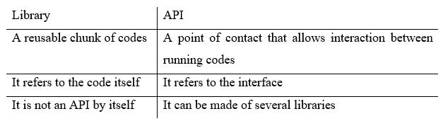
https://rapidapi.com/blog/api-vs-library/

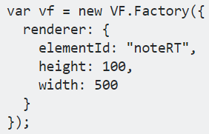
For rendering the music notation, this project uses a JavaScript library called EasyScore. This library exposes all VexFlow elements through its APIs. VexFlow itself is an open-source web-based music notation rendering API, that is written completely in JavaScript. For the purpose of simplicity of just displaying the staff and some notes on it, this project sticks with the usage of EasyScore. EasyScore creates a Scalable Vector Graphics (SVG) and attach it to an HTML element. The code in the project looks like this:
Rendering a staff into an HTML element with ID noteRT

Another important feature for a music learning application, is obviously the sound.
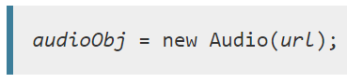
For playing the audio files and the metronome sound effect, this project uses a Web Audio API. The Web Audio API provides a powerful and versatile system for controlling audio on the Web, allowing developers to choose audio sources, add effects to audio, create audio visualizations, apply spatial effects (such as panning) and much more [19]. The Web Audio API has an Audio() constructor. It creates and returns a new HTML audio element , that can be manipulated or to play audio. The syntax for using this contructor is:
Source: MDN Web Audio API

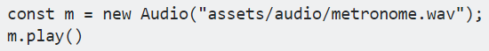
In the project, the url is the path to the music source that is located the project folder
Example code of an Audio constructor in project

Styling – Responsive Design

Since most of web applications (and websites) are accessed in mobile devices, it has become more relevant to consider how they look like on smaller screens. The term responsive design starting to make a big impact for web application development.
Responsive design, overall, is a way to make websites that can be easily viewed and used on any type of device and size of screen, all the way from the smallest mobile phones up to the widest desktop monitors [20].

Using the CSS this can be accomplished by a technique called Media Query. Media Query lets developer to applying many adjustments, such as smaller margins between two elements on smaller devices or larger (and more readable) font size on larger devices.

Considering there are so many devices with various screen sizes, this project only covers three media queries for phones with minimum width of 350 pixels and maximal of 480 pixels, tablets with minimum width of 768 pixels and maximal of 1024 pixels, and laptops with minimal width of 1025 pixels.
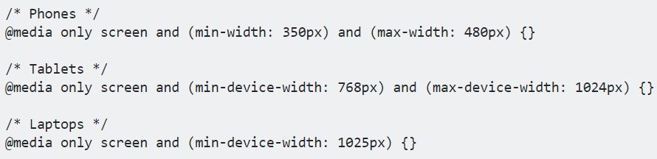
The keyword @media rule is used in media queries to apply different styles for different media types/devices [21]. The only keyword is used to prevent older browsers that do not support media queries with media features from applying the specified styles [22].

// pic of app on all devices

Hosting and Deployment

Deployment is a process to make an application available to end users. This means, when users type the URL, users can see the latest and newest version of the application. To be able to do this, this project uses the hosting service from Firebase.

Firebase is a mobile and web application development platform by Google, that provides useful services for building a better application, such as authentication, real-time database, analytics , etc. Using Firebase developers can focus on their application features, because Firebase takes care of everything related with the server. Firebase also provides free subdomains on the web.app and firebase.app.com domains.
This project can be found under the URL thesis-dw96.web.app or thesis-dw96.firebase.app.com

Installable PWA

One of PWA core feature is its installability, that allow users to add the application to the home screen and it will be displayed just like a native application. For doing this, users can add it manually by clicking on the options on their browser and select the option Add to Home Screen.

On Chrome & Firefox, if the PWA meets the following criteria [23]:
- The application is not already installed.
- Served over HTTPS
- Has registered a service worker with a fetch handler
- Includes a web app manifest, that includes:
  - Short_name or name
  - Icons must include a 192px and a 512px sized icons
  - Start_url
  - Display must be one of: fullscreen, standalone or minimal-ui
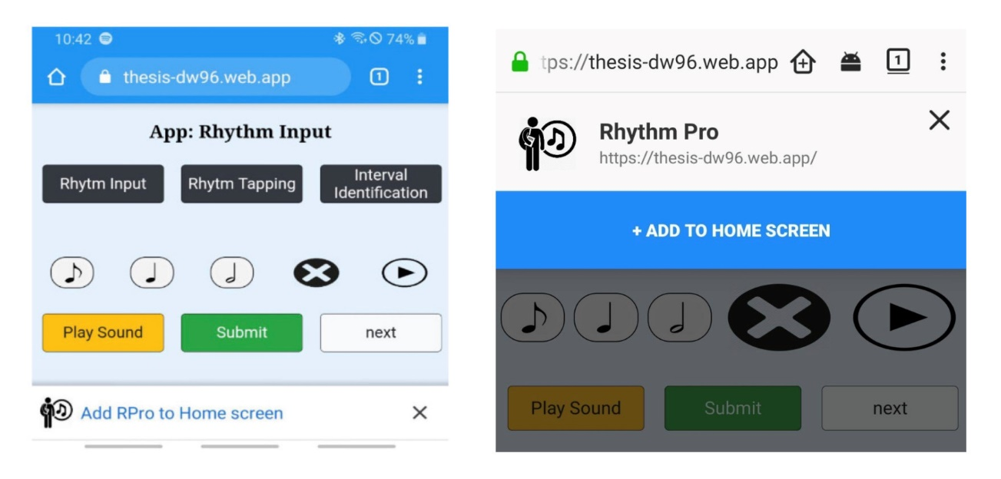
An event beforeinstallpromt will be triggered and show a banner indicating that its possible to install the application as a PWA.
left to right: Add to Home Screen banner for Chrome and Firefox
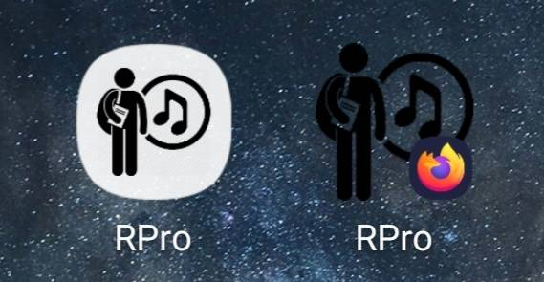
Icons for the PWA, left in Chrome and right in Firefox

Every Operating System treats PWA differently. While displaying a banner to install the PWA on Chrome and Firefox is possible, this can’t be done on Chrome for iOS.
On iOS devices, users can only install PWAs by visiting its URL in Safari, since third-party browsers are not allowed to install PWA and some of them don’t support service workers [24]
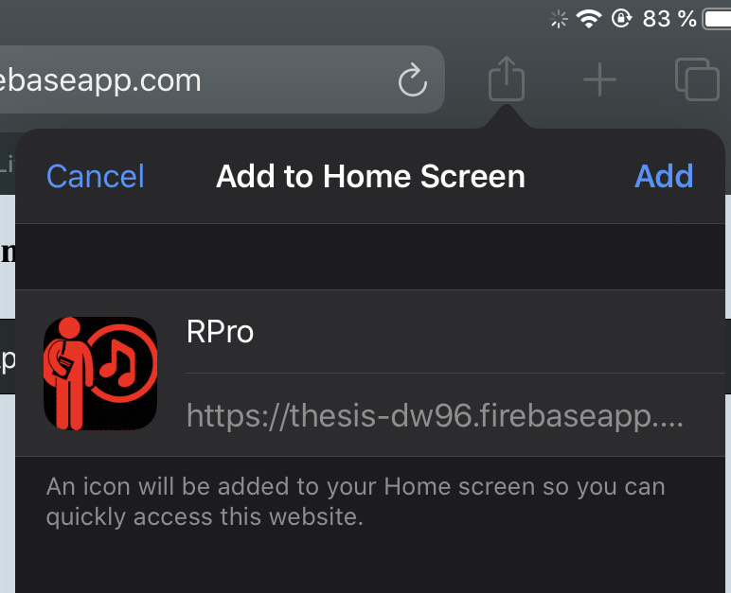
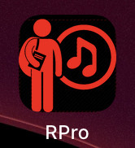
Installing a PWA in Safari & Icon for the PWA

Although PWAs can be launched in Safari there are still some limitations for this kind of application when run on iOS devices:
- The feature Add to Home Screen banner is not available in Safari, therefore users won’t be aware of the app’s capabilities.
- Limitation in how much data it can be stored.
- Inability to show web push notification
- iOS don’t use the icons specified in the web app manifest file, for this reason, the icon of this project has a different color with one in Chrome or Firefox. To add icon developers must add the following specified linked resource:

PWAs are developed to offers users a similar experience to native applications. While this can be executed really well on Android devices, there are still some major problems to be fixed for iOS devices.

App – VanillaJS

This chapter digs deeper into the details of developing this PWA with each feature. Every sub chapter will explain more about the the UI, the functionality of the core feature, and how the user input processed and compared with the solution.

App – Header

The PWA header is located on the top of the app. The header has a title of the running app and a navigation bar in form of buttons to switching from one app to another app. The content of the app is shown below the header.
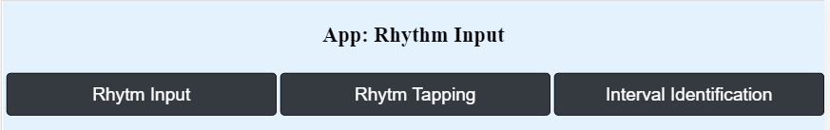

App – Rhythm Input

User will hear a rhythm pattern played and then the user must input that rhythm on the music staff. There are three notes options for the user to input: An Eighth, a Quarter and a Half note.

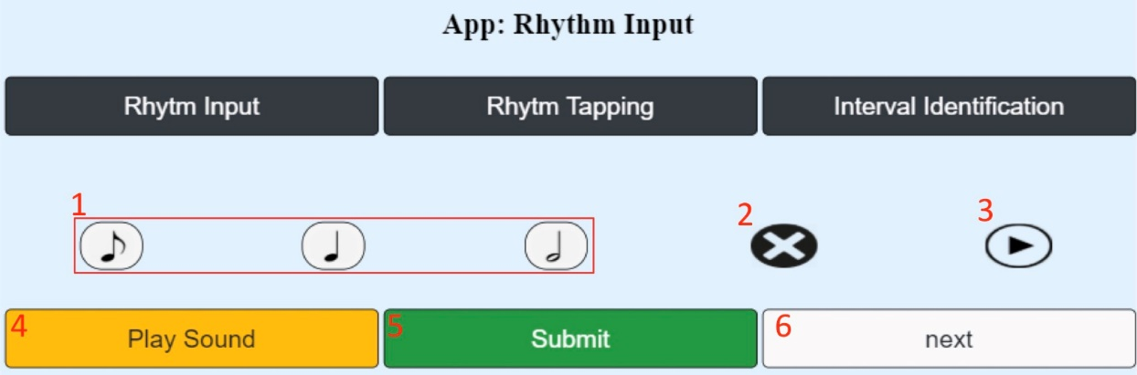
App start

- User Input: User has three options: An Eighth, a Quarter and a Half note.

- Delete Input Button: Upon clicking this button, all user input will be removed.

- Play Input Button: User can preview their input before submitting their answer.

- Play Exercise: This button works to start and replay the current exercise.

- Submit Input: User Input will be compared to the solution of the exercise

- Go to next exercise: After submitting, user can go to next exercise. Otherwise the current exercise will be skipped if the user hasn’t submitted anything.

After the user input the note and submit their answer, the application will compare the input with the solution of the exercise. Promptly the user will tell the user, either their input is correct or wrong. This “Correct ! or Wrong !” message is placed right below the Play Sound button.

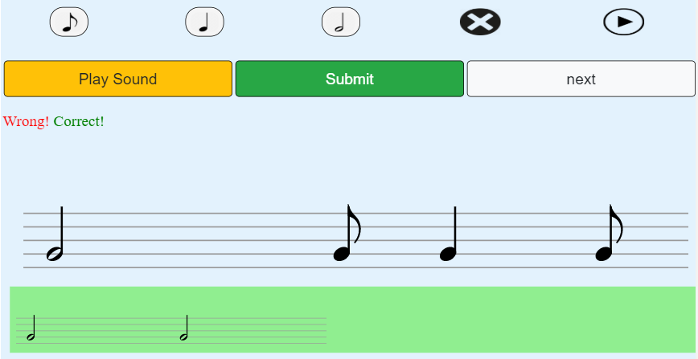
App after input was submitted

If the input doesn’t match the solution, a green staff with the correct rhythm pattern will added right below the user’s input, otherwise the user will only see the message “Correct !”

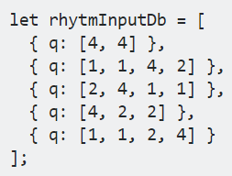
The exercise and its solution are declared in an array variable.

Every object in the array represents the task. The q keyword stands for question. The q keyword can have 3 possible values: 1, 2 and 4, which are used to display the Eighth, Quarter and Half note, respectively. To show the solution when the user gave the wrong input, the content of the array will be rearranged using the map JavaScript method.
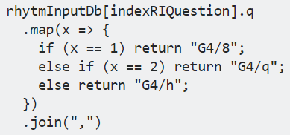
The processed array results a string, that will be passed in the VexFlow’s method to show the right notes.

After all the tasks have been answered, users can find a summary page, that contains the users score and a short message “Exercise done!”. The app will be started over again after 3 seconds.

App – Rhythm Tapping

Users will see a rhythm pattern on the staff. Users must tap that rhythm with the metronome as accurately as possible. The durations of the notes in this exercise will be the same one with the app “Rhythm Input”, which are an Eighth, a Quarter and a Half note. After users are finished with their input, users can see the solution using the hint button. Upon clicking this button, green dots will appear and show the users the right spots. The exercise starts right after users click on the Rhythm Tapping button.
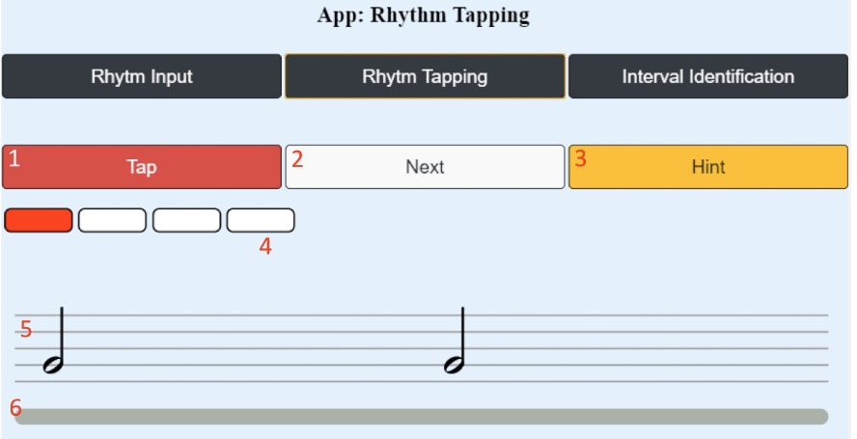
App start

- Tap for user input: Every time users click the tap button; a yellow dot will appear on the grey line. This button represents the position of the ongoing progress.

- Next Button: Go to the next task.

- Hint Button: This button will show the user the right solution represented with green dots. After this button is clicked, all user input (yellow dots) will change their opacity, so the green dots will be more visible than the user input.

- Metronome Bar: The metronome bar consists of four small blocks and every block represents one beat.

- Staff for the Task : A staff represents four beats or a semibreve (also called a whole note).

- Gray Bar: On this bar, every user’s tap will fill the bar with yellow dots. Otherwise green dots, when the hint button is clicked

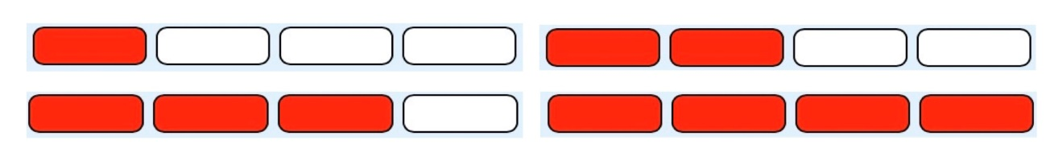
This app has two important features, which are the metronome bar, that helps the users to decide when to click, and the grey bar for the visualization if the users tap the button on time. When the app starts, users will see that the metronome bar will changing its color from white to red and a tick sound playing simultaneously.
Metronome bar state from left to right

The metronome bar plays in an endless loop and it starts with one red block, two blocks, until all the blocks are red, then it will go back to the start with only one red block. The state where only one block is red, is the time when users have to start tapping.

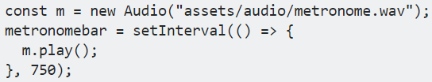
The metronome visualization and sound are played harmoniously using the setInterval method in JavaScript. The function inside the interval will be executed repeatedly, starting after the interval of time, then repeating continuously at that interval
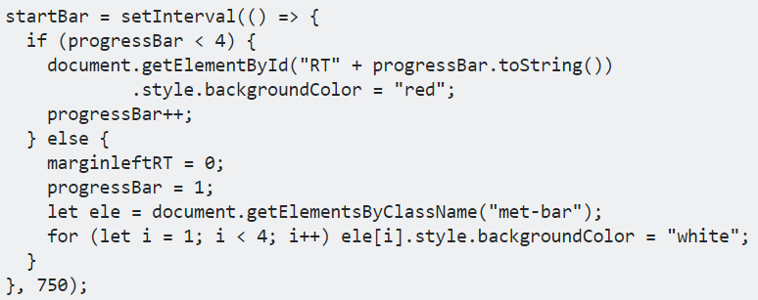
Interval for the metronome sound
Interval for the metronome visualization

For the metronome visualization, the red blocks styles will be manipulated using the JavaScript Document Object Model (DOM) in the interval method. It is a simple conditional statement to decide, which blocks should be colored in red.

The grey bar below the music staff is the area, where both user’s input and solution will be appeared on. Every time users click the tap button, a new element will be created, styled with a custom class, and eventually its left margin will be adjusted. The left margin of each dots has different values, that makes the dots standing side by side.
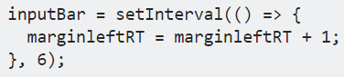
Interval for determining where the user’s input should be displayed
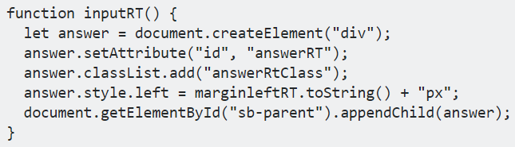
Function that draws the yellow dot on the gray bar
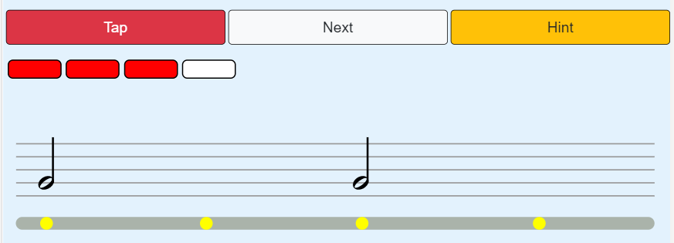
User’s input right after the metronome bar change its state

The gray bar has the same width of 500 pixel just like the staff. The idea is to add the current left margin of the yellow dot as long as the value of the left margin keeps increasing due to the interval. From the figure above, the gray bar is divided in 4 areas, where each area has the length of 125 pixels. In short,
1 metronome block = 125 pixel = 750 milliseconds
The interval (Figure RT 2) adding the margin left by one pixel every 6 milliseconds comes from this equation.

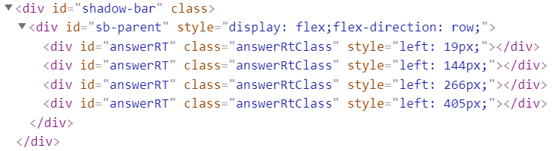
The CSS position attribute is also important here.
HTML structure of the grey bar.

The gray bar is a DIV element with the ID shadow-bar, whereas the DIV element with ID sb-parent is a container for the yellow dots with ID answerRT. The shadow-bar has the CSS position attribute of relative which means the element is positioned relative to its normal position. Inside the shadow-bar, the sb-parent container is styled to be a flex box container, with its child items to be display in a row position. The child components answer-RT are positioned absolutely to its first positioned parent, the shadow-bar. This makes the yellow dots margin left counted starting from the left edge side of the shadow-bar.

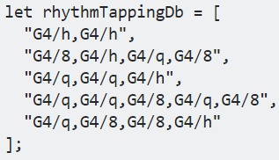
To rendering the notes on the staff, all the exercise is defined in a string and saved in an array. Each element of the array is passed to the renderer one by one using an index corresponding to which exercise the users are on.
Each character in the string represents the note and its beat

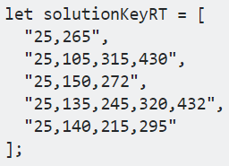
The hint button helps users to know where to tap precisely. The hint is an array variable contains two until four numbers in a string. These numbers are the left margin of each green dots.
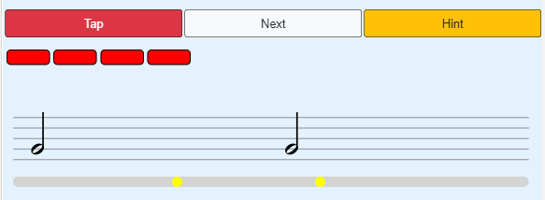
For example, the first string of the solutionKeyRT array, “25,265”, means this exercise has two notes with its first dot located 25 pixels and the second dot 265 pixels away from the left of the grey bar, respectively.
User input before hint button clicked

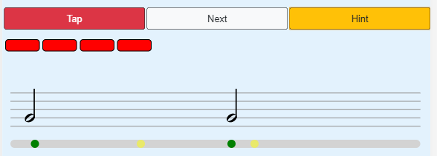
After hint button clicked

By the end of the exercise, a message “Exercise Done.” will be displayed. Users can try again by clicking the app button, and the app will start over.

Interval Identification
User needs to identify the interval played by the app and select it from the available presented options:
- Unison – 2 tones with the same interval?
- Minor – also called a half step or half tone. It is defined as the interval between two adjacent notes in a 12-tone scale. For example, C is adjacent to C♯; the interval between them is a semitone or minor second [11].
- Major – or called whole note is a musical interval encompassing two adjacent staff positions [12]. For example, C to D.

The Interval Identification feature has a piano element, that can be used as a hint for the beginners. This feature will be also developed in Angular. Eventually developing this feature on VanillaJS and Angular will be compared at the end of this chapter.

[1] https://www.millforbusiness.com/how-many-websites-are-there/
[3] https://de.ryte.com/wiki/Native_App.
[4] Building-Progressive-Web-Apps_-Bringing by Tal Ater ,page 15
[5] https://www.w3schools.com/html/html_intro.asp
[6] https://developer.mozilla.org/en-US/docs/Learn/CSS/First_steps/What_is_CSS
[7] Steven M. Schafer. HTML, XHTML, and CSS Bible, 5th Edition. Crosspoint Boulevard, IN: Wiley Publishing; 2010
[8] [Jablonski et al., 2011] Stefan Jablonski, Ilia Petrov, Christian Meiler and Udo Mayer, Guide to Web Application and Platform Architectures, 2011. University of
Erlangen-Nuremberg, Dept. of Computer Science 6 (Database Systems). Web app definition
[9] JavaScript Unit testing – Hazem Saleh
[10] andre osmani – learning javascript design pattern
[11] minor second – https://en.wikipedia.org/wiki/Semitone
[12] major second - https://en.wikipedia.org/wiki/Major_second
[13] https https://developers.google.com/web/fundamentals/security/encrypt-in-transit/why-https
[14] service worker - https://developers.google.com/web/ilt/pwa/introduction-to-service-worker
[15] what is an api – apis a strategy guide – daniel jacobson
[16] browser api - https://developer.mozilla.org/en-US/docs/Learn/JavaScript/Client-side_web_APIs/Introduction
[17] https://developer.mozilla.org/en-US/docs/Learn/JavaScript/Client-side_web_APIs/Third_party_APIs
[18] https://en.wikipedia.org/wiki/JavaScript_library
[19] https://developer.mozilla.org/en-US/docs/Web/API/Web_Audio_API
[20] Learning responsive web design – Clarissa Peterson
[21] @media keyword - https://www.w3schools.com/cssref/css3_pr_mediaquery.asp
[22] media queryonly screen - https://www.geeksforgeeks.org/what-is-the-difference-between-screen-and-only-screen-in-media-queries/
[23] https://developers.google.com/web/fundamentals/app-install-banners
[24] https://www.idownloadblog.com/2018/07/19/howto-progressive-web-apps-iphone-ipad/

