

"Application for Car rental"

Student: Uscat Alexandra

Podar Delia

Profesor indrumator: Tufisi Radu

* **Instalation & configuration:**

1) Node Js

**Node.js** is an open-source, cross-platform, [JavaScript](https://en.wikipedia.org/wiki/JavaScript) [runtime environment](https://en.wikipedia.org/wiki/Runtime_system) that executes JavaScript code outside of a browser. Node.js lets developers use JavaScript to write command line tools and for [server-side scripting](https://en.wikipedia.org/wiki/Server-side_scripting)—running scripts server-side to produce dynamic web page content before the page is sent to the user's web browser. Consequently, Node.js represents a "JavaScript everywhere" paradigm, unifying web application development around a single programming language, rather than different languages for server- and client-side scripts.

Though .js is the standard [filename extension](https://en.wikipedia.org/wiki/Filename_extension) for JavaScript code, the name "Node.js" does not refer to a particular file in this context and is merely the name of the product. Node.js has an [event-driven architecture](https://en.wikipedia.org/wiki/Event-driven_architecture) capable of [asynchronous I/O](https://en.wikipedia.org/wiki/Asynchronous_I/O). These design choices aim to optimize [throughput](https://en.wikipedia.org/wiki/Throughput) and [scalability](https://en.wikipedia.org/wiki/Scalability) in web applications with many input/output operations, as well as for [real-time Web](https://en.wikipedia.org/wiki/Real-time_Web) applications (e.g., [real-time communication](https://en.wikipedia.org/wiki/Real-time_communication) programs and [browser games](https://en.wikipedia.org/wiki/Browser_game)). Node.js can be combined with a browser, a database that supports JSON data (such as [Postgres](https://en.wikipedia.org/wiki/PostgreSQL),[74] [MongoDB](https://en.wikipedia.org/wiki/MongoDB), or [CouchDB](https://en.wikipedia.org/wiki/CouchDB)) and [JSON](https://en.wikipedia.org/wiki/JSON) for a unified JavaScript development stack. With the adaptation of what were essentially server-side development patterns such as [MVC](https://en.wikipedia.org/wiki/Model–view–controller), [MVP](https://en.wikipedia.org/wiki/Model_View_Presenter), [MVVM](https://en.wikipedia.org/wiki/Model_View_ViewModel), etc., Node.js allows the reuse of the same model and service interface between client side and server side.

2) React js

**React** (also known as React.js or ReactJS) is a [JavaScript library](https://en.wikipedia.org/wiki/JavaScript_library) for building [user interfaces](https://en.wikipedia.org/wiki/User_interfaces). It is maintained by [Facebook](https://en.wikipedia.org/wiki/Facebook) and a community of individual developers and companies. React can be used as a base in the development of [single-page](https://en.wikipedia.org/wiki/Single-page_application) or mobile applications, as it is optimal for fetching rapidly changing data that needs to be recorded. However, fetching data is only the beginning of what happens on a web page, which is why complex React applications usually require the use of additional libraries for [state management](https://en.wikipedia.org/wiki/State_management), routing, and interaction with an [API](https://en.wikipedia.org/wiki/API): Redux[9], React Router[10] and axios[11] are examples of such libraries.

3) Express js

**Express is** a minimal and flexible Node.js web application framework that provides a robust set of features for web and mobile applications.

4) MongoDB

**MongoDB** is a [cross-platform](https://en.wikipedia.org/wiki/Cross-platform) [document-oriented database](https://en.wikipedia.org/wiki/Document-oriented_database) program. Classified as a [NoSQL](https://en.wikipedia.org/wiki/NoSQL) database program, MongoDB uses [JSON](https://en.wikipedia.org/wiki/JSON)-like documents with [schema](https://en.wikipedia.org/wiki/Database_schema). MongoDB is developed by [MongoDB Inc.](https://en.wikipedia.org/wiki/MongoDB_Inc.) and licensed under the Server Side Public License (SSPL). It can be used as a [file system](https://en.wikipedia.org/wiki/File_system), called [GridFS](https://en.wikipedia.org/w/index.php?title=GridFS&action=edit&redlink=1), with load balancing and data replication features over multiple machines for storing files. JavaScript can be used in queries, aggregation functions (such as [MapReduce](https://en.wikipedia.org/wiki/MapReduce)), and sent directly to the database to be executed. MongoDB provides high availability with replica sets.[10] A replica set consists of two or more copies of the data. Each replica set member may act in the role of primary or secondary replica at any time. All writes and reads are done on the primary replica by default. Secondary replicas maintain a copy of the data of the primary using built-in replication. When a primary replica fails, the replica set automatically conducts an election process to determine which secondary should become the primary. Secondaries can optionally serve read operations, but that data is only eventually consistent by default.

**II) Diagrama bazei de date:**

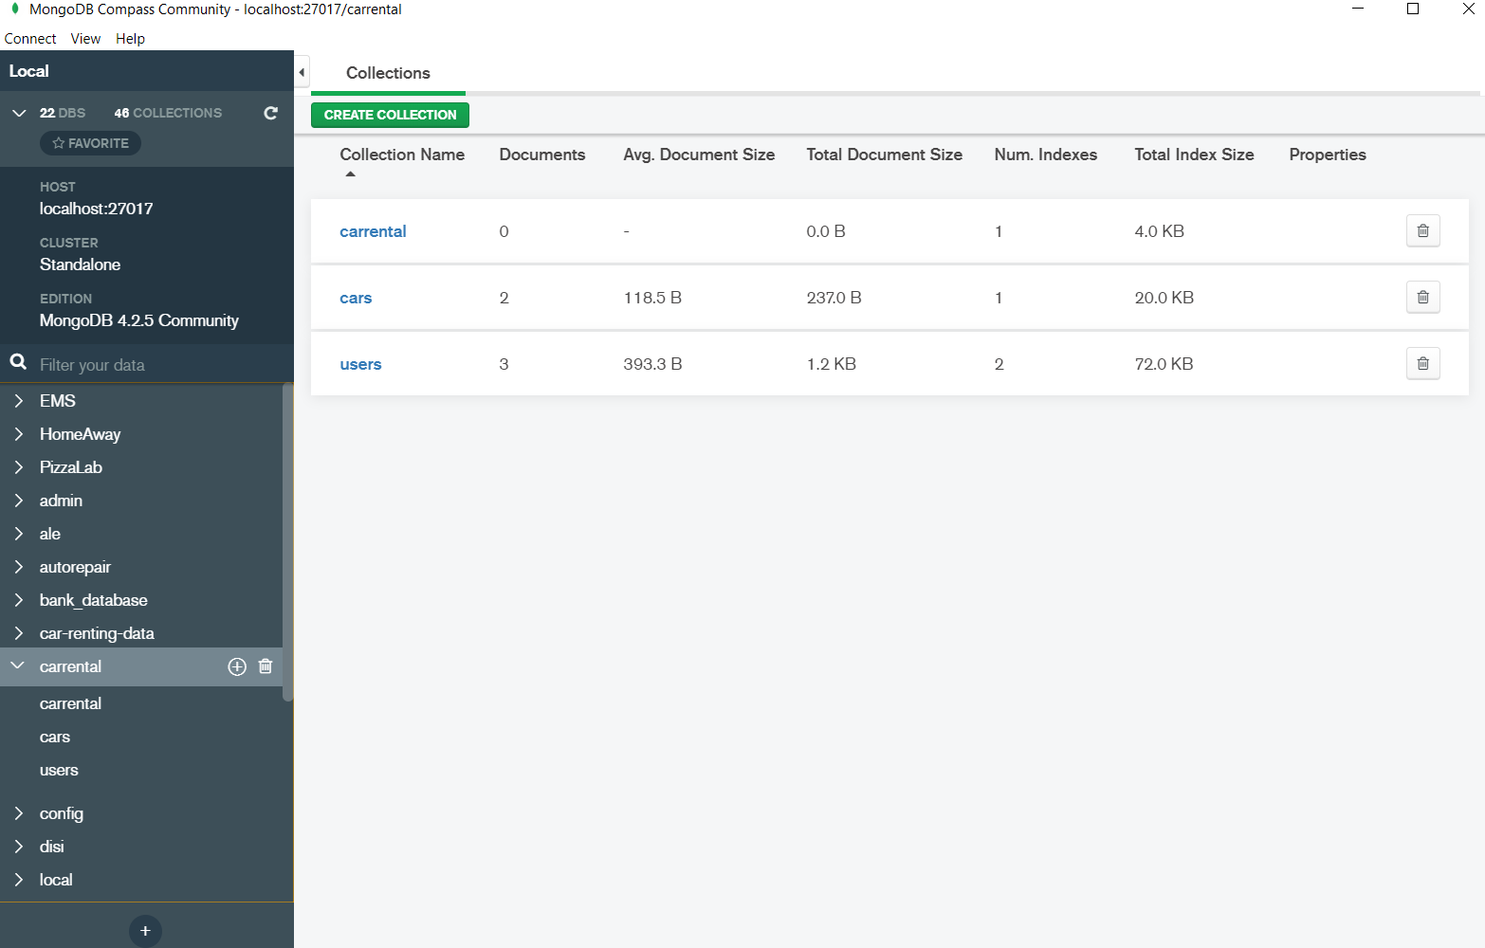**IV) Conceptual architecture of the distributed system.**

**Add car page**

The admin can add a new car in the system with the necessary details.

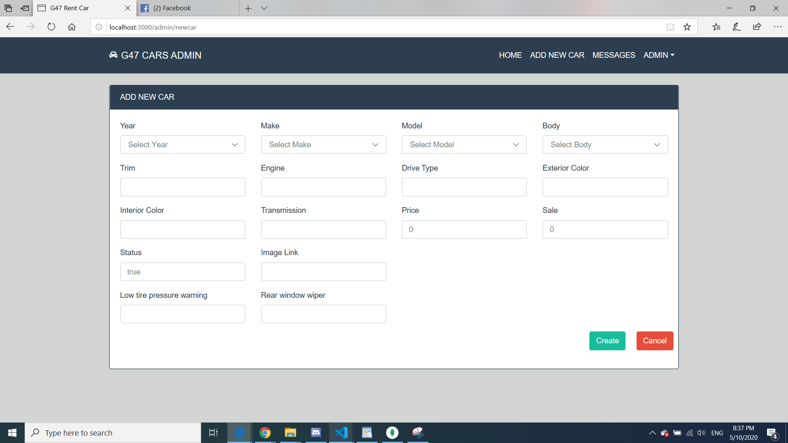

**Search and rent a car:**

As a user, you can search a car by name, price and body type. After that, you can reserve that car.

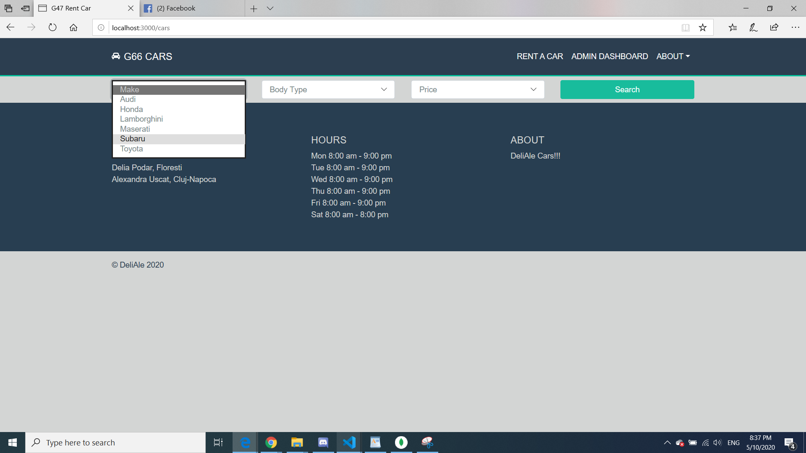

**Dashboard**

Here is the home page, where you can see some of the top model cars and if you scroll down you can see our services.

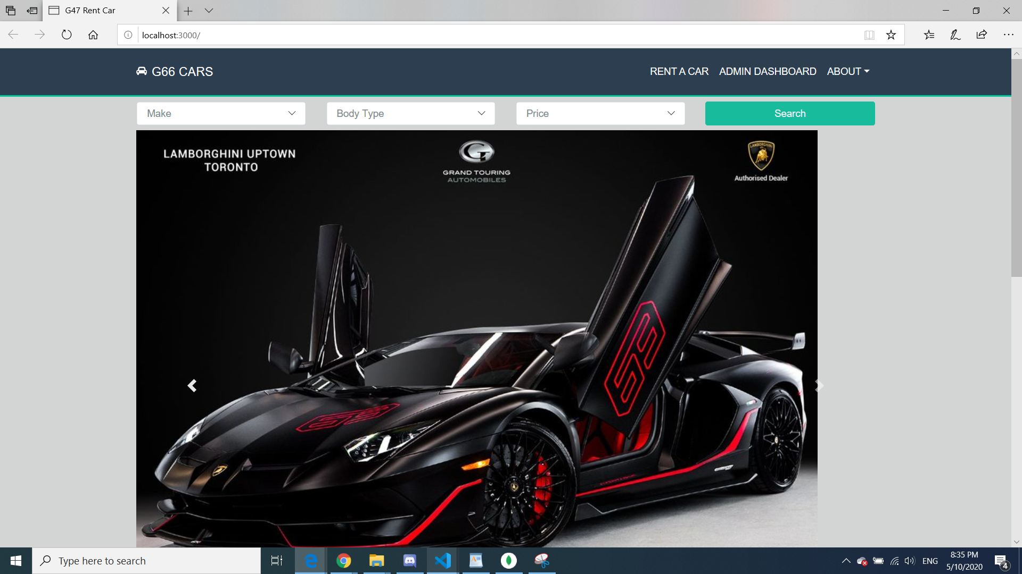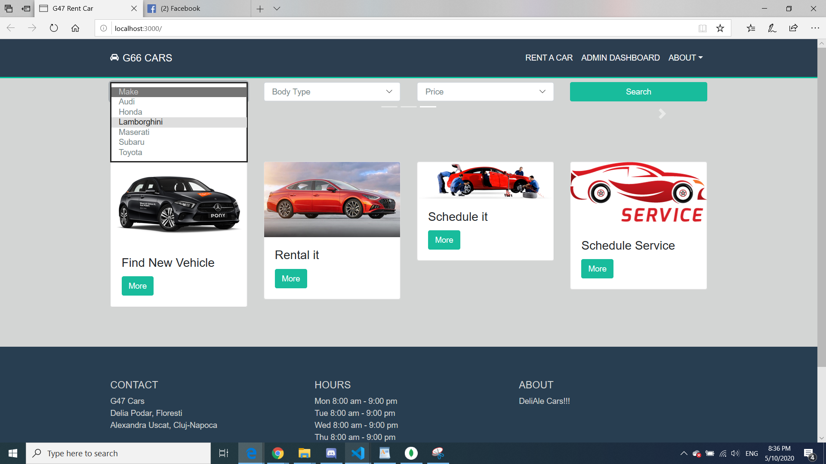

**Feature**:

As a feature, after the customer has renting a car, the admin should recive a message.

