Queue Simulation System
Academic Project Report
Data Structures Project
Faculty of Computers and Artificial Intelligence
C++ and SFML Queue-Based Simulation Application

Team Member | Student ID | Main Responsibility
Khaled Ibrahim | 320250003 | GUI & Simulation 1
Adham Ayman | 320250014 | Controller & Main
Asser Ahmed | 320250015 | Queue
Ahmed Dyaa | 320250018 | Simulation 2
Youssuf Ahmed | 320250025 | Customer & Server

Submitted as a professional academic report for the Queue Simulation System project.

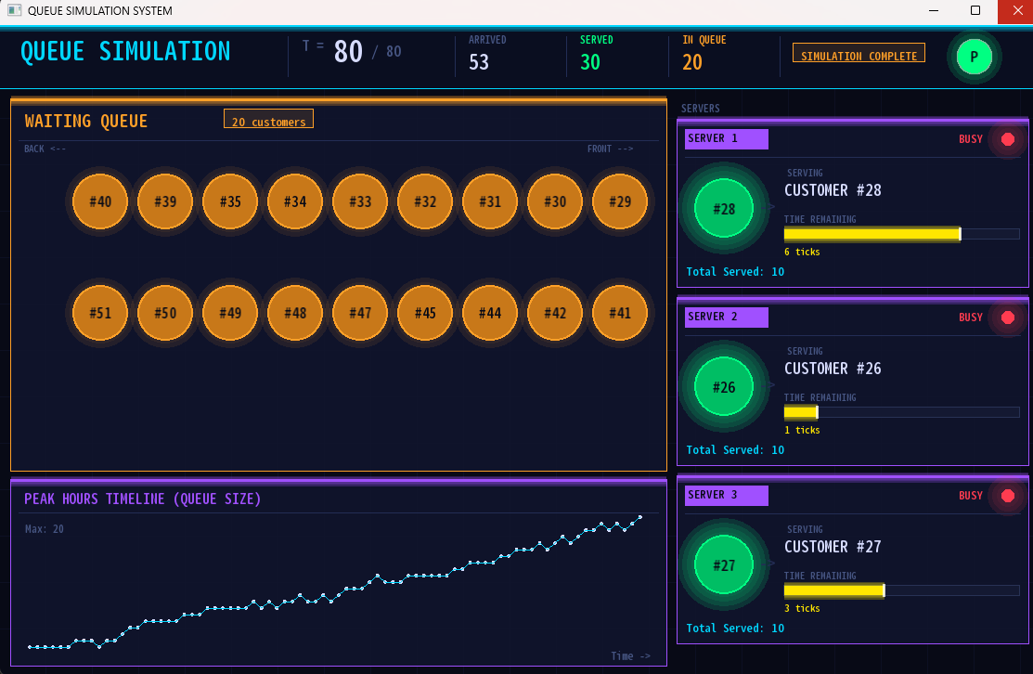
Cover Preview: Final SFML graphical interface of the Queue Simulation System.

Contents
1. Abstract 3
2. Introduction 3
3. Problem Definition and Project Objectives 3
4. System Requirements and Tools 4
5. System Architecture and File Organization 4
6. Object-Oriented Design 5
7. Queue Data Structure and VIP Priority 6
8. Simulation Engine and Timing Model 6
9. Server Management and Customer Service Logic 8
10. Graphical User Interface Design 8
11. Algorithms and Pseudocode 9
11.1 Main Simulation Update Algorithm 9
11.2 VIP Enqueue Algorithm 10
11.3 Server Update Algorithm 10
11.4 Controller Timing Algorithm 10
12. Testing and Validation 10
13. Results and Discussion 11
14. Complexity Analysis 11
15. Challenges, Limitations, and Future Improvements 12
16. Team Contribution 12
17. Conclusion 13
18. References 13
Appendix A. UML Class Diagram 14
Appendix B. Important Final Simulation Parameters 14

1. Abstract
This report presents the design, implementation, and evaluation of a Queue Simulation System developed as a Data Structures project. The system models a service environment such as a bank, clinic, or customer service center, where customers arrive over time, wait in a queue, and are assigned to available servers. The project focuses on the queue as a core data structure and uses object-oriented programming to separate the responsibilities of customers, servers, the waiting queue, the simulation logic, the controller, and the graphical user interface. The final application was implemented in C++ with SFML for real-time visualization. It includes multiple servers, randomly generated customer arrivals, random service times, VIP customer priority, a pause/resume button, live statistics, and a line graph showing the queue size over time. The simulation is controlled using a discrete tick-based time model in which one real second corresponds to one simulation time tick. This report explains the project motivation, class structure, algorithms, simulation workflow, GUI design, testing process, results, challenges, and possible future improvements.

2. Introduction
Queues are one of the most important data structures in computer science because they represent the First-In, First-Out ordering rule used in many real-world systems. In a queue, the first item inserted is the first item removed. This behavior appears in operating systems, printers, networks, banking services, hospital reception systems, call centers, and many other applications where requests must be handled in the same order in which they arrive.
The Queue Simulation System was created to demonstrate the practical value of queues by simulating a service environment. Instead of only implementing enqueue and dequeue operations in isolation, the project connects the queue to a complete application with time, customers, servers, statistics, and a graphical interface. This makes the data structure easier to understand because the effect of each operation becomes visible on the screen.
The project also introduces a more realistic extension to the normal FIFO rule: VIP priority. A VIP customer should receive faster service than a normal customer, but the system should still preserve fairness among VIP customers. Therefore, a new VIP customer is inserted after existing VIP customers and before the first normal customer. This design keeps the relative order of VIP customers while allowing them to be served before normal customers.
The final system is organized using object-oriented programming. Each class has a clear purpose, and the Controller connects the simulation logic with the SFML-based GUI. The GUI updates continuously while the simulation logic advances at a fixed tick rate. This separation reduces complexity and makes the project easier to maintain, explain, and extend.

3. Problem Definition and Project Objectives
The problem addressed by this project is the need to model and visualize how a queue behaves in a service system with multiple servers. In real situations, if the arrival rate is high or the number of servers is low, the queue may grow quickly, resulting in longer waiting times. A simulation allows students and developers to observe these effects without needing to test on a real service facility.
The system must answer the following practical questions: How many customers arrive during the simulation? How many customers are successfully served? How long does the queue become over time? What happens when a server becomes free? How does VIP priority affect the order of customers? The project uses a discrete-time model to make these questions measurable and visible.
The main objectives of the project are:
- Implement a queue-based service simulation using C++ and object-oriented programming.
- Use a custom linked-list queue instead of relying only on ready-made library containers.
- Support normal customers and VIP customers while preserving a clear priority rule.
- Manage multiple servers and update each server according to its remaining service time.
- Use a tick-based simulation clock to control arrivals, service progress, and statistics.
- Provide a graphical user interface that displays queue state, server state, time, and results in real time.
- Include a simple and controlled user interaction through a single Pause/Resume button.
- Produce a system that is readable, maintainable, and suitable for academic discussion.

4. System Requirements and Tools
The project was implemented using C++ as the main programming language. C++ is suitable for this project because it supports classes, dynamic memory management, standard library utilities, and efficient execution. The graphical interface was developed using SFML 3.0.2, which provides window management, drawing, text rendering, shapes, colors, timing, and event handling.
Category | Used in the Project | Purpose
Programming Language | C++ | Implementation of all classes, logic, and data structures.
Graphics Library | SFML 3.0.2 | Rendering the GUI, shapes, text, animation, and event handling.
Core Data Structure | Linked List Queue | Storing waiting customers and supporting VIP priority insertion.
Timing Tools | sf::Clock and discrete ticks | Controlling real-time updates and simulation progression.
Random Generation | std::mt19937 | Generating service times, arrival intervals, and VIP probability.
Development Style | Object-Oriented Programming | Separating Customer, Server, Queue, Simulation, Controller, and GUI responsibilities.

The system was designed as a desktop application. The simulation window uses a resolution of 1120 by 700 pixels and is limited to 60 frames per second. The GUI refreshes every frame, while the simulation logic updates only when the tick clock reaches the selected time interval. This prevents the simulation from running too fast and makes the output understandable for the user.

5. System Architecture and File Organization
The system follows a layered architecture. The lowest layer contains the basic entities, such as Customer and Server. The queue layer stores customers waiting for service. The simulation layer controls time, arrivals, server updates, and queue history. The controller layer links the simulation with the interface. Finally, the GUI layer visualizes the system state and receives the user pause/resume action.
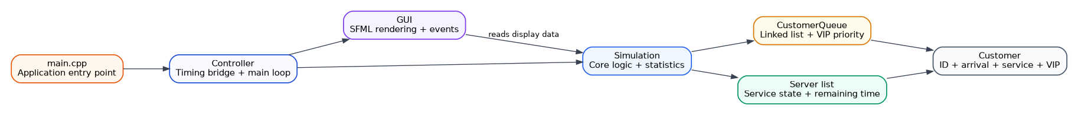
Figure 1. High-level architecture of the Queue Simulation System.
The project files are organized in a way that separates declarations and implementations. Header files define the public interface of each class, while source files implement the functions. This improves readability and allows each team member to focus on a specific system component. A simplified final file organization is shown below.

Folder / File | Description
assets/font.ttf | Font file used by the SFML graphical interface.
build/sim_app.exe | Executable application and required SFML dynamic link libraries.
src/Customer.h and Customer.cpp | Customer data model.
src/Server.h and Server.cpp | Server state and service logic.
src/CustomerQueue.h and CustomerQueue.cpp | Linked-list queue with VIP priority.
src/Simulation.h and Simulation.cpp | Simulation clock, arrivals, servers, statistics, and queue history.
src/Controller.h and Controller.cpp | Connects simulation timing with the GUI loop.
src/GUI.h and GUI.cpp | SFML drawing, interface layout, events, and animation.
src/main.cpp | Application entry point that creates and starts the controller.

This organization supports modular development. For example, changing the way a server updates its remaining time does not require editing the GUI drawing code. Similarly, changing colors or layout in the GUI does not require editing the queue implementation. This separation is one of the main strengths of the final project.

6. Object-Oriented Design
The object-oriented design of the project is based on assigning one major responsibility to each class. This follows the principle that a class should represent a clear concept in the problem domain. The Customer class stores customer information, the Server class handles service progress, the CustomerQueue class stores and orders waiting customers, the Simulation class manages the core logic, the Controller class coordinates execution, and the GUI class displays the results.
Class | Main Responsibility | Important Data / Functions
Customer | Represents one customer in the system. | id, arrivalTime, serviceTime, isVip, getId(), getServiceTime(), getIsVIP().
Server | Represents one service point. | freeStatus, remainingTime, currentCustomer, assignCustomer(), updateTime(), finishService().
CustomerQueue | Stores waiting customers and applies VIP priority. | front, rear, count, enqueueCustomer(), dequeueCustomer(), getCustomerAtIndex().
Simulation | Controls time, arrivals, server updates, and statistics. | currentTime, maxSimulationTime, servers, customerQueue, queueHistory, updateSimulation().
Controller | Controls the application loop and tick timing. | tickClock, timePerTick, initializeSystem(), startSimulation(), updateSystem().
GUI | Draws the simulation and handles the pause/resume button. | RenderWindow, Font, simRef, drawQueue(), drawServers(), drawGraph(), handleEvents().

A key design decision is that the GUI does not own the simulation data directly. Instead, it holds a pointer to the Simulation object. This allows the GUI to read the current state, such as current time, number of arrivals, number served, queue size, server states, and graph history. The simulation remains responsible for changing the data, while the GUI remains responsible for displaying it.
Another important design choice is that the Controller owns both the Simulation and GUI objects. This gives the Controller the role of a bridge. It initializes both parts, connects the GUI to the simulation, and controls when simulation ticks occur. This organization makes main.cpp very simple and keeps the application startup logic clean.

7. Queue Data Structure and VIP Priority
The final queue implementation uses a linked list through the CustomerQueue class. Internally, the class defines a Node structure containing a Customer object and a pointer to the next node. The queue stores two pointers: front and rear. The front pointer identifies the next customer to be served, while the rear pointer identifies the last customer in the waiting line. The count variable stores the current queue size.
A normal FIFO queue inserts all new customers at the rear and removes customers from the front. The project keeps this behavior for normal customers. However, the VIP feature modifies insertion for VIP customers. When a VIP customer arrives, the queue searches for the last existing VIP customer and inserts the new VIP after that customer. If the front customer is normal, the VIP is inserted at the front. If all customers are VIP, the new VIP is inserted at the end of the VIP group. This makes VIP service faster but still fair among VIP customers.
Operation | Description | Expected Cost
enqueueCustomer(normal) | Adds the normal customer to the rear of the queue. | O(1)
enqueueCustomer(VIP) | Searches the current VIP block and inserts the VIP before normal customers. | O(n) in the worst case
dequeueCustomer() | Removes and returns the customer at the front. | O(1)
getQueueSize() | Returns the number of customers currently waiting. | O(1)
getCustomerAtIndex(index) | Traverses the linked list to access a customer for drawing. | O(n)
clearQueue() | Deletes all nodes and resets front, rear, and count. | O(n)

The linked-list implementation is suitable because the queue can grow without needing a fixed array capacity. It also supports efficient insertion at the front or after a specific node, which is useful for VIP priority. Because nodes are dynamically allocated, the class includes a destructor, copy constructor, copy assignment operator, and clearQueue() function to manage memory safely. This is important in C++ because dynamic memory must be released to avoid memory leaks.
The VIP priority algorithm can be summarized as follows:
- Create a new node for the arriving customer.
- If the queue is empty, set both front and rear to the new node.
- If the customer is normal, attach the new node after rear and update rear.
- If the customer is VIP and the front is normal, insert the new node before front.
- If the front is VIP, traverse the VIP block until the last VIP node is found.
- Insert the new VIP node after the last existing VIP node and update rear if needed.

8. Simulation Engine and Timing Model
The Simulation class is the core of the project. It stores the current simulation time, maximum simulation time, the number of customers that arrived, the number of customers served, the next scheduled arrival time, the list of servers, the waiting queue, the queue history, and the running or paused state. It also owns a random number generator used to create more realistic arrival and service behavior.
The final simulation uses a maximum simulation time of 80 ticks and three servers. Customer arrivals are scheduled randomly every one or two ticks. Each new customer receives a random service time between five and ten ticks. The system also randomly marks approximately 20 percent of customers as VIP. These simple random choices create a changing queue size and make the simulation more realistic than a fixed sequence.
The time model is based on discrete ticks. A tick is a simulation unit, not a real-world second by itself. The Controller maps real time to simulation time by using an sf::Clock object. In the current implementation, timePerTick is 1.0, which means one real second triggers one simulation tick. The GUI may redraw many times per second, but the simulation state changes only once per tick. This is why the visual interface can be smooth while the simulation remains controlled and readable.
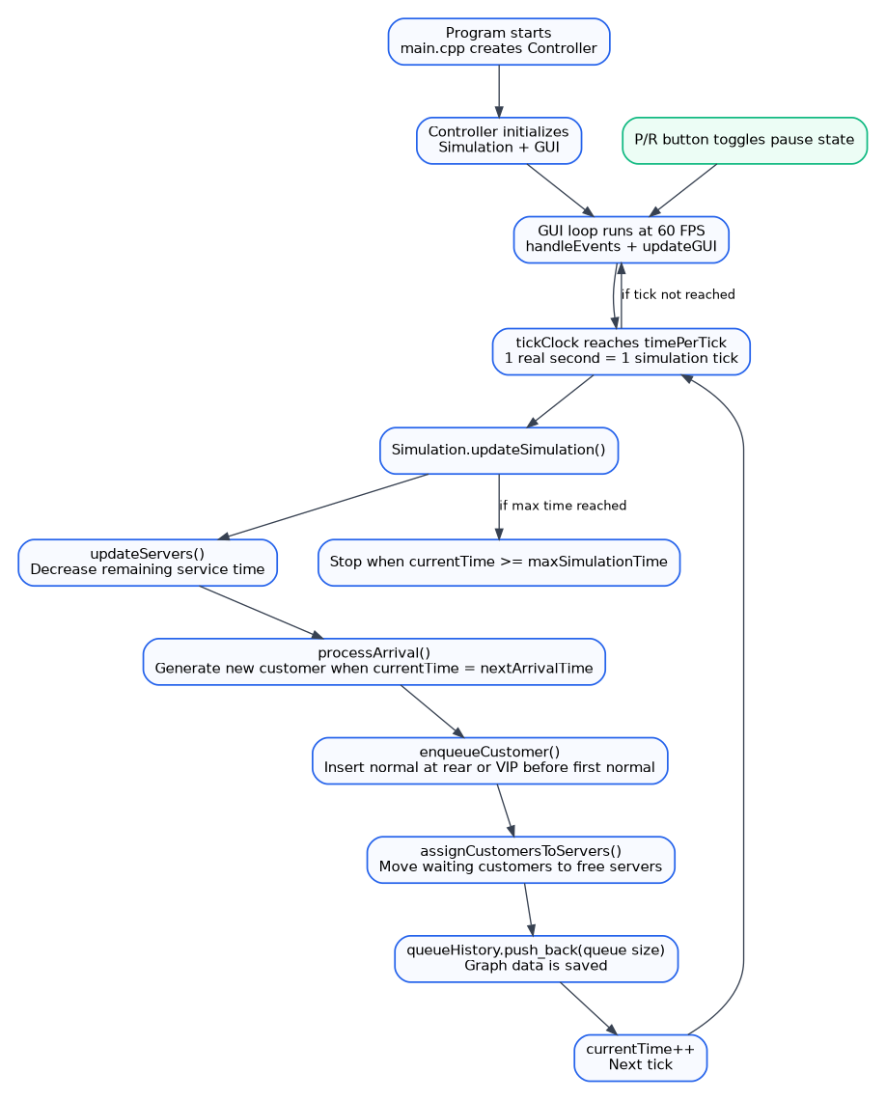
Figure 2. Simulation update workflow and tick-based execution model.
The updateSimulation() function performs the main logic in a fixed order. It first checks whether the simulation is running and not paused. Then it checks the stop condition. If the current time has reached the maximum time, the simulation stops. Otherwise, it updates all servers, processes customer arrivals, assigns waiting customers to free servers, saves the queue size in queueHistory, and increments currentTime.
The order of operations matters. Updating servers first allows a server to become free at the start of a tick. Processing arrivals then adds any new customer scheduled for that time. Assigning customers afterward allows newly free servers to immediately take waiting customers. This creates a natural service flow and avoids unnecessary delay between a server becoming free and receiving the next customer.

9. Server Management and Customer Service Logic
Each Server object represents one service point. It stores whether it is free, the remaining service time for the current customer, the total number of customers served by that server, and the current customer being served. When a customer is assigned to a server, the server becomes busy and its remaining time is set to the customer service time.
During each simulation tick, updateServers() calls updateTime() for every server. If a server is busy and its remaining time is greater than zero, the remaining time decreases by one. When the remaining time becomes zero, finishService() is called. The server becomes free, its total served count increases, and the current customer is reset to a default customer. The Simulation class also increases the global total served count when a server changes from busy to free.
The assignment process is simple and effective. The Simulation class loops through all servers. For each free server, it checks whether the queue is not empty. If both conditions are true, the system dequeues the customer at the front and assigns that customer to the server. Because customers are always removed from the front, the service order follows the queue order after VIP priority has already been applied during insertion.
Server State | Meaning in the System | Displayed in GUI
FREE | The server is available and waiting for a customer. | Free label, idle icon, and cyan/green visual feedback.
BUSY | The server is serving a customer and remainingTime is decreasing. | Busy label, red LED, customer ID, and progress bar.
FINISHED | remainingTime reached zero and the customer has completed service. | Server returns to free state and total served count increases.

This server logic helps the user observe how the number of servers affects the queue. With more servers, customers can be served faster, while fewer servers usually create a longer waiting line. The current implementation uses three servers, which produces a visible queue while still allowing steady service progress.

10. Graphical User Interface Design
The graphical interface is one of the strongest parts of the project. It was implemented using SFML and designed with a modern dashboard style. The interface contains a top statistics bar, a waiting queue area, a server status panel, a queue history graph, and a circular Pause/Resume button. The interface uses a dark background, neon-like colors, glowing borders, progress bars, and animated pulse effects.

Figure 3. Final SFML graphical interface of the Queue Simulation System.
The GUI is connected to the Simulation through connectToSimulation(). After this connection, the GUI can access the current simulation state. For example, displayTime() shows currentTime and maxSimulationTime, displaySimulationStatus() shows arrived, served, and queue size, drawServers() reads the server list, drawQueue() reads customers from the queue, and drawGraph() reads queueHistory.
The waiting queue is drawn as circular customer nodes. Each node displays the customer ID. VIP customers are given a special color and label to make priority visible. The queue direction is shown in the panel so the viewer can understand which side represents the front and which side represents the back. To keep the interface readable, only a limited number of rows are displayed at once.
The server panel shows each server as a separate card. When a server is busy, the card displays the customer being served, the remaining time, a progress bar, and the number of customers already served by that server. When a server is free, the interface displays an idle message. This makes the current state of the service system easy to understand without reading console output.
The pause/resume button is the only user interaction in the final interface. It uses a circular button marked P when the simulation is running. When the button is clicked, the simulation pauses and the button changes to R, meaning Resume. This satisfies the requirement of having only one main user interaction while still giving the user control over the simulation.

11. Algorithms and Pseudocode
This section summarizes the most important algorithms used in the system. The algorithms are written in simplified pseudocode to make the project logic easier to discuss and evaluate.

11.1 Main Simulation Update Algorithm
IF simulation is not running OR simulation is paused: return
IF currentTime >= maxSimulationTime: set isRunning to false and return
FOR each server: decrease remaining time if the server is busy
IF a server finishes service: update served counters
IF currentTime equals nextArrivalTime: generate and enqueue a new customer
FOR each free server: dequeue the next customer and assign to that server
Save current queue size into queueHistory
Increment currentTime by one tick

11.2 VIP Enqueue Algorithm
Create a new queue node containing the customer
IF queue is empty: front = rear = newNode
ELSE IF customer is not VIP: rear.next = newNode; rear = newNode
ELSE IF front customer is normal: newNode.next = front; front = newNode
ELSE: traverse while the next node exists and the next customer is VIP
Insert the new VIP after the last VIP node
IF inserted at the end: update rear

11.3 Server Update Algorithm
FOR each server in servers:
Remember whether the server was busy
Call server.updateTime()
IF the server was busy and is now free:
Increase totalCustomersServed

11.4 Controller Timing Algorithm
Start the GUI loop while the window is open
Handle GUI events every frame
IF tickClock elapsed time >= timePerTick:
IF simulation is running and not paused:
updateSimulation()
Restart tickClock
Redraw the GUI every frame

12. Testing and Validation
Testing was performed by observing the system behavior during execution and checking that the visual interface matched the expected simulation logic. Because the application is graphical and time-based, validation focused on both data correctness and interface consistency.
Test Case | Expected Result | Validation Method
Program start | Window opens, simulation initializes at time 0, and three servers are created. | Run application and observe top bar and server cards.
Customer arrival | A new customer is generated when currentTime reaches nextArrivalTime. | Observe arrived count and queue display.
Normal enqueue | Normal customers are added after existing waiting customers. | Check visual order of customer IDs in the queue panel.
VIP enqueue | VIP customers appear before normal customers but after previous VIPs. | Observe VIP labels and order in the queue.
Server assignment | Free servers take customers from the front of the queue. | Observe customer movement from queue to server cards.
Service completion | Remaining time decreases to zero and server becomes free. | Observe progress bar and server state change.
Pause button | Simulation time stops while GUI remains open. | Click P and verify time/counts stop changing.
Resume button | Simulation continues from the paused time. | Click R and verify time/counts continue.
End condition | Simulation stops when currentTime reaches maxSimulationTime. | Observe SIMULATION COMPLETE status.
Graph drawing | Queue history graph grows as queue size changes over time. | Observe timeline panel and plotted points.

The tests show that the main simulation events occur in the expected order. The graphical interface provides immediate feedback, making it easier to detect errors such as incorrect queue size, wrong server state, or missing pause behavior. The use of the queue history graph also helps validate that queue size is recorded continuously during the simulation.

13. Results and Discussion
The final project successfully demonstrates a queue-based service system with multiple servers and a real-time graphical interface. During execution, customers arrive randomly, wait in the queue, and are assigned to available servers. The top dashboard displays the current simulation time, maximum time, number of arrived customers, number of served customers, and number of customers currently waiting.
The server cards provide detailed service information. Each busy server displays the current customer ID and remaining service time. The progress bar visually shows how much service time remains. This makes server behavior easy to understand during discussion or presentation. The total served count per server also helps explain how work is distributed across the servers.
The queue history graph shows how the queue size changes over time. In a system with random arrivals and service durations, the queue may increase during busy periods and decrease when servers handle customers faster than new arrivals. This visual result connects the theoretical queue concept with a real performance indicator.
One important observation is that a high arrival frequency can cause the queue to grow, especially when service times are longer than the time between arrivals. Because the simulation uses three servers and service times between five and ten ticks, the system often develops a visible waiting line. This makes the graph useful because it highlights peak queue size and general trend over the simulation period.
The VIP priority feature changes the order of service. VIP customers do not simply go to the rear like normal customers. Instead, they are inserted in the VIP section of the queue. This behavior is visible in the queue panel through special styling. It shows how a small change in queue insertion logic can significantly affect service order.

14. Complexity Analysis
Time and space complexity analysis is important because this is a Data Structures project. The following analysis is based on the final linked-list queue implementation and the main simulation operations.
Component / Operation | Time Complexity | Space Complexity | Explanation
Normal enqueue | O(1) | O(1) | Uses rear pointer to insert directly at the end.
VIP enqueue | O(n) | O(1) | May traverse part or all of the queue to find the last VIP.
Dequeue | O(1) | O(1) | Removes the front node directly.
Get queue size | O(1) | O(1) | Uses the count variable.
Get customer at index | O(n) | O(1) | Traverses the linked list for GUI drawing.
Update servers | O(s) | O(1) | Loops through s servers once per tick.
Assign customers to servers | O(s) | O(1) | Checks every server and dequeues at most one customer per free server.
Graph history storage | O(1) per tick | O(t) | Stores one queue size value per simulation tick.

The most expensive regular operation is VIP insertion because it can require traversal through the queue. However, this is acceptable for the project because the queue size is limited by the simulation time and because VIP insertion provides an important functional feature. Server updates are efficient because the number of servers is small and fixed in the final configuration.
The memory usage of the queue is proportional to the number of waiting customers. Each customer requires one linked-list node. The queue history also uses memory proportional to the number of simulation ticks, which is acceptable because the maximum simulation time is 80 ticks in the final version.

15. Challenges, Limitations, and Future Improvements
Several challenges appeared during the project. The first challenge was integrating data structure logic with graphical output. A queue can be tested easily in the console, but displaying it correctly in a GUI requires additional functions such as getCustomerAtIndex(). The second challenge was keeping the simulation time separate from real rendering time. The GUI refreshes at 60 FPS, while the simulation should advance only once per tick. This was solved using sf::Clock and timePerTick in the Controller.
Another challenge was implementing VIP priority without breaking FIFO behavior completely. The final solution preserves FIFO order among normal customers and also preserves order among VIP customers. This provides a balanced priority model. Memory management was also important because the linked-list queue uses dynamic allocation. The destructor, copy constructor, assignment operator, and clearQueue() help make the queue safer.
The current version has some limitations. The number of servers, maximum simulation time, arrival interval range, service time range, and VIP probability are fixed in code. The GUI also focuses mainly on arrivals, served count, queue size, server status, and queue history. More advanced statistics such as average waiting time, maximum waiting time, and server utilization percentage can be added in future versions.
Recommended future improvements include:
- Add an input menu that allows the user to choose number of servers, simulation time, arrival rate, service time range, and VIP probability.
- Add average waiting time and maximum waiting time statistics.
- Add server utilization percentage for each server.
- Export the final simulation results to a text file or CSV file.
- Add reset and start buttons if more user interactions are allowed.
- Add animation for customer movement from the queue to the server.
- Display more rows or add scrolling when the queue becomes very large.
- Compare different scenarios, such as two servers versus four servers, in a final summary chart.

16. Team Contribution
The project was divided among team members according to system components. This distribution helped each member focus on a clear part of the project while still allowing integration through the Simulation and Controller classes.

Member | Student ID | Contribution
Khaled Ibrahim | 320250003 | GUI design and part of the simulation implementation.
Adham Ayman | 320250014 | Controller logic and main application entry point.
Asser Ahmed | 3200015 | Queue implementation and VIP priority logic.
Ahmed Dyaa | 320250018 | Additional simulation logic and testing.
Youssuf Ahmed | 320250025 | Customer and Server classes.

Although the project is divided into components, the final result depends on integration between all parts. The Customer and Server classes provide the basic entities, the Queue stores waiting customers, the Simulation connects all logic, the Controller manages execution, and the GUI displays the final result.

17. Conclusion
The Queue Simulation System successfully applies the queue data structure in a complete practical application. It demonstrates FIFO behavior, linked-list implementation, VIP priority insertion, multiple-server service logic, discrete simulation time, live statistics, and graphical visualization using SFML. The project shows that data structures are not only theoretical concepts but can be used to model and analyze real service systems.
The object-oriented structure makes the system understandable and maintainable. Each class has a clear role, and the Controller separates timing logic from graphical drawing. The final GUI improves the project presentation by making the queue, servers, and performance changes visible in real time. Overall, the project meets the academic goals of a Data Structures course and provides a strong foundation for future extensions such as advanced statistics, configurable scenarios, and result export.

18. References
- Course lecture notes on Queue data structure and FIFO processing.
- C++ Standard Library documentation for vectors, random number generation, and object-oriented programming concepts.
- SFML documentation for graphics, window handling, clocks, events, shapes, and text rendering.
- Project source code: Customer, Server, CustomerQueue, Simulation, Controller, GUI, and main files.

Appendix A. UML Class Diagram
The following UML diagram summarizes the final class relationships and the main responsibilities of each component. It shows that main.cpp starts the Controller, the Controller controls the Simulation and connects the GUI, the Simulation uses the CustomerQueue and manages Servers, while the Queue and Server classes depend on Customer objects.
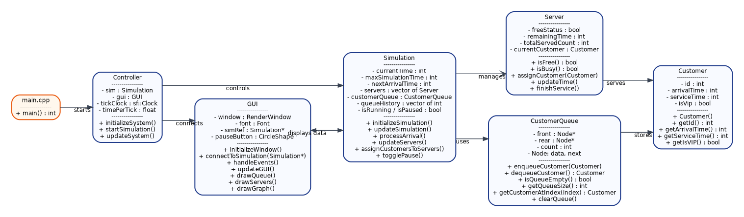
Figure 4. UML class diagram of the final Queue Simulation System.

Appendix B. Important Final Simulation Parameters
Parameter | Final Value | Meaning
Maximum simulation time | 80 ticks | The simulation stops when currentTime reaches this value.
Number of servers | 3 | Three service points process customers.
Arrival interval | Random 1-2 ticks | The next customer arrives after one or two ticks.
Service time | Random 5-10 ticks | Each customer requires a randomly selected service duration.
VIP probability | 20% | A randomly generated customer has a 20% chance of being VIP.
Time mapping | 1 real second = 1 simulation tick | Implemented through sf::Clock and timePerTick = 1.0.

