جامعة الأزهــر – غـــــــــــــــزة
Al-Azhar University – Gaza



FACULTY OF ENGINEERING AND INFORMATION TECHNOLOGY

Web Applications Development // ITSE3302

H.W ‘1’

prepared by:
Khaled Elbardweel 20173784

Supervisor by:
Dr. Moamar Elyazgi

Semester|| 2019/2020

Q1)
- HTTP(hypertext transfer protocol) : is a network protocol used to retrieve documents from a variety of machines in a minimum amount of time
Over the Internet - Using Syncrify you can perform remote backups of any machine to a remote location of your choice
Secure - When using HTTPS, data across the network is completely secure using industry standard SSL encryption.
Firewall friendly - Most companies allow HTTP(S) traffic through their company firewall. Reducing tremendous amount of network administration.

Q2)
- A client (a browser) sends an HTTP request to the web
- The server returns an HTTP response (output) to the browser
- The client (the browser) receives the response
- The browser requests an HTML page. The server returns an HTML file
- The browser requests JavaScript code. The server returns a JS file

Q3)
- GET || The GET method is used to retrieve information from the given server using a given URI. Requests using GET should only retrieve data and should have no other effect on the data.
- POST || A POST request is used to send data to the server, for example, customer information, file upload, etc. using HTML forms.
- PUT || Replaces all current representations of the target resource with the uploaded content
- DELETE || Removes all current representations of the target resource given by a URI.

Q4)
- Domain names are used to identify one or more IP addresses.

Q5)

- An IP address:
IP (internet protocol) it is one of the network protocols that is used in addressing which allows networks and different types of devices to communicate with each other.

- MAC address:
media access control address (MAC address) is a unique identifier assigned to a network interface controller (NIC) for use as a network address in communications within a network segment.

- A DNS hostname:
A DNS hostname is a name that uniquely and absolutely names a computer; it's composed of a host name and a domain name. DNS servers resolve DNS hostnames to their corresponding IP addresses.

- Network Sniffing:
Networking sniffing is a form of data packet analysis enabling real-time network monitoring. Network sniffing is used to diagnose network problems and analyze overall network and application activity.

Q6)

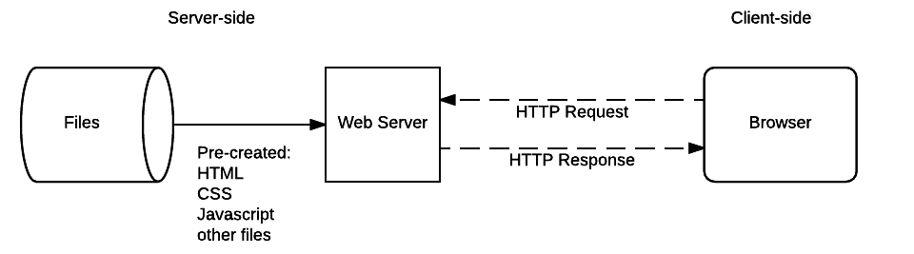

Q7)
- the client sends a HTTP GET request to the server to retrieve the webpage it should display. After the server has sent the response, it closes the TCP connection. If you open the website in your browser again, or if your browser automatically requests something from the server, a new connection is opened which follows the same process described above. GET requests are one kind of HTTP method a client can call. You can learn more about the other common ones (POST, PUT and DELETE) in this article.

Q8)Write the basic structure of HTTP Request and Response Message Structure?

Request message
- OPTIONS methods.
- POST / HTTP/1.1
- GET /background.png HTTP/1.0
- HEAD /test.html?query=alibabaHTTP/1.1

Response message
- Host: localhost:8000
- Connection: keep-alive
- Upgrade-Insecure-Requests:1
- Content-Type:text/html
- Content-Length:345

Q9)
- HTML stand for hypertext markup language which means you user HTML to simply "mark-up" , and it is the most widely used language to write web pages .
- hypertext markup language
- most widely used.
- used language to simply "mark-up".
- defining the structure of documents like paragraph and heading…

Q10)
- CSS (Cascading style sheet) , is a simple design language intended to simplify the process of making web pages presentable.
- Easier to maintain and update
- Greater consistency in design
- More formatting options

Q11):
- HTML tags <div> and <span> serve.
allow you to group together several elements to create sections of a page
- Two HTTP Request Methods.
The Hypertext Transfer Protocol (HTTP) is designed to enable communications between clients and servers. HTTP works as a request-response protocol between a client and server.
- HTML <body> Tag
hold the information that should be displayed.
- HTML <form> Tag.
to refer to different elements that allow you to collect information from visitors to your site.
- HTML <header> Tag
holds information about the document itself.
- HTML <p> Tag
to create paragraph .
- HTML <frameset> Tag
how to divide the window into frames.
- HTML <video> Tag
to embed a video in a web page.
- HTML <FORM> Tag
creating an HTML forms

Q12)
- If a field is disabled , the value of the field is not sent to the server when the form is submitted. If a field is read only, the value is sent to the server.
Q13)
- The client-server model is just one way for the computers to communication via the web , the client is based on a centralized structure , there is another way to communication via decentralized structure , It is the peer-to peer model.

Q14)
- Sniffing is a process of monitoring and capturing all data packets passing through given network. Sniffers are used by network/system administrator to monitor and troubleshoot network traffic. Attackers use sniffers to capture data packets containing sensitive information such as password, account information.

Q15)
- SSL, otherwise known as Secure Sockets Layer or Transport Layer Security (TLS), is a protocol that provides a secure channel of communication for two programs. This creates endpoints for communication called the "sockets" to affect connections. A bit of the process can be compared with TCP, but the encryption capabilities present in SSL are greater than TCP.

Q16)
- a client certificate is a type of digital certificate that is used by client systems to make authenticated requests to a remote server. Client certificates play a key role in many mutual authentication designs
- Advantages of SSL :
Provides Information Encryption Information transmission that occurs over a website using SSL certificates is being encrypted ensuring security to the sensitive information. When the information is being encrypted, it is hard for the intruders to understand the content in it.
- Disadvantages of SSL:
Cost SSL Certificates are not normally free (though some hosting companies offer free SSL certificates). Having SSL certificates installed on your websites would probably cost some bucks.
Extra Resources Required SSL Certificates would consume some extra resources in your server as the information has to be

Q17)
- The full form of SSL is secure sockets layer; it provides security to your websites and helps in keeping your client’s sensitive information like their names, phone numbers, addresses and credit card numbers safe and secure. SSL has been found very essential for websites which sell goods and services as it ensures that the information provided by the client will be kept private and secure.

Q18)
- DELETE is pretty easy to understand. It is used to ‘delete’ a resource identified by a URI. On successful deletion, return HTTP status 200 (OK) along with a response body, perhaps the representation of the deleted item (often demands too much bandwidth), or a wrapped response (see Return Values below).
Q19)
- SQL is based on a relational database model whereas HQL is a combination of object-oriented programming with relational database concepts.
- SQL manipulates data stored in tables and modifies its rows and columns. HQL is concerned about objects and its properties.
- SQL is concerned about the relationship that exists between two tables while HQL considers the relation between two objects.

Q20)
- there are two ways to reduce web server I/O. one is to reduce the amount of data that needs to be sent (local caching compression ,modification),the time it takes to deal with those requests and be dividing up the work across multiple servers

