Airport Management Information System
CMPE343 Database Project

Introduction
This project involves creating an Airport Management database system with SQLite. The database holds information on airplanes, employees, hangars, tests, technicians, and traffic controllers. The system also assists airport management in organizing airplane testing and employee data.

Assumptions
• Each airplane is assigned a unique plane number.
• One model has one airplane.
• One model can have several airplanes.
• Planes can move hangar to hangar.
• if outdate is NULL airplane still inside hangar.
• Each employee has a unique social security number.
• Airport staff are technicians and traffic controllers.
• Technician is able to work on more than one airplane model.

ER Diagram
The ERD displays all tables and relationships between them. The tables are linked to each other by foreign keys. 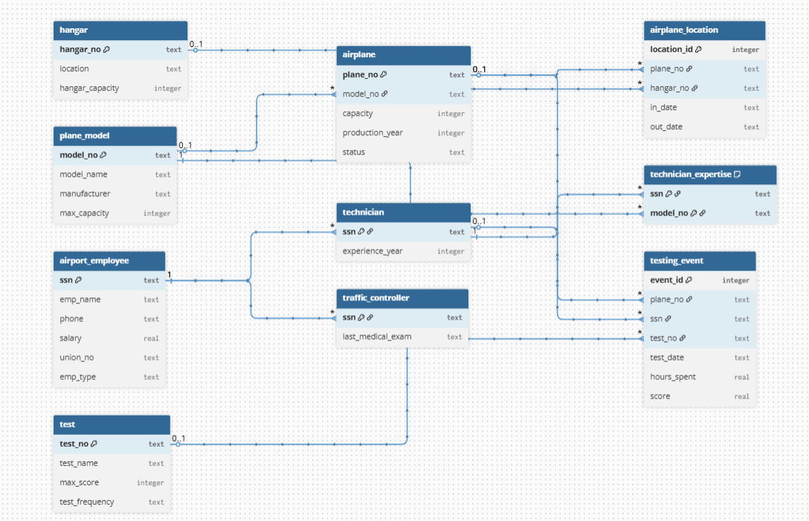

Relational Data Model
PLANE_MODEL model_no PK model_name manufacturer max_capacity.
AIRPLANE plane_no PK model_no FK capacity production_year status.
HANGAR hangar_no PK location hangar_capacity.
AIRPLANE_LOCATION location_id PK plane_no FK hangar_no FK in_date out_date.
AIRPORT_EMPLOYEE ssn PK emp_name phone salary union_no emp_type.
TECHNICIAN ssn PK FK experience_year.
TRAFFIC_CONTROLLER ssn PK FK last_medical_exam.
TEST test_no PK test_name max_score test_frequency.
TECHNICIAN_EXPERTISE ssn PK FK model_no PK FK.
TESTING_EVENT event_id PK plane_no FK ssn FK test_no FK test_date hours_spent score.

DDL
DDL commands are used to create the tables. In this project primary keys and foreign keys are used. The database has ten tables so it pass the minimum requirement. The command PRAGMA foreign_keys = ON is used because SQLite need it to check foreign keys.

DML
DML commands are used to populate all the tables with sample data. The data include: airplane models airplanes hangars employees technicians traffic controllers tests and testing events.

SQL Queries
The SQL file contains 20 management queries. The queries use the commands and functions from the slides like SELECT WHERE ORDER BY LIKE BETWEEN JOIN GROUP BY HAVING subquery and UNION.
The functions that are used are COUNT AVG SUM MAX MIN UPPER LOWER LENGTH SUBSTR INSTR ROUND IFNULL COALESCE NULLIF and CASE.

Conclusion
I learned relational database design and SQL through this project. It also helps to practice tables, keys, joins, functions, group queries and subqueries using SQL lite.

