6.1 . ls – short for list

The command “ls” use to describe the file s in the current folder.

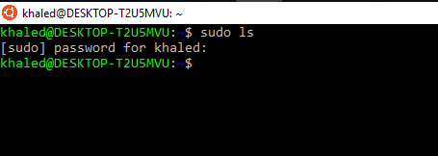

There is no file in the current folder.

“ls –al –color=yes”

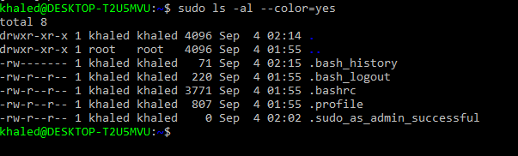

6.2. pwd –print name of current/working directo

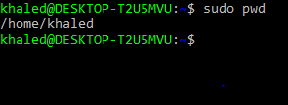

Pwd print the fully resolved name of the current(working) directory.

6.3. cd – change directory

Cd stands for change (working ) directory and that’s what it dose. The folder below we (unless we are in /, where there is no lower directory) called

To go one folder down:

