SJF scheduling Algorithm

Shortest Job First scheduling works on the process with the shortest burst time or duration first.
- This is the best approach to minimize waiting time.
- This is used in Batch
- It is of two types:
  - Non Pre-emptive
  - Pre-emptive
- To successfully implement it, the burst time/duration time of the processes should be known to the processor in advance, which is practically not feasible all the time.
- This scheduling algorithm is optimal if all the jobs/processes are available at the same time. (either Arrival time is 0 for all, or Arrival time is same for all)

Implementation in C
#include<bits/stdc++.h>
using namespace std;

main()
{
int n;
float avg_wt,avg_tat;
printf("Enter number of process:");
scanf("%d",&n);
int bt[n],p[n],wt[n],i,j,total=0,pos,temp;

for(i=0; i<n; i++)
{
printf("\nEnter Burst Time of processs %d : ",i+1);
scanf("%d",&bt[i]);
p[i]=i+1;
}

sort(bt,bt+n);

wt[0]=0;
for(i=1; i<n; i++)
{
wt[i]=0;
for(j=0; j<i; j++)
wt[i]+=bt[j];

total+=wt[i];
}

avg_wt=(float)total/(float)n;

printf("\nProcess\t Burst Time \tWaiting Time");
for(i=0; i<n; i++)
{

printf("\np%d\t\t %d\t\t %d",p[i],bt[i],wt[i]);
}

printf("\n\nAverage Waiting Time=%f",avg_wt);

return 0;
}

Output :
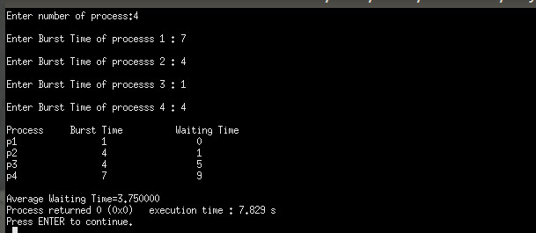

Conclusion :
SJF is an easy to implement in c programming. It work base on the shortest job.

