FCFS Scheduling Algorithm

FCFS Scheduling : First come first serve (FCFS) scheduling algorithm simply schedules the jobs according to their arrival time. The job which comes first in the ready queue will get the CPU first. The lesser the arrival time of the job, the sooner will the job get the CPU. FCFS scheduling may cause the problem of starvation if the burst time of the first process is the longest among all the jobs.

Implementation in C
Source code :
#include<bits/stdc++.h>
using namespace std;
void findWaitingTime(int processes[], int n,int bt[], int wt[])
{

wt[0] = 0;
int i=1;

while(i<n)
{

printf("wait");
wt[i] = bt[i-1] + wt[i-1] ;
i++;
}
}

void findTurnAroundTime( int processes[], int n,int bt[], int wt[], int tat[])
{

int i=1;
while(i<n)
{

printf("turn");
tat[i] = bt[i] + wt[i];
i++;
}
}

void findavgTime( int processes[], int n, int bt[])
{
int wt[n], tat[n], total_wt = 0, total_tat = 0;

findWaitingTime(processes, n, bt, wt);

findTurnAroundTime(processes, n, bt, wt, tat);

printf("\n\nProcesses Burst time Waiting time Turn around time\n");

int i=0;
while(i<n)

{
total_wt = total_wt + wt[i];
total_tat = total_tat + tat[i];
printf(" %d %d %d %d\n",(i+1), bt[i],wt[i],tat[i]);
i++;
}
int s=(float)total_wt / (float)n;
int t=(float)total_tat / (float)n;

printf("\nAverage waiting time = %d\n",s);
printf("\n");
printf("Average turn around time = %d \n",t);
}

int main()
{
int n,i;
printf("Enter the number of process : ");
scanf("%d",&n);

int processes[n],burst_time[n];

i=0;
while(i<n)

{
printf("Enter process %d bust time : ",i+1);
processes[i] = i+1;

scanf("%d",&burst_time[i]);
i++;
}

findavgTime(processes, n, burst_time);
return 0;
}

Output :
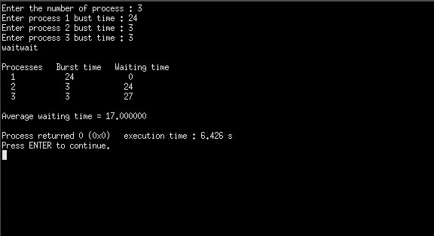

Conclusion:
FIFS is very simple CPU scheduling algorithm. It is also easy to implementation in c programming.

