Priority Scheduling Algorithm

- Priority scheduling is a non-preemptive algorithm and one of the most common scheduling algorithms in batch systems.
- Each process is assigned a priority. Process with highest priority is to be executed first and so on.
- Processes with same priority are executed on first come first served basis.
- Priority can be decided based on memory requirements, time requirements or any other resource requirement.

Implementation in C
#include<bits/stdc++.h>
using namespace std;

int main()
{

int n;
printf("Enter Total Number of Process: ");
scanf("%d",&n);
int bt[n], p[n], wt[n], tat[n], pr[n],i,j,total=0,pos,temp;

for(i=0; i<n; i++)
{
printf("\nEnter Burst Time and Priority of process %d : \n",i+1);

scanf("%d%d",&bt[i],&pr[i]);

p[i]=i+1;
}

for(i=0; i<n; i++)
{
pos=i;
for(j=i+1; j<n; j++)
{
if(pr[j]<pr[pos])
pos=j;
}

temp=pr[i];
pr[i]=pr[pos];
pr[pos]=temp;

temp=bt[i];
bt[i]=bt[pos];
bt[pos]=temp;

temp=p[i];
p[i]=p[pos];
p[pos]=temp;
}

wt[0]=0;

for(i=1; i<n; i++)
{
wt[i]=0;
for(j=0; j<i; j++)
wt[i]+=bt[j];

total+=wt[i];
}

float avg_wt= (float)total/(float)n;
total=0;

printf("\nProcess\t Burst Time \tWaiting Time");
for(i=0; i<n; i++)
{

printf("\nP%d\t\t %d\t\t %d\t\t\t%d",p[i],bt[i],wt[i]);
}

printf("\n\nAverage Waiting Time=%f",avg_wt);

printf("\n");
return 0;
}

Output:

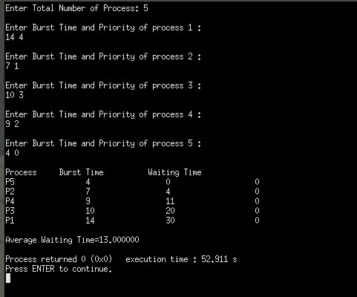

Conclusion:
Priority scheduling is am important CPU scheduling algorithms . It give the service base on the priority of the processes.

