FIFO page replacement algorithm

This is the simplest page replacement algorithm. In a page replacement algorithm we decide when a page replacement occurs then which frames are to be replaced. For evaluating an algorithm we take a particular string of memory references ,called reference string.
In FIFO page replacement algorithm- for each page we track the time when it was brought into the memory and when any replacement request comes then oldest page is chosen. If we choose a queue to hold all pages in memory then its more easy to understand and implement rather than tracking time of all pages.

Implementation in C

Source code :

#include<bits/stdc++.h>
using namespace std;

int main()
{
int i,j,n,a[50],frame[10],no,k,avail,count=0;

printf("Enter the number of pages: ");
scanf("%d",&n);

for(i=1; i<=n; i++){
printf("\n Enter page number %d : ",i);
scanf("%d",&a[i]);
}

printf("\n Enter the number frames : ");
scanf("%d",&no);

for(i=0; i<no; i++)
frame[i]= -1;
j=0;

for(i=1; i<=n; i++)
{

avail=0;

for(k=0; k<no; k++)
if(frame[k]==a[i])
avail=1;
if (avail==0)
{
frame[j]=a[i];
j=(j+1)%no;
count++;

}

}

printf("\n\nPage Fault Is %d\nPage Hit is : %d\n",count, n-count);
return 0;
}

Output :
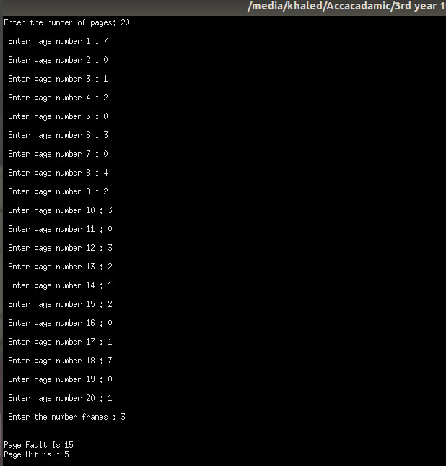

Conclusion :
FIFO is the simplest page replacement algorithm. It is very useful. It help to maximum use of RAM.

