Docker Commands
Tuesday, February 27, 2024
10:50 AM

New Docker Commands:
======================

I saved my Artifactory Credentials inside ~/.docker/config.json in order to avoid having to input my credentials every time.
Also, I saved my redhat.registry.io inside ~/.docker/config.json

Credentials for docker.artifactory.pb.lz.us-cert.gov: (Artifactory)
------------------------------------------------------------------------
Username: khaled.elsayed@cisa.gov
Password: a2hhbGVkLmVsc2F5ZWRAY2lzYS5nb3Y6Y21WbWRHdHVPakF4T2pFM09EY3pNell4TkRrNlJWUnBkMVk1YUU0MVZqZEpkVkZUVUZGR1dqRXpTREpQVldwTg==

Credentials for redhat.registry.io:
----------------------------------------------
This will convert them to base 64, and then you can store them in ~/.docker/config.json

khaled.fouad ~/.config ❯ echo -n "khaled.elsayed@mail.associates.cisa.dhs.gov:Hanaa12345678@" | base64
a2hhbGVkLmVsc2F5ZWRAbWFpbC5hc3NvY2lhdGVzLmNpc2EuZGhzLmdvdjpIYW5hYTEyMzQ1Njc4QA==

My Credentials for Artifactory & redhat.registry.io:
----------------------------------------------------------------------

khaled.fouad ~/.docker ❯ cat config.json
{
"auths": {
"https://docker.artifactory.pb.lz.us-cert.gov" : {
"auth": "a2hhbGVkLmVsc2F5ZWRAY2lzYS5nb3Y6Y21WbWRHdHVPakF4T2pFM09EY3pNell4TkRrNlJWUnBkMVk1YUU0MVZqZEpkVkZUVUZGR1dqRXpTREpQVldwTg==",
"email": "khaled.elsayed@cisa.gov"
},
"https://registry.redhat.io" : {
"auth":
"a2hhbGVkLmVsc2F5ZWRAbWFpbC5hc3NvY2lhdGVzLmNpc2EuZGhzLmdvdjpIYW5hYTEyMzQ1Njc4QA==",
"email": "khaled.elsayed@mail.associates.cisa.dhs.gov"
}
}
}

Docker Login Artifactory - LZ:
-----------------------------------------

If you have any Failures in Building or Pushing Docker Images, You need to Make sure that you are correctly Logged in to Artifactory.

Go to Artifactory --> Click on your Profile ---> Set Me Up ---> Select Docker ---> Generate Token

docker login docker.artifactory.pb.lz.us-cert.gov

  - Username: kelsayed
  - Password: cmVmdGtuOjAxOjE3NzMzNDM4NTE6ZFJ6YXlWeWlPanBiT012MUd4Mm5TNDJaMWtE ----> Generated Password from Artifactory

Also, Make sure you have the correct settings for Docker.sock file which should be "666".

  - sudo chmod 666 /var/run/docker.sock
  - Password: cmVmdGtuOjAxOjE3NzMzNDM4NTE6ZFJ6YXlWeWlPanBiT012MUd4Mm5TNDJaMWtE ----> Generated Password from Artifactory

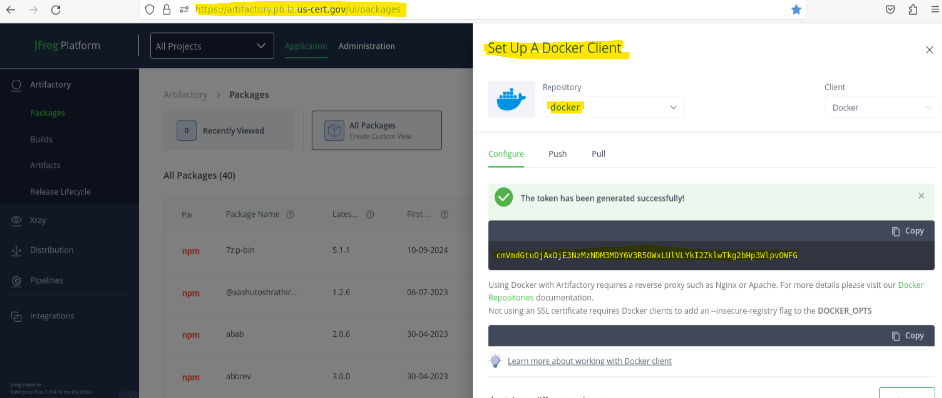

Verify Docker is Running in Workspace:
---------------------------------------------------------

[root@a-1spquvzhx6ii ~]# systemctl daemon-reload
[root@a-1spquvzhx6ii ~]# systemctl restart docker
[root@a-1spquvzhx6ii ~]# systemctl status docker

Setup Docker Permissions in Workspace:
---------------------------------------------------------

Make sure /var/run/docker.sock has permission of 666.

khaled.fouad ~ ❯ sudo su -
[sudo] password for workspaces\khaled.elsayed:

[root@a-1spquvzhx6ii ~]# cd /var/run/
[root@a-1spquvzhx6ii run]# chmod 666 docker.sock
[root@a-1spquvzhx6ii run]# exit
logout

[root@a-1spquvzhx6ii run]# ls -l /var/run/docker.sock
srw-rw-rw- 1 root docker 0 Apr 29 07:53 /var/run/docker.sock

Docker Login Artifactory - LZ:
-----------------------------------------

khaled.fouad ~ ❯ docker login docker.artifactory.pb.lz.us-cert.gov
Authenticating with existing credentials...
Login did not succeed, error: Error response from daemon: Get "https://docker.artifactory.pb.lz.us-cert.gov/v2/": unknown: Token failed verification: revoked
Username (kelsayed):
Password: cmVmdGtuOjAxOjE3NzMzNDM4NTE6ZFJ6YXlWeWlPanBiT012MUd4Mm5TNDJaMWtE ----> Generated Password from Artifactory
WARNING! Your password will be stored unencrypted in /home/khaled.elsayed/.docker/config.json.
Configure a credential helper to remove this warning. See
https://docs.docker.com/engine/reference/commandline/login/#credentials-store

Login Succeeded
khaled.fouad ~ ❯

Test Pulling Docker Images from Docker Hub through Artifactory:
------------------------------------------------------------------------------------------

khaled.fouad ~ ❯ docker pull docker.artifactory.pb.lz.us-cert.gov/python:latest
latest: Pulling from python
155ad54a8b28: Pull complete
8031108f3cda: Pull complete
1d281e50d3e4: Pull complete
447713e77b4f: Pull complete
21754c21aa78: Pull complete
854e2aed8deb: Pull complete
5e9ad5aa09b4: Pull complete
Digest: sha256:385ccb8304f6330738a6d9e6fa0bd7608e006da7e15bc52b33b0398e1ba4a15b
Status: Downloaded newer image for docker.artifactory.pb.lz.us-cert.gov/python:latest
docker.artifactory.pb.lz.us-cert.gov/python:latest

khaled.fouad ~ ❯ docker pull docker.artifactory.pb.lz.us-cert.gov/httpd:2.4
2.4: Pulling from httpd
7cf63256a31a: Pull complete
d2f10b557009: Pull complete
4f4fb700ef54: Pull complete
38fd0d422c41: Pull complete
470035b3d48f: Pull complete
fdebd6c6e1b2: Pull complete
Digest: sha256:10381816bb7e60ae3a9db3784f2966a8910b6ff07c4da54bd2d62d2671c8ab6e
Status: Downloaded newer image for docker.artifactory.pb.lz.us-cert.gov/httpd:2.4
docker.artifactory.pb.lz.us-cert.gov/httpd:2.4

khaled.fouad ~ ❯ docker pull docker.artifactory.pb.lz.us-cert.gov/httpd:2.4-buster
2.4-buster: Pulling from httpd
b380bbd43752: Pull complete
d0c6942edac3: Pull complete
d027638c026c: Pull complete
17082a2122d5: Pull complete
0b7d42e498cc: Pull complete
Digest: sha256:f03a63735d3653045a3b1f5490367415e9534d8abfe0b21252454dc85ca09800
Status: Downloaded newer image for docker.artifactory.pb.lz.us-cert.gov/httpd:2.4-buster
docker.artifactory.pb.lz.us-cert.gov/httpd:2.4-buster

khaled.fouad ~ ❯ docker images
REPOSITORY TAG IMAGE ID CREATED SIZE
docker.artifactory.pb.lz.us-cert.gov/python latest 36d17f72f4f3 5 weeks ago 1.02GB
docker.artifactory.pb.lz.us-cert.gov/httpd 2.4 0de612e99135 6 weeks ago 148MB
docker.artifactory.pb.lz.us-cert.gov/jenkins-workers/jenkins-agent-iac test 2238cb1c0b09 5 months ago 3.26GB
docker.artifactory.pb.us-cert.gov/jenkins-workers/jenkins-agent-iac test 2238cb1c0b09 5 months ago 3.26GB
python-agent v1 45432f3817e4 7 months ago 2.61GB
docker.artifactory.pb.lz.us-cert.gov/ubi8/python-311 1-68.1721725204 4ab69be404a6 7 months ago 923MB
docker.artifactory.pb.lz.us-cert.gov/nginx latest e4720093a3c1 13 months ago 187MB
docker.artifactory.pb.lz.us-cert.gov/httpd 2.4-buster d54056386fbb 3 years ago 138MB

Test Pulling Docker Images from Docker Hub through Artifactory using Podman:
------------------------------------------------------------------------------------------------------------

khaled.fouad ~ ❯ podman pull docker.artifactory.pb.lz.us-cert.gov/python:latest
Trying to pull docker.artifactory.pb.lz.us-cert.gov/python:latest...
Getting image source signatures
Copying blob 2effe4ca65f9 done |
Copying blob ebed137c7c18 done |
Copying blob 37f838b71c6b done |
Copying blob c2e76af9483f done |
Copying blob 873a4c802874 done |
Copying blob 51f8af1d7d36 done |
Copying blob e5af76e56a46 done |
Copying config 4bbf6d52fe done |
Writing manifest to image destination
4bbf6d52fe8de40e9e20b1453e14abb40eb1c73cd1d2b22e8ed015ad0817a088

khaled.fouad ~ ❯ docker images
Emulate Docker CLI using podman. Create /etc/containers/nodocker to quiet msg.
REPOSITORY TAG IMAGE ID CREATED SIZE
docker.artifactory.pb.lz.us-cert.gov/python latest 4bbf6d52fe8d 6 weeks ago 1.04 GB

khaled.fouad ~ ❯ podman images
REPOSITORY TAG IMAGE ID CREATED SIZE
docker.artifactory.pb.lz.us-cert.gov/python latest 4bbf6d52fe8d 6 weeks ago 1.04 GB

Tagging & Pushing Docker Images from Redhat Registry through Artifactory using Podman:
----------------------------------------------------------------------------------------------------------------------------
khaled.fouad ~ ❯ podman tag registry.redhat.io/ubi9/python-312:latest docker.artifactory.pb.lz.us-cert.gov/ubi9/python-312:latest

khaled.fouad ~ ❯ podman push docker.artifactory.pb.lz.us-cert.gov/ubi9/python-312:latest --remove-signatures

Login to Redhat Registry using Podman:
-------------------------------------------------------
khaled.fouad ~ ❯ podman login registry.redhat.io
Username: khaled.elsayed@mail.associates.cisa.dhs.gov
Password: Hanaa12345678@
Login Succeeded!

Pull docker image from Redhat Registry using Podman:
---------------------------------------------------------------------------
khaled.fouad ~ ❯ podman pull registry.redhat.io/rhel9/mysql-84:latest
Trying to pull registry.redhat.io/rhel9/mysql-84:latest...
Getting image source signatures
Checking if image destination supports signatures
Copying blob 08213ff3d21b done |
Copying blob 8dc3dd507e8f done |
Copying blob 56dd0a75a416 done |
Copying config 50d2dba68f done |
Writing manifest to image destination
Storing signatures
50d2dba68fe60fce0da6c3b5f48524e73a73cb8f52576f04dc556e03aff9cc68
khaled.fouad ~ ❯

khaled.fouad ~ ❯ podman images
REPOSITORY TAG IMAGE ID CREATED SIZE
registry.redhat.io/rhel9/mysql-84 latest 50d2dba68fe6 4 hours ago 543 MB
docker.artifactory.pb.lz.us-cert.gov/ubi9/python-312 latest 07cbc7d4ab6b 8 days ago 1.04 GB
docker.artifactory.pb.lz.us-cert.gov/nginx latest 2cd1d97f893f 4 weeks ago 196 MB
docker.artifactory.pb.lz.us-cert.gov/python latest 4bbf6d52fe8d 2 months ago 1.04 GB

How to fix Failure to pull Docker Images from Artifactory using Podman:
----------------------------------------------------------------------------------------------------
1- Pull the docker Image from registry.redhat.io/

podman pull registry.redhat.io/rhel9/mysql-84:latest

2- Tag the image using the same tag from Redhat Registry

podman tag registry.redhat.io/ubi9/python-312:latest docker.artifactory.pb.lz.us-cert.gov/ubi9/python-312:latest

3- Push the updated image to Artifactory

podman push docker.artifactory.pb.lz.us-cert.gov/ubi9/python-312:latest --remove-signatures

4- The build can now succeed in pulling the docker image through Artifactory.

Podman Build & Run & Push:
----------------------------------------
khaled.fouad ~/Documents/Repos/dso-pipeline-tools/jenkins-workers/jenkins-agent-kubernetes (khaled-test) ❯ podman build -t docker.artifactory.pb.lz.us-cert.gov/jenkins-workers/jenkins-agent-kubernetes:2.516.1.28666 .

khaled.fouad ~/Documents/Repos/dso-pipeline-tools/jenkins-workers/jenkins-agent-kubernetes (khaled-test) ❯ podman run -it e5bc452e5050 bash

khaled.fouad ~/Documents/Repos/dso-pipeline-tools/jenkins-workers/jenkins-agent-kubernetes (khaled-test) ❯ podman push docker.artifactory.pb.lz.us-cert.gov/jenkins-workers/jenkins-agent-kubernetes:2.516.1.28666

khaled.fouad ~/Documents/Repos/dso-pipeline-tools/jenkins-workers/jenkins-agent-kubernetes (khaled-test) ❯ podman images
REPOSITORY TAG IMAGE ID CREATED SIZE
docker.artifactory.pb.lz.us-cert.gov/jenkins-workers/jenkins-agent-kubernetes 2.516.1.28666 e5bc452e5050 38 minutes ago 1.95 GB
docker.artifactory.pb.lz.us-cert.gov/jenkins-workers/jenkins-agent-kubernetes 2.504.1.8 e5bc452e5050 38 minutes ago 1.95 GB
localhost/jenkins-agent-kubernetes 2.504.1.8 e5bc452e5050 38 minutes ago 1.95 GB
<none> <none> 7cbb3fbfb748 41 minutes ago 859 MB
registry.redhat.io/rhel9/mysql-84 latest 50d2dba68fe6 2 days ago 543 MB
docker.artifactory.pb.lz.us-cert.gov/ubi8 latest 67d90e44bceb 8 days ago 205 MB
docker.artifactory.pb.lz.us-cert.gov/ubi9/python-312 latest 07cbc7d4ab6b 10 days ago 1.04 GB
docker.artifactory.pb.lz.us-cert.gov/cloudbees/cloudbees-core-agent 2.516.1.28665 b76664cfe674 2 weeks ago 506 MB
docker.artifactory.pb.lz.us-cert.gov/nginx latest 2cd1d97f893f 4 weeks ago 196 MB
docker.artifactory.pb.lz.us-cert.gov/python latest 4bbf6d52fe8d 2 months ago 1.04 GB

Docker Build & Run:
-----------------------------
khaled.fouad ~/Documents/Repos/Applications/Yellowdog/Yellowdog-Apps/yellowdog-frontend (staging/khaled-test) ❯ docker build -t npm:1 .

khaled.fouad ~/Documents/Repos/Applications/Yellowdog/Yellowdog-Apps/yellowdog-frontend (staging/khaled-test) ❯ docker run -it b47dfc1efb31 bash

Docker Errors:
---------------------
khaled.fouad ~/Documents/Repos/Applications/Claw/claw-logstash (feature/khaled-test) ❯ docker build -f ecs/image/Dockerfile -t logstash-test .
ERROR: permission denied while trying to connect to the Docker daemon socket at unix:///var/run/docker.sock: Get "http://%2Fvar%2Frun%2Fdocker.sock/_ping": dial unix /var/run/docker.sock: connect: permission denied

khaled.fouad ~/Documents/Repos/Applications/Claw/claw-logstash (feature/khaled-test) ❯ sudo chmod 666 /var/run/docker.sock
[sudo] password for workspaces\khaled.elsayed:

[root@a-1spquvzhx6ii ~]# systemctl restart docker

[root@a-1spquvzhx6ii ~]# systemctl status docker
● docker.service - Docker Application Container Engine
Loaded: loaded (/usr/lib/systemd/system/docker.service; enabled; vendor preset: disabled)
Drop-In: /etc/systemd/system/docker.service.d
└─http-proxy.conf
Active: active (running) since Thu 2025-04-03 16:02:49 EDT; 2s ago
Docs: https://docs.docker.com
Process: 16452 ExecStartPre=/usr/libexec/docker/docker-setup-runtimes.sh (code=exited, status=0/SUCCESS)
Process: 16449 ExecStartPre=/bin/mkdir -p /run/docker (code=exited, status=0/SUCCESS)
Main PID: 16455 (dockerd)
Tasks: 15
Memory: 31.8M
CGroup: /system.slice/docker.service
└─16455 /usr/bin/dockerd -H fd:// --containerd=/run/containerd/containerd.sock --default-ulimit nofile=32768:65536

Apr 03 16:02:48 a-1spquvzhx6ii systemd[1]: Starting Docker Application Container Engine...
Apr 03 16:02:48 a-1spquvzhx6ii dockerd[16455]: time="2025-04-03T16:02:48.945558547-04:00" level=info msg="Starting up"
Apr 03 16:02:49 a-1spquvzhx6ii dockerd[16455]: time="2025-04-03T16:02:49.027998721-04:00" level=info msg="[graphdriver] using prior storage driver: overlay2"
Apr 03 16:02:49 a-1spquvzhx6ii dockerd[16455]: time="2025-04-03T16:02:49.051286709-04:00" level=info msg="Loading containers: start."
Apr 03 16:02:49 a-1spquvzhx6ii dockerd[16455]: time="2025-04-03T16:02:49.234473587-04:00" level=info msg="Default bridge (docker0) is assigned with an IP address 172.17.0.0/16... IP address"
Apr 03 16:02:49 a-1spquvzhx6ii dockerd[16455]: time="2025-04-03T16:02:49.299116849-04:00" level=info msg="Loading containers: done."
Apr 03 16:02:49 a-1spquvzhx6ii dockerd[16455]: time="2025-04-03T16:02:49.319326031-04:00" level=info msg="Docker daemon" commit=71907ca containerd-snapshotter=false storage-dr...rsion=25.0.8
Apr 03 16:02:49 a-1spquvzhx6ii dockerd[16455]: time="2025-04-03T16:02:49.319467821-04:00" level=info msg="Daemon has completed initialization"
Apr 03 16:02:49 a-1spquvzhx6ii dockerd[16455]: time="2025-04-03T16:02:49.483790227-04:00" level=info msg="API listen on /run/docker.sock"
Apr 03 16:02:49 a-1spquvzhx6ii systemd[1]: Started Docker Application Container Engine.
Hint: Some lines were ellipsized, use -l to show in full.
[root@a-1spquvzhx6ii ~]# exit

khaled.fouad ~/Documents/Repos/Applications/Claw/claw-logstash (feature/khaled-test) ❯ docker build -f ecs/image/Dockerfile -t logstash-test .
[+] Building 0.4s (6/16) docker:default
=> [internal] load build definition from Dockerfile 0.0s
=> => transferring dockerfile: 1.65kB 0.0s
=> [internal] load metadata for docker.artifactory.pb.lz.us-cert.gov/logstash/logstash:7.17.22 0.0s
=> [internal] load .dockerignore 0.0s
=> => transferring context: 2B 0.0s
=> [internal] load build context 0.1s
=> => transferring context: 30.15kB 0.0s
=> [ 1/12] FROM docker.artifactory.pb.lz.us-cert.gov/logstash/logstash:7.17.22

Docker Login Artifactory - ECC:
------------------------------------------

If you have any Failures in Building or Pushing Docker Images, You need to Make sure that you are correctly Logged in to Artifactory.

docker login docker.artifactory.pb.us-cert.gov

  - Username: kelsayed
  - Password: ECC IDM Production Password

Also, Make sure you have the correct settings for Docker.sock file which should be "666".

  - sudo chmod 666 /var/run/docker.sock
  - Password: My IDM DEV Password

Docker Commands:
----------------------------
Link: kubernetes - How to delete a docker image? - Stack Overflow

At first, We need to delete/stop the running container that is using your image(which one you want to remove).

  - docker ps -a
    - To see all the running containers in your machine.
  - docker stop <container_id>
    - To stop a running container.
  - docker rm <container_id>
    - To remove/delete a docker container(only if it stopped).
  - docker image ls
    - To see the list of all the available images with their tag, image id, creation time and size.
  - docker rmi <image_id>
    - To delete a specific image.
  - docker rmi -f <image_id>
    - To delete a docker image forcefully
  - docker rm -v $(docker ps --filter status=exited -q)
    - To delete all the docker container available in your machine
  - docker image rm <image_name>
    - To delete a specific image
  - docker rmi $(docker images | grep 'ruby')
    - To delete all docker images with a name of "ruby"
  - docker images --format '{{.Repository}}:{{.Tag}}' | grep "ruby:" | grep -v "ruby:17"
    - delete all docker images for ruby, except ruby:17.
    - khaled.fouad ~ ❯ docker images --format '{{.Repository}}:{{.Tag}}' | grep "ruby:" | grep -v "ruby:17"
ruby:8
ruby:7
ruby:6
ruby:5
ruby:4
ruby:3

khaled.fouad ~ ❯ docker images --format '{{.Repository}}:{{.Tag}}' | grep "ruby:" | grep -v "ruby:17" | xargs -r docker rmi
Untagged: ruby:8
Deleted: sha256:814006b03268084a67d08c054bf2b0044b3066df87858d12d8f4b701f2ed50f5
Untagged: ruby:7
Deleted: sha256:9ad2e4b89c37e1e1c04740c64eb9bcc5569c842ef9fda6120fff0cadefede7cf
Untagged: ruby:6
Deleted: sha256:92db8b840562919c8bccd250d5380eb2e0eed64e7362c2c5cb7a38bd99ea4dd3
Untagged: ruby:5
Deleted: sha256:de864b8b638028ea2df4af4c059f32e2a1b91287e76572a9abf23d373d5a8726
Untagged: ruby:4
Deleted: sha256:04293d99cdf360db22fc3824c54eaabec49d1a7c04438f7fce1004d2a4d2e473
Untagged: ruby:3
Deleted: sha256:a9c2cc802aab51b77431e7b0dca1174bed346faa3a383721cb288580456a5616

khaled.fouad ~ ❯ docker images
REPOSITORY TAG IMAGE ID CREATED SIZE
docker.artifactory.pb.lz.us-cert.gov/yellowdog-dev/yellowdog latest 2c6540861cdb 2 hours ago 521MB
ruby 17 72a018ecd11d 2 weeks ago 1.34GB
docker.artifactory.pb.lz.us-cert.gov/ubi8/nginx-124 latest b47dfc1efb31 3 weeks ago 438MB
logstash-test latest b06744acfee9 5 weeks ago 991MB
docker.artifactory.pb.lz.us-cert.gov/httpd 2.4 0de612e99135 3 months ago 148MB
docker.artifactory.pb.lz.us-cert.gov/jenkins-workers/jenkins-agent-iac test 2238cb1c0b09 7 months ago 3.26GB
docker.artifactory.pb.us-cert.gov/jenkins-workers/jenkins-agent-iac test 2238cb1c0b09 7 months ago 3.26GB
python-agent v1 45432f3817e4 9 months ago 2.61GB
docker.artifactory.pb.lz.us-cert.gov/ubi8/python-311 1-68.1721725204 4ab69be404a6 9 months ago 923MB
docker.artifactory.pb.lz.us-cert.gov/nginx latest e4720093a3c1 15 months ago 187MB
docker.artifactory.pb.lz.us-cert.gov/httpd 2.4-buster d54056386fbb 3 years ago 138MB

Delete Docker Image By Force:
------------------------------------------
khaled.fouad ~/Documents/Repos/Applications/Claw/claw-logstash/ecs/image (feature/khaled-test) ✗ ❯ docker rmi -f 754beee29bc7
Untagged: docker.artifactory.pb.lz.us-cert.gov/logstash/logstash:7.17.22
Untagged: docker.artifactory.pb.lz.us-cert.gov/logstash/logstash@sha256:eba4cdfa70bee0adc78f2c5dbbb0f10f10012e8de5ba7d72381468a5b823da3c
Deleted: sha256:754beee29bc7ef2c65327f541a9d8d04d326b03773bf75997f1c6b791b59d941

Clear All Docker Images:
-----------------------------------
docker image prune --all --force
docker system prune --all --force
docker system prune -a
  - To clean the docker environment, removing all the containers and images.

How to Fix Docker Image Vulnerabilities:
--------------------------------------------------------
Project: Claw-Logstash
Link: https://git.pb.lz.us-cert.gov/claw/claw-logstash/blob/feature/khaled-test/ecs/image/Dockerfile

I had to remove all the files that refers to the old packages inside my docker file, as shown below.

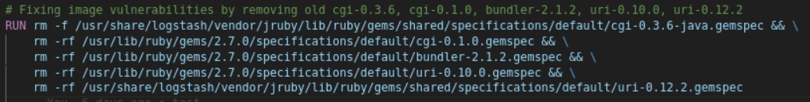

Then, I had to install the new versions for these packages as shown below.

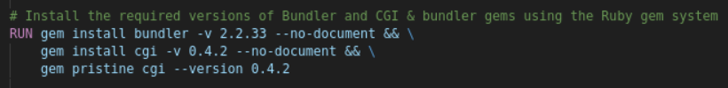

Remember to search for all the related files for any package using this command.
This will help you identify all files that need to be removed for a package, in order to resolve the vulnerabilities.

  - find / -name cgi* 2>/dev/null

  - find / -name bundler* 2>/dev/null

  - Cgi Package Fix:

This is what I see before removing the old gemspec files for cgi packages.
The default cgi v.0.1.0 is the package causing the image vulnerability with Prisma Cloud (Twistlock), and it had to be removed from the image.

logstash@d79fd394b61d:~$ find / -name cgi*gemspec 2>/dev/null
/usr/lib/ruby/gems/2.7.0/specifications/default/cgi-0.1.0.gemspec
/usr/share/logstash/vendor/bundle/jruby/3.1.0/specifications/cgi-0.4.2.gemspec
logstash@d79fd394b61d:~$ gem list cgi

*** LOCAL GEMS ***

cgi (0.4.2, default: 0.1.0)

Solution:

This is what I see After removing the old gemspec files for cgi packages.
Notice that cgi shows ONLY the latest v.0.4.2.
Notice that I had to remove these files, which points to the old cgi v.0.3.6, cgi v.0.1.0

khaled.fouad ~/Documents/Repos/Applications/Claw/claw-logstash/ecs/image (feature/khaled-test) ❯ docker run -it 1f0cb023971e bash
logstash@f20a76508c07:~$ gem list cgi

*** LOCAL GEMS ***

cgi (0.4.2)
logstash@f20a76508c07:~$ find / -name cgi*gemspec 2>/dev/null
/usr/share/logstash/vendor/bundle/jruby/3.1.0/specifications/cgi-0.4.2.gemspec

=======================================================================

  - Bundler Package Fix:

This is what I see before removing the old gemspec files for bundler packages.
The default bundler v.2.1.2 is the package causing the image vulnerability with Prisma Cloud (Twistlock), and it had to be removed from the image.

logstash@f4b1147161e9:~$ bundler -v
Bundler version 2.2.33
logstash@f4b1147161e9:~$ which bundler
/usr/share/logstash/vendor/bundle/jruby/3.1.0/bin/bundler
logstash@f4b1147161e9:~$ gem list bundler

*** LOCAL GEMS ***

bundler (2.2.33, default: 2.1.2)

Solution:

This is what I see After removing the old gemspec files for bundler packages.
Notice that I had to remove these files, which points to the old bundler v.2.1.2

Notice that bundler shows ONLY the latest v.2.2.33.

logstash@7e77ecc3a152:~$ gem list | grep bundler
bundler (2.2.33)
logstash@7e77ecc3a152:~$ bundler -v
Bundler version 2.2.33
logstash@7e77ecc3a152:~$ gem list bundler

*** LOCAL GEMS ***

bundler (2.2.33)

=======================================================================

  - Uri Package Fix:

This is what I see before removing the old gemspec files for uri packages.
The default uri v.0.10.0 is the package causing the image vulnerability with Prisma Cloud (Twistlock), and it had to be removed from the image.

logstash@7537916c015b:~$ gem list uri

*** LOCAL GEMS ***

uri (1.0.3, default: 0.10.0)
logstash@7537916c015b:~$ find / -name uri*gemspec 2>/dev/null
/usr/lib/ruby/gems/2.7.0/specifications/default/uri-0.10.0.gemspec
/usr/share/logstash/vendor/bundle/jruby/3.1.0/specifications/uri-1.0.3.gemspec
/usr/share/logstash/vendor/jruby/lib/ruby/gems/shared/specifications/default/uri-0.12.2.gemspec

Solution:

This is what I see After removing the old gemspec files for uri packages.
Notice that I had to remove these files, which points to the old uri v.0.10.0, uri v.0.12.2.
Notice that uri shows ONLY the latest v.1.0.3.

khaled.fouad ~/Documents/Repos/Applications/Claw/claw-logstash/ecs/image (feature/khaled-test) ❯ docker run -it 67a3b986e49c bash
logstash@d79fd394b61d:~$ gem list uri

*** LOCAL GEMS ***

uri (1.0.3)
logstash@d79fd394b61d:~$ find / -name uri*gemspec 2>/dev/null
/usr/share/logstash/vendor/bundle/jruby/3.1.0/specifications/uri-1.0.3.gemspec

Cloudbees Log After Fixing All Image Vulnerabilities - Claw Logstash:
------------------------------------------------------------------------------------------------------

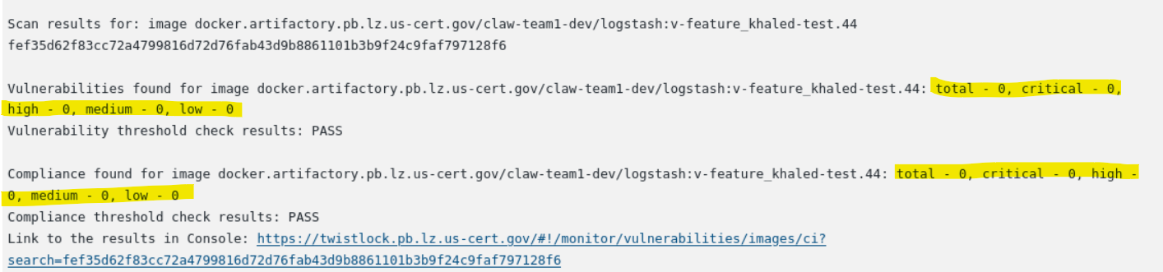

Prisma Cloud (TwistLock) Showing No Image Vulnerabilities:
----------------------------------------------------------------------------------

Image: Passed

No Image Vulnerabilities are found as shown below.

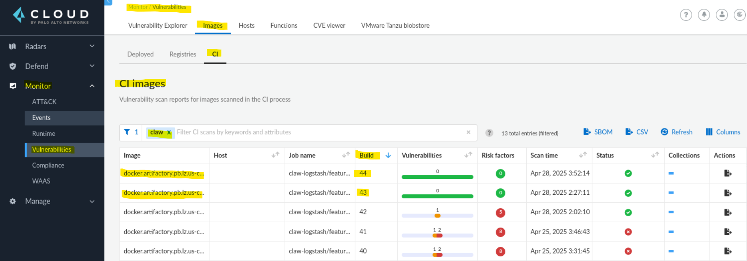

Always check the Image layers, to check for the details for vulnerabilities.

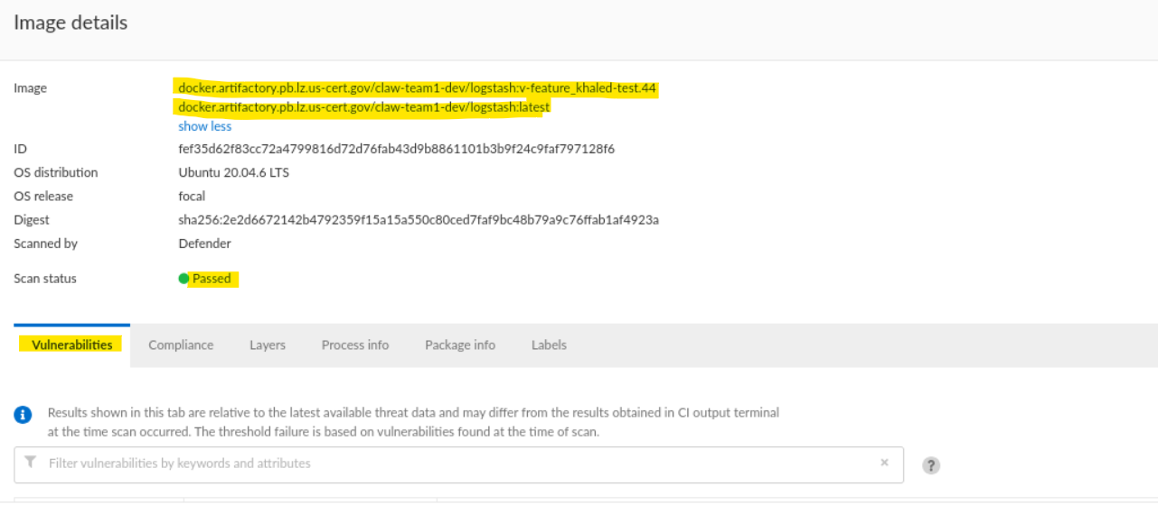

Image: Passed

No Image Vulnerabilities are found as shown below.

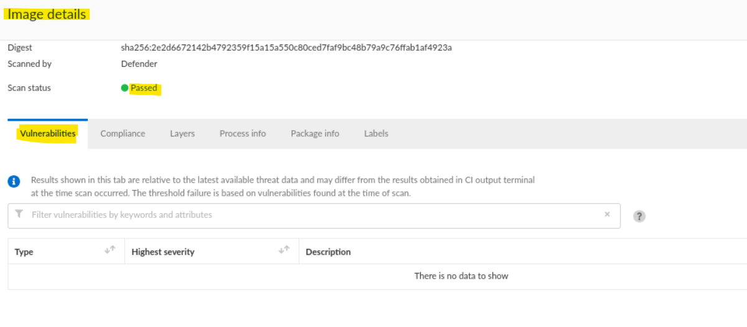
Twistlock Example for the vulnerabilities before they were fixed
----------------------------------------------------------------------------------------

Failed Image Vulnerabilities showing bundler & uri vulnerabilities.

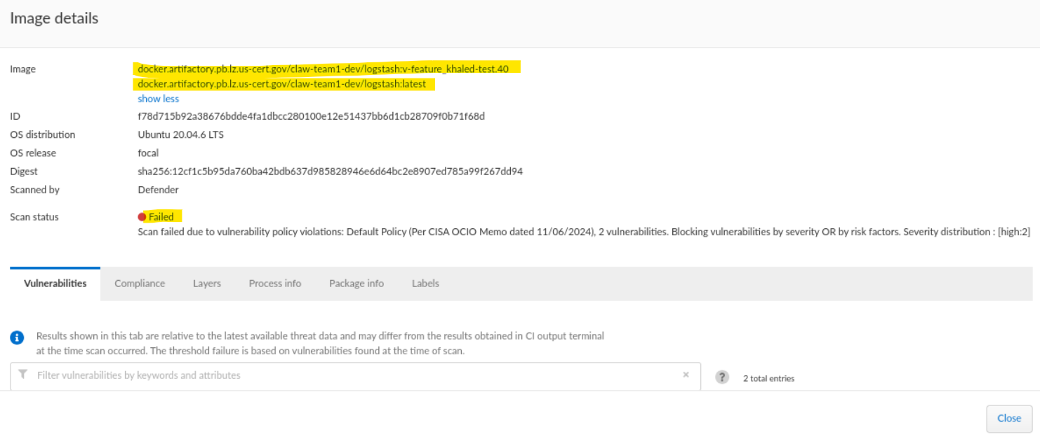

Image Vulnerabilities showing bundler & uri vulnerabilities.

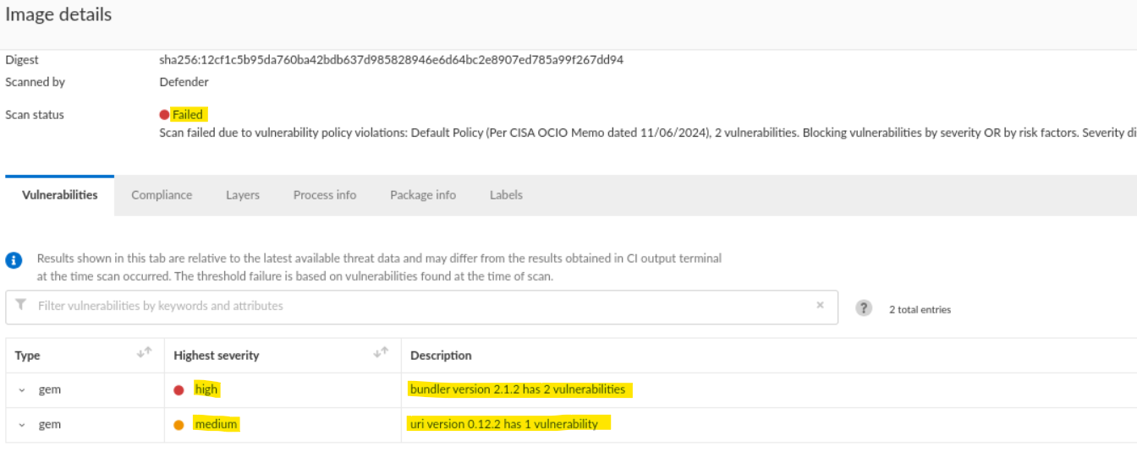

Image Layers showing the failed vulnerabilities

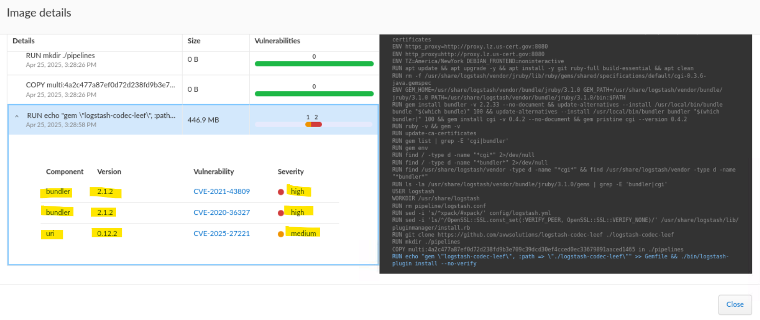
==============================================================================================================================================

#####################################################################################################################################################################################
#####################################################################################################################################################################################

- docker run = docker create + docker start

- docker create hello-world

This will create a new container using the hello-world image, but it will not Start it yet.

- docker start -a 21738926836128639812639826398313761830

This will start the container and show the output message from the container.

- docker run hello-world

This is to create a container using the hello-world image.

- docker run stephengrider/redis:latest

This is to create a container using the “stephengrider/redis” image using the “latest” version for my image.

- docker run stephengrider/redis

This is to create a container using the “stephengrider/redis” image, and by default the “latest” version will be used since I didn’t specify a version for my image.

- docker run busybox echo hi there

This is to create a container using the busybox image, and run this command inside my container “echo hi there”
This command is basically calling a program within the filesystem of the “busybox” image to be able to run it.

- docker run busybox ls

This is to create a container using the busybox image, and run this command inside my container “ls” which will list all the directories inside my “busybox” filesystem image .

- docker run busybox ping google.com

This is to create a container using the busybox image, and run this command inside my container “ping google.com” which will ping the google site.

- docker run -it busybox sh

This is to run a container and open a shell terminal inside the container to type any linux commands.

- docker run -d redis

This will start a redis container in the background.

- docker run -p 5000:8080 stephengrider/simpleweb

This is to do port mapping between my localhost machine and the running container, to be able to visit a website on my localhost machine.
The first 5000 port is considered the source port for the incoming traffic on my localhost machine.
The second 8080 is considered the destination port for the container port.
Then, you can visit “https:localhost:5000”, and see your application.

- docker run -p 3000:3000 -v /app/node_modules -v $(pwd):/app 68dafjdsah

-p is used for port mapping
-v is used for volume mapping

This will create a new folder “node_modules” under the “/app” directory inside the container, which is needed while creating the volume mapping below.

Volume Mapping between my localhost machine and Docker Container:
This will map the “present working directory (pwd)” on my local machine, which is “/Users/Khaled/Frontend” directory, to “/app” directory inside the container, and start containers using the image id “68dafjdsah”
We are basically doing that to make docker containers use the volume of my localhost machine, so that it reflects anything that is updated in my source code
immediately without having to build a new docker image and start new containers from this updated image.
We do this to avoid having to build a new docker image every time we change something in our source code and start new containers from the updated image.

We can do the same using “docker-compose”. Check the “docker-compose.yaml” file inside the folder “Repos/Docker/5-Frontend” in VsCode to see how we did it.

- docker start -a 261378y23

This is to start a container using its container-id, and reissue the same command that was made when the container was first created. In this case, the message was “hi there” out of the container. You can’t replace the “hi there” message for a previously started container.

- docker stop 261378y23

This is to stop a container and give the procceses inside it a little bit of time to shutdown.

- docker kill 261378y23

This is to kill this container immediately without any grace period.

- docker images

This is to show docker images

- docker image ls

This is to show the list of all docker images.

- docker ps

This will list all the running containers on my machine.

- docker ps --all

This will list all the containers that were ever created and started up on our machine.

- docker build -t stephengrider/multi-client:v5 .

This is to build a new docker image with version = “v5”

- docker build -t stephengrider/redis:latest .

This is to build a new docker image with version = “latest”

- docker build -t stephengrider/simpleweb .

By default, the docker image will append the “latest” version to your image if you didn’t specify it.

- docker build -f Dockerfile.dev .

This is to specify the filename “Dockerfile.dev” to use while building the docker image.
Docker expects the filename to be “Dockerfile”. So, this is to help docker understand which file to use while building the image.

- docker push stephengrider/multi-client:v5

This is to push the docker image to docker hub.

- docker logs cee3abw28

This is to show the logs of a particular container.

- docker exec -it cee3abw28 sh

This is to start a shell inside a container, so that you can run any linux command that you wish to run inside the container.

- docker exec -it cee3abw28 redis-cli

This is to start a redistribution shell inside a container, and type any redis commands inside the container.

- docker run b256sdhj28 npm run test -- --coverage

The “-- -- coverage” option will run our tests using “npm run tests” inside the container and return back to the shell.

- docker system prune -a

This will remove all the stopped containers, and remove all unused networks not used by at least one container, and remove all images without at least one container associated to them, and remove all build cache.

- echo “$DOCKER_PASSWORD” | docker login -u “$DOCKER_ID” --password-stdin

This is to export the “DOCKER_PASSWORD” and pass that as an argument variable to standard input through “--password-stdin” so, that I can login to Docker Hub using the “docker-compose” file.

- docker-compose up

This is to start docker containers using docker-compose.yaml file.
docker-compose is used to spin up multiple containers for applications and databases.
The docker-compose will automatically create a local network to join all the containers together, so that they can talk to each other.

If we changed anything in the “docker-compose.yaml” file and we ran “docker-compose up”, the new docker containers will use the new configuration settings in the updated “docker-compose.yaml” file.
Example: we added the “restart: always” configuration setting, and then we used the “docker-compose up”, this will create new containers using the updated “docker-compose.yaml” file

This is equivalent to running “docker run myimage”, when you want to spin up a single container.

- docker-compose up --build

This is to build your docker-compose image, and start new containers using the new image.
The docker-compose is used to start multi containers running for different applications.
This will rebuild our containers using the updated source code files.
Every time we change something in the “index.js” file, the “docker-compose up --build” will create a new image and start new containers using the new image.

This is equivalent to running ( “docker build .” + “docker run myimage” )

- docker-compose up -d

This is to start multiple containers in the background.

- docker-compose down

This is to stop multiple containers at the same time and remove them.

- docker-compose ps

This is to show the running containers for docker-compose.
Remember that you must run this command in the same directory that contains the docker-compose.yaml file.

Multi-Step Build Process:
—————————————
This allows you to use different base images, where you would start in “build” phase with one base image, then copy the results of that to the “Run” phase and start the run phase with a different base image.
If you want to start docker with a different docker image than the provided one initially, then you will need to have two stages. The first is “Docker Build” phase, and the second is “Docker Run” phase.
Check the “Dockerfile” in the “6-Multi-Step-Build-Process” in VsCode in “/Repos/Docker” Directory

