## Reseller:

### Adding order frequency in dimreseller to be able to display data on charts.



### Adding age group column in Dim customer transforming it from age

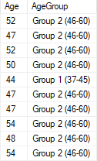

### Adding balance group in dim customer table transforming it from YearlyIncome

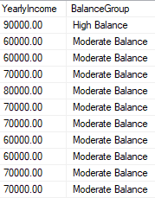

### Adding marital status abbrto transform abbr marital status in dim customer table

